Programmer Logic Test
- SQL Server (5)
  - Create tables as below, and insert some data in these 2 tables
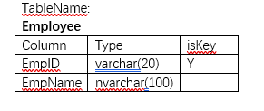

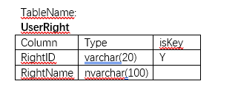

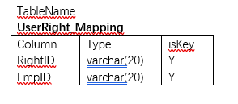

1.2 Insert Employee name “Earth” and have UserRight “Maintain program” and “Delete program”

1.3 How to query when you need to combine 2 rows into 1 row
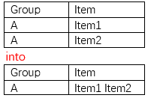

Please following table to answer the questions 1.4-1.5
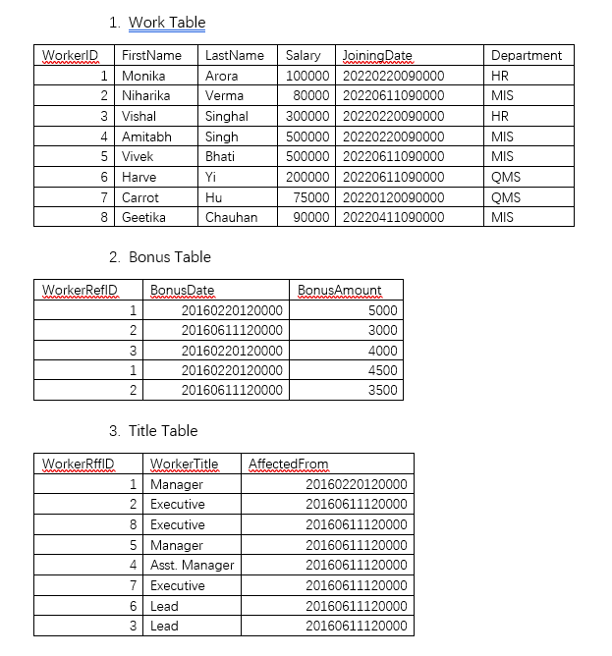

1.4. Write an SQL query to fetch how many persons in “QMS” Department

1.5. Write an SQL query to fetch records having matching data in some fields of Work table, Bonus Table, Title Table

- HTML & CSS (3)

2.1. Please write the HTML code that gives the result following the picture below.


2.2. Please write the HTML code that gives the table result following the picture below.


2.3 Please give an example of how to write CSS structure

- C# (1)


