Assignment-1
Installation and Configuration of Ubuntu Virtual Machine Using Oracle VirtualBox

Step 01-Install and open Oracle VirtualBox and upload the ISO file.
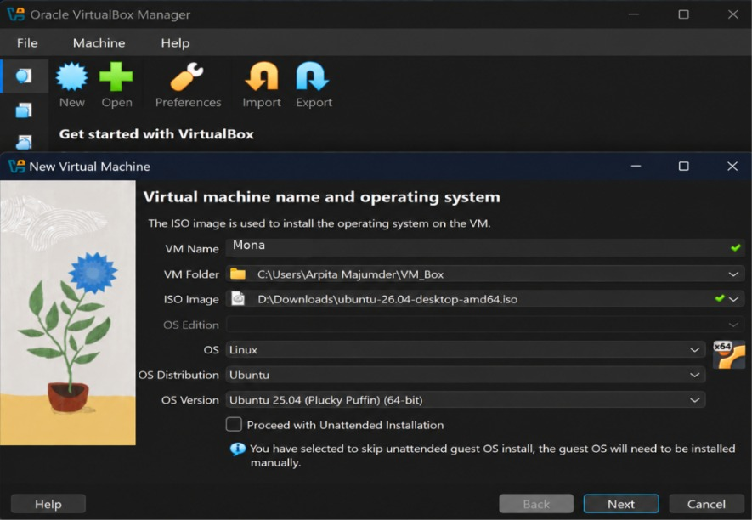

Step 02- Set the Base Memory, Number of CPUs and Disk Size according to the System.
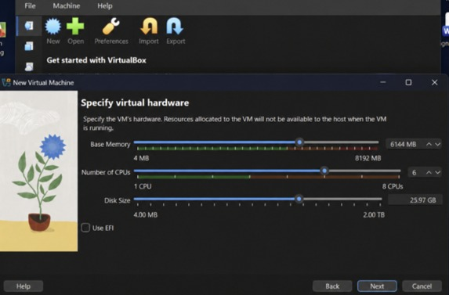

Step 03-Verify the summary.
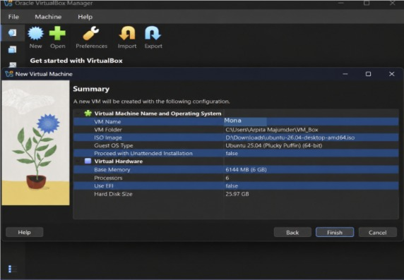
Step 04- Click on Start and create a User.
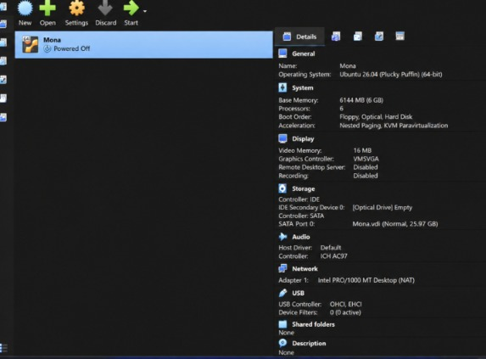
Step 05-Ubuntu Home Screen.


