**EXECUTION**

1. **Insert an Order with Enough Stock**

INSERT INTO OrderDetails (OrderDetailID, OrderID, ProductID, Quantity)

VALUES (3, 1002, 1, 10); -- 10 Chai, stock is 45 (after previous 5 used)

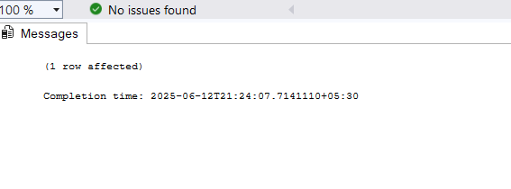

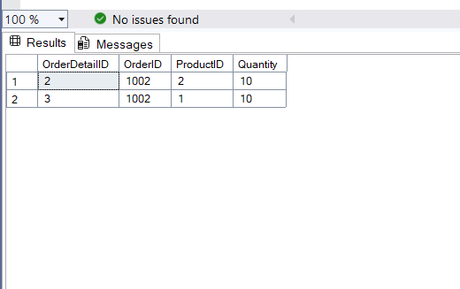

1. **Insert an Order with Insufficient Stock**

INSERT INTO OrderDetails (OrderDetailID, OrderID, ProductID, Quantity)

VALUES (4, 1002, 1, 1000); -- Should fail and rollback

