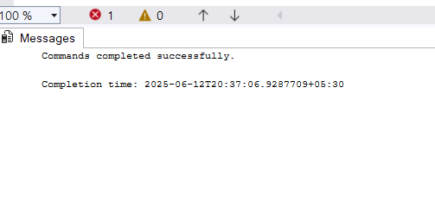

SELECT \* FROM vwCustomerOrders

WHERE OrderID = 43659;

