Commands :

npm run dev (to start the server)

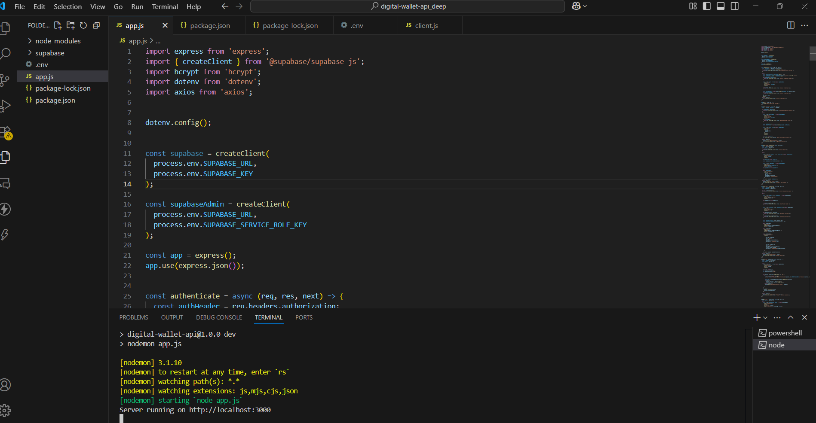

*# Set the base URL for your API*

$API_URL = <http://localhost:3000>

*# Register a new user 'sucharita123' with password 'password123'*

curl.exe -X POST "$API_URL/register" -H "Content-Type: application/json" -d '{\"username\": \"sucharita123\", \"password\": \"password123\"}'

*# Register another user 'testuser1' with password 'password1'*

curl.exe -X POST "$API_URL/register" -H "Content-Type: application/json" -d '{\"username\": \"testuser1\", \"password\": \"password1\"}'

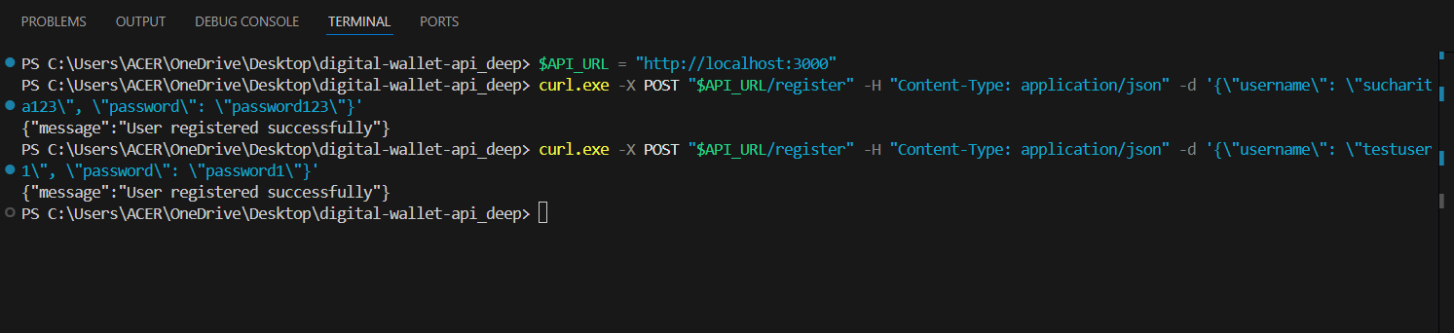

*# Generate the Base64-encoded credentials for Basic Auth for both users* *# sucharita123:password123 -> $auth1*

*# testuser1:password1 -> $auth2*

$API_URL = "http://localhost:3000"

$auth1 = [Convert]::ToBase64String([Text.Encoding]::ASCII.GetBytes("sucharita:password123")) $auth2 = [Convert]::ToBase64String([Text.Encoding]::ASCII.GetBytes("testuser1:password1"))

*# Fund 'testuser1' account with 500 units*

curl.exe -X POST "http://localhost:3000/fund" -H "Content-Type: application/json" -H "Authorization: Basic $auth2" -d '{\"amt\": 500}'



*# Fund 'sucharita123' account with 1000 units*

*# Fund 'testuser1' account with 500 units*

curl.exe -X POST "$API_URL/fund" -H "Content-Type: application/json" -H "Authorization: Basic $auth1" -d '{\"amt\": 1000}'



*# Check 'sucharita123' balance in INR*

*# Check 'sucharita123' balance in USD (converted using external currency API)*

curl.exe -X GET "http://localhost:3000/bal" -H "Authorization: Basic $auth1"

curl.exe -X GET "http://localhost:3000/bal?currency=USD" -H "Authorization: Basic $auth1"



*# Pay 200 units from 'sucharita123' to another user 'testuser456'*

curl.exe -X GET "http://localhost:3000/bal" -H "Authorization: Basic $auth1"

curl.exe -X GET "http://localhost:3000/bal?currency=USD" -H "Authorization: Basic $auth1"



*# Add a new product 'Smartphone' to the catalog as 'sucharita123'*

curl.exe -X POST "http://localhost:3000/pay" -H "Content-Type: application/json" -H "Authorization: Basic $auth1" -d '{\"to\": \"testuser456\", \"amt\": 200}'



*List all products in the global catalog (no authentication required)*

curl.exe -X POST "http://localhost:3000/product" -H "Content-Type: application/json" -H "Authorization: Basic $auth1" -d '{\"name\": \"Smartphone\", \"price\": 299.99, \"description\": \"Latest model smartphone\"}'

curl.exe -X GET <http://localhost:3000/product>

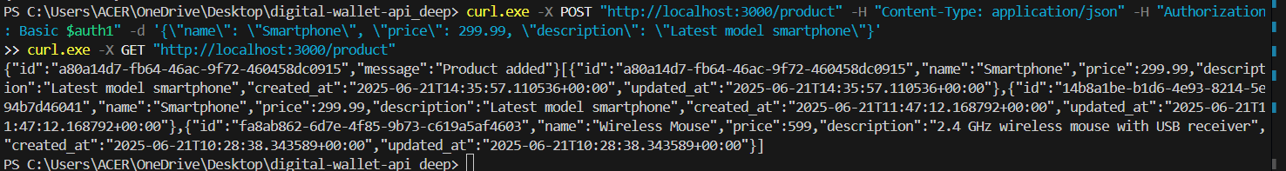

*# View 'sucharita123' transaction history (statement)*

curl.exe -X GET "http://localhost:3000/stmt" -H "Authorization: Basic $auth1"



*# Buy a product (replace PRODUCT_ID with the actual product ID from the product list*)

curl.exe -X POST "http://localhost:3000/buy" -H "Content-Type: application/json" -H "Authorization: Basic $auth1" -d '{\"product_id\": \"14b8a1be-b1d6-4e93-8214-5e94b7d46041\"}'



Database Schema

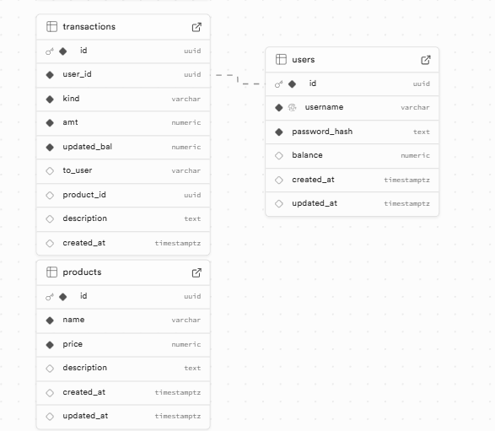

PRODUCTS TABLE

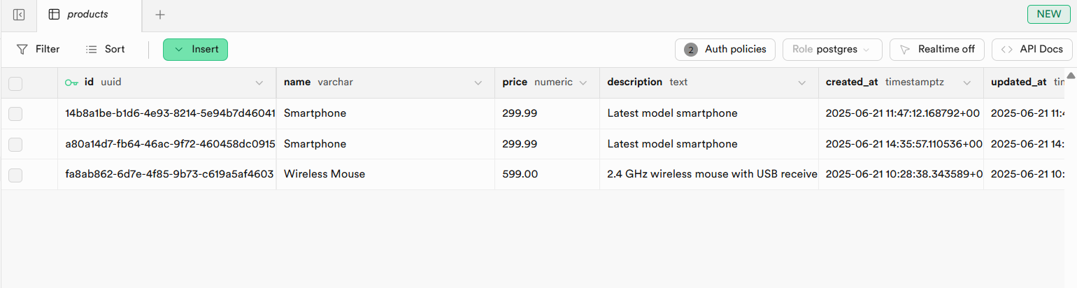

TRANSACTION TABLE

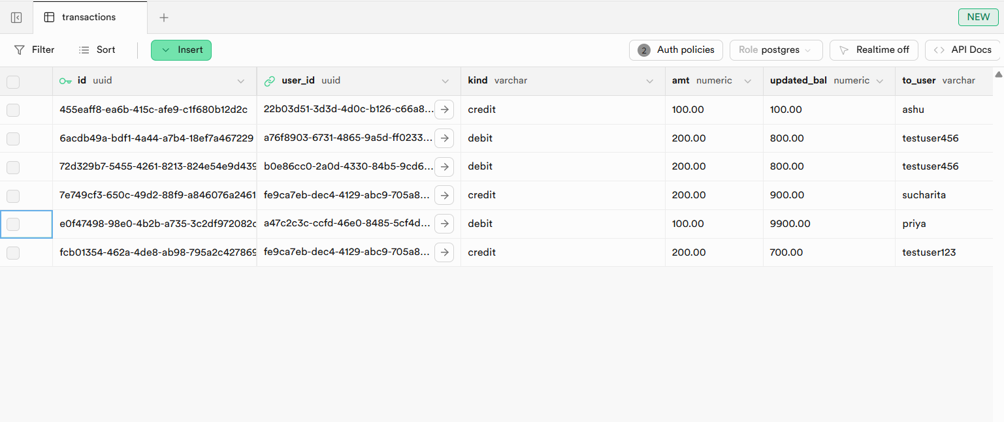

USERS TABLE

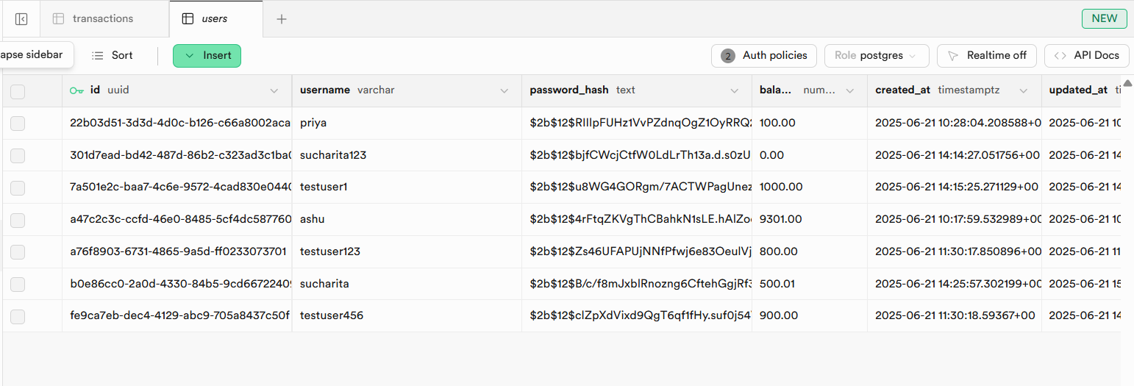

A quick check of authentication

