]SCHOOL OF COMPUTER SCIENCE AND ARTIFICIAL INTELLIGENCE |  |  |  |  | DEPARTMENT OF COMPUTER SCIENCE ENGINEERING
ProgramName:M. Tech |  |  |  | Assignment Type: Lab |  |  | AcademicYear:2025-2026
CourseCoordinatorName |  |  |  | Venkataramana Veeramsetty
rCourseCode |  |  | 24CS002PC215 | CourseTitle |  | AI Assisted Problem Solving Using Python
Year/Sem |  |  | II/I | Regulation |  | R24
Date and Day  of Assignment |  |  | 10.11.2025 | Time(s)
Duration |  |  | 2 Hours | Applicableto  Batches
AssignmentNumber:9.3(Present assignment number)/24(Total number of assignments)
 | Q.No. | Question |  |  |  |  |  | ExpectedTime  to complete
 | 1 | Lab 9: Documentation Generation: Automatic documentation and code comments  Lab Objectives:  - To understand the importance of documentation and code comments in software development.  - To explore how AI-assisted coding tools can generate meaningful documentation and inline comments.  - To practice generating function-level and module-level docstrings automatically.  - To evaluate the quality, accuracy, and limitations of AI-generated documentation.  - To develop a small automated tool for documentation generation in Python..  Lab Outcomes (LOs):  After completing this lab, students will be able to:  - Apply AI-assisted coding tools to generate docstrings and inline comments for Python code.  - Critically analyze AI-generated documentation for correctness, completeness, and readability.  - Create structured documentation (function-level, module-level) following standard formats.  - Design and implement a mini documentation generator tool to automate code commenting and docstring creation.  Task Description#1 Basic Docstring Generation  - Write python function to return sum of even and odd numbers in the given list.  - Incorporate manual docstring in code with Google Style  - Use an AI-assisted tool (e.g., Copilot, Cursor AI) to generate a docstring describing the function.  - Compare the AI-generated docstring with your manually written one.  Expected Outcome#1: Students understand how AI can produce function-level documentation  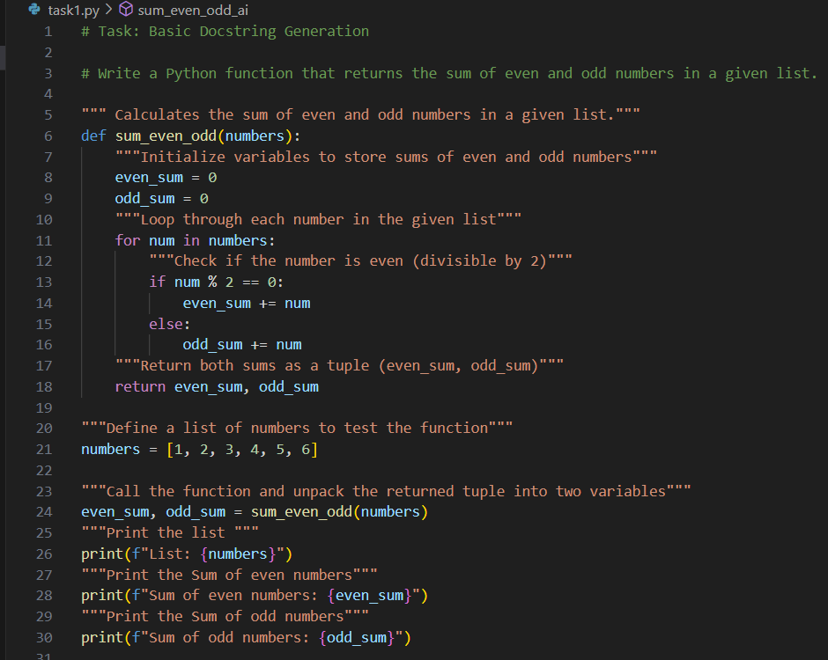  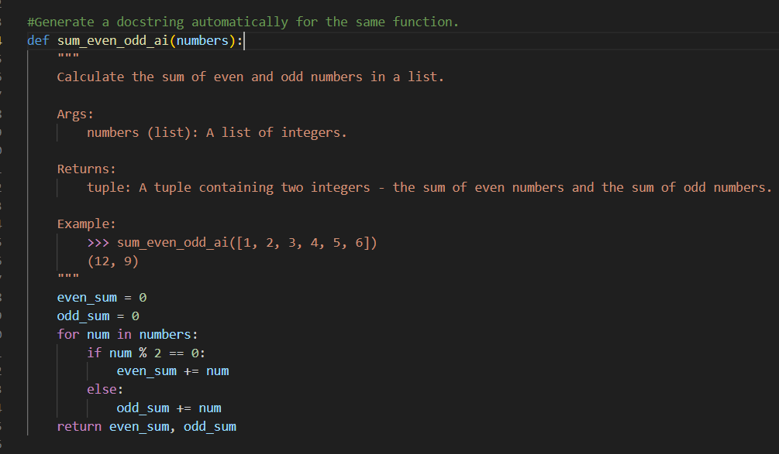  Output:  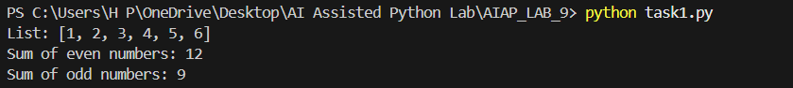  Comparision:  .  Task Description#2 Automatic Inline Comments  - Write python program for sru_student class with attributes like name, roll no., hostel_status and fee_update method and display_details method.  - Write comments manually for each line/code block  - Ask an AI tool to add inline comments explaining each line/step.  - Compare the AI-generated comments with your manually written one.  Expected Output#2: Students critically analyze AI-generated code comments.  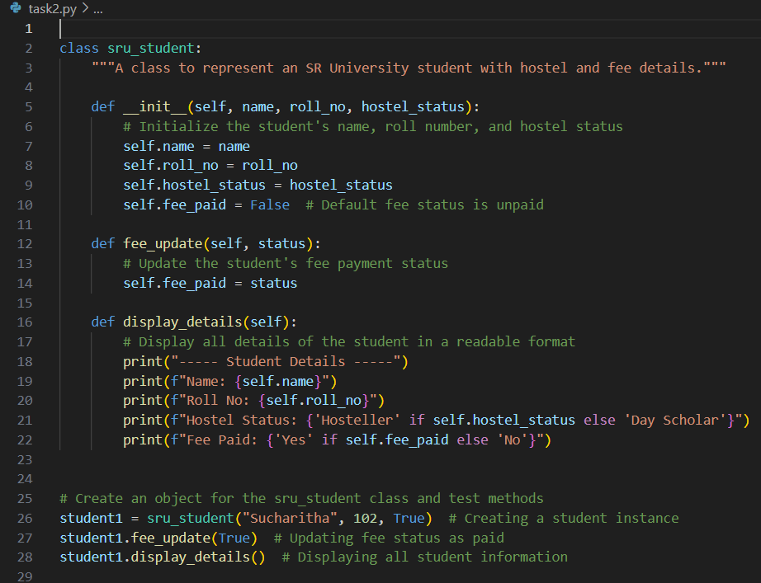  AI Generated Inline Comments Code:  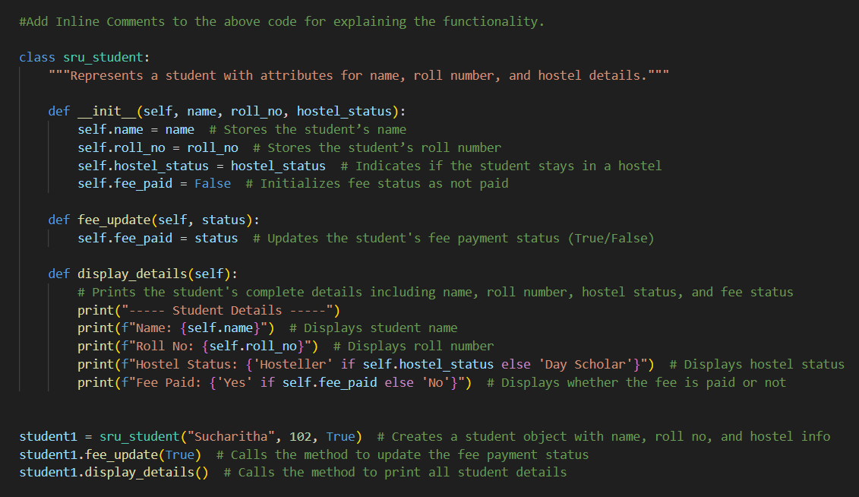  Output:  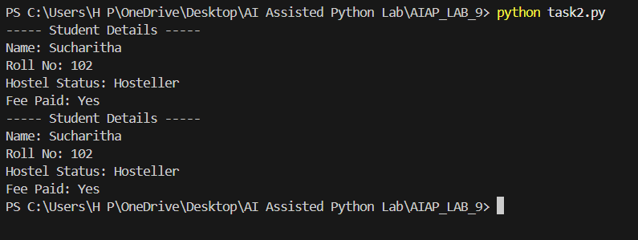  Analysis:  - The AI-generated comments are more technical and focus mainly on what each line of code does, not why it is written.  - My manually written comments are more detailed and explanatory, helping beginners understand the purpose and logic behind the code.  - The AI comments are short, neat, and consistent, making them good for documentation or professional codebases.  - However, they feel mechanical and repetitive, lacking the reasoning or intent behind the steps.  - Human-written comments add context and explain the flow of the program in a more understandable way.  - AI comments are suitable for experienced developers, while manual comments are better for learners and beginners.  - Overall, both have value — AI comments are efficient, but manual comments are more meaningful and educational.  Task Description#3  - Write a Python script with 3–4 functions (e.g., calculator: add, subtract, multiply, divide).  - Incorporate manual docstring in code with NumPy Style  - Use AI assistance to generate a module-level docstring + individual function docstrings.  - Compare the AI-generated docstring with your manually written one.  Expected Output#3: Students learn structured documentation for multi-function scripts  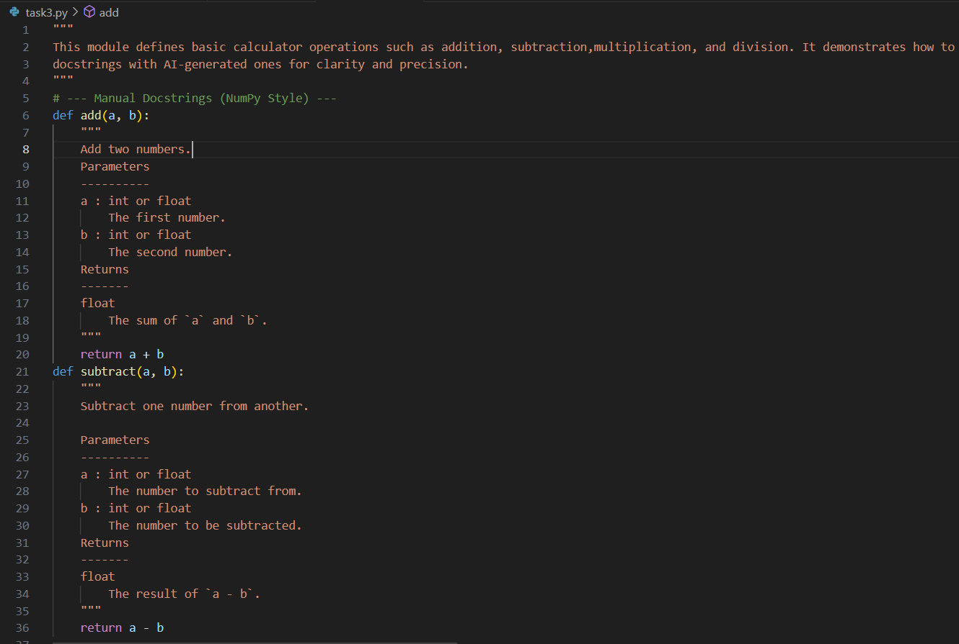  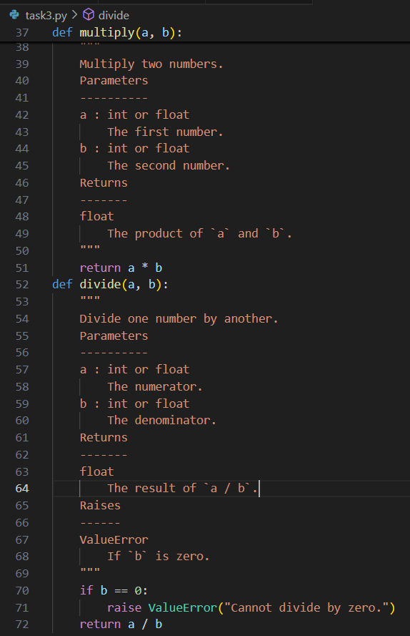  AI Generated Code:  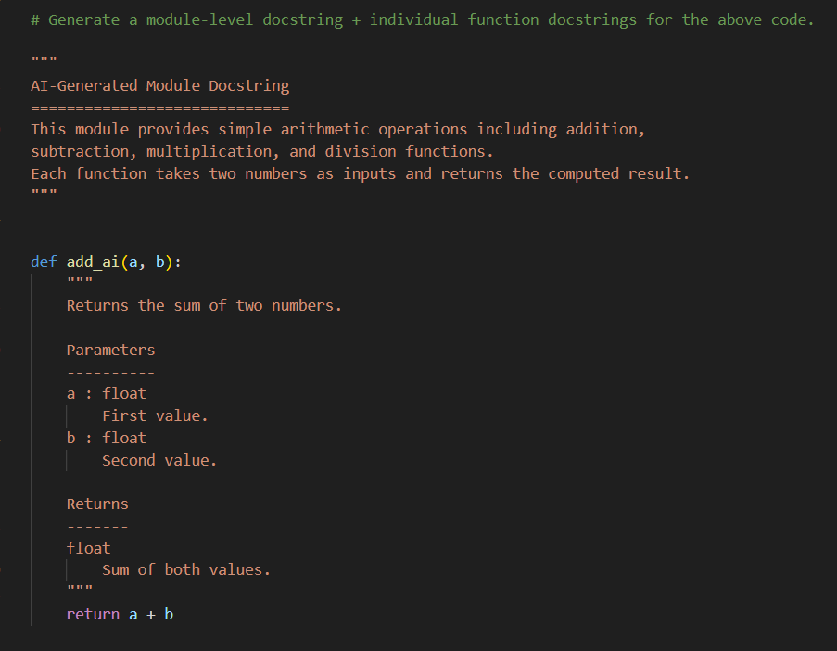  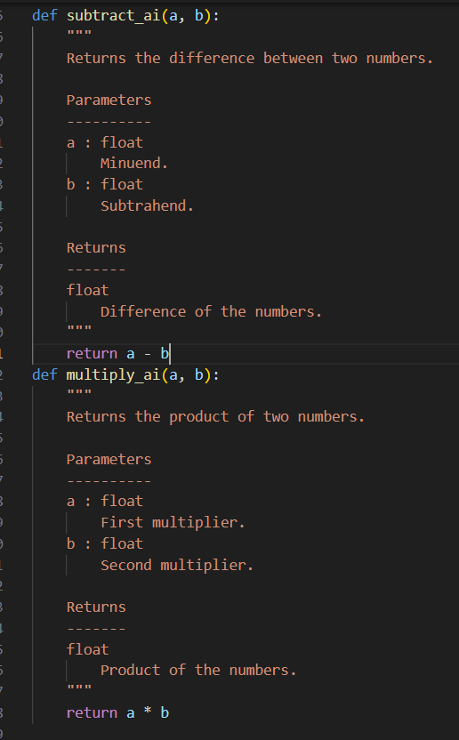  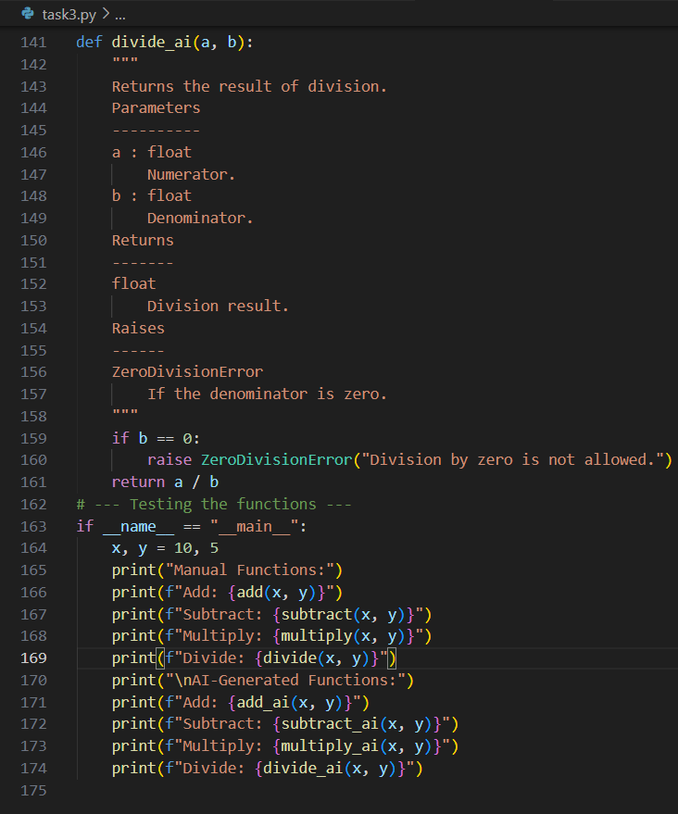  Output:  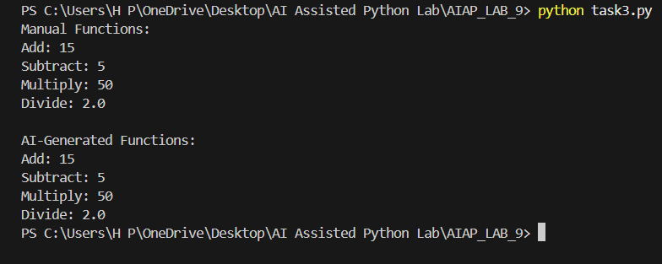  Comparision:  Push documentation whole workspace as .md file in GitHub Repository  Note: Report should be submitted a word document for all tasks in a single document with prompts, comments & code explanation, and output and if required, screenshots |  |  |  |  |  | Week4 - Wednesday
  Feature | Manual Docstring | AI-Generated Docstring
  Style | Written in a simple, informal, and explanatory way. | Structured and formal, following Google-style formatting.
  Focus | Describes step-by-step logic for understanding the code. | Focuses on summarizing the function’s purpose and usage.
  Usefulness for beginners | Very helpful for learners due to detailed explanations. | Moderately helpful, assumes prior understanding of docstring formats.
  Structured fields (Args, Returns) | Missing structured fields, focuses on plain text. | Clearly defines Args and Returns for better readability and standardization.
  Feature | Manual Docstring | AI-Generated Docstring
  Writing Style | More descriptive and explained in simple words. | Short, formal, and professional-looking.
  Structure | Follows NumPy style but not very strict. | Perfectly follows NumPy format automatically.
  Clarity | Easy for beginners to understand. | Concise and clear for experienced users.
  Consistency | Slight variations between functions. | Very consistent across all functions.
  Technical Accuracy | Correct but less standardized wording. | Uses accurate and standardized technical terms.
  Ease of Understanding | Explains logic clearly in simple language. | More focused on output and usage than logic.
  Documentation Readiness | Good for reading manually in code. | Excellent for use in auto-generated documentation tools.

