Assignment-3
Enrollment Number: 2503B05108

Task:1
Problem-01:
A bit stream 1101011011 is transmitted using the standard CRC method. The generator polynomial is x⁴+x+1. What is the actual bit string transmitted?
Code:
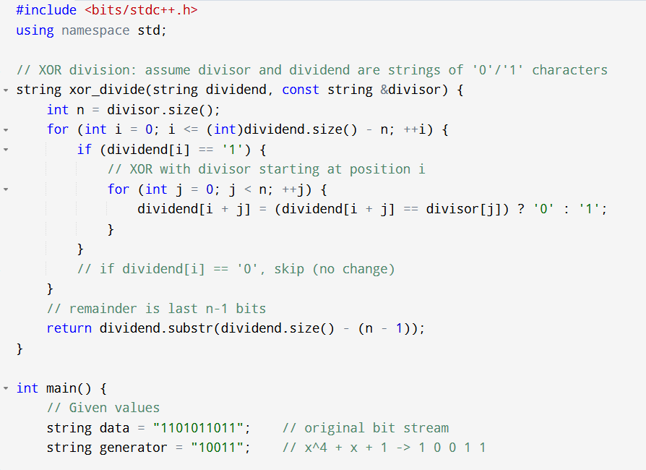
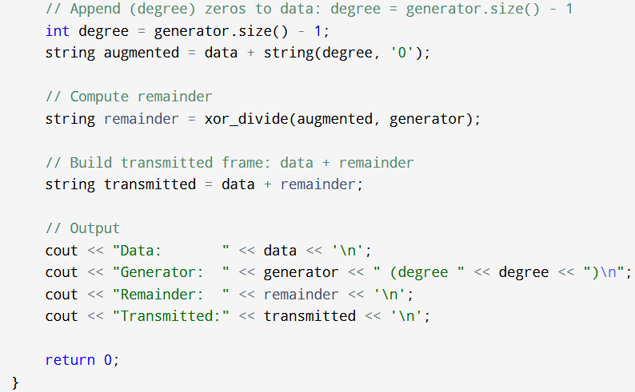
Output:
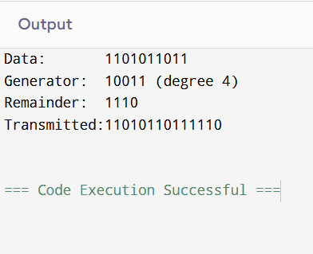

Task:2
Problem-02:
A bit stream 10011101 is transmitted using the standard CRC method. The generator polynomial is x³+1.
Code:
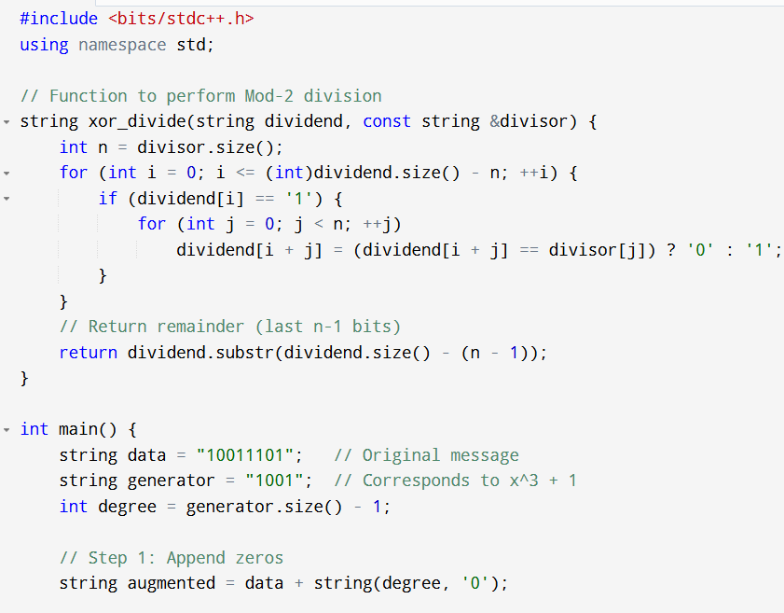
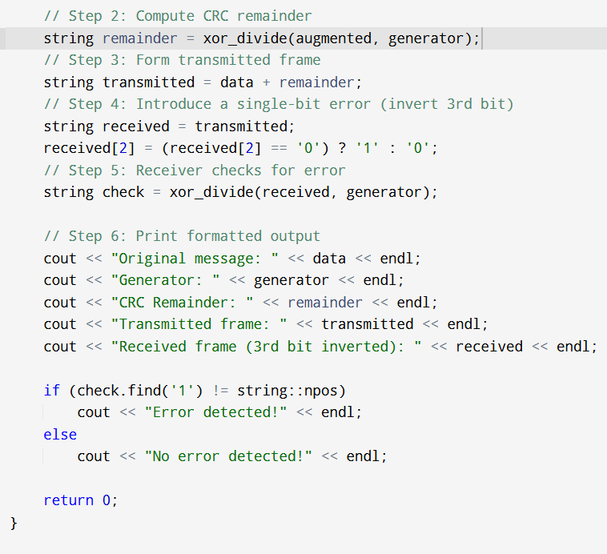
Output:
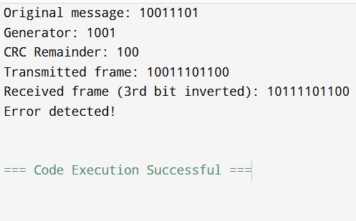

- What is the actual bit string transmitted?

Transmitted Frame = Data Bits + CRC Remainder
= 10011101 + 100 ( Binary addition)
Transmitted = 10011101100

- Suppose the third bit from the left is inverted during transmission. How will receiver detect this error?
Received frame: 10111101100
Divisor : 1001
After receiving the data / Frame the receiver will perform modulo-2 division with the divisor
If the remainder == 000 then the data received has no error
If the remainder != 000 then the data received has the error

