MODERN OPERATING SYSTEMS AND COMPUTER NETWORKS
ENROLLMENT NUMBER :2503B05205
NAME : SUCHARITHA KONDAPARTHI

Question:
Write a C++ program to implement Hamming Code for error detection and correction.
Requirements:
- Accept a binary data string as input.
- Determine the number of redundant bits required.
- Insert the redundant bits into appropriate positions (1, 2, 4, 8, …).
- Calculate and set the parity bits using even parity logic.
- Display the final data packet (data bits + redundant bits) to be transmitted.
- Simulate the receiver side to:
  - Recalculate parity bits.
  - Detect if there is any single-bit error.
  - Display the position of the erroneous bit or confirm no error if data is correct.
Example Output:
Input data: 1011001
The data packet to be sent is: 1 0 1 0 1 1 0 1
Correct data packet received

Code:
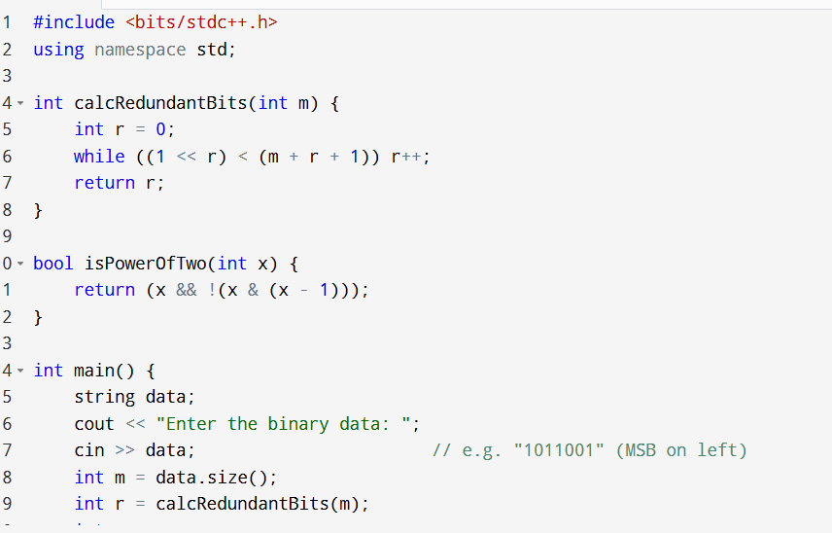
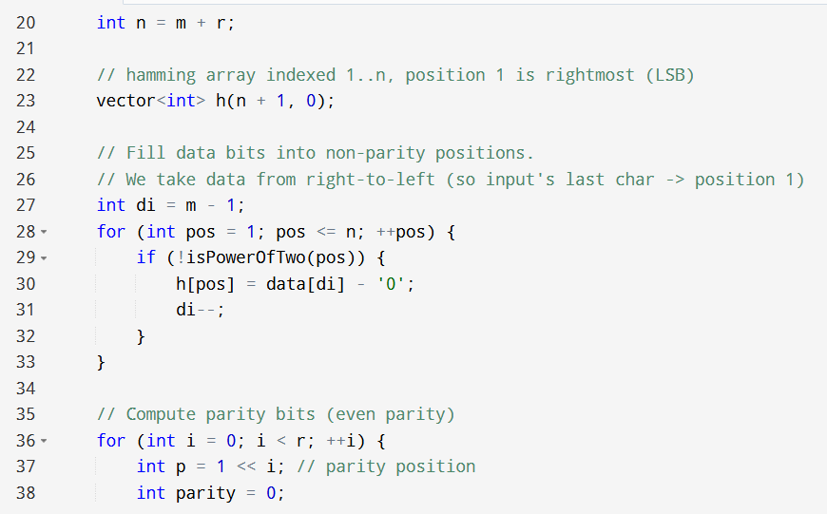
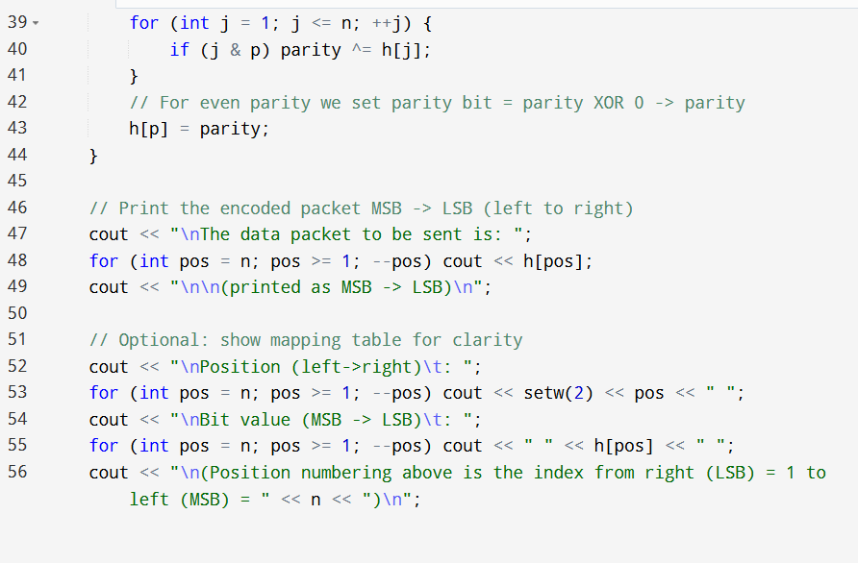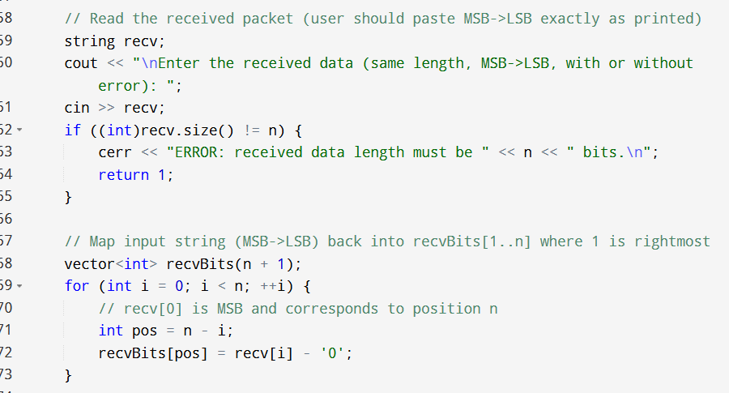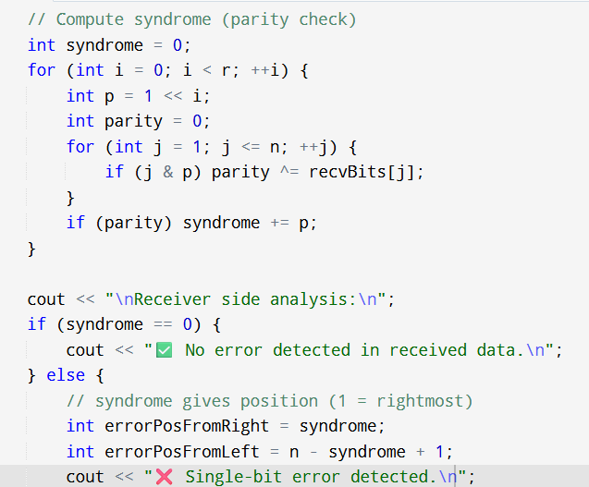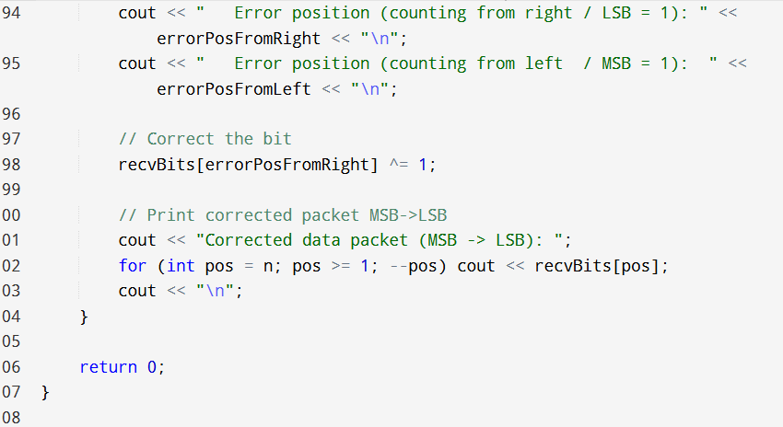
OUTPUT:
