SuchetaWS9

Sucheta

19/11/2021

#solution 1  
  
x = c(1:6) #generates the range of roll of a dice  
prob = c(1/6,1/6,1/6,1/6,1/6,1/6) #probability of each roll of a fair dice  
dice1 = sample(x,size=100,replace = TRUE, prob=prob) #generates a sample of size 100  
table(dice1) #generates a table of the counts of range(X)

## dice1  
## 1 2 3 4 5 6   
## 17 22 17 11 20 13

hist(dice1,breaks = seq(1,6, by=0.25)) #Plots the histogram

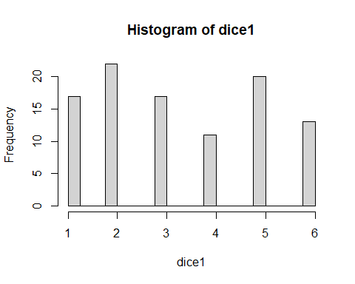

#solution 2  
  
x = c(1:6) #generates the range of roll of a dice  
probx = c(1/6,1/6,1/6,1/6,1/6,1/6) #probability of each roll of a fair dice  
dice=sample(x, size=500, replace=TRUE, prob=probx) #generates a sample of sixe 500  
dicem=matrix(dice, 5) #generated a 100*5 matrix of elements of dice  
dice_sum = apply(dicem, 2, sum) #adds the elements columnwise  
table(dice_sum) #generates a table of counts of the sum of five rolls of a dice

## dice_sum  
## 11 12 13 14 15 16 17 18 19 20 21 22 23 25   
## 4 8 2 4 9 13 6 8 12 9 8 8 5 4

hist(dice_sum,breaks = seq(5,30, by=1),xlab ="Sum of five rolls") #histogram for sum of five rolls of a dice  
  
  
#Solution 3  
  
library(tidyverse)

## -- Attaching packages --------------------------------------- tidyverse 1.3.1 --

## v ggplot2 3.3.5 v purrr 0.3.4  
## v tibble 3.1.4 v dplyr 1.0.7  
## v tidyr 1.1.3 v stringr 1.4.0  
## v readr 2.0.1 v forcats 0.5.1

## -- Conflicts ------------------------------------------ tidyverse_conflicts() --  
## x dplyr::filter() masks stats::filter()  
## x dplyr::lag() masks stats::lag()

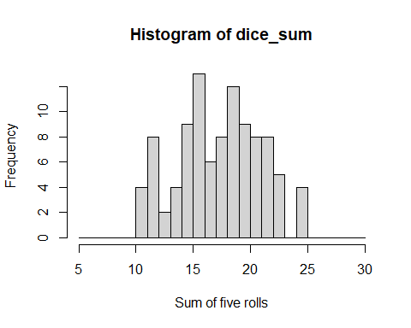

x = c(1:6) #generates the range of roll of a dice  
prob2 = c(1/6,1/6,1/6,1/6,1/6,1/6) #probability of each roll of a fair dice  
dice2=sample(x, size=5000, replace=TRUE, prob=probx) #generates a sample of size 5000  
dicem2=matrix(dice2, 50) #generated a 100*50 matrix of elements of dice  
dice_sum2 = apply(dicem2, 2, sum) #adds the elements columnwise  
table(dice_sum2) #generates a table of counts of the sum of fifty rolls of a dice

## dice_sum2  
## 143 148 151 152 153 156 157 158 159 160 162 163 164 165 166 167 168 169 170 171   
## 1 1 1 1 3 1 2 1 1 1 2 3 3 3 4 1 1 2 2 2   
## 173 174 175 176 177 178 179 180 181 182 183 184 185 186 187 188 189 190 191 192   
## 1 6 5 5 2 1 6 3 4 1 4 2 2 4 1 2 1 3 2 6   
## 194 196 198   
## 1 1 1

hist(dice_sum2,xlab ="Sum of 50 rolls") #histogram for sum of fifty rolls of a dice

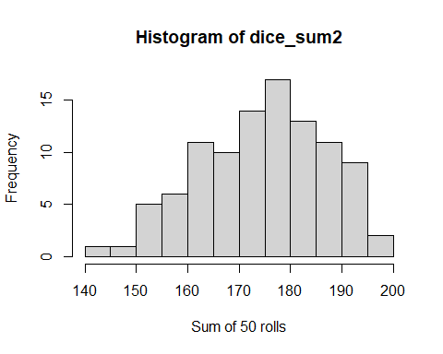

mean(dice_sum2)

## [1] 175.01

sd(dice_sum2)

## [1] 12.11935

true_mean = 50*mean(x) #calculates the true mean   
true_var = 50*var(x) #calculates the true variance  
true_sd = (true_var)^0.5 #calculates the true standard deviation  
  
  
#We can see that the true mean and standard deviation are almost same  
  
n_dist = rnorm(500,true_mean, true_sd) #generates sample with normal distribution  
df_n = data.frame(n_dist) #creates a table  
head(df_n)

## n_dist  
## 1 188.4131  
## 2 179.0223  
## 3 192.0431  
## 4 190.1009  
## 5 149.5422  
## 6 186.1883

ggplot(df_n) + geom_histogram(mapping=aes(x=n_dist), color="black", fill="black", binwidth=1) #plots a histogram

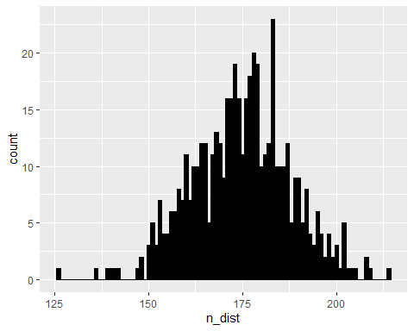

#the graph for sum of 50 dice rolls and normal dist look the same. We can see that for sum of 50 rolls the graph is an inverted bell which is approximately symmetric at around 170-180.

## R Markdown

This is an R Markdown document. Markdown is a simple formatting syntax for authoring HTML, PDF, and MS Word documents. For more details on using R Markdown see <http://rmarkdown.rstudio.com>.

When you click the **Knit** button a document will be generated that includes both content as well as the output of any embedded R code chunks within the document. You can embed an R code chunk like this:

summary(cars)

## speed dist   
## Min. : 4.0 Min. : 2.00   
## 1st Qu.:12.0 1st Qu.: 26.00   
## Median :15.0 Median : 36.00   
## Mean :15.4 Mean : 42.98   
## 3rd Qu.:19.0 3rd Qu.: 56.00   
## Max. :25.0 Max. :120.00

## Including Plots

You can also embed plots, for example:



Note that the echo = FALSE parameter was added to the code chunk to prevent printing of the R code that generated the plot.