Assignment 2

Group Members:

1. Sucheta Jhunjhunwala,MDS202151
2. Ujjwal Saxena, MDS202152
3. Ved Prakash, MDS202153

**SQL Queries:**

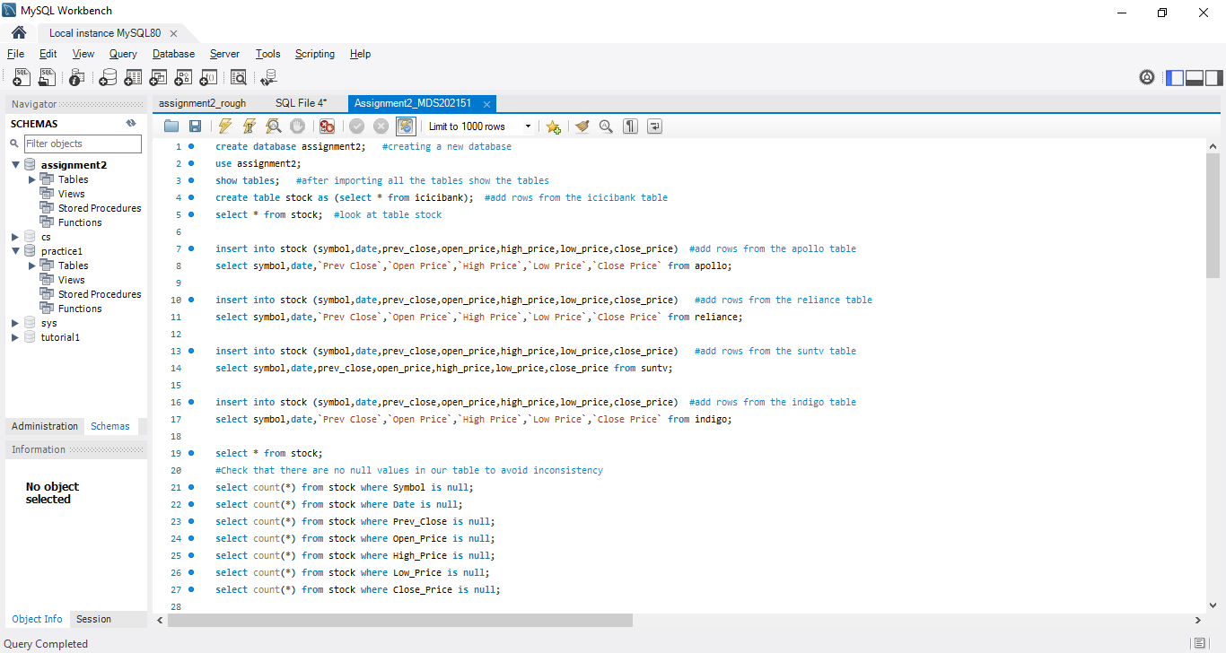

Task 1 Query:

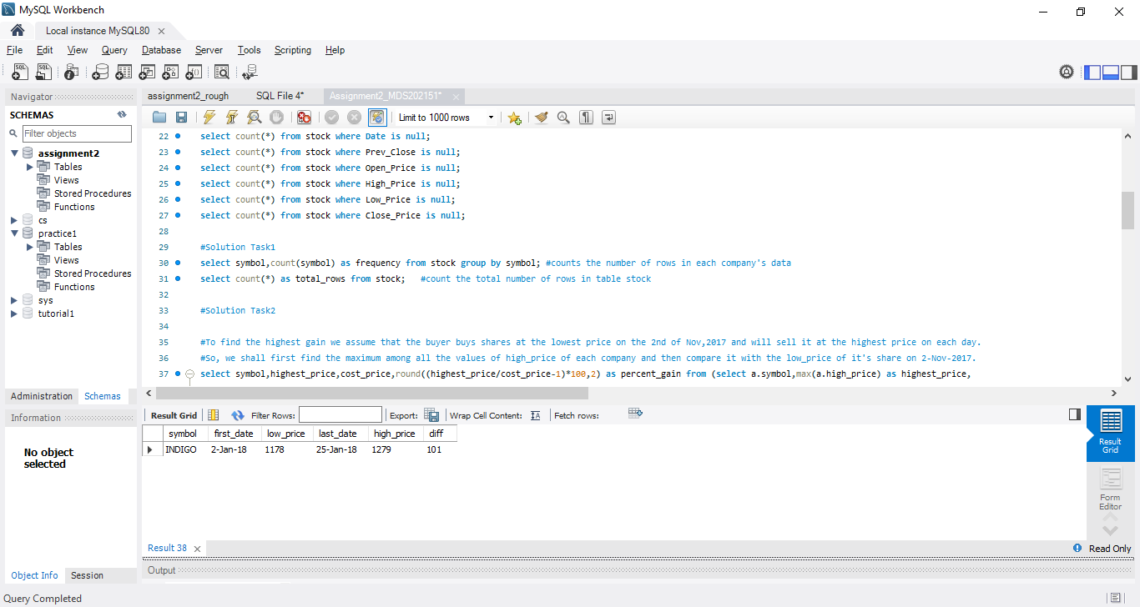

Showing the Number of rows in Result: Showing the number of rows in table stock

each category of stock company.

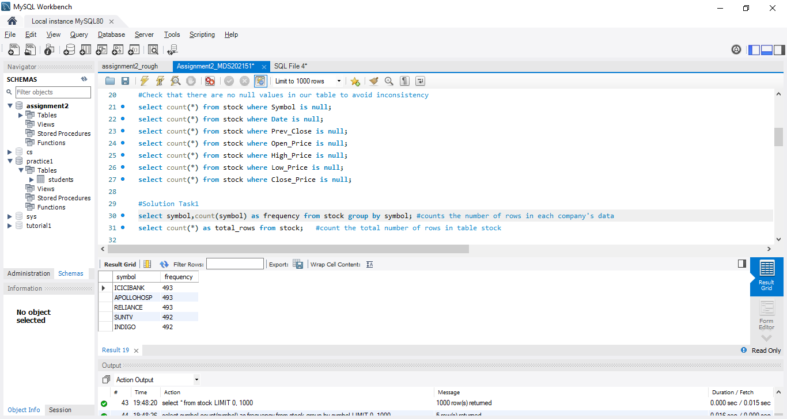 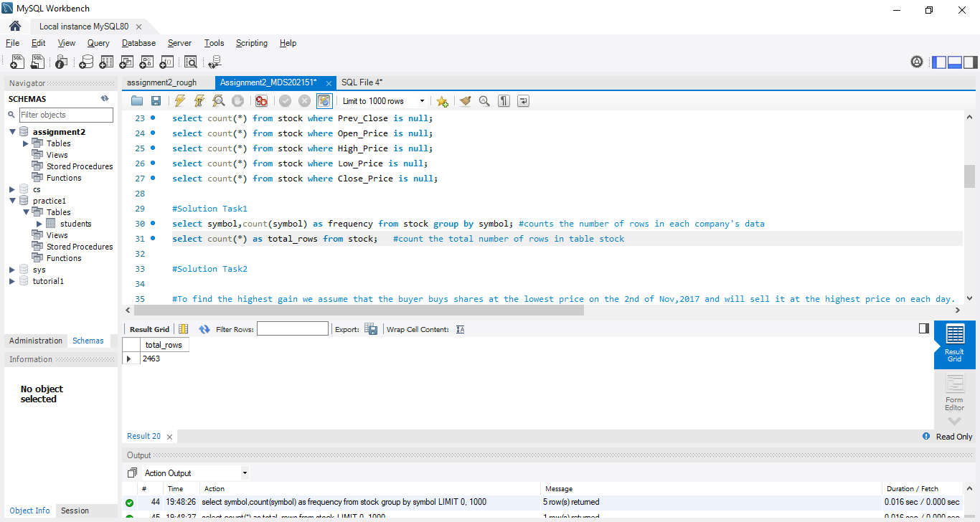

Task 2 queries: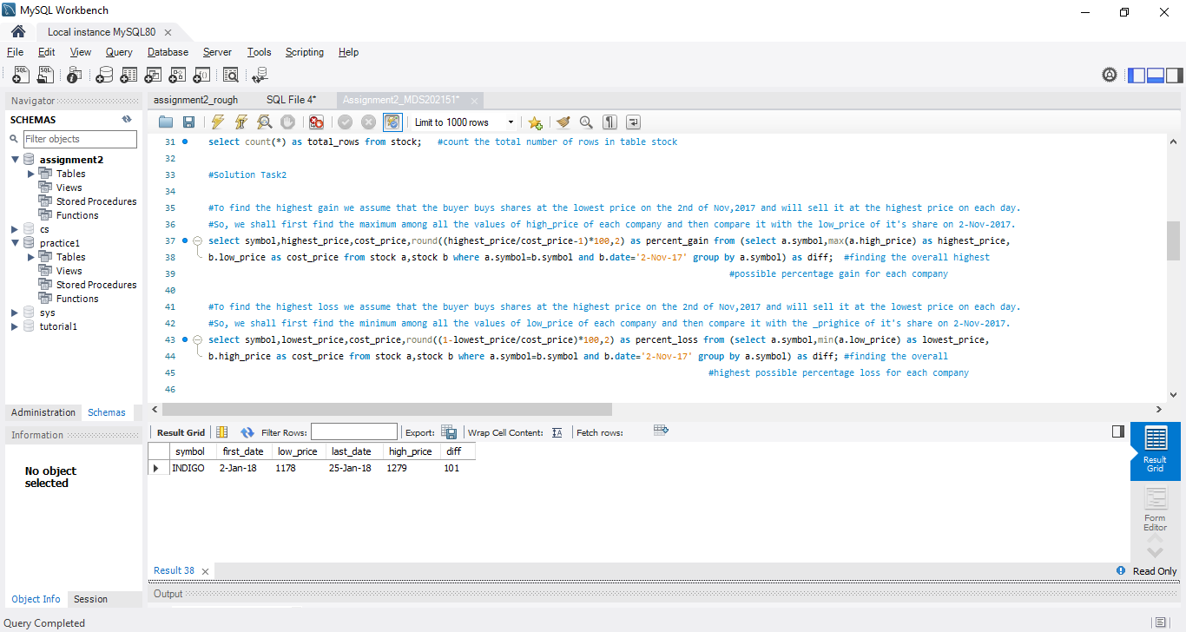

Result: Showing the highest overall percentage gain of each company.

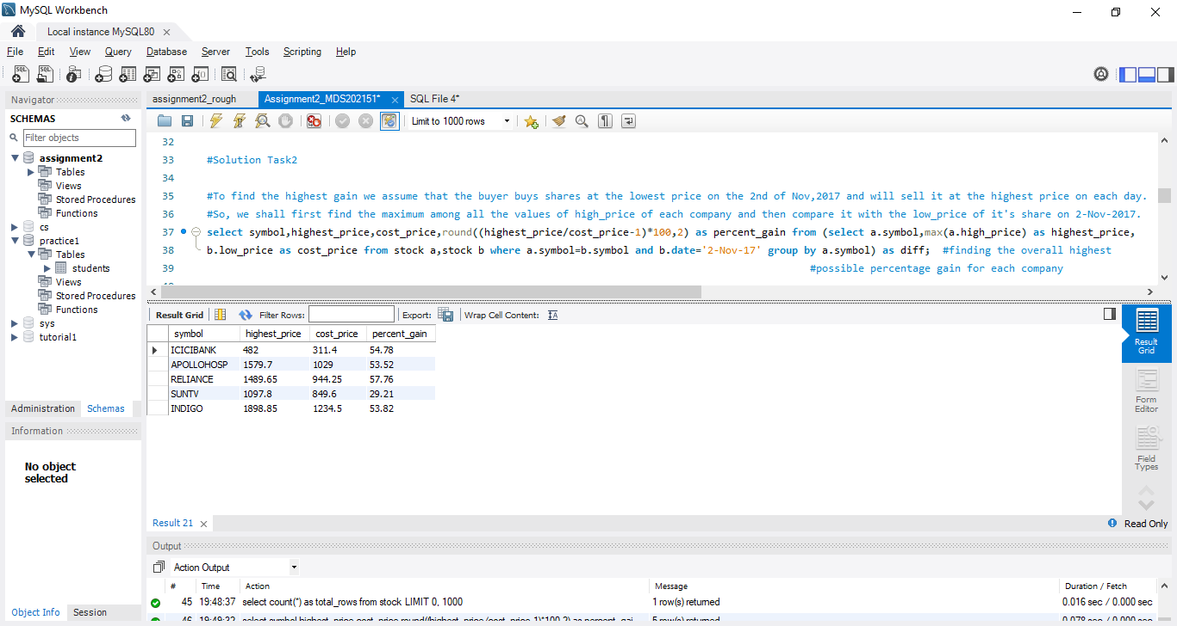

Result: Showing the highest overall percentage loss of each company.

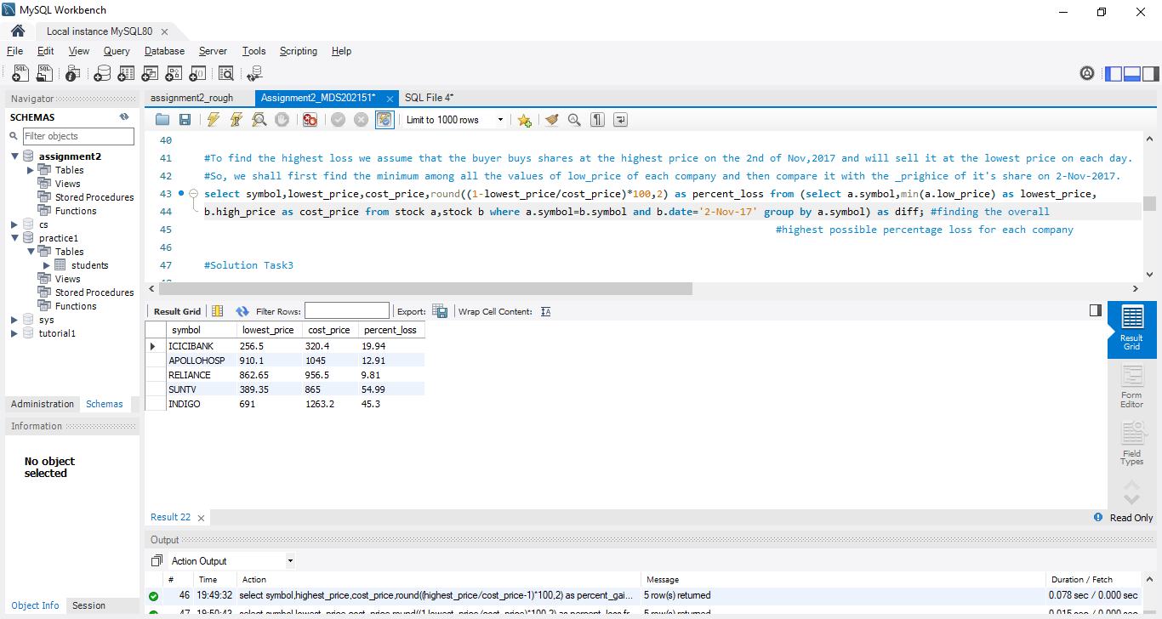

Task 3 queries: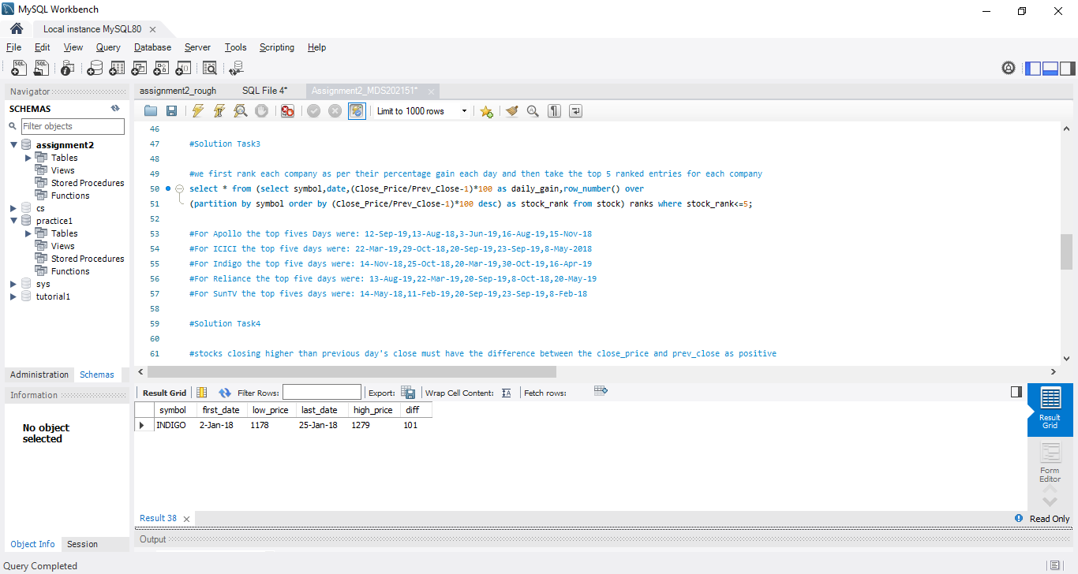

Task 4 queries:

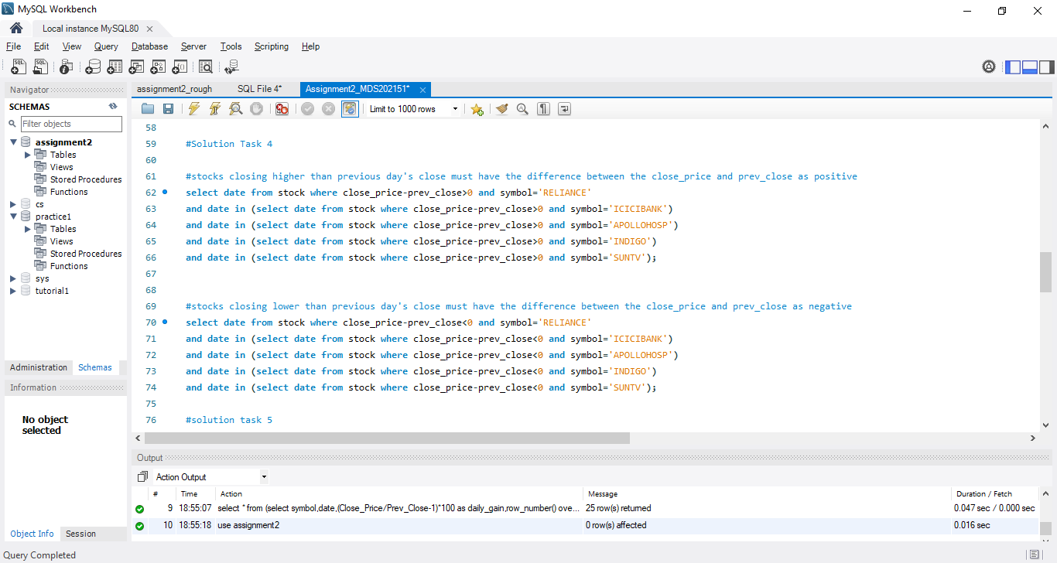

Task 5 queries: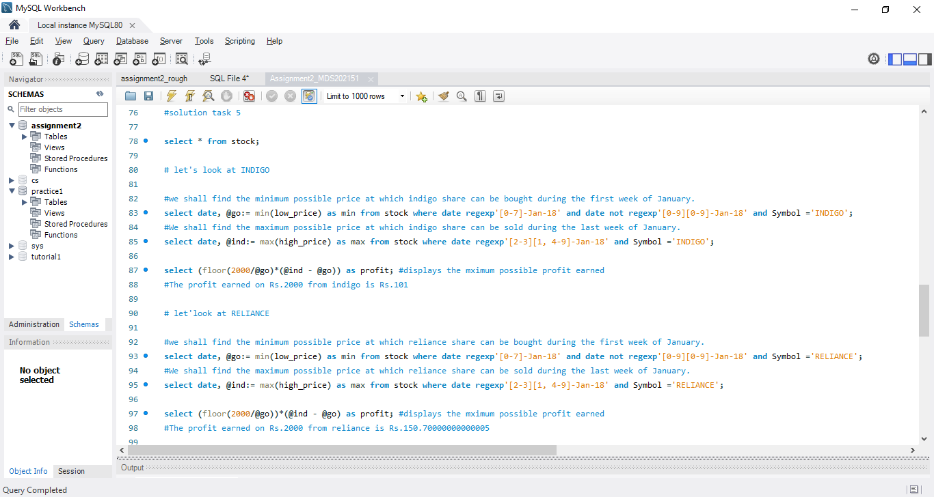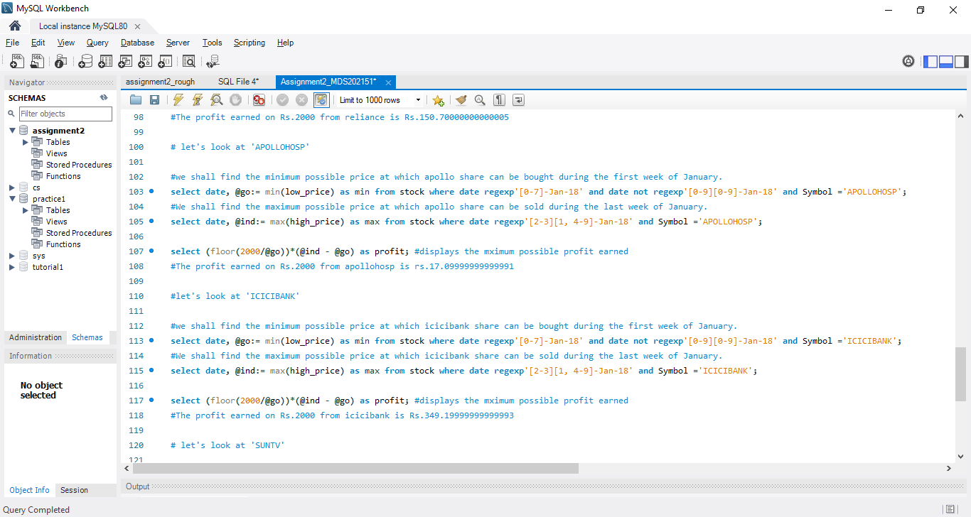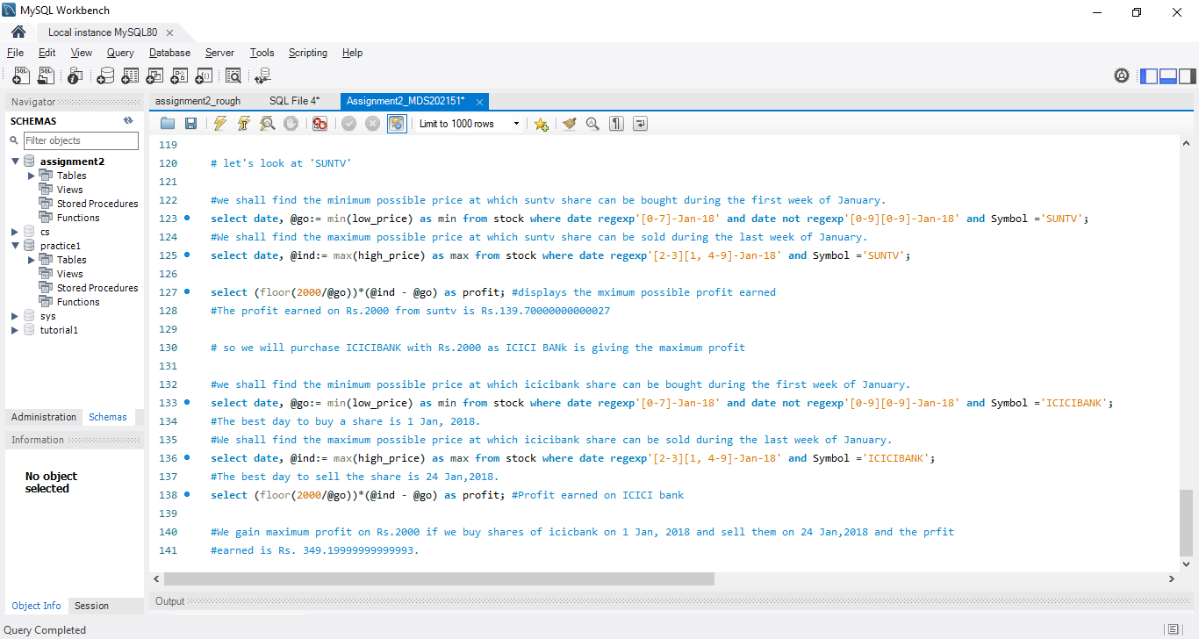

Buying date: 1 Jan,2018

Selling date: 24 Jan,2018

Name of the stock: ICICIBANK

Profit earned = Rs. 349.19999999999993