Assignment 01)

Create Visualizations using the attached csv files.

Customer

Product

Orders

Order_line

1. Create a single chart to show Total sales and total quantity bought for each product .
2. For the above chart, display only top 5 product details based on total sales.(Use calculations and filter)
3. Create a Heat Map to show number of orders made by each customer.
4. Create a chart to show trend in buying number of products wrt months.

Data cleaning:

Given csv files were already cleaned

Data Analysis:

1. 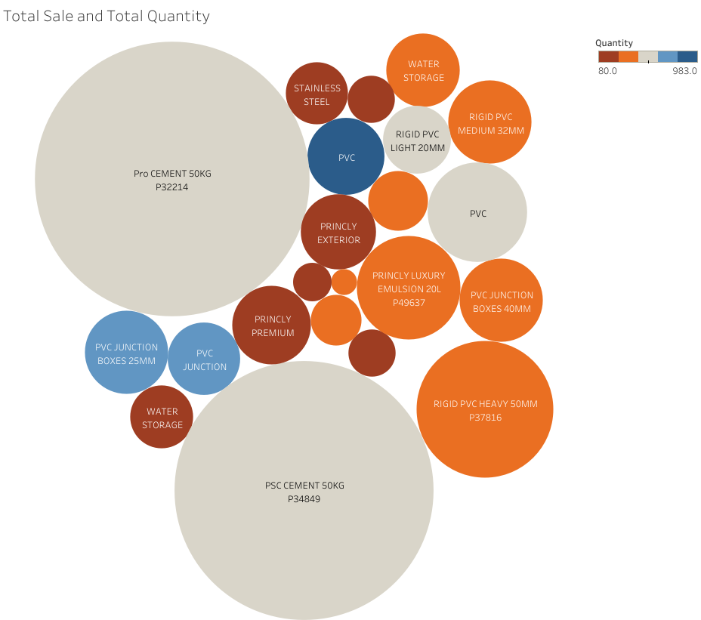**Total sales and total quantity bought for each product** .

LINK:<https://public.tableau.com/profile/sucheta.kar#!/vizhome/Assignment1_16173846728250/TotalSaleandTotalQuantity>

Created the custom measure

Total sale= SUM([Quantity])*SUM([Price In Rs])

Here color represting total quantity of a product

And size represting total sale of a product(i.e bigger the size of bubble bigger is the sale)

2**. For the above chart, display only top 5 product details based on total sales.**

LINK:<https://public.tableau.com/profile/sucheta.kar#!/vizhome/Assignment1_16173846728250/Top5TotalSale>

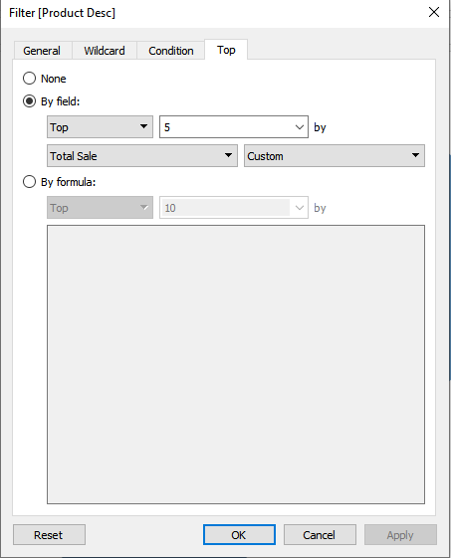I have used Product desc to filter top 5 product according to total sale of the product

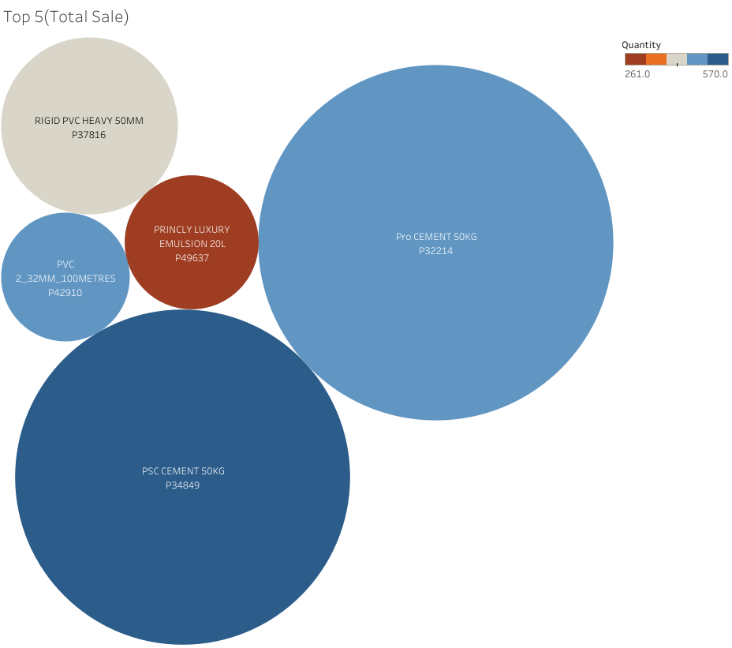

3) **Create a Heat Map to show number of orders made by each customer.**

LINK:

<https://public.tableau.com/profile/sucheta.kar#!/vizhome/Assignment1_16173846728250/HeatMap>

I have used count product in size tab

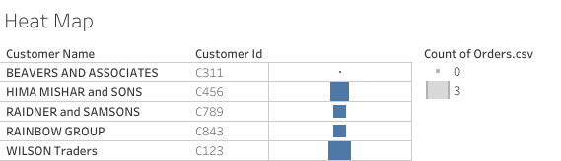

4) **Create a chart to show trend in buying number of products wrt months.**

LINK:<https://public.tableau.com/profile/sucheta.kar#!/vizhome/Assignment1_16173846728250/Trendofproductbuyingwrttocountofproduct>

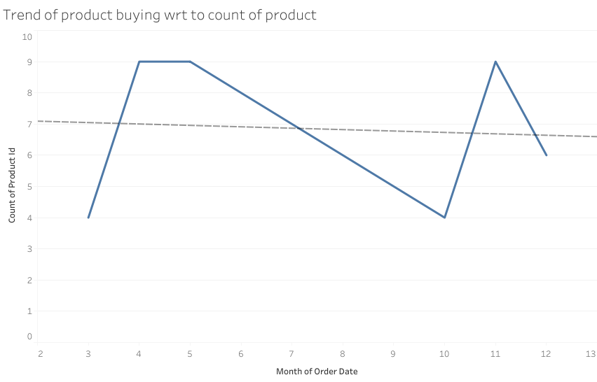

In the month of-April, May ,November have highest no. of product sale have happen

In the month of-March , October have lowest no. of product sale have happen

Other:

5) TREND OF BUYING PRODUCT FOR EACH CUSTOMER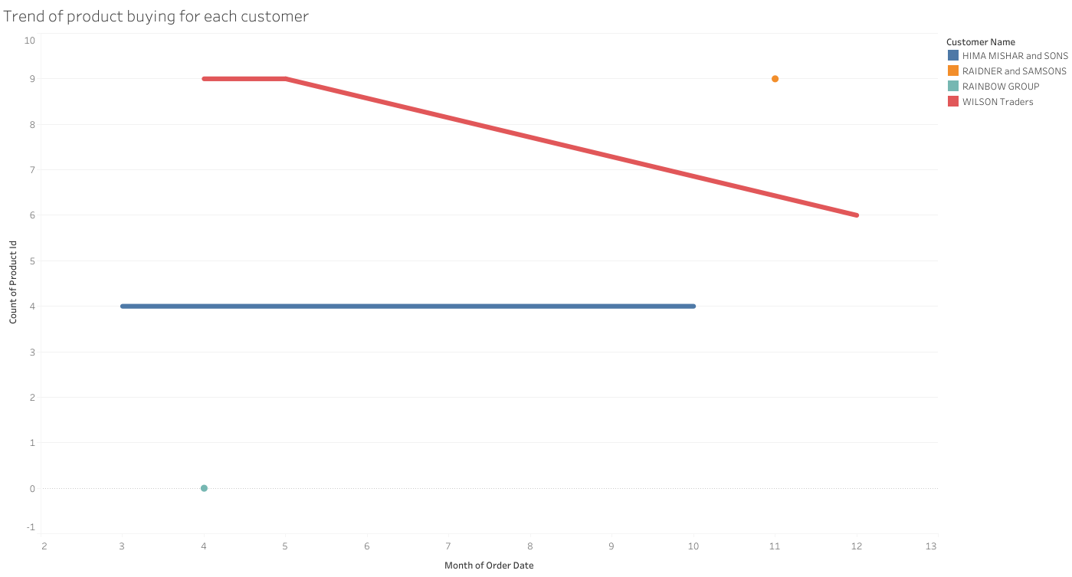

In a trend of buying product for every customer we can see Wilson traders quantity of buying product decrease overtime

6)TABLE OF CUSTOMER ID,CUSTOMER NAME ,ORDER ID, NO. OF PRODUCT ORDRED IN EACH ORDER

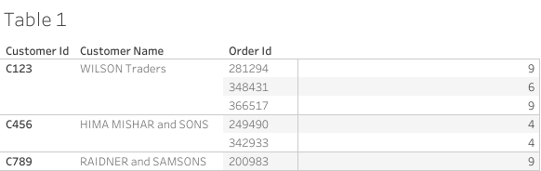

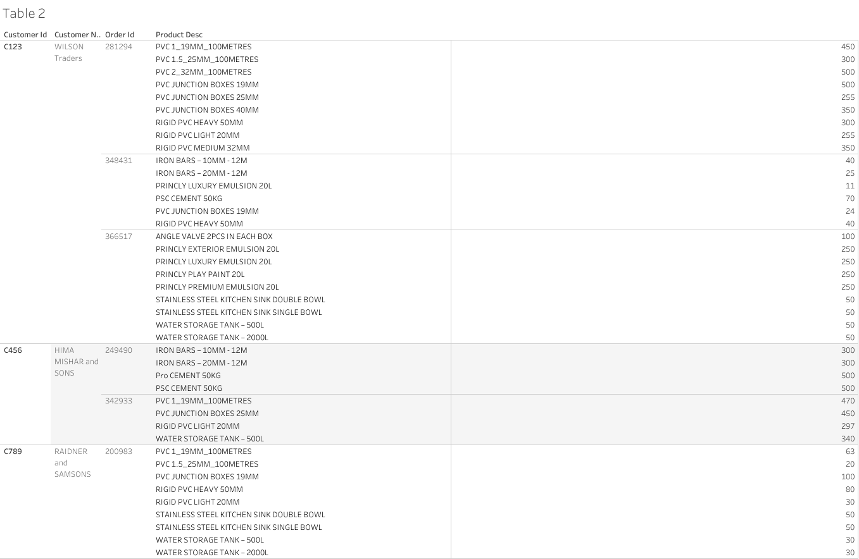7) TABLE OF CUSTOMER ID,CUSTOMER NAME ,ORDER ID, PRODUCT NAME,QUANTITY OF EACH PRODUCT ORDERED