Database Step
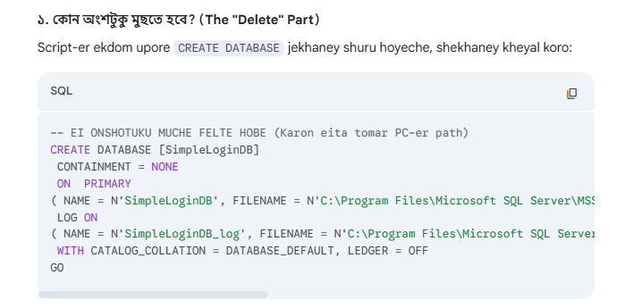
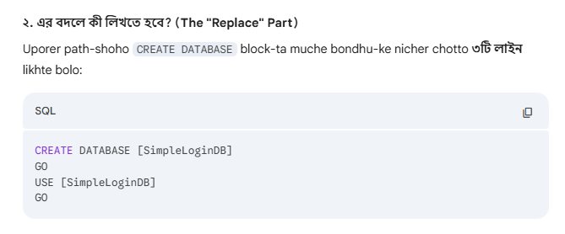

CREATE DATABASE [PetShopManagementDB] GO
USE [PetShopManagementDB] GO

Baki tuku same to same

