# Document 1

Content

Multiple Shapes



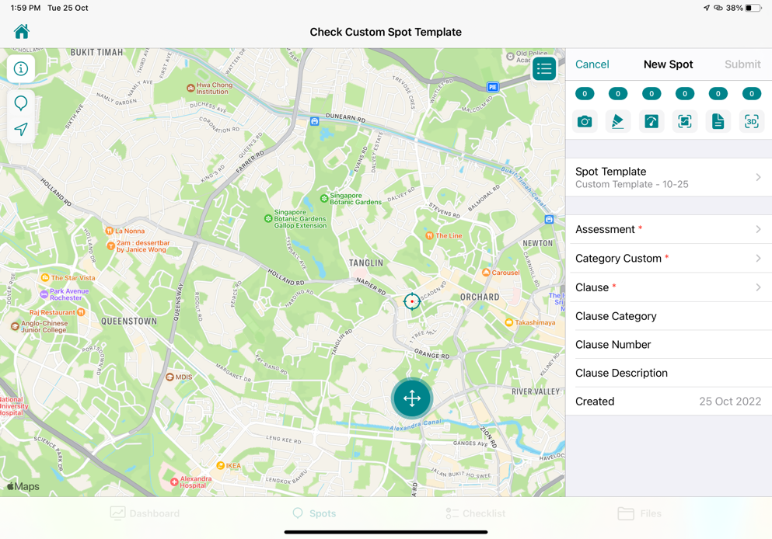

# Document 2

Doc 2 content

Field Name style

Field value style



# Doc 3

The doc 3 content

Topic Field Name

Topic field value

Image caption

