|  |  |  |  |  |
| --- | --- | --- | --- | --- |
| desc |  |  |  |  |
| Suchira D's Personal Company  Company Address, Company Address, Company Address  email.email@email.com  +99128786982  https://web-dev.screeningeagle.com/ |  | Second Company Name |

test

Prepared By

Suchira D

Created Date

27 May 2024

|  |
| --- |
| desc |

### 

Asset Name

BCA Test

Asset Location

Singapore, Singapore

Inspection Date

03 Mar 2023 - 18 Dec 2023

This Is the summary text title This Is the summary text title This Is the summary text title This Is the summary text title This Is the summary text title This Is the summary text title This Is the summary text title This Is the summary text title This Is the summary text title This Is the summary text title This Is the summary text title This Is the summary text title This Is the summary text title This Is the summary text title This Is the summary text title This Is the summary text title This

This is the summary text content. This is the summary text content. This is the summary text content. This is the summary text content. This is the summary text content. This is the summary text content. This is the summary text content. This is the summary text content. This is the summary text content. This is the summary text content. This is the summary text content. This is the summary text content. This is the summary text content. This is the summary text content. This is the summary text content. This is the summary text content. This is the summary text content. This is the summary text content. This is the summary text content. This is the summary text content. This is the summary text content. This is the summary text content. This is the summary text content. This is the summary text content. This is the summary text content. This is the summary text content. This is the summary text content. This is the summary text content. This is the summary text content. This is the summary text content. This is the summary text content. This is the summary text content. This is the summary text content. This is the summary text content. This is the summary text content. This is the summary text content. This is the summary text content. This is the summary text content. This is the summary text content. This is the summary text content. This is the summary text content. This is the summary text content. This is the summary text content. This is the summary text content. This

# Map

|  |  |
| --- | --- |
|  | Total Spots In View  2 Spots |

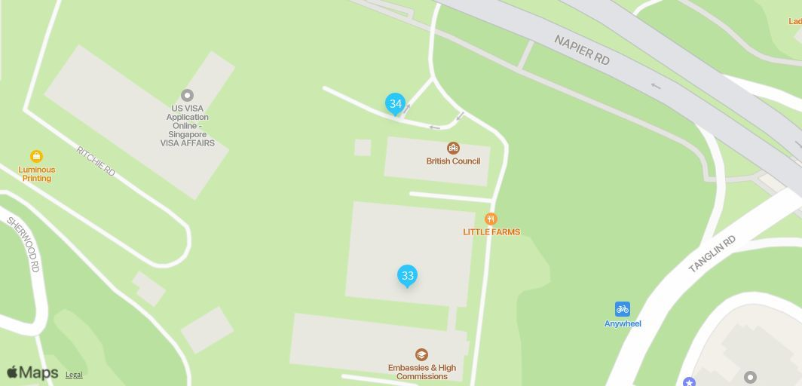

| [Spo 33](https://web-dev.screeningeagle.com/company/961ee9e2-f462-477f-b278-ab6b089f9d42/projects/5eaf88f0-45b1-4366-9acf-e5e45e93b073/topics?topicID=1c948664-ba43-4ba8-b99a-fa5dbc37f616) |
| --- |
| |  |  |  | | --- | --- | --- | | Reporter | Category | Component | | Suchira D | Dampness | Beam |      |  | | --- | | Updated Date | | 01 Dec 2023 |      |  | | --- | | Created Date | | 01 Dec 2023 |      |  | | --- | | Created By | | Suchira D |      |  | | --- | | Updated By | | Suchira D | |
| Location  |  |  |  | | --- | --- | --- | | desc |  | desc | |