Lab 4

Họ tên : Vũ Bá Lực

MSSV : 1150080104

Lớp : 11_ĐH_THMT

**Câu 1 :**

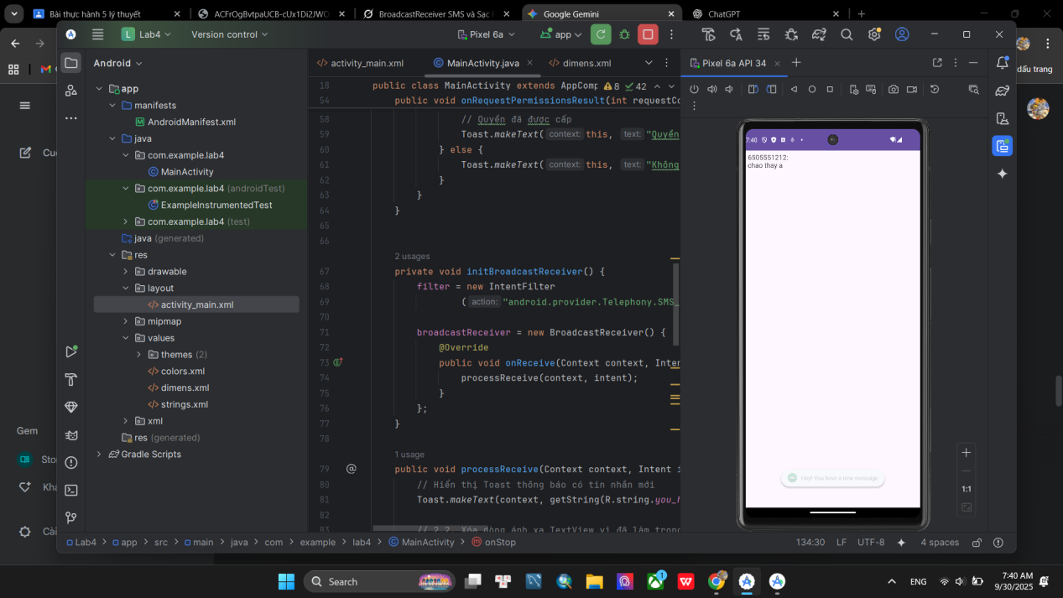

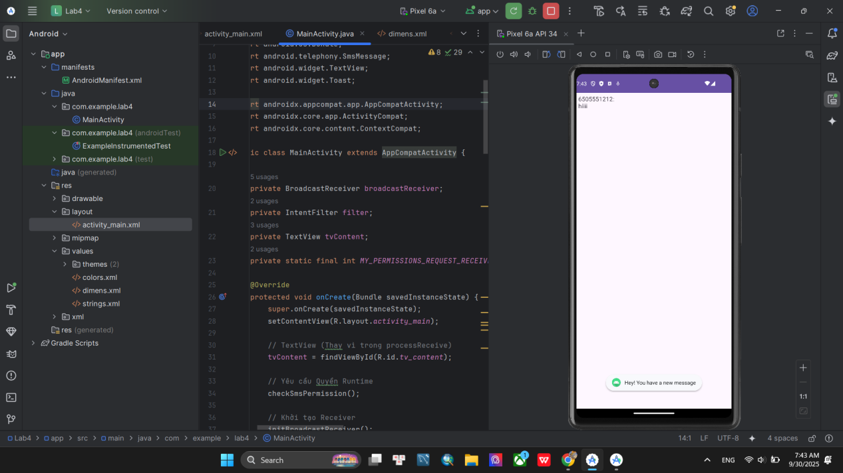

**File AndroidManifest**

<?xml version="1.0" encoding="utf-8"?>

<manifest xmlns:android="http://schemas.android.com/apk/res/android"

xmlns:tools="http://schemas.android.com/tools">

<uses-feature

android:name="android.hardware.telephony"

android:required="false" />

<uses-permission android:name="android.permission.RECEIVE_SMS" />

<application

android:allowBackup="true"

android:dataExtractionRules="@xml/data_extraction_rules"

android:fullBackupContent="@xml/backup_rules"

android:icon="@mipmap/ic_launcher"

android:label="@string/app_name"

android:roundIcon="@mipmap/ic_launcher_round"

android:supportsRtl="true"

android:theme="@style/Theme.Lab4">

<activity

android:name=".MainActivity"

android:exported="true">

<intent-filter>

<action android:name="android.intent.action.MAIN" />

<category android:name="android.intent.category.LAUNCHER" />

</intent-filter>

</activity>

</application>

</manifest>

**File MainActivity**

package com.example.lab4;

import android.Manifest;

import android.content.BroadcastReceiver;

import android.content.Context;

import android.content.Intent;

import android.content.IntentFilter;

import android.content.pm.PackageManager;

import android.os.Bundle;

import android.telephony.SmsMessage;

import android.widget.TextView;

import android.widget.Toast;

import androidx.appcompat.app.AppCompatActivity;

import androidx.core.app.ActivityCompat;

import androidx.core.content.ContextCompat;

public class MainActivity extends AppCompatActivity {

private BroadcastReceiver broadcastReceiver;

private IntentFilter filter;

private TextView tvContent;

private static final int MY_PERMISSIONS_REQUEST_RECEIVE_SMS = 1; // Hằng số cho xin quyền

@Override

protected void onCreate(Bundle savedInstanceState) {

super.onCreate(savedInstanceState);

setContentView(R.layout.activity_main);

// TextView (Thay vì trong processReceive)

tvContent = findViewById(R.id.tv_content);

// Yêu cầu Quyền Runtime

checkSmsPermission();

// Khởi tạo Receiver

initBroadcastReceiver();

}

// kiểm tra và yêu cầu quyền nhận SMS

private void checkSmsPermission() {

if (ContextCompat.checkSelfPermission(this, Manifest.permission.RECEIVE_SMS)

!= PackageManager.PERMISSION_GRANTED) {

// Yêu cầu người dùng cấp quyền

ActivityCompat.requestPermissions(this,

new String[]{Manifest.permission.RECEIVE_SMS},

MY_PERMISSIONS_REQUEST_RECEIVE_SMS);

}

}

// Xử lý kết quả xin quyền

@Override

public void onRequestPermissionsResult(int requestCode, String[] permissions, int[] grantResults) {

super.onRequestPermissionsResult(requestCode, permissions, grantResults);

if (requestCode == MY_PERMISSIONS_REQUEST_RECEIVE_SMS) {

if (grantResults.length > 0 && grantResults[0] == PackageManager.PERMISSION_GRANTED) {

// Quyền đã được cấp

Toast.makeText(this, "Quyền nhận SMS đã được cấp.", Toast.LENGTH_SHORT).show();

} else {

Toast.makeText(this, "Không có quyền nhận SMS, ứng dụng sẽ không nhận tin nhắn.", Toast.LENGTH_LONG).show();

}

}

}

private void initBroadcastReceiver() {

filter = new IntentFilter

("android.provider.Telephony.SMS_RECEIVED");

broadcastReceiver = new BroadcastReceiver() {

@Override

public void onReceive(Context context, Intent intent) {

processReceive(context, intent);

}

};

}

public void processReceive(Context context, Intent intent) {

// Hiển thị Toast thông báo có tin nhắn mới

Toast.makeText(context, getString(R.string.you_have_a_new_message), Toast.LENGTH_LONG).show();

// Xóa ánh xạ TextView vì đã làm trong onCreate

final String SMS_EXTRA = "pdus";

Bundle bundle = intent.getExtras();

Object[] messages = (Object[]) bundle.get(SMS_EXTRA);

if (messages == null) return;

String sms = "";

// Lặp qua từng phần tử tin nhắn

for (int i = 0; i < messages.length; i++) {

SmsMessage smsMsg;

// Xử lý sự khác biệt trong việc tạo SmsMessage trên các phiên bản SDK khác nhau (>= 23)

if (android.os.Build.VERSION.SDK_INT >= 23) {

smsMsg = SmsMessage.createFromPdu((byte[]) messages[i], SmsMessage.FORMAT_3GPP);

} else {

smsMsg = SmsMessage.createFromPdu((byte[]) messages[i]);

}

String msgBody = smsMsg.getMessageBody();

String address = smsMsg.getDisplayOriginatingAddress();

// Nối địa chỉ và nội dung tin nhắn vào chuỗi

sms += address + ":\n" + msgBody + "\n";

}

if (tvContent != null) {

tvContent.setText(sms);

}

}

@Override

protected void onResume() {

super.onResume();

if (broadcastReceiver == null) initBroadcastReceiver();

registerReceiver(broadcastReceiver, filter);

}

@Override

protected void onStop() {

super.onStop();

// Kiểm tra trước khi unregister để tránh crash nếu chưa đăng ký

if (broadcastReceiver != null) {

unregisterReceiver(broadcastReceiver);

}

}

}

**Câu 2 :**

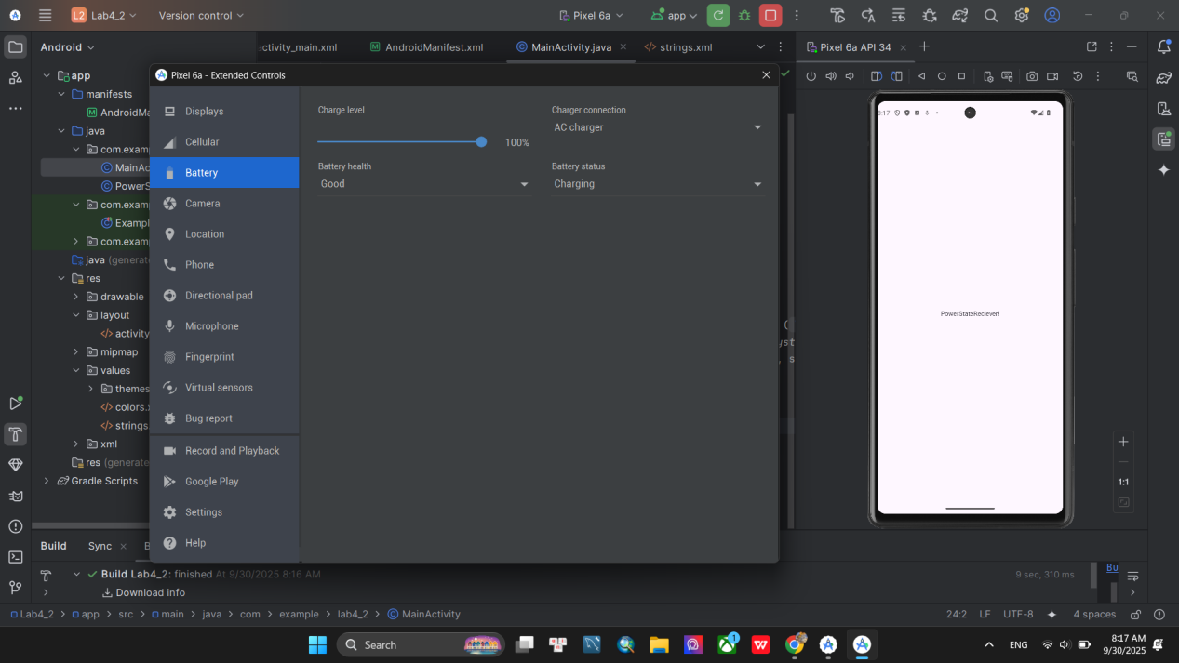

**File AndroidManifest**

<?xml version="1.0" encoding="utf-8"?>

<manifest xmlns:android="http://schemas.android.com/apk/res/android"

xmlns:tools="http://schemas.android.com/tools">

<application

android:allowBackup="true"

android:dataExtractionRules="@xml/data_extraction_rules"

android:fullBackupContent="@xml/backup_rules"

android:icon="@mipmap/ic_launcher"

android:label="@string/app_name"

android:roundIcon="@mipmap/ic_launcher_round"

android:supportsRtl="true"

android:theme="@style/Theme.Lab4_2">

<activity

android:name=".MainActivity"

android:exported="true">

<intent-filter>

<action android:name="android.intent.action.MAIN" />

<category android:name="android.intent.category.LAUNCHER" />

</intent-filter>

</activity>

<receiver android:name=".PowerStateChangeReceiver"

android:exported="true">

<intent-filter>

<action android:name="android.intent.action.ACTION_POWER_CONNECTED" />

<action android:name="android.intent.action.ACTION_POWER_DISCONNECTED" />

</intent-filter>

</receiver>

</application>

</manifest>

**File PowerStateChangeReceiver**

package com.example.lab4_2;

import android.content.BroadcastReceiver;

import android.content.Context;

import android.content.Intent;

import android.util.Log;

import android.widget.Toast;

public class PowerStateChangeReceiver extends BroadcastReceiver {

private final static String TAG = "PowerStateReceiver";

@Override

public void onReceive(Context context, Intent intent) {

if (context == null) return;

Log.e(TAG, "Context is null"); // Log: Báo Context là null (sẽ không chạy nếu context != null)

String action = intent.getAction();

Log.d(TAG, "Received action: " + action);

// Kiểm tra sự kiện Cắm sạc

if (Intent.ACTION_POWER_CONNECTED.equals(action)) {

Log.d(TAG, "Power connected event received");

// Hiển thị Toast (sử dụng string resource R.string.power_connected)

Toast.makeText(context, R.string.power_connected, Toast.LENGTH_SHORT).show();

}

// Kiểm tra sự kiện Rút sạc

else if (Intent.ACTION_POWER_DISCONNECTED.equals(action)) {

Log.d(TAG, "Power disconnected event received");

// Hiển thị Toast (sử dụng string resource R.string.power_disconnected)

Toast.makeText(context, R.string.power_disconnected, Toast.LENGTH_SHORT).show();

}

// Hành động không xác định

else {

Log.w(TAG, "Unknown action: " + action);

}

}

}

**File MainActivity**

package com.example.lab4_2;

import android.os.Bundle;

import androidx.activity.EdgeToEdge;

import androidx.appcompat.app.AppCompatActivity;

import androidx.core.graphics.Insets;

import androidx.core.view.ViewCompat;

import androidx.core.view.WindowInsetsCompat;

public class MainActivity extends AppCompatActivity {

@Override

protected void onCreate(Bundle savedInstanceState) {

super.onCreate(savedInstanceState);

EdgeToEdge.enable(this);

setContentView(R.layout.activity_main);

ViewCompat.setOnApplyWindowInsetsListener(findViewById(R.id.main), (v, insets) -> {

Insets systemBars = insets.getInsets(WindowInsetsCompat.Type.systemBars());

v.setPadding(systemBars.left, systemBars.top, systemBars.right, systemBars.bottom);

return insets;

});

}

}

**File activity_main.xml**

<?xml version="1.0" encoding="utf-8"?>

<androidx.constraintlayout.widget.ConstraintLayout xmlns:android="http://schemas.android.com/apk/res/android"

xmlns:app="http://schemas.android.com/apk/res-auto"

xmlns:tools="http://schemas.android.com/tools"

android:id="@+id/main"

android:layout_width="match_parent"

android:layout_height="match_parent"

tools:context=".MainActivity">

<TextView

android:layout_width="wrap_content"

android:layout_height="wrap_content"

android:text="PowerStateReciever!"

app:layout_constraintBottom_toBottomOf="parent"

app:layout_constraintEnd_toEndOf="parent"

app:layout_constraintStart_toStartOf="parent"

app:layout_constraintTop_toTopOf="parent" />

</androidx.constraintlayout.widget.ConstraintLayout>’

**Câu 4 :**

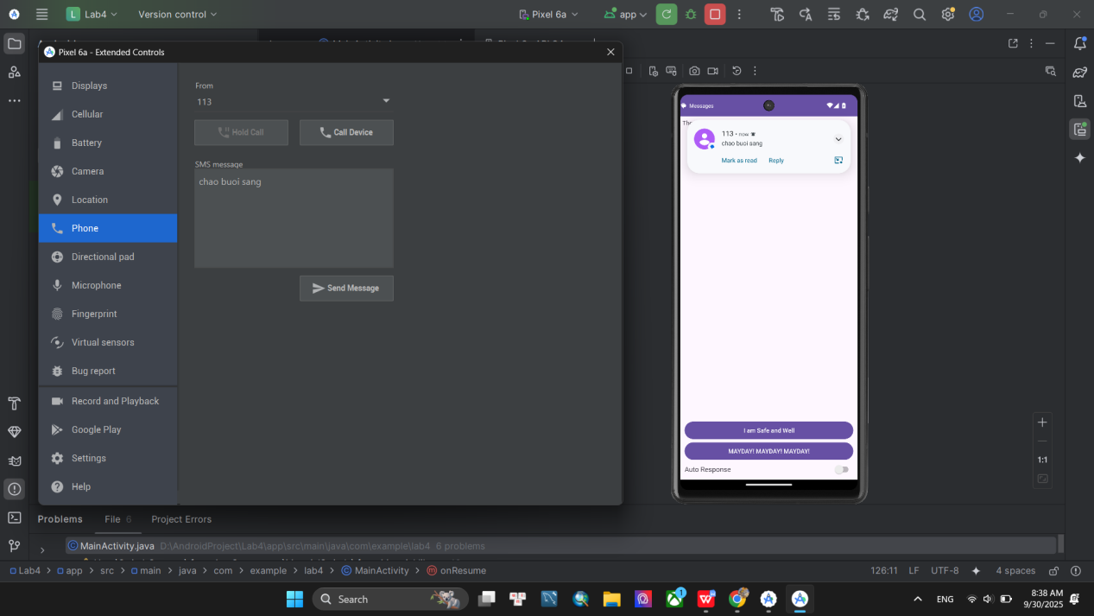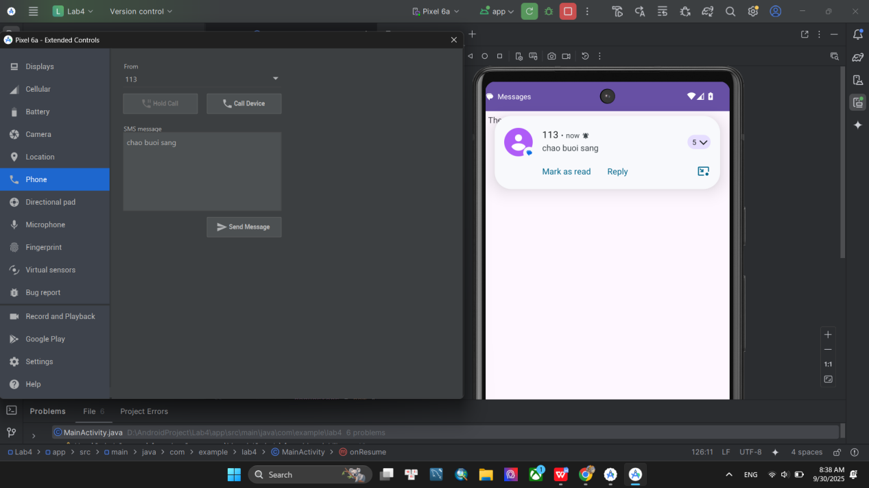

**File AndroidManifest**

<?xml version="1.0" encoding="utf-8"?>

<manifest xmlns:android="http://schemas.android.com/apk/res/android"

xmlns:tools="http://schemas.android.com/tools">

<uses-feature

android:name="android.hardware.telephony"

android:required="false" />

<uses-permission android:name="android.permission.RECEIVE_SMS" />

<uses-permission android:name="android.permission.SEND_SMS"/>

<uses-permission android:name="android.permission.ACCESS_FINE_LOCATION"/>

<application

android:allowBackup="true"

android:dataExtractionRules="@xml/data_extraction_rules"

android:fullBackupContent="@xml/backup_rules"

android:icon="@mipmap/ic_launcher"

android:label="@string/app_name"

android:roundIcon="@mipmap/ic_launcher_round"

android:supportsRtl="true"

android:theme="@style/Theme.Lab4">

<activity

android:name=".MainActivity"

android:exported="true">

<intent-filter>

<action android:name="android.intent.action.MAIN" />

<category android:name="android.intent.category.LAUNCHER" />

</intent-filter>

</activity>

</application>

</manifest>

**File SmsReceiver**

package com.example.lab4;

import android.content.BroadcastReceiver;

import android.content.Context;

import android.content.Intent;

import android.os.Bundle;

import android.telephony.SmsMessage;

import java.util.ArrayList;

public class SmsReceiver extends BroadcastReceiver {

public static final String SMS_FORWARD_BROADCAST_RECEIVER = "SMS_FORWARD";

public static final String SMS_MESSAGE_ADDRESS_KEY = "addresses";

@Override

public void onReceive(Context context, Intent intent) {

Bundle bundle = intent.getExtras();

ArrayList<String> addresses = new ArrayList<>();

if (bundle != null) {

Object[] pdus = (Object[]) bundle.get("pdus");

if (pdus != null) {

for (Object pdu : pdus) {

SmsMessage sms = SmsMessage.createFromPdu((byte[]) pdu);

String body = sms.getMessageBody();

String sender = sms.getOriginatingAddress();

if (body != null && body.toLowerCase().contains("are you ok?")) {

addresses.add(sender);

}

}

}

}

if (!addresses.isEmpty()) {

if (MainActivity.isRunning) {

// forward broadcast cho MainActivity

Intent i = new Intent(SMS_FORWARD_BROADCAST_RECEIVER);

i.putStringArrayListExtra(SMS_MESSAGE_ADDRESS_KEY, addresses);

context.sendBroadcast(i);

} else {

// start MainActivity khi app đang tắt

Intent iMain = new Intent(context, MainActivity.class);

iMain.putStringArrayListExtra(SMS_MESSAGE_ADDRESS_KEY, addresses);

iMain.addFlags(Intent.FLAG_ACTIVITY_CLEAR_TOP | Intent.FLAG_ACTIVITY_NEW_TASK);

context.startActivity(iMain);

}

}

}

}

**File MainActivity**

package com.example.lab4;

import android.content.BroadcastReceiver;

import android.content.Context;

import android.content.Intent;

import android.content.IntentFilter;

import android.content.SharedPreferences;

import android.os.Build;

import android.os.Bundle;

import android.telephony.SmsManager;

import android.view.View;

import android.widget.*;

import androidx.annotation.RequiresApi;

import androidx.appcompat.app.AppCompatActivity;

import java.util.ArrayList;

public class MainActivity extends AppCompatActivity {

private Switch swAutoResponse;

private LinearLayout llButtons;

private Button btnSafe, btnMayday;

private ArrayList<String> requesters;

private ArrayAdapter<String> adapter;

private ListView lvMessages;

private BroadcastReceiver broadcastReceiver;

public static boolean isRunning;

private SharedPreferences.Editor editor;

private SharedPreferences sharedPreferences;

private final String AUTO_RESPONSE = "auto_response";

@Override

protected void onCreate(Bundle savedInstanceState) {

super.onCreate(savedInstanceState);

setContentView(R.layout.activity_main);

findViewsByIds();

initVariables();

handleOnClickListener();

// Nếu được start từ SmsReceiver với danh sách addresses

Intent i = getIntent();

ArrayList<String> addresses = i.getStringArrayListExtra(SmsReceiver.SMS_MESSAGE_ADDRESS_KEY);

if (addresses != null) {

processReceiveAddresses(addresses);

}

}

private void findViewsByIds() {

swAutoResponse = findViewById(R.id.sw_auto_response);

llButtons = findViewById(R.id.ll_buttons);

lvMessages = findViewById(R.id.lv_messages);

btnSafe = findViewById(R.id.btn_safe);

btnMayday = findViewById(R.id.btn_mayday);

}

private void initVariables() {

requesters = new ArrayList<>();

adapter = new ArrayAdapter<>(this, android.R.layout.simple_list_item_1, requesters);

lvMessages.setAdapter(adapter);

sharedPreferences = getSharedPreferences("settings", Context.MODE_PRIVATE);

editor = sharedPreferences.edit();

boolean auto = sharedPreferences.getBoolean(AUTO_RESPONSE, false);

swAutoResponse.setChecked(auto);

llButtons.setVisibility(auto ? View.GONE : View.VISIBLE);

initBroadcastReceiver();

}

private void handleOnClickListener() {

btnSafe.setOnClickListener(v -> respond(true));

btnMayday.setOnClickListener(v -> respond(false));

swAutoResponse.setOnCheckedChangeListener((buttonView, isChecked) -> {

llButtons.setVisibility(isChecked ? View.GONE : View.VISIBLE);

editor.putBoolean(AUTO_RESPONSE, isChecked).apply();

});

}

private void respond(boolean safe) {

if (!requesters.isEmpty()) {

String msg = safe ? getString(R.string.i_am_safe_and_well_worry_not)

: getString(R.string.tell_my_mother_i_love_her);

SmsManager smsManager = SmsManager.getDefault();

for (String addr : requesters) {

smsManager.sendTextMessage(addr, null, msg, null, null);

}

requesters.clear();

adapter.notifyDataSetChanged();

}

}

private void processReceiveAddresses(ArrayList<String> addresses) {

requesters.addAll(addresses);

adapter.notifyDataSetChanged();

if (swAutoResponse.isChecked()) {

respond(true);

}

}

private void initBroadcastReceiver() {

broadcastReceiver = new BroadcastReceiver() {

@Override

public void onReceive(Context context, Intent intent) {

ArrayList<String> addresses = intent.getStringArrayListExtra(SmsReceiver.SMS_MESSAGE_ADDRESS_KEY);

if (addresses != null) {

processReceiveAddresses(addresses);

}

}

};

}

@RequiresApi(api = Build.VERSION_CODES.TIRAMISU)

@Override

protected void onResume() {

super.onResume();

isRunning = true;

if (broadcastReceiver == null) initBroadcastReceiver();

registerReceiver(

broadcastReceiver,

new IntentFilter(SmsReceiver.SMS_FORWARD_BROADCAST_RECEIVER),

Context.RECEIVER_NOT_EXPORTED

);

}

@Override

protected void onStop() {

super.onStop();

isRunning = false;

unregisterReceiver(broadcastReceiver);

}

}

**File activity_main.xml**

<RelativeLayout xmlns:android="http://schemas.android.com/apk/res/android"

xmlns:tools="http://schemas.android.com/tools"

android:layout_width="match_parent"

android:layout_height="match_parent"

android:orientation="vertical"

android:padding="@dimen/margin_base"

tools:context=".MainActivity" >

<TextView

android:id="@+id/tv_request_list"

android:layout_width="match_parent"

android:layout_height="wrap_content"

android:layout_alignParentTop="true"

android:text="@string/these_people_want_to_know_if_u_are_ok" />

<LinearLayout

android:id="@+id/ll_control"

android:layout_width="match_parent"

android:layout_height="wrap_content"

android:layout_alignParentBottom="true"

android:orientation="vertical"

android:padding="@dimen/margin_base">

<LinearLayout

android:id="@+id/ll_buttons"

android:layout_width="match_parent"

android:layout_height="wrap_content"

android:orientation="vertical">

<Button

android:id="@+id/btn_safe"

android:layout_width="match_parent"

android:layout_height="wrap_content"

android:text="@string/i_am_safe_and_well" />

<Button

android:id="@+id/btn_mayday"

android:layout_width="match_parent"

android:layout_height="wrap_content"

android:text="@string/mayday" />

</LinearLayout>

<LinearLayout

android:layout_marginTop="@dimen/margin_base"

android:layout_width="match_parent"

android:layout_height="wrap_content"

android:orientation="horizontal">

<TextView

android:layout_width="0dp"

android:layout_height="wrap_content"

android:layout_weight="1"

android:text="@string/auto_response"

android:textSize="@dimen/text_medium" />

<Switch

android:id="@+id/sw_auto_response"

android:layout_width="wrap_content"

android:layout_height="wrap_content"

android:checked="false" />

</LinearLayout>

</LinearLayout>

<ListView

android:id="@+id/lv_messages"

android:layout_width="match_parent"

android:layout_height="match_parent"

android:layout_above="@id/ll_control"

android:layout_below="@id/tv_request_list" />

</RelativeLayout>