Họ tên : Vũ Bá Lực
MSSV : 1150080104
Lớp : 11_ĐH_THMT

BT1 : Viết một ứng dụng MultiThread sử dụng Message.

MainActivity

package com.example.bt6;

import android.os.Bundle;
import android.os.Handler;
import android.os.Message;
import android.view.View;
import android.widget.Button;
import android.widget.ProgressBar;
import android.widget.TextView;

import androidx.activity.EdgeToEdge;
import androidx.appcompat.app.AppCompatActivity;
import androidx.core.graphics.Insets;
import androidx.core.view.ViewCompat;
import androidx.core.view.WindowInsetsCompat;

import java.util.Random;

public class MainActivity extends AppCompatActivity {

private ProgressBar pbFirst, pbSecond;
private TextView tvMsgWorking, tvMsgReturned;
private boolean isRunning;
private int MAX_SEC;
private int intTest;
private Thread bgThread;
private Handler handler;
private Button btnStart;

Trong Mainthread (luồng chính) sẽ khởi tạo giao diện và xử lý các sự kiện click trên layout giao diện và xử lý message từ luồng phụ trong hàm onCreate và handler

@Override
protected void onCreate(Bundle savedInstanceState) {
super.onCreate(savedInstanceState);
EdgeToEdge.enable(this);
setContentView(R.layout.activity_main);
ViewCompat.setOnApplyWindowInsetsListener(findViewById(R.id.main), (v, insets) -> {
Insets systemBars = insets.getInsets(WindowInsetsCompat.Type.systemBars());
v.setPadding(systemBars.left, systemBars.top, systemBars.right, systemBars.bottom);
return insets;
});

findViewByIds();
initVariables();

// Handle clickListenner
btnStart.setOnClickListener(new View.OnClickListener() {
@Override
public void onClick(View v) {
isRunning = true;
pbFirst.setVisibility(View.VISIBLE);
pbSecond.setVisibility(View.VISIBLE);
btnStart.setVisibility(View.GONE);
bgThread.start();
}
});
}

@Override
protected void onStart() {
super.onStart();
initBgThread();
}

@Override
protected void onStop() {
super.onStop();
isRunning = false;
}

private void findViewByIds() {
pbFirst = (ProgressBar) findViewById(R.id.pb_first);
pbSecond = (ProgressBar) findViewById(R.id.pb_second);
tvMsgWorking = (TextView) findViewById(R.id.tv_working);
tvMsgReturned = (TextView) findViewById(R.id.tv_return);
btnStart = (Button) findViewById(R.id.btn_start);
}

private void initVariables() {
isRunning = false;
MAX_SEC = 20;
intTest = 1;
pbFirst.setMax(MAX_SEC);
pbFirst.setProgress(0);

// Init Views
pbFirst.setVisibility(View.GONE);
pbSecond.setVisibility(View.GONE);

handler = new Handler() {
@Override
public void handleMessage(Message msg) {
super.handleMessage(msg);

String returnedValue = (String) msg.obj;

// Do something with the value sent by background thread here...
tvMsgReturned.setText(getString(R.string.returned_by_bg_thread) + returnedValue);
pbFirst.incrementProgressBy(2);

// Testing thread's termination
if (pbFirst.getProgress() == MAX_SEC) {
tvMsgReturned.setText(getString(R.string.done_background_thread_has_been_stopped));
tvMsgWorking.setText(getString(R.string.done));
pbFirst.setVisibility(View.GONE);
pbSecond.setVisibility(View.GONE);
btnStart.setVisibility(View.VISIBLE);
isRunning = false;
} else {
tvMsgWorking.setText(getString(R.string.working) + pbFirst.getProgress());
}
}
};
}

Luồng phụ sẽ phụ trách những việc tốn thời gian (ở trong code dưới được giả định là delay 1 giây cho việc tốn thời gian) tạo dữ liệu và gửi kết quả về luồng chính, mục đích chính là tránh cho main thread bị làm quá nhiều việc và phải xử lý đa luồng kể cả các việc nặng gây ra bị đơ app và không phản hồi, ARN.

private void initBgThread()
{
bgThread = new Thread(new Runnable() {
@Override
public void run() {
try {
for (int i = 0; i < MAX_SEC && isRunning; i++) {
// Sleep one second
Thread.sleep(1000);

Random rnd = new Random();
// This is a locally generated value
String data = "Thread value: " + (int) rnd.nextInt(101);

// We can see change (global) class variables
data += getString(R.string.global_value_seen) + " " + intTest;
intTest++;
// If thread is still alive send the message
if (isRunning) {
// Request a message token and put some data in it
Message msg = handler.obtainMessage(1, (String) data);
handler.sendMessage(msg);
}
}
} catch (Throwable t) {
// Handle exception
}
}
});
}
}

activity_main.xml

<?xml version="1.0" encoding="utf-8"?>
<LinearLayout xmlns:android="http://schemas.android.com/apk/res/android"
xmlns:tools="http://schemas.android.com/tools"
android:layout_width="match_parent"
android:layout_height="match_parent"
android:orientation="vertical"
android:padding="@dimen/margin_base"
tools:context=".MainActivity"
android:id="@+id/main">
<TextView
android:id="@+id/tv_working"
android:layout_width="match_parent"
android:layout_height="wrap_content"
android:textSize="@dimen/text_medium_large"
android:textStyle="bold" />
<ProgressBar
android:id="@+id/pb_first"
style="?android:attr/progressBarStyleHorizontal"
android:layout_width="match_parent"
android:layout_height="wrap_content"
android:layout_marginTop="@dimen/margin_base" />
<TextView
android:id="@+id/tv_return"
android:layout_width="match_parent"
android:layout_height="wrap_content"
android:textSize="@dimen/text_medium" />
<FrameLayout
android:layout_width="match_parent"
android:layout_height="wrap_content">
<Button
android:id="@+id/btn_start"
android:layout_width="wrap_content"
android:layout_height="wrap_content"
android:layout_gravity="center"
android:text="@string/start" />
<ProgressBar
android:id="@+id/pb_second"
android:layout_width="match_parent"
android:layout_height="wrap_content"
android:layout_gravity="center"
android:layout_marginTop="@dimen/margin_base" />
</FrameLayout>
</LinearLayout>

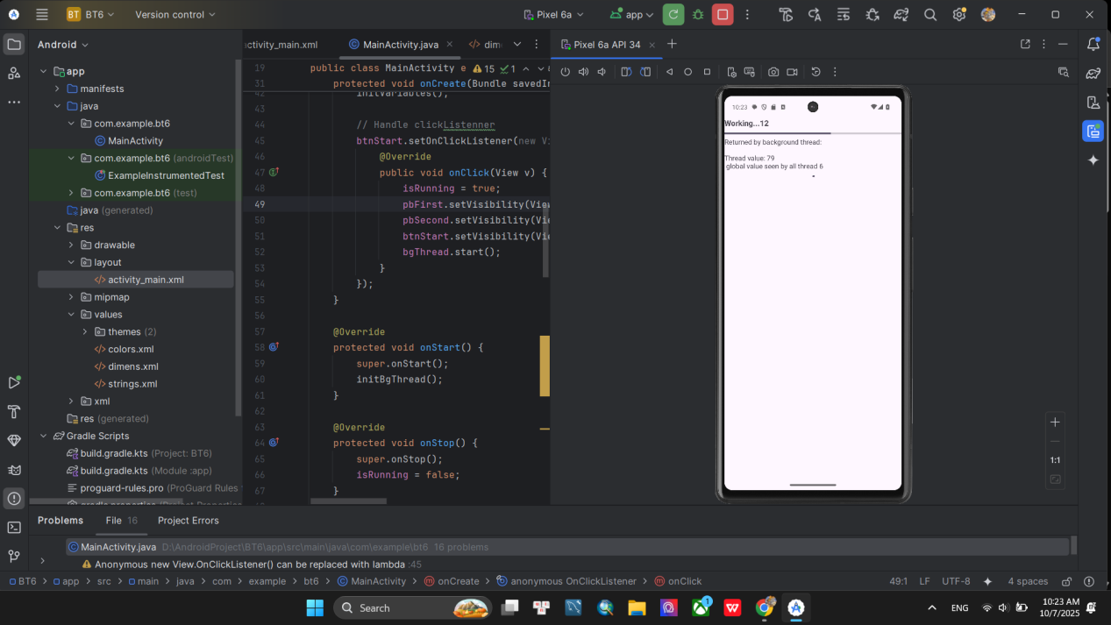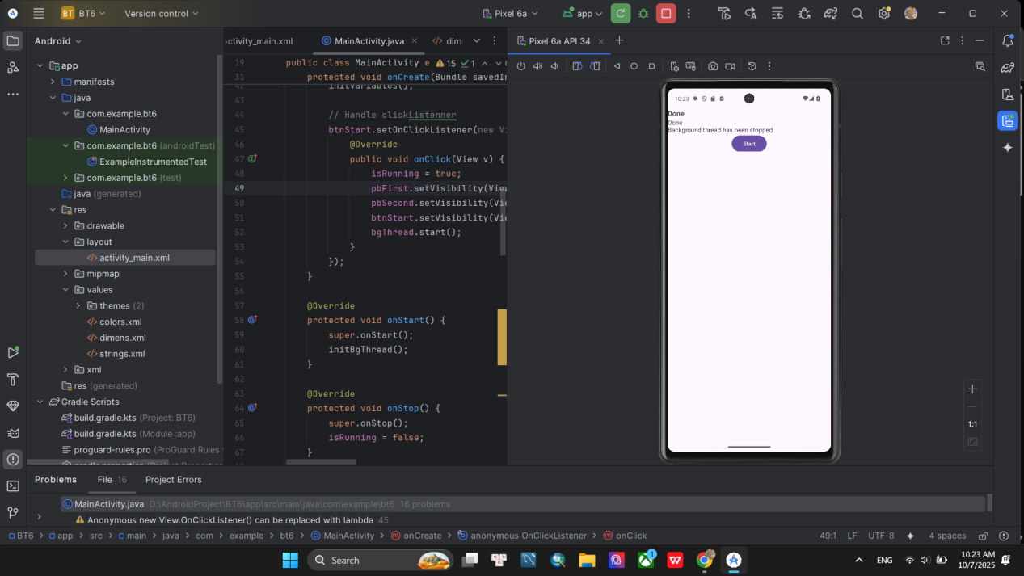

BT2 : Viết ứng dụng MultiThread sử dụng Post

MainActivity

package com.example.bt6_2;

import android.os.Bundle;
import android.os.Handler;
import android.util.Log;
import android.view.View;
import android.widget.Button;
import android.widget.EditText;
import android.widget.ProgressBar;
import android.widget.TextView;
import android.widget.Toast;

import androidx.activity.EdgeToEdge;
import androidx.appcompat.app.AppCompatActivity;
import androidx.core.graphics.Insets;
import androidx.core.view.ViewCompat;
import androidx.core.view.WindowInsetsCompat;

public class MainActivity extends AppCompatActivity {

private ProgressBar pbWaiting;
private TextView tvTopCaption;
private EditText etInput;
private Button btnExecute;
private int globalValue, accum;
private long startTime;
private final String PATIENCE = "Some important data is being collected now.\nPlease be patient...wait...";
private Handler handler;
private Runnable fgRunnable, bgRunnable;
private Thread testThread;

@Override
protected void onCreate(Bundle savedInstanceState) {
super.onCreate(savedInstanceState);
EdgeToEdge.enable(this);
setContentView(R.layout.activity_main);
ViewCompat.setOnApplyWindowInsetsListener(findViewById(R.id.main), (v, insets) -> {
Insets systemBars = insets.getInsets(WindowInsetsCompat.Type.systemBars());
v.setPadding(systemBars.left, systemBars.top, systemBars.right, systemBars.bottom);
return insets;
});

findViewByIds();
intVariables();

fgRunnable = new Runnable() {
@Override
public void run() {
try {
// Calculate new value
int progressStep = 5;
double totalTime = (System.currentTimeMillis() - startTime) / 1000;
synchronized (this) {
globalValue += 100;
}

// Update UI
tvTopCaption.setText(PATIENCE + totalTime + " - " + globalValue);
pbWaiting.incrementProgressBy(progressStep);
accum += progressStep;

// Check to stop
if (accum >= pbWaiting.getMax()) {
tvTopCaption.setText(getString(R.string.bg_work_is_over));
pbWaiting.setVisibility(View.GONE);
}

} catch (Exception e) {
Log.e("fgRunnable", e.getMessage());
}
}
};

bgRunnable = new Runnable() {
@Override
public void run() {
try {
for (int i = 0; i < 20; i++) {
// Sleep 1 second
Thread.sleep(1000);

// Now talk to main thread
// Optinally change some global variable such as: globalValue
synchronized (this) {
globalValue += 1;
}

handler.post(fgRunnable);
}
} catch (Exception e) {
Log.e("bgRunnable", e.getMessage());
}
}
};

testThread = new Thread(bgRunnable);

// Handle onClickListenner
btnExecute.setOnClickListener(new View.OnClickListener() {
@Override
public void onClick(View v) {
String input = etInput.getText().toString();
Toast.makeText(MainActivity.this, "You said: " + input, Toast.LENGTH_SHORT).show();
}
});

// Start thread
testThread.start();
pbWaiting.incrementProgressBy(0);
}

private void findViewByIds() {
tvTopCaption = (TextView) findViewById(R.id.tv_top_caption);
pbWaiting = (ProgressBar) findViewById(R.id.pb_waiting);
etInput = (EditText) findViewById(R.id.et_input);
btnExecute = (Button) findViewById(R.id.btn_execute);
}

private void intVariables() {
globalValue = 0;
accum = 0;
startTime = System.currentTimeMillis();
handler = new Handler();
pbWaiting.setMax(100);
}
}

activity_main.xml

<?xml version="1.0" encoding="utf-8"?>
<LinearLayout xmlns:android="http://schemas.android.com/apk/res/android" xmlns:tools="http://schemas.android.com/tools"
android:layout_width="match_parent"
android:layout_height="match_parent"
android:orientation="vertical"
android:padding="@dimen/margin_base"
tools:context="MainActivity"
android:id="@+id/main">
<TextView
android:id="@+id/tv_top_caption"
android:layout_width="match_parent"
android:layout_height="wrap_content"
android:textSize="@dimen/text_medium" />
<ProgressBar
android:id="@+id/pb_waiting"
style="?android:attr/progressBarStyleHorizontal"
android:layout_width="match_parent"
android:layout_height="wrap_content"
android:layout_marginTop="@dimen/margin_base" />
<EditText
android:id="@+id/et_input"
android:layout_width="match_parent"
android:layout_height="wrap_content"
android:hint="@string/enter_some_data_here"
android:textSize="@dimen/text_medium" />
<Button
android:id="@+id/btn_execute"
android:layout_width="wrap_content"
android:layout_height="wrap_content"
android:layout_gravity="center"
android:text="@string/execute" />
</LinearLayout>

