Bài tập 1: Trong bài luyện tập 1, viết code để mỗi khi chạy lên sẽ ra một màu nền khác nhau và 1 icon khác nhau.

Tạo cấu trúc thư mục cho 4 bài lab (thêm icon, hình, layout và chèn các value vào string, colors)

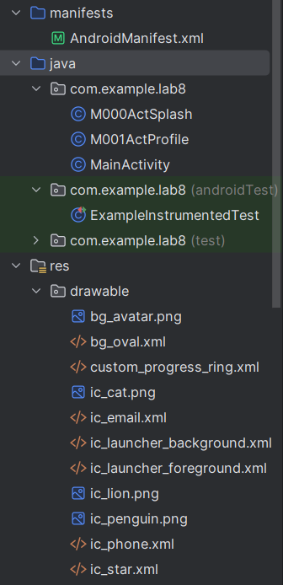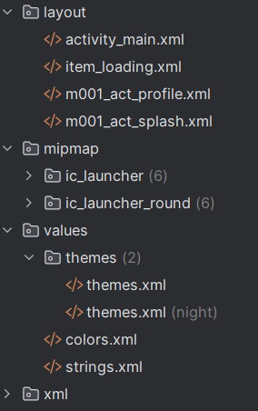

Trong strings , ta thêm

<resources>
<string name="app_name">Lab8</string>
<string name="txt_loading">Loading...</string>
</resources>

Trong colors, ta thêm

<?xml version="1.0" encoding="utf-8"?>
<resources>
<color name="black">#FF000000</color>
<color name="white">#FFFFFFFF</color>
<color name="purple">#FFA020F0</color>
<color name="purple_200">#FFBB86FC</color>
<color name="purple_500">#FF6200EE</color>
<color name="bg_splash_blue">#FF03A9F4</color>
<color name="bg_splash_green">#FF4CAF50</color>
<color name="bg_splash_orange">#FF9800</color>
<color name="bg_splash_red">#FFF44336</color>
<color name="bg_splash_yellow">#FFFFEB3B</color>
</resources>

File layout act_splash

<?xml version="1.0" encoding="utf-8"?>
<LinearLayout xmlns:android="http://schemas.android.com/apk/res/android"
xmlns:tools="http://schemas.android.com/tools"
android:id="@+id/layout_splash" android:layout_width="match_parent"
android:layout_height="match_parent"
android:background="@color/design_default_color_primary_dark"
android:gravity="center"
android:orientation="vertical">

<ImageView
android:id="@+id/iv_animal_icon" android:layout_width="128dp"
android:layout_height="128dp"
android:src="@drawable/ic_penguin"
tools:ignore="ContentDescription" />

<TextView
android:layout_width="wrap_content"
android:layout_height="wrap_content"
android:layout_marginTop="10dp"
android:fontFamily="sans-serif-light"
android:text="@string/app_name"
android:textColor="@color/white"
android:textSize="24sp" />
</LinearLayout>

File mainActSplash

package com.example.lab8;

import android.os.Bundle;
import android.widget.ImageView;
import android.widget.LinearLayout;
import androidx.appcompat.app.AppCompatActivity;
import androidx.core.content.ContextCompat;
import java.util.Random;

public class M000ActSplash extends AppCompatActivity {

@Override
protected void onCreate(Bundle savedInstanceState) {
super.onCreate(savedInstanceState);
setContentView(R.layout.m001_act_splash);

// 1. View từ layout
LinearLayout layoutSplash = findViewById(R.id.layout_splash);
ImageView ivAnimalIcon = findViewById(R.id.iv_animal_icon);

// 2. Tạo danh sách tài nguyên (icon và màu)
int[] icons = {
R.drawable.ic_penguin,
R.drawable.ic_lion,
R.drawable.ic_cat
};

int[] colors = {
R.color.bg_splash_blue,
R.color.bg_splash_green,
R.color.bg_splash_orange
};

// 3. Lấy số ngẫu nhiên
Random rand = new Random();
// Random một số từ 0 đến (số_lượng_icon - 1)
int randomIndex = rand.nextInt(icons.length);

// 4. Gán tài nguyên ngẫu nhiên cho View
ivAnimalIcon.setImageResource(icons[randomIndex]);
layoutSplash.setBackgroundColor(ContextCompat.getColor(this, colors[randomIndex]));
}
}

Trong manifest

<?xml version="1.0" encoding="utf-8"?>
<manifest xmlns:android="http://schemas.android.com/apk/res/android"
xmlns:tools="http://schemas.android.com/tools">

<application
android:allowBackup="true"
android:dataExtractionRules="@xml/data_extraction_rules"
android:fullBackupContent="@xml/backup_rules"
android:icon="@mipmap/ic_launcher"
android:label="@string/app_name"
android:roundIcon="@mipmap/ic_launcher_round"
android:supportsRtl="true"
android:theme="@style/Theme.Lab8"> <activity
android:name=".MainActivity"
android:exported="true">
<intent-filter>
<action android:name="android.intent.action.MAIN" />
<category android:name="android.intent.category.LAUNCHER" />
</intent-filter>
</activity>

<activity
android:name=".M000ActSplash"
android:noHistory="true"
android:theme="@style/Full_Screen">

</activity>

<activity
android:name=".M001ActProfile"
android:theme="@style/Theme.MaterialComponents.DayNight.NoActionBar" />
</application>

</manifest>

Ở theme ta thêm style Full_Screen

<resources xmlns:tools="http://schemas.android.com/tools">
<style name="Base.Theme.Lab8" parent="Theme.Material3.DayNight.NoActionBar">
</style>

<style name="Theme.Lab8" parent="Base.Theme.Lab8" />

<style name="Full_Screen" parent="Theme.MaterialComponents.DayNight.NoActionBar"/>

</resources>

Kết quả khi chạy lên giao diện thì ra màu bg và icon thú khác nhau
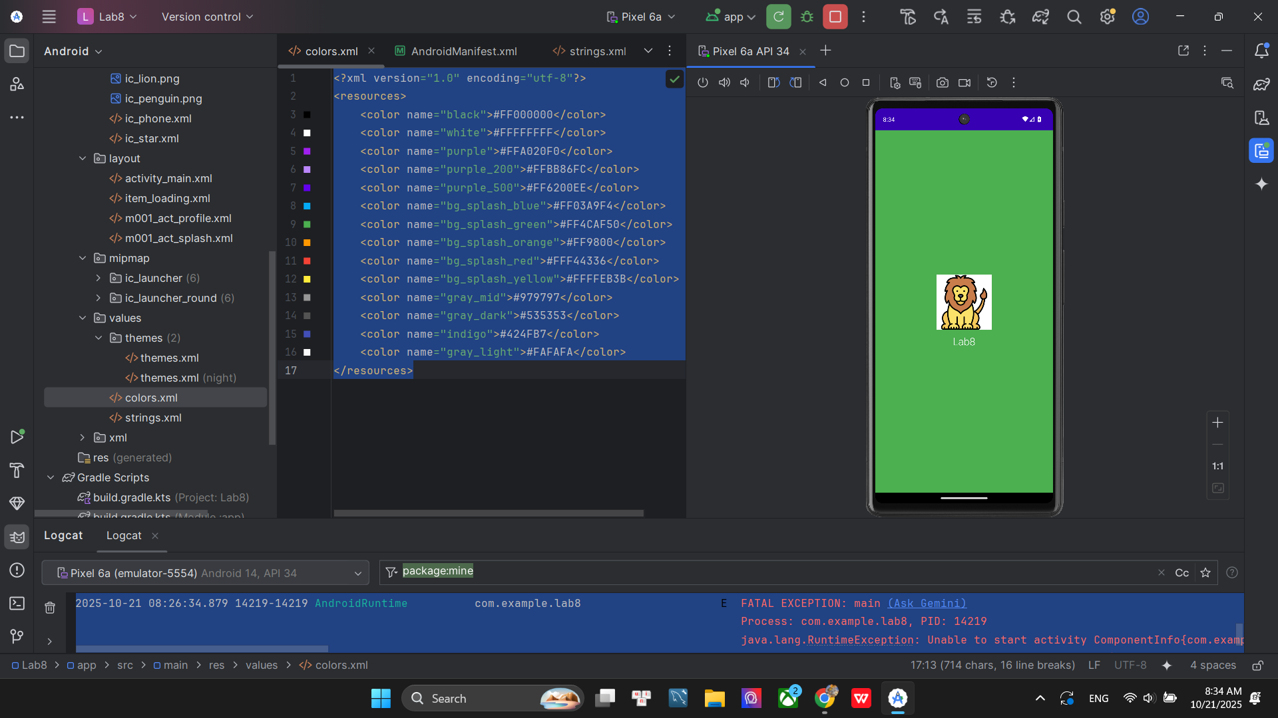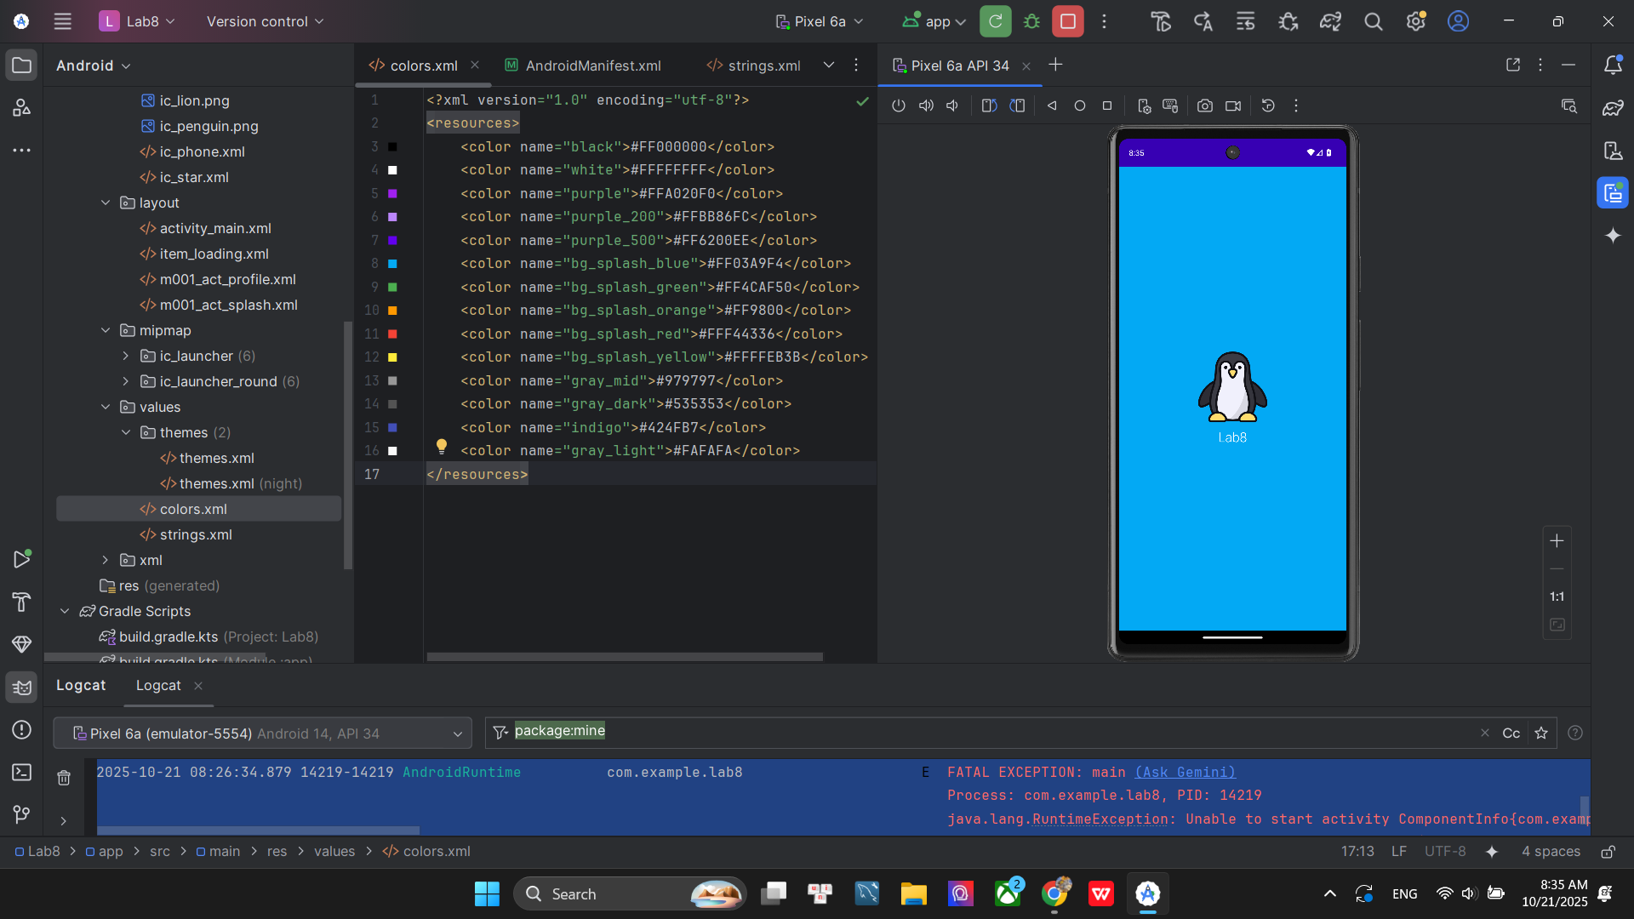
Bài tập 2: Trong bài luyện tập 2, sử dụng Custom ProgressBar để làm giao diện đẹp hơn.

Để code thanh tiến tiến trình hoặc vòng tiến trình ta thêm file item_loading và code như sau

<?xml version="1.0" encoding="utf-8"?>
<LinearLayout xmlns:android="http://schemas.android.com/apk/res/android"
android:layout_width="match_parent"
android:layout_height="match_parent"
android:background="#BF000000"
android:gravity="center"
android:orientation="vertical">

<ProgressBar
android:layout_width="60dp"
android:layout_height="60dp"
android:indeterminateDrawable="@drawable/custom_progress_ring" /> <TextView
android:layout_width="wrap_content"
android:layout_height="wrap_content"
android:fontFamily="sans-serif-light"
android:text="@string/txt_loading"
android:textColor="@color/white"
android:textSize="24sp" />
</LinearLayout>

Sau đó thêm trang item_loading vào trong trang act_splash để trang act_splash có tiến trình

<?xml version="1.0" encoding="utf-8"?>
<FrameLayout xmlns:android="http://schemas.android.com/apk/res/android"
xmlns:tools="http://schemas.android.com/tools"
android:layout_width="match_parent"
android:layout_height="match_parent"
android:background="@color/design_default_color_primary_dark">

<LinearLayout
android:id="@+id/layout_splash"
android:layout_width="match_parent"
android:layout_height="match_parent"
android:background="@color/design_default_color_primary_dark"
android:gravity="center"
android:orientation="vertical">

<ImageView
android:id="@+id/iv_animal_icon"
android:layout_width="128dp"
android:layout_height="128dp"
android:src="@drawable/ic_penguin"
tools:ignore="ContentDescription" />

<TextView
android:layout_width="wrap_content"
android:layout_height="wrap_content"
android:layout_marginTop="10dp"
android:fontFamily="sans-serif-light"
android:text="@string/app_name"
android:textColor="@color/white"
android:textSize="24sp" />
</LinearLayout>

<include layout="@layout/item_loading" /> # Thêm dòng này để gọi

</FrameLayout>
Kết quả khi chạy thì nó sẽ có thanh tiến trình loading

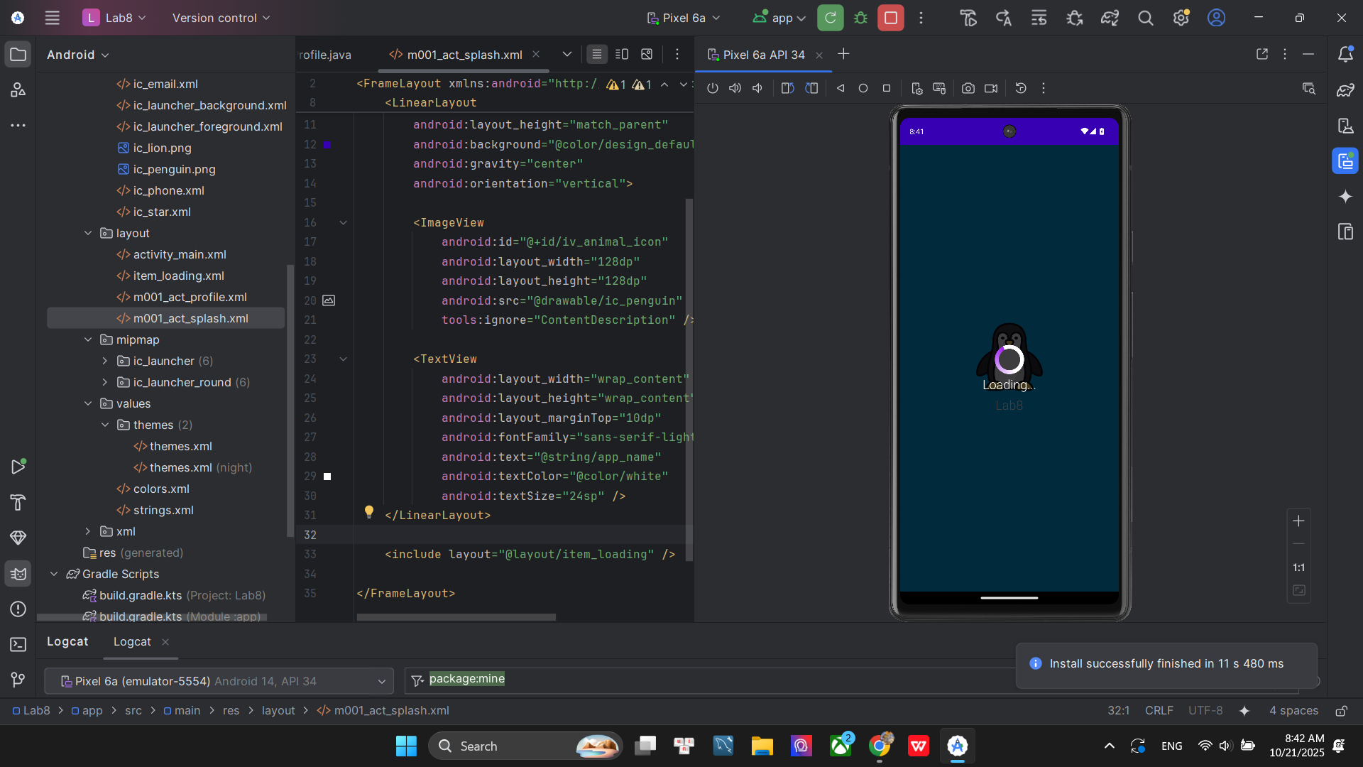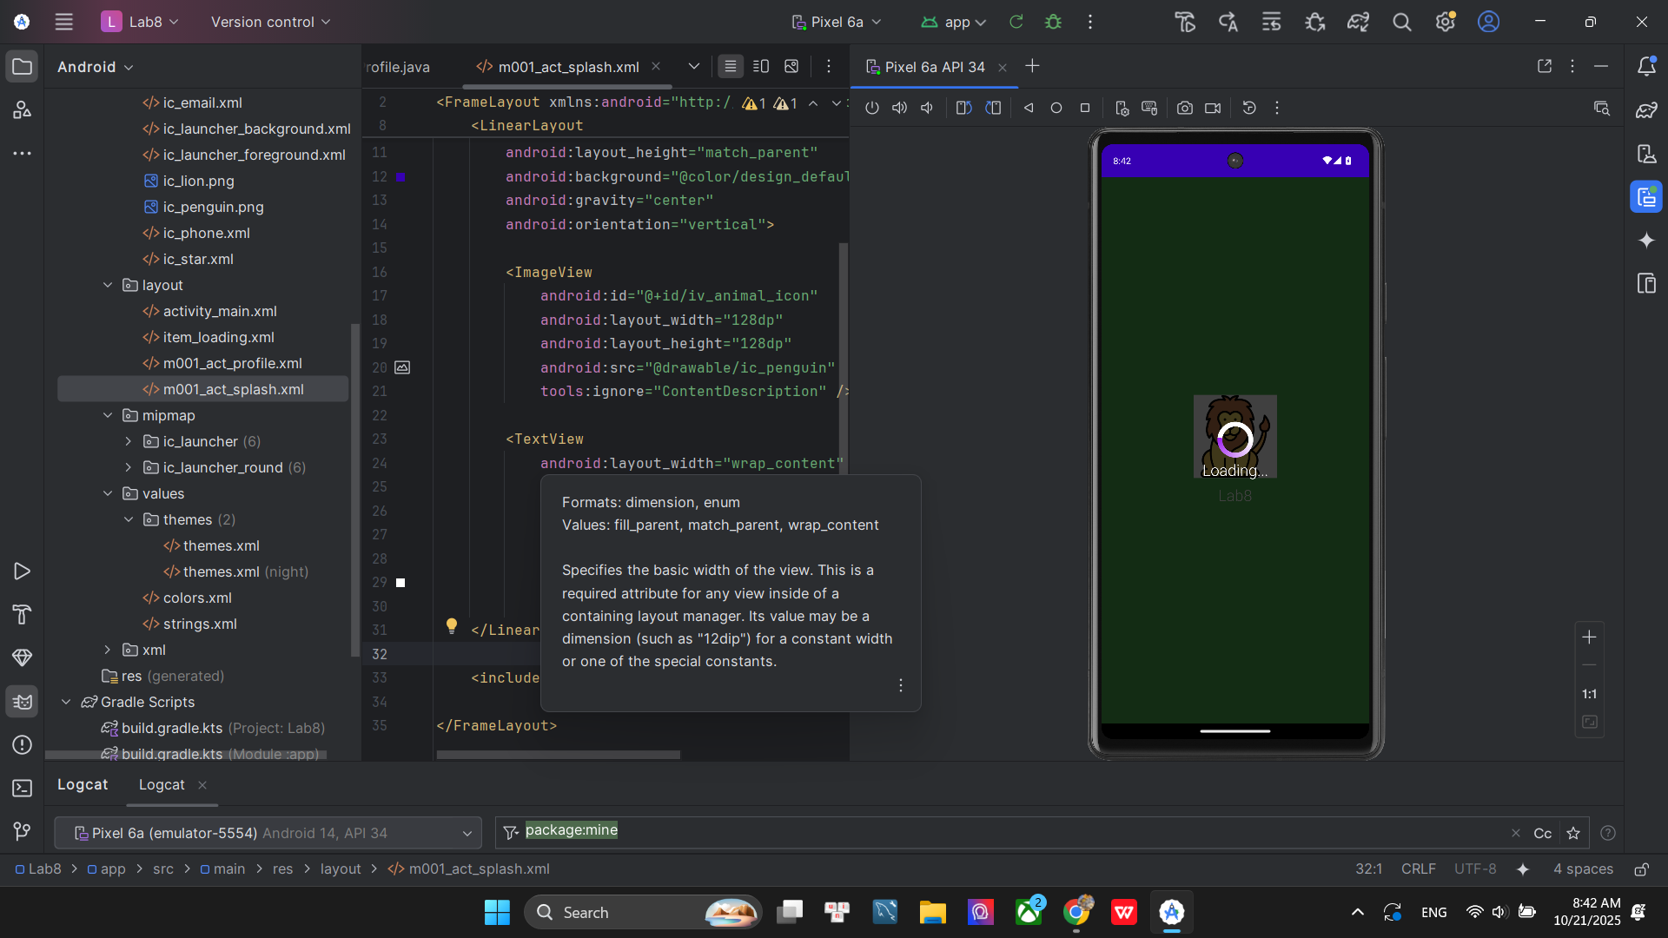

Bài tập 3: Lập trình để khi bấm vào icon thì chuyển về cuộc gọi, sử dụng Intent.

File string và colors thêm vào các value để đẹp hơn như sau

String.xml

<resources>
<string name="app_name">Lab8</string>
<string name="txt_loading">Loading...</string>
<string name="txt_name">luc day</string>
<string name="txt_phone1">(650) 555-1234</string>
<string name="txt_title_mobile">Mobile</string>
<string name="txt_phone2">(323) 555-6789</string>
<string name="txt_email">luc@example.com</string>
</resources>

Colors.xml

<?xml version="1.0" encoding="utf-8"?>
<resources>
<color name="black">#FF000000</color>
<color name="white">#FFFFFFFF</color>
<color name="purple">#FFA020F0</color>
<color name="purple_200">#FFBB86FC</color>
<color name="purple_500">#FF6200EE</color>
<color name="bg_splash_blue">#FF03A9F4</color>
<color name="bg_splash_green">#FF4CAF50</color>
<color name="bg_splash_orange">#FF9800</color>
<color name="bg_splash_red">#FFF44336</color>
<color name="bg_splash_yellow">#FFFFEB3B</color>
<color name="gray_mid">#979797</color>
<color name="gray_dark">#535353</color>
<color name="indigo">#424FB7</color>
<color name="gray_light">#FAFAFA</color>
</resources>

Trong file Layout act_profile, thiết kế giao diện trang profile

<?xml version="1.0" encoding="utf-8"?>
<LinearLayout xmlns:android="http://schemas.android.com/apk/res/android"
xmlns:app="http://schemas.android.com/apk/res-auto"
xmlns:tools="http://schemas.android.com/tools"
android:layout_width="match_parent"
android:layout_height="match_parent"
android:background="@color/gray_light"
android:orientation="vertical">

<FrameLayout
android:layout_width="match_parent"
android:layout_height="350dp">

<ImageView
android:layout_width="match_parent"
android:layout_height="300dp"
android:scaleType="centerCrop"
android:src="@drawable/bg_avatar"
tools:ignore="ContentDescription" />

<TextView
android:layout_width="wrap_content"
android:layout_height="wrap_content"
android:layout_gravity="bottom"
android:layout_marginStart="70dp"
android:layout_marginBottom="90dp"
android:fontFamily="sans-serif"
android:text="@string/txt_name"
android:textColor="@color/white"
android:textSize="40sp" />

<ImageView
android:id="@+id/iv_phone_call"
android:layout_width="80dp"
android:layout_height="80dp"
android:layout_gravity="end|bottom"
android:layout_marginEnd="20dp"
android:layout_marginBottom="10dp"
android:background="@drawable/bg_oval"
android:padding="20dp"
android:src="@drawable/ic_star"
app:tint="@color/white"
tools:ignore="ContentDescription" />
</FrameLayout>

<TableRow
android:layout_width="match_parent"
android:layout_height="wrap_content"
android:padding="20dp">

<ImageView
android:layout_width="60dp"
android:layout_height="60dp"
android:padding="10dp"
android:src="@drawable/ic_phone"
app:tint="@color/indigo"
tools:ignore="ContentDescription" />

<LinearLayout
android:layout_width="match_parent"
android:layout_height="wrap_content"
android:layout_marginStart="30dp"
android:orientation="vertical">

<TextView
android:id="@+id/tv_phone_number_1"
android:layout_width="match_parent"
android:layout_height="wrap_content"
android:text="@string/txt_phone1"
android:textColor="@color/gray_dark"
android:textSize="20sp" />

<TextView
android:layout_width="match_parent"
android:layout_height="wrap_content"
android:layout_marginTop="5dp"
android:text="@string/txt_title_mobile"
android:textColor="@color/gray_mid"
android:textSize="18sp" />

<TextView
android:layout_width="match_parent"
android:layout_height="wrap_content"
android:layout_marginTop="30dp"
android:text="@string/txt_phone2"
android:textColor="@color/gray_dark"
android:textSize="20sp" />

<TextView
android:layout_width="match_parent"
android:layout_height="wrap_content"
android:layout_marginTop="5dp"
android:text="@string/txt_title_mobile"
android:textColor="@color/gray_mid"
android:textSize="18sp" />

<View
android:layout_width="match_parent"
android:layout_height="0.5dp"
android:layout_marginTop="30dp"
android:background="@color/gray_mid" />
</LinearLayout>
</TableRow>

<TableRow
android:layout_width="match_parent"
android:layout_height="wrap_content"
android:padding="20dp">

<ImageView
android:layout_width="60dp"
android:layout_height="60dp"
android:padding="10dp"
android:src="@drawable/ic_email"
app:tint="@color/indigo"
tools:ignore="ContentDescription" />

<LinearLayout
android:layout_width="match_parent"
android:layout_height="match_parent"
android:layout_marginStart="30dp"
android:orientation="vertical">

<TextView
android:layout_width="match_parent"
android:layout_height="wrap_content"
android:text="@string/txt_email"
android:textColor="@color/gray_dark"
android:textSize="20sp" />

<TextView
android:layout_width="match_parent"
android:layout_height="wrap_content"
android:layout_marginTop="5dp"
android:text="@string/txt_title_mobile"
android:textColor="@color/gray_mid"
android:textSize="18sp" />
</LinearLayout>
</TableRow>
</LinearLayout>

Trong M001ActProfile, tạo ra 1 intent để khi click vào sdt thì sẽ chuyển qua màn hình cuộc gọi

package com.example.lab8;

import android.content.Intent;
import android.net.Uri;
import android.os.Bundle;
import android.widget.ImageView;
import android.widget.TextView;
import androidx.appcompat.app.AppCompatActivity;

public class M001ActProfile extends AppCompatActivity {

@Override
protected void onCreate(Bundle savedInstanceState) {
super.onCreate(savedInstanceState);
setContentView(R.layout.m001_act_profile);

ImageView ivPhoneCall = findViewById(R.id.iv_phone_call);
TextView tvPhoneNumber1 = findViewById(R.id.tv_phone_number_1);

ivPhoneCall.setOnClickListener(v -> {
String phoneNumber = tvPhoneNumber1.getText().toString();

Intent intent = new Intent(Intent.ACTION_DIAL);
intent.setData(Uri.parse("tel:" + phoneNumber));
startActivity(intent);
});
}
}

Màn hình giao diện và kết quả khi click vào icon điện thoại

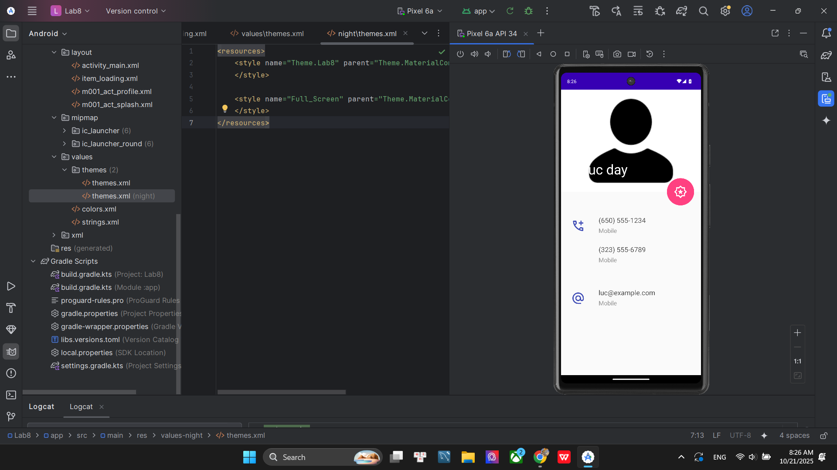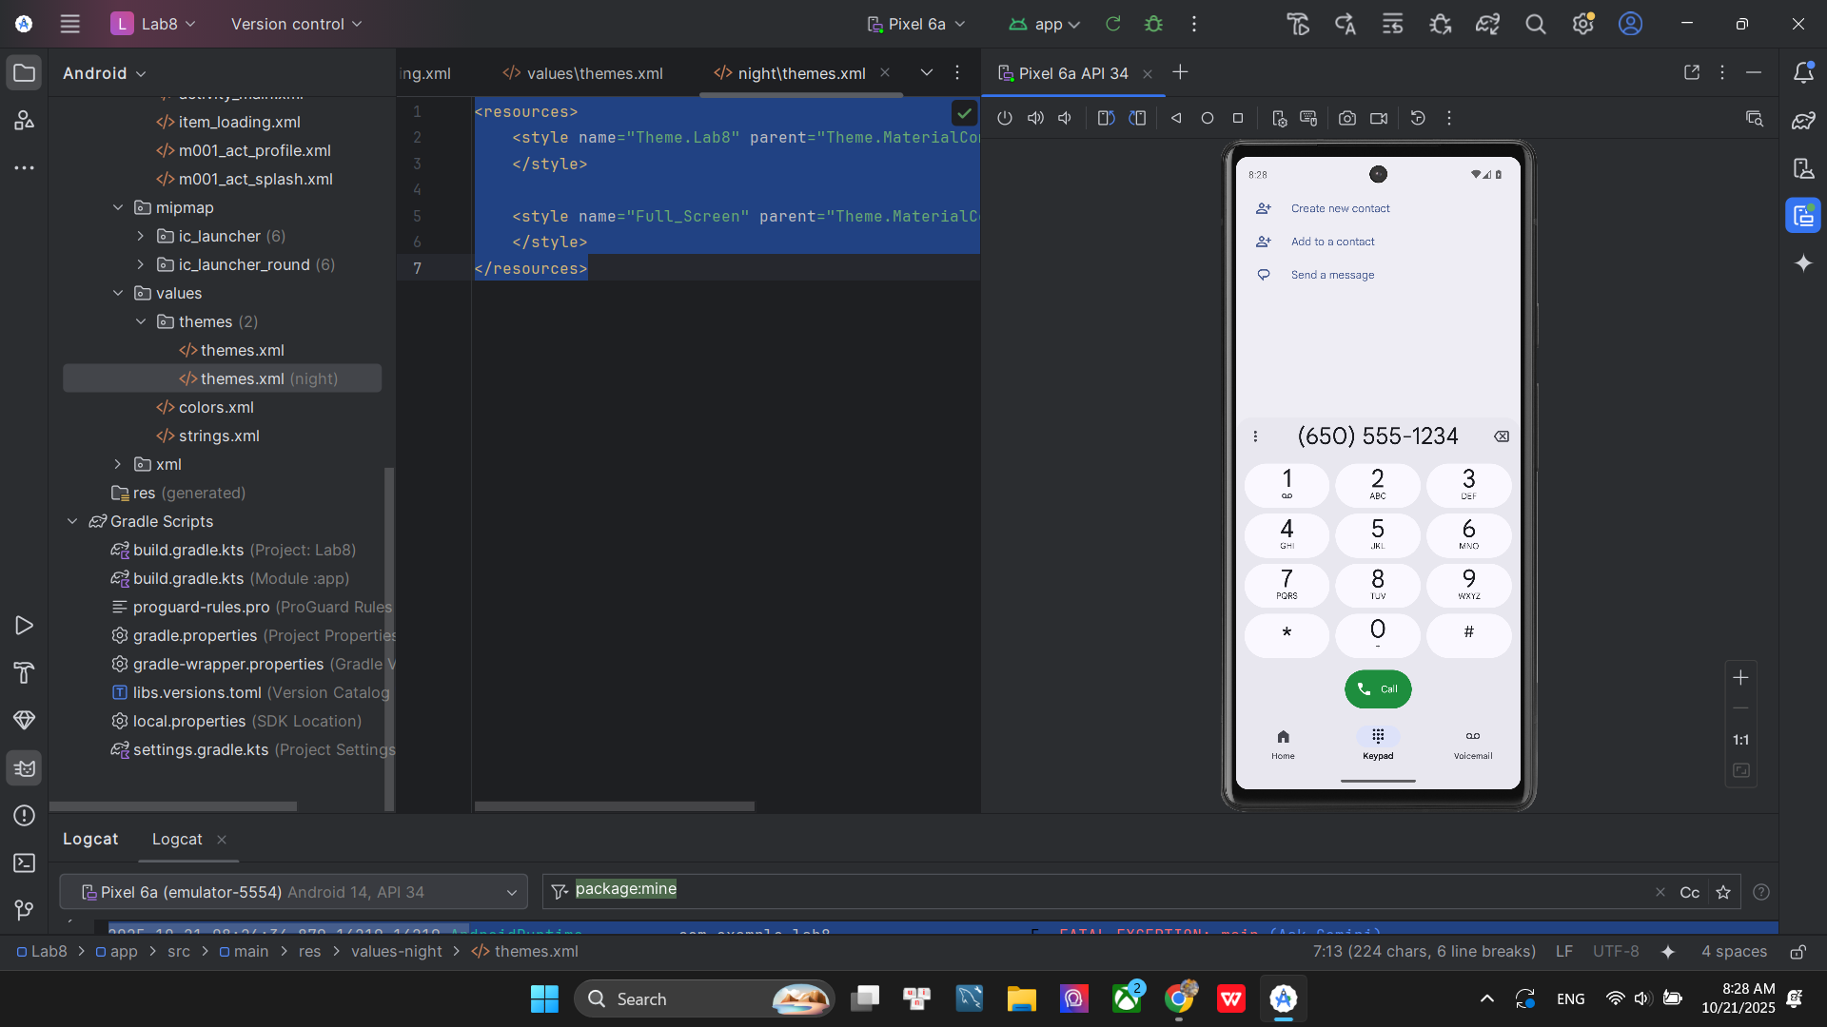

Bài tập 4: Tạo màn hình chính MainActivity để chuyển qua và chuyển về giữa các màn hình ở các phần luyện tập.

Trong file layout activity_main ta code như sau :

<?xml version="1.0" encoding="utf-8"?>
<LinearLayout xmlns:android="http://schemas.android.com/apk/res/android"
xmlns:tools="http://schemas.android.com/tools"
android:layout_width="match_parent"
android:layout_height="match_parent"
android:gravity="center"
android:orientation="vertical"
android:padding="20dp"
tools:context=".MainActivity">

<Button
android:id="@+id/btn_go_to_splash"
android:layout_width="match_parent"
android:layout_height="wrap_content"
android:text="Mở Splash (Bài 1 và 2)" />

<Button
android:id="@+id/btn_go_to_profile"
android:layout_width="match_parent"
android:layout_height="wrap_content"
android:layout_marginTop="20dp"
android:text="Mở Profile (Bài 3)" />

</LinearLayout>

Trong MainActivity ta code xử lý click để chuyển qua 2 màn hình splash và profile như sau

package com.example.lab8;

import android.content.Intent;
import android.os.Bundle;
import android.widget.Button;
import androidx.appcompat.app.AppCompatActivity;

public class MainActivity extends AppCompatActivity {

@Override
protected void onCreate(Bundle savedInstanceState) {
super.onCreate(savedInstanceState);
setContentView(R.layout.activity_main);

Button btnGoToSplash = findViewById(R.id.btn_go_to_splash);
Button btnGoToProfile = findViewById(R.id.btn_go_to_profile);

// Nút 1: Chuyển đến M000ActSplash
btnGoToSplash.setOnClickListener(v -> {
Intent intent = new Intent(MainActivity.this, M000ActSplash.class);
startActivity(intent);
});

// Nút 2: Chuyển đến M001ActProfile
btnGoToProfile.setOnClickListener(v -> {
Intent intent = new Intent(MainActivity.this, M001ActProfile.class);
startActivity(intent);
});
}
}

Kết quả : khi click vào button 1 thì sẽ mở ra bài 1 và 2 , button 2 thì sẽ mở ra bài 3
