LAB 2 : Giao diện cơ bản
Tên : Vũ Bá Lực
MSSV : 1150080104
Lớp : 11_ĐH_THMT

Bài 1 : Giao diện đăng ký

Source code :

activity_main.xml

<?xml version="1.0" encoding="utf-8"?>
<RelativeLayout xmlns:android="http://schemas.android.com/apk/res/android"
android:layout_width="match_parent"
android:layout_height="match_parent"
android:id="@+id/main"
android:paddingLeft="20dp"
android:paddingRight="20dp" >
<TextView
android:id="@+id/tv_sign_in"
android:layout_width="wrap_content"
android:layout_height="wrap_content"
android:layout_marginEnd="50dp"
android:text="sign up"
android:textAllCaps="true"
android:layout_centerHorizontal="true"
android:layout_marginTop="@dimen/margin_basex4"
android:textSize="@dimen/text_large"
/>
<TextView
android:layout_marginTop="@dimen/margin_basex4"
android:layout_width="80dp"
android:layout_height="wrap_content"
android:layout_marginStart="@dimen/margin_left"
android:layout_marginEnd="@dimen/margin_right"
android:text="@string/username"
android:id="@+id/tv_user_name"
android:layout_below="@+id/tv_sign_in"
android:layout_alignParentLeft="true" />
<EditText
android:layout_width="270dp"
android:layout_height="wrap_content"
android:id="@+id/et_username"
android:hint="username@gmail.com"
android:layout_alignTop="@+id/tv_user_name"
android:layout_toRightOf="@+id/tv_user_name"
/>
<TextView
android:layout_marginTop="@dimen/margin_base"
android:layout_width="80dp"
android:layout_height="wrap_content"
android:layout_marginStart="@dimen/margin_left"
android:layout_marginEnd="@dimen/margin_right"
android:text="@string/password"
android:id="@+id/tv_password"
android:hint="******"
android:layout_below="@+id/et_username"
android:layout_alignParentLeft="true" />
<EditText
android:layout_width="270dp"
android:layout_height="wrap_content"
android:id="@+id/et_password"
android:password="true"
android:layout_alignTop="@+id/tv_password"
android:layout_toRightOf="@+id/tv_password"
/>
<Button
android:layout_width="wrap_content"
android:layout_height="wrap_content"
android:padding="@dimen/margin_base"
android:textAllCaps="true"
android:text="sign up"
android:id="@+id/btn_sign_in"
android:layout_marginTop="@dimen/margin_base"
android:layout_below="@+id/et_password"
android:layout_alignParentRight="true"/>
</RelativeLayout>

dimens.xml

<?xml version="1.0" encoding="utf-8"?>
<resources>
<dimen name="activity_horizontal_margin">16dp</dimen>
<dimen name="activity_vertical_margin">16dp</dimen>
<dimen name="margin_base">5dp</dimen>
<dimen name="margin_basex2">10dp</dimen>
<dimen name="margin_basex3">15dp</dimen>
<dimen name="margin_basex4">20dp</dimen>
<dimen name="margin_left">15dp</dimen>
<dimen name="margin_right">15dp</dimen>
<dimen name="margin_leftx2">20dp</dimen>
<dimen name="margin_rightx2">20dp</dimen>
<dimen name="text_small">16sp</dimen>
<dimen name="text_medium">18sp</dimen>
<dimen name="text_large">20sp</dimen>
</resources>

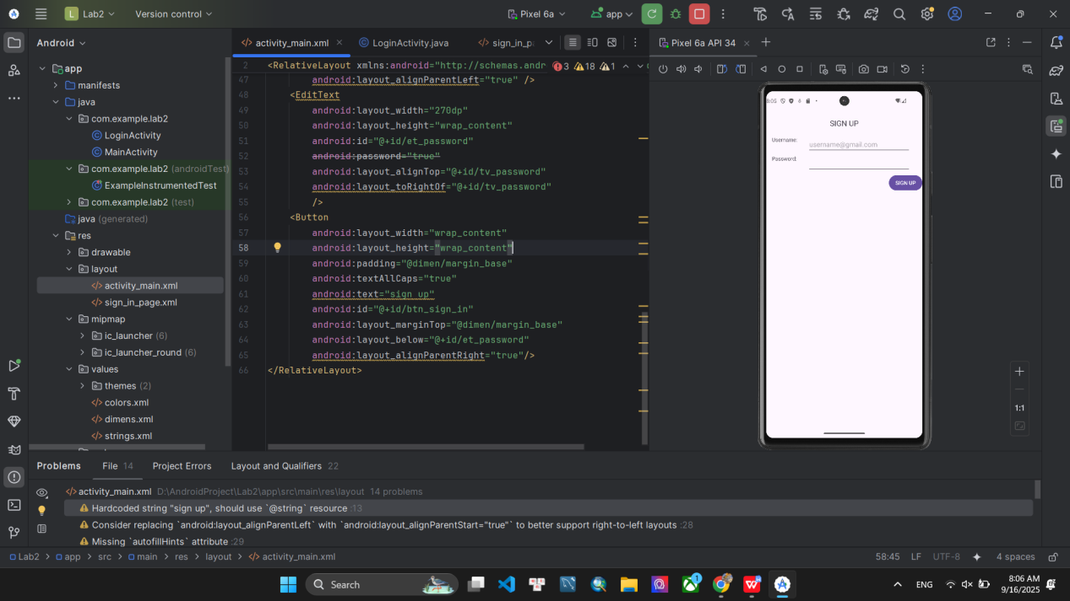

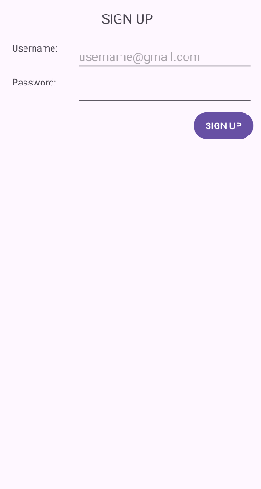

Bài 2 : Giao diện đăng nhập

Source code

colors.xml

<?xml version="1.0" encoding="utf-8"?>
<resources>
<color name="black">#FF000000</color>
<color name="white">#FFFFFFFF</color>
<color name="green">#59AC77</color> // thêm
<color name="lightblue">#6D94C5</color> // thêm
</resources>

activity_main.xml

<?xml version="1.0" encoding="utf-8"?>
<RelativeLayout xmlns:android="http://schemas.android.com/apk/res/android"
android:layout_width="match_parent"
android:layout_height="match_parent"
android:id="@+id/main"
android:paddingLeft="20dp"
android:paddingRight="20dp" >
<TextView
android:id="@+id/tv_sign_in"
android:layout_width="wrap_content"
android:layout_height="wrap_content"
android:layout_marginEnd="50dp"
android:text="sign in"
android:textAllCaps="true"
android:layout_centerHorizontal="true"
android:layout_marginTop="@dimen/margin_basex4"
android:textSize="@dimen/text_large"
/>
<TextView
android:layout_marginTop="@dimen/margin_basex4"
android:layout_width="80dp"
android:layout_height="wrap_content"
android:layout_marginStart="@dimen/margin_left"
android:layout_marginEnd="@dimen/margin_right"
android:text="username"
android:id="@+id/tv_user_name"
android:layout_below="@+id/tv_sign_in"
android:layout_alignParentLeft="true" />
<EditText
android:layout_width="270dp"
android:layout_height="wrap_content"
android:id="@+id/et_username"
android:hint="username@gmail.com"
android:layout_alignTop="@+id/tv_user_name"
android:layout_toRightOf="@+id/tv_user_name"
/>
<TextView
android:layout_marginTop="@dimen/margin_base"
android:layout_width="80dp"
android:layout_height="wrap_content"
android:layout_marginStart="@dimen/margin_left"
android:layout_marginEnd="@dimen/margin_right"
android:text="password"
android:id="@+id/tv_password"
android:hint="******"
android:layout_below="@+id/et_username"
android:layout_alignParentLeft="true" />
<EditText
android:layout_width="270dp"
android:layout_height="wrap_content"
android:id="@+id/et_password"
android:password="true"
android:layout_alignTop="@+id/tv_password"
android:layout_toRightOf="@+id/tv_password"
/>
<Button
android:layout_width="wrap_content"
android:layout_height="wrap_content"
android:padding="@dimen/margin_base"
android:textAllCaps="true"
android:text="sign in"
android:id="@+id/btn_sign_in"
android:layout_marginTop="@dimen/margin_base"
android:layout_below="@+id/et_password"
android:layout_alignParentRight="true"/>
<Button
android:layout_alignParentBottom="true"
android:layout_width="match_parent"
android:layout_marginBottom="90dp"
android:text="sign in via google"
android:backgroundTint="@color/green"
android:textAllCaps="true"
android:layout_height="50dp"/>
<Button
android:layout_alignParentBottom="true"
android:layout_width="match_parent"
android:layout_marginBottom="40dp"
android:text="sign up"
android:backgroundTint="@color/lightblue"
android:textAllCaps="true"
android:layout_height="50dp"/>
</RelativeLayout>

