**SOFTWARE REQUIREMENT SPECIFICATION**

**XenoX**

Automatic Traffic Signal Control System

|  |  |
| --- | --- |
| VERSION: 1.0 | REVISION DATE: 10/03/2016 |

**Contents**

[Automatic Traffic Control System] i

1. Product Description 1

1.1 Purpose 1

1.2 Scope 1

1.3 Stakeholders and Users 1

1.4 Assumptions 1

1.5 Constraints 1

2. Functional Requirements 2

2.1 Requirement X 2

2.1.1 Requirement X1 2

3. Non-Functional Requirements 3

3.1 Requirement Z 3

3.1.1 Requirement Z1 3

4. Interface Requirements 4

4.1 Hardware Interfaces 4

4.2 Software Interfaces 4

5. Use Case Model 5

5.1 Use Case Diagram 5

5.2 Use Case Description 5

6. Glossary 6

7. References 7

## 1. Product Description

### Purpose

Traffic jams in our city of Kolkata, especially in our locality of Sector V, Salt Lake, is a very pressing issue and they are quite frequent.

This leads to huge delay in daily functioning.One of the main reasons for the occurrence of such traffic jams is the still prevalent manual method of controlling the traffic signal at each crossing. These existing methods cannot handle the high amounts of traffic efficiently.

There is a need for automation and use of electronic means to make the system more efficient and hence reduce traffic jams, saving the people a lot of time and energy.

### 1.2 Scope

### To bring about automation to the prevalent method of traffic signal monitoring, we aim to use image processing and advanced algorithms.

* Videos recorded at various crossings across Sector V and New Town, Rajarhat will be used to analyse the traffic load in each lane of the crossing.
* Using this we can determine and automate the process of triggering the traffic signals based on the traffic load in each lane.
* This will help to ensure that the lanes having heavier traffic are cleared out faster and hence reduce delays due to traffic jams.
* Project deliverable is the software that can control traffic signals depending on the no of vehicles.

### 1.3 Stakeholders and Users

The Traffic Control Department of the West Bengal Police Commission are the stakeholders as they will provide the necessary financial backup and required permissions to set up the project if they deem the project a successful venture.

The users of the software include the Traffic Guards on duty and the Traffic Commissioners who are in charge of the posts. The common people are affected by the use of the software which regulates the traffic signal.

### 1.4 Assumptions

1. a) Assuming it is a four - way junction.

b) Video cameras will be installed for each forward lane of all roads at a particular crossing and will be able to provide the footage of the vehicles at a particular instance of time.

c) Moreover the video footage will be of high quality so that the footage captured is not too hazy even in heavy rainfall.

d) The computer will have the following required specification to be able to run the software:

a)Operating System(Linux, Windows)

b) MATLAB R2013a

### 1.5 Constraints

1. Whenever notified by the proposed system, traffic guard is present to handle

1. the emergency situation (ex. Ambulance)
2. the exceptions raised by the system during its failures.

2.Proposed system will not be able to monitor the load of vehicles taking right turns. So it will function as per the current rule.

## 

## 2. Functional Requirements

1. **Record video**
   1. Description

The videos are recorded for every forward lane in all the directions at the crossing. If it is a 4-way crossing, there are a total of 8 lanes (4 forward and 4 backward). Of these, video footage of only the 4 forward lanes are taken into consideration.

* 1. Stimulus/Response Sequences

1.2.1 The video is recorded continuously using a proper video camera. When the system requests for footage, it is sent to the system through wires or cables connected to it.

1.2.2 The function is called after definite intervals of time – after each cycle of the system process.

1.3 Requirements

1.3.1 Clarity of the video is essential for the proper functioning of the system.

The near end, approximately first 120-200 m of the view should be clear enough such that various vehicles can be differentiated by the naked eye itself. However clarity at the rear end or far end is not that essential.

1.3.2 If the camera fails, then an exception is thrown to the system and a notification is sent to the system.

1. **Set timer**
   1. Description

To set the time interval in which decision is taken. It is the interval between one capture video function to another capture video function. This is set by the traffic guard and can be changed by him as and when required depending on traffic load on the road.

2.2 Stimulus/Response Sequences

2.2.1 The traffic guard will set the interval depending on the load of the traffic.

2.3 Requirements

2.3.1 The time period of a single cycle of the system is to be set by the admin or the traffic guard team using the user interface of the system. This is also the time for which a single signal stays active.

2.3.2 When this time ends, the number of cars in the video footage at that particular instant is obtained by using image processing. Footages from all the directions are used for this purpose

* + 1. The timer can be set irrespective of any mode.

1. **Process Video**
   1. Description

The videos recorded by the camera are processed and the necessary features are obtained by means of segmentation. The presence of emergency vehicles in any lane is also detected at this stage. In case the footage is hazy for processing, the traffic guard on duty is notified to take necessary steps. Processing of video takes place for footage recorded by all the cameras at the crossing. If it is a 4-way crossing, 4 footages are processed.

* 1. Stimulus/Response Sequences
     1. At the end of the timer, the recorded video is processed and through segmentation, necessary features like number of cars, presence of emergency vehicles are detected.
     2. Once the features have been obtained, the best route is selected and the traffic signal is set accordingly.
     3. On detecting an emergency vehicle, a notification is sent to the traffic guard.
  2. Requirements
     1. The video footage recorded by the cameras is read by the system at the end of the timer period. Footages from all the lanes are read for this purpose.
     2. The frames in the video are extracted and various algorithms for car count are applied on that frame.
     3. Any coloured circle above any vehicle will be treated as an emergency vehicle and a notification will be sent to the traffic guard for his involvement.

1. **Car Count**
   1. Description
   2. Stimulus/Response Sequences
      1. When the video has been read and frames have been extracted from it, the number of cars in that frame is to be counted.
      2. The number of cars in the frame is obtained and helps in deciding the route to be selected for the green signal.
   3. Requirements
      1. For counting the number of cars, a particular frame is extracted from the video footage. This frame is usually when the timer is about to end. For example if the timer has a value of 40 seconds, then the frame at, say, 35 seconds is chosen for this purpose.
      2. Objects in the frame are differentiated based on their intensity values. So, objects having an intensity value above a given threshold are taken into consideration while the others are suppressed. This helps in getting rid of footpaths or grass growing along the side of the lanes.
      3. This is followed by the removal of small items in that image. Vehicles being larger in size do not get removed.
      4. This is followed by the detection of vehicles and hence being able to count it.
2. **Set priority**
   1. Description

To set the time interval in which decision is taken. It is the interval between one capture video function to another capture video function. This is set by the traffic guard and can be changed by him as and when required depending on traffic load on the road.

* 1. Stimulus/Response Sequences
     1. Priority is applied based on count of vehicles and detection of ambulance or other higher priority vehicles.
     2. Priority can be applied by the traffic guard manually.
  2. Requirements

5.3.1 The priority of a particular lane can be increased by the traffic guard on duty using the user interface of the system. If a lane has higher priority, then it is subjected to green signal first. This usually happens when any important personnel is set to travel on that lane.

1. **Route selection**
   1. Description

The extracted features from the processed videos like count of vehicles and detection of emergency situations, priority is assigned based on these features and route is selected based on that priority.

* 1. Stimulus/Response Sequences

6.2.1 After getting the video footage, the footage is sent to be processed by the system.

6.2.2 After getting the extracted features like count of the vehicles and priority information from the processed videos, a select route is done.

* 1. Requirements
     1. The lane with maximum traffic is given the green signal under normal circumstances. The car count in the various lanes is taken into consideration and the lane combination with higher load is given the green signal.

For example we consider a situation where lane 1 and 3 are in opposite directions and are perpendicular to lanes 2 and 4. If we find that lane 1 has a car count of approximately 30 and lane 3 has 25 as compared to 5 and 10 respectively in lanes 2 and 4, then lanes 1 and 3 are given the green signal.

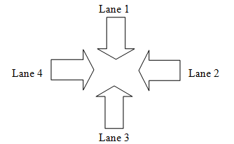

* + 1. If there is an ambulance on any road, then the traffic guard on duty is given an indication of the situation. This is done by sending an alert through the system.
    2. If the priority of any road is increased by external controls (traffic guard) owing to some important personnel, then that road is given maximum priority. For example, if any minister is scheduled to travel along lane 3, then the traffic guard will increase the priority of that road using the manual system controls. Hence that lane will experience green signals more frequently than others.
    3. If after the completion of 1 cycle, the same road is still containing more cars than the others, then there will be no change in signal. For example if in the case stated above, at the time of car count, if lanes 1 and 3 are already green and still they are having more load than the other lanes, then there will be no change in signaling.
    4. After the route decision is conveyed to the traffic signal and the traffic signal has worked properly, the system gets updated with the new signal change.

2.3.6 If there are any connectivity issues or for some reason, the traffic signal is unable to change the signal colours, an exception is thrown and the same process is attempted again.

## 3. Non-Functional Requirements

Some typical non-functional requirements of the proposed system includes:

1. Performance
2. Capacity
3. Scalability
4. Maintainability
5. Reliability
6. Security
7. Usability

### 3.1 Performance: The system is supposed to provide 24 x 7 support to the traffic guards on duty at the various traffic crossings where the system is to be installed. Solar power is used to ensure that the system power does not go off.

#### 3.2Capacity:The cameras which are installed in four directions should be able to capture footage of the car at large spans of around 120-200 meters. So that the correct decision could be taken by the proposed system after analyzing the images. And moreover the response time of the proposed system will be within 5 seconds, thus providing high quality service within a short period of time.

**3.3Scalability:**The proposed system can be scaled by incorporating the following aspects:

1. The system should be able to perform admirably even under adverse weather conditions such as night time and rain. The system will function accurately as long as the images being captured do not get hazy.
2. The system can take into consideration the number of vehicles waiting to take the right turn and adjust the signal for the right turn accordingly.
3. The system can be made to communicate with systems placed at junctions ahead so as to be able to coordinate traffic and emergency situations better.

**3.4Maintainability:**The proposed system will be maintained by checking for bugs at intervals as decided by the stakeholders. Better algorithms for route selection or image processing may also be incorporated to maintain proper functioning of the system.

**3.5Reliability:**By incorporating a robust algorithm into the proposed system, reliable performance is ensured. The system will be able to detect any kinds of emergency situations and instead of handling it on its own, it will notify these to the traffic guards. Hence, the system is reliable in handling the traffic automatically.

**3.6 Security:**The images captured by the camera should not be used by the common public. They should only be used by the Police Commission and the Government and all those permissible by them. Nobody but the system admin will be able to use the images captured by the system.

**3.7Usability:**The proposed system will be able to control the traffic automatically hence providing smart traffic management. The traffic guards will require minimal training to operate it.Knowledge of how to change cycle time and lane priority is enough to control the system.

## 4. Interface Requirements

### 4.1 Hardware Interfaces

There are two hardware interfaces that our system uses.

* ***Interfacing with the External Camera***:It is used for taking pictures of a given lane at a junction.

The external camera, connected to the system via wires, is sent a signal from the system to capture the image at a particular instant. The signal is sent via the ‘*inread*’ command of the *Matlab* software, which is used for image processing. The camera takes the picture of the lane at that instant and sends back the picture to the system. It takes about 2 to 3 seconds.

The ‘*inread*’ command is called after given intervals of time as set by the traffic guard on duty.

* ***Interfacing with the External Traffic Signal***:This interface will be accessible both automatically and manually. Wires will be connected to the signal controller from the system. The system automatically changes the traffic signal as per the decision it takes.

Manual intervention is done in cases of emergency, such as red light vehicles and the like. The traffic guard on duty will be able to adjust the signal controller as per requirement.

### 4.2 Software Interfaces

There is minimal User Interface in our software. The traffic controlling system is mostly automatic except during emergency or special situations. During such situations, which includes red light vehicles like ambulances and VIP cars or other traffic scenarios, the traffic guard will be notified by the system. In such cases, human intervention is required.

The user of the system, i.e., the traffic guard will interact with the system through a simple graphical user interface which has following features:

1. There will be two options to select.
   1. ***Auto Mode***–It is the default mode. During special situations, the traffic guard will be notified and***Manual Mode*** will be automatically set by the system and the traffic guard will have to reset it to the ***AutoMod to*** resume the automatic process of controlling traffic signals.
   2. ***Manual Mode*** - During this mode, the traffic guards control the signal for each direction manually.
2. There will also be a simple entry box where the traffic guard can change the timer of the traffic lights as per required. It can also be used to set the initial signal interval.
3. There is a button on clicking which the timerand mode will be set.

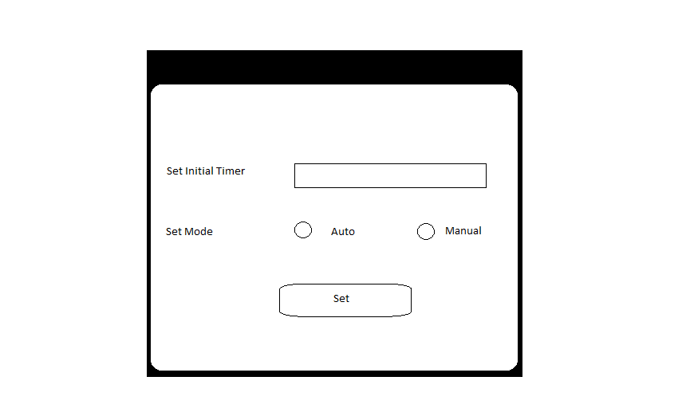

Figure: Sample Image of User Interface

## 5. Use Case Model

The top-level use case diagram, followed by the use case description for each use case.

### 5.1 Use Case Diagram

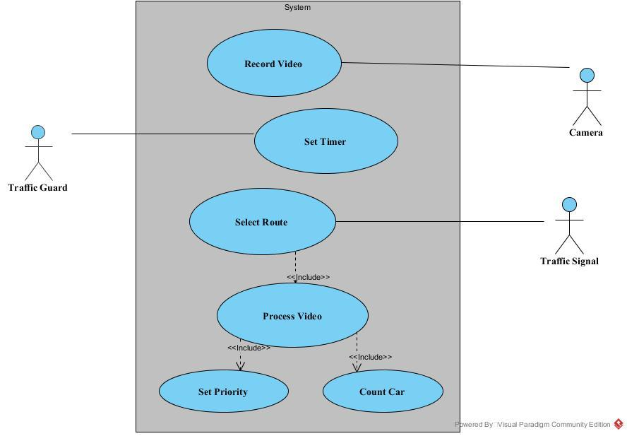

### 5.2 Use Case Description

### Use Case Description

|  |  |  |  |
| --- | --- | --- | --- |
| Use Case ID: | 1 | | |
| Use Case Name: | Record Video | | |
| Created By: | Shubhayu Chakraborty | Last Updated By: | Diptesh Sil |
| Date Created: | 24/2/2016 | Date Last Updated: | 03/03/2016 |

|  |  |
| --- | --- |
| Actor: | Camera |
| Description: | The video is recorded continuously using a proper video camera. When the system requests for footage, it is sent to the system through wires or cables connected to it. |
| Pre Conditions: | 1. The function is called after definite intervals of time – after each cycle of the system process. |
| Post Conditions: | 1. Video to be sent to the system immediately. |
| Priority: | 1 |
| Frequency of Use: | If the total system takes 1 unit of time, then it will be called for 1 time per unit of time. |
| Flow of Events: | * 1. The system requests the cameras, connected over cables, to record videos of the load in all the directions.   2. The captured videos are then sent to the system for processing. |
| Alternative Flows: | NA |
| Exceptions: | 1. If the camera fails, then an exception is thrown to the system and a notification is sent to the system. |
| Includes: | NA |
| Special Requirements: | NA |
| Assumptions: | 1. The video should be clear irrespective of weather and day/night conditions. 2. The cable connections are in proper order. |
| Notes and Issues: | NA |

|  |  |  |  |
| --- | --- | --- | --- |
| Use Case ID: | 2 | | |
| Use Case Name: | Set Timer | | |
| Created By: | Shubhayu Chakraborty | Last Updated By: | SuchismitaGoswami |
| Date Created: | 27/02/2016 | Date Last Updated: | 03/03/2016 |

|  |  |
| --- | --- |
| Actor: | Traffic Guard |
| Description: | To set the time interval in which decision is taken. It is the interval between one capture video function to another capture video function. This is set by the traffic guard and can be changed by him as and when required depending on traffic load on the road. |
| Preconditions: | The traffic guard has set an interval for that time of the day. |
| Post conditions: | The traffic signal stays green according to the time interval set by the traffic guard. |
| Priority: | 2 |
| Frequency of Use: | For every cycle of the system, this may or may not be called. Once set, it will continue to have that value unless changed by the traffic guard. |
| Flow of Events: | 4.1) The traffic guard will set the interval depending on the traffic load on the road.  4.2) System will then request videos depending on this interval. |
| Alternative Flows: | NA |
| Exceptions: | NA |
| Includes: | NA |
| Special Requirements: | NA |
| Assumptions: | NA |
| Notes and Issues: | NA |

|  |  |  |  |
| --- | --- | --- | --- |
| Use Case ID: | 3 | | |
| Use Case Name: | Process Video | | |
| Created By: | SushmitaGoswami | Last Updated By: | SuchismitaGoswami |
| Date Created: | 24/2/2016 | Date Last Updated: | 03/03/2016 |

|  |  |
| --- | --- |
| Actor: | Camera |
| Description: | The videos captured by the four cameras in each direction (N, S, E, W) are processed to find the load (number of vehicles) in each direction.  Emergency cases (e.g.: ambulance) and the directions in which an emergency case has arrived are also identified from the videos. |
| Pre Conditions: | 1. Receiving videos from cameras in all directions. |
| Post Conditions: | 1. Information after processing of videos is sent back to the system for selecting the route. |
| Priority: | 2 |
| Frequency of Use: | If the total system takes 1 unit of time, then it will be called for 1 time per unit of time. |
| Flow of Events: | 2.1) The cameras in each direction take videos of the road in each direction. Then it sends the videos to the system connected over wire.   * 1. The system processes the videos and extracts the necessary features (load, emergency situations) through segmentation. |
| Alternative Flows: | NA |
| Exceptions: | 2.1) If the video in a particular direction is hazy, the system requests for another video in that direction.  2.2) If the videos in all the four directions are hazy, the traffic guard is intimated to manually control the traffic as this may be a condition of rain, fog etc. |
| Includes: | NA |
| Special Requirements: | NA |
| Assumptions: | 2.1) The videos are not hazy. |
| Notes and Issues: | NA |

|  |  |  |  |
| --- | --- | --- | --- |
| Use Case ID: | 4 | | |
| Use Case Name: | Count Car | | |
| Created By: | SuchismitaGoswami | Last Updated By: | SushmitaGoswami |
| Date Created: | 27/02/2016 | Date Last Updated: | 03/03/2016 |

|  |  |
| --- | --- |
| Actor: | NA |
| Description: | Method to find load (no of vehicles) in each direction (North, South, East and West) on the road. |
| Pre Conditions: | Video captured by the camera is processed to find the load (no of vehicles) in each direction. |
| Post Conditions: | Information about the load on the road is then sent back to the controller. |
| Priority: | 4 |
| Frequency of Use: | If the total system takes 1 unit of time, then it will be called for 1time per unit of time. |
| Flow of Events: | The video is processed and the number of vehicles in each lane is counted. This helps in deciding the route which is to be made green. |
| Alternative Flows: | NA |
| Exceptions: | If the traffic is huge then the identification of each vehicle in a lane may not be accurate by the video analyzer. |
| Includes: | NA |
| Special Requirements: | NA |
| Assumptions: | NA |
| Notes and Issues: | NA |

|  |  |  |  |
| --- | --- | --- | --- |
| Use Case ID: | 4 | | |
| Use Case Name: | Set Priority | | |
| Created By: | SuchismitaGoswami | Last Updated By: | Subhasree Bose |
| Date Created: | 25/02/2016 | Date Last Updated: | 03/03/2016 |

|  |  |
| --- | --- |
| Actor: | Traffic guard |
| Description: | Method to assign priority to the roads. Ideally all the lanes have the same priority. However, in case of any ambulance or fire brigade, the system automatically sets a higher priority to the lane containing them. Moreover if any important personnel travelling along that route, the traffic guard will manually set a higher priority according to his route. |
| Pre Conditions: | There is an ambulance on any lane or any important personnel is scheduled to travel by that route. |
| Post Conditions: | The priority will be increased as per the route and that route will be experiencing green signal for more periods of time as compared to the other lanes. |
| Priority: | 5 |
| Frequency of Use: | If the total system takes 1 unit of time, then it will be called for 1  time per unit of time. |
| Flow of Events: | 4.1) After analysis of the video, feature extraction is done by the system to detect certain special cases.  4.1.1) In case of an ambulance, priority will be assigned to the roads and the selected route will decide.  4.1.2) In the case of emergency personnel, the traffic guard will manually change the priority. |
| Alternative Flows: | NA |
| Exceptions: | NA |
| Includes: | NA |
| Special Requirements: | NA |
| Assumptions: | 4.1) Any ambulance or fire brigade in any lane is successfully detected. |
| Notes and Issues: | NA |

|  |  |  |  |
| --- | --- | --- | --- |
| Use Case ID: | 6 | | |
| Use Case Name: | Select Route | | |
| Created By: | Subhasree Bose | Last Updated By: | DipteshSil |
| Date Created: | 25/2/2016 | Date Last Updated: | 03/03/2016 |

|  |  |
| --- | --- |
| Actor: | Traffic Signal |
| Description: | After the videos are processed and the features are extracted, the system selects the route applying the following logic.   * 1. Generally, the route with the greater number of vehicles is selected for more time period of green signal.   2. If after completion of one cycle, the lane with green signal still has a greater number of vehicles as compared to the other, there is no change of traffic colours.   3. However, if there are more cars on the other lane, the other route is selected for a green signal.   4. In case any emergency case occurs (e.g. Arrival of ambulance,), higher priority is assigned to that direction, on the basis of which route selection is done.   5. However, if a particular lane has higher priority, then that lane is subject to green signal more as compared to the other lane.   After the route decision is conveyed to the traffic signal and the traffic signal has worked properly, the system gets updated with the new signal change. |
| Pre Conditions: | 1. The videos have been processed and necessary features have been extracted successfully. |
| Post Conditions: | 1. The decision of the route selection is sent to the traffic signal controller to change the state of the signal. |
| Priority: | 3 |
| Frequency of Use: | If the total system takes 1 unit of time, then it will be called for 1 time per unit of time. |
| Flow of Events: | 3.1) The system selects the route based on the load in various lanes.  3.2) This decision is then sent to the traffic signal controller to change the state of the signal.  3.3) After the route decision is conveyed to the traffic signal and the traffic signal has worked properly, the system gets updated with the new signal change. |
| Alternative Flows: | NA |
| Exceptions: | 3.1) If there are any connectivity issues or for some reason, the traffic signal is unable to change the signal colours, an exception is thrown and the same process is attempted again |
| Includes: | 1.Process Video. |
| Special Requirements: | NA |
| Assumptions: | NA |
| Notes and Issues: | NA |

***6. GLOSSARY***

1. ***Admin***- The people in charge of the system. It refers to the traffic police departments and the developers involved in the making of this system.
2. ***Cycle***- The interval after which images are requested for and the process of setting the signal is done.
3. ***Load***- The density of cars in a particular lane is referred to as the load. Higher the density of cars more is the load.
4. ***Features***- All the necessary information to be obtained after processing the captured images is being referred to as features. This involves the load in individual lanes as well as the detection of special vehicles like ambulances.
5. ***Lane***- One half of the road(where vehicles are moving in the same direction) is considered as a lane. Here we take into consideration the lane in which vehicles are moving towards the signal.
6. ***Emergency***- An ambulance or fire truck or important personnel getting stuck in traffic is considered as an emergency situation in this case. In such cases higher priority is given to the lanes in which they are stuck.
7. ***Priority***- The importance given to the various lanes at a traffic signal is considered as priority. Ideally all lanes have the same priority unless some emergency situations arise.

## 7. References

Provide a list of all documents and other sources of information referenced in the SRS and utilized in developing the SRS. Include for each the document number, title, date and author.

|  |  |  |  |
| --- | --- | --- | --- |
| **Document No.** | **Document Title** | **Date** | **Author** |
|  |  |  |  |
|  |  |  |  |
|  |  |  |  |
|  |  |  |  |
|  |  |  |  |
|  |  |  |  |