Installation of Java :

**Step 0: Un-Install Older Version(s) of JDK/JRE**

If you have previously installed older version(s) of JDK/JRE, un-install ALL of them. Go to "Control Panel" ⇒ "Program and Features" ⇒ Un-install ALL programs begin with "Java", such as "Java SE Development Kit ...", "Java SE Runtime ...", and etc.

**Step 1: Download JDK**

1. Under "Java Platform, Standard Edition" ⇒ "Java SE 8u{xx}", where {xx} is the latest update number ⇒ Click the "JDK Download" button.
2. Check "Accept License Agreement".
3. Choose your operating platform, e.g., "Windows x64" (for 64-bit Windows OS) or "Windows x86" (for 32-bit Windows OS). You can check whether your Windows OS is 32-bit or 64-bit via "Control Panel" ⇒ "System" ⇒ Under "System Type".

**Step 2: Install JDK and JRE**

Run the downloaded installer, which installs both the JDK and JRE. By default, the JDK will be installed in directory "C:\Program Files\Java\jdk1.8.0_xx", where xx denotes the latest upgrade number; and JRE in "C:\Program Files\Java\jre1.8.0_*xx*".

For novices, accept the defaults. Follow the screen instructions to install JDK and JRE.

Check the JDK installed directory by inspecting these folders using File Explorer. Take note of your JDK installed directory, which you will need in the next step.

**Step 3: Include JDK's "bin" Directory in the PATH**

Windows OS searches the current directory and the directories listed in the PATH *environment variable* for executable programs. JDK's programs (such as Java compiler javac.exe and Java runtime java.exe) reside in directory "<JAVA_HOME>\bin" (where <JAVA_HOME> denotes the JDK installed directory). You need to include "<JAVA_HOME>\bin" in the PATH to run the JDK programs.

To edit the PATH environment variable in Windows XP/Vista/7/8/10:

1. Launch "Control Panel" ⇒ "System" ⇒ Click "Advanced system settings".
2. Switch to "Advanced" tab ⇒ "Environment Variables".
3. Under "System Variables", scroll down to select "Path" ⇒ "Edit...".
4. **For Windows 10**: You see a table listing the existing PATH entries. Click "New" ⇒ Enter the JDK's binary directory "c:\Program Files\Java\jdk1.8.0_xx\bin" (Replace xx with your installation's upgrade number!!!) ⇒ Select "Move Up" to move it all the way to the top.  
   **Prior to Windows 10**: In "Variable value" field, INSERT "c:\Program Files\Java\jdk1.8.0_xx\bin" (Replace xx with your installation upgrade number!!!) IN FRONT of all the existing directories, followed by a semi-colon (;) which separates the JDK's binary directory from the rest of the existing directories. DO NOT DELETE any existing entries; otherwise, some existing applications may not run.
5. Variable name : **PATH**

Variable value : **c:\Program Files\Java\jdk1.8.0_xx\bin;[*exiting entries...*]**

**Step 4: Verify the JDK Installation**

Launch a CMD shell (Click "Start" button ⇒ run... ⇒ enter "cmd"; OR from "Start" button ⇒ All Programs ⇒ Accessories ⇒ Command Prompt).

1. Issue "path" command to list the contents of the PATH environment variable. Check to make sure that your <JAVA_HOME>\bin is listed in the PATH.
2. // Display the PATH entries
3. prompt> **path**

PATH=**c:\Program Files\Java\jdk1.8.0_xx\bin**;

Issue the following commands to verify that JDK/JRE are properly installed and display their version:

1. <prompt> **java -version**
2. prompt> **javac -version**

javac 1.8.0_xx

**Step 5: Write a Hello-World Java Program**

1. Create a directory to keep your works, e.g., "d:\myProject", or "c:\myProject", or any directory of your choice. Do NOT save your works in "Desktop" or "Documents" as their paths are hard to locate. The directory name shall not contain *blank* or special characters. Use meaningful but short name as it is easier to type.
2. Launch a programming text editor (such as [TextPad](https://www3.ntu.edu.sg/home/ehchua/programming/howto/CMD_Survival.html#textpad) or [NotePad++](https://www3.ntu.edu.sg/home/ehchua/programming/howto/CMD_Survival.html#NotePadPP) or Sublime Text). Begin with a *new file* and enter the following source code. Save the file as

**Step 6: Compile and Run the Hello-World Java Program**

To compile the source code "Hello.java":

1. Start a CMD Shell (Click the "Start" button ⇒ "run..." ⇒ Enter "cmd").
2. Set the *Current Drive* to the drive where you saved your source file "Hello.java". For example, suppose that your source file is saved in drive "d", enter "**d:**" as follow:
3. prompt> **d:**

D:\xxx>

1. Set the *Current Working Directory* to the directory that you saved your source file via the **cd** (*Change Directory*) command. For example, suppose that your source file is saved in directory "d:\myProject".
2. D:\xxx> **cd \myProject**

D:\myProject>

1. Issue a **dir** (*List Directory*) command to confirm that your source file is present in the *current directory*.
2. D:\myProject> **dir**

**Hello.java**

1. Invoke the JDK compiler "**javac**" to compile the source code "Hello.java".

D:\myProject> **javac Hello.java**

The compilation is successful if the command prompt returns. Otherwise, error messages would be shown. Correct the errors in your source file and re-compile. Check "[Common JDK Installation Errors](https://www3.ntu.edu.sg/home/ehchua/programming/howto/ErrorMessages.html#JDKErrors)", if you encounter problem compiling your program.

1. The output of the compilation is a Java class called "Hello.class". Issue a **dir** (*List Directory*) command again to check for the output.
2. D:\myProject> **dir**

**Hello.class**

Hello.java

To run the program, invoke the Java Runtime "**java**":

D:\myProject> **java Hello**

Hello, world!

Installation of Android studio :

## Step 1 - System Requirements

You will be delighted, to know that you can start your Android application development on either of the following operating systems −

* Microsoft® Windows® 8/7/Vista/2003 (32 or 64-bit).
* Mac® OS X® 10.8.5 or higher, up to 10.9 (Mavericks)

Second point is that all the required tools to develop Android applications are open source and can be downloaded from the Web. Following is the list of software's you will need before you start your Android application programming.

* Java JDK5 or later version
* Java Runtime Environment (JRE) 6
* Android Studio

## Step 2 - Setup Android Studio

## Overview

Android Studio is the official IDE for android application development. It works based on**IntelliJ IDEA**, You can download the latest version of android studio from [Android Studio Download](http://developer.android.com/sdk/index.html), If you are new to installing Android Studio on windows, you will find a file, which is named as *android-studio-bundle-135.17407740-windows.exe*.So just download and run on windows machine according to android studio wizard guideline.

If you are installing Android Studio on Mac or Linux, You can download the latest version from [Android Studio Mac Download](https://dl.google.com/dl/android/studio/install/1.1.0/android-studio-ide-135.1740770-mac.dmg), or [Android Studio Linux Download](https://dl.google.com/dl/android/studio/ide-zips/1.1.0/android-studio-ide-135.1740770-linux.zip), check the instructions provided along with the downloaded file for Mac OS and Linux. This tutorial will consider that you are going to setup your environment on Windows machine having Windows 8.1 operating system.

## Installation

So let's launch *Android Studio.exe*, Make sure before launch Android Studio, Our Machine should required installed Java JDK. To install Java JDK, take a references of [Android environment setup](http://www.tutorialspoint.com/android/android_environment_setup.htm)

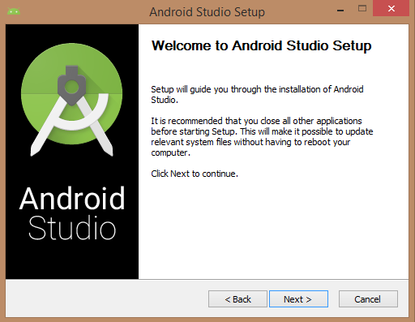

Once you launched Android Studio, its time to mention JDK5 path or later version in android studio installer.

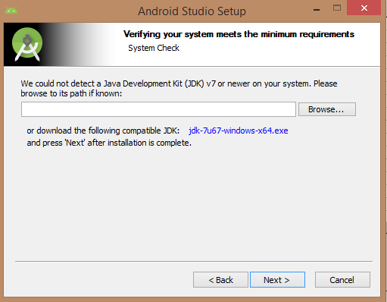

Below the image initiating JDK to android SDK

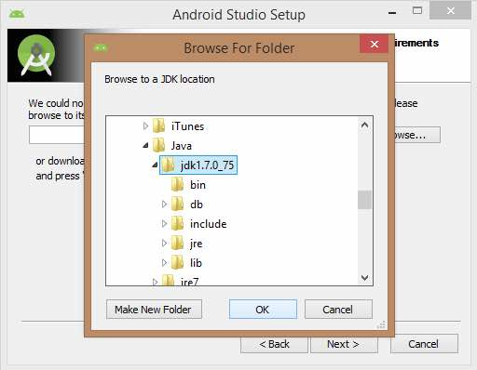

Need to check the components, which are required to create applications, below the image has selected **Android Studio**,**Android SDK**,**Android Virtual Machine** and **performance(Intel chip).**

Need to specify the location of local machine path for Android studio and Android SDK, below the image has taken default location of windows 8.1 x64 bit architecture.

Need to specify the ram space for Android emulator by default it would take 512MB of local machine RAM

At final stage, it would extract SDK packages into our local machine, it would take a while time to finish the task and would take 2626MB of Hard disk space.

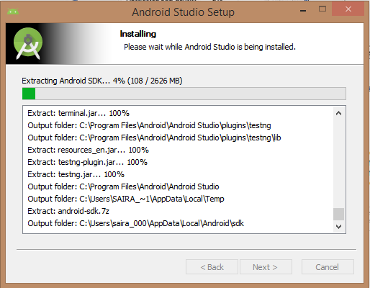

After done all above steps perfectly, you must get finish button and it gonna be open android studio project with Welcome to android studio message as shown below.

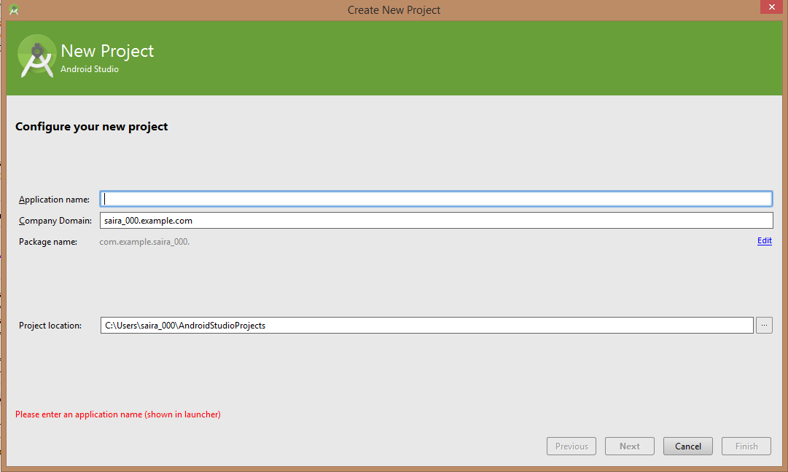

After entered application name, it going to be called select the form factors your application runs on, here need to specify Minimum SDK, in our tutorial, I have declared as API21: Android 5.0(Lollipop)



The next level of installation should contain selecting the activity to mobile, it specifies the default layout for Applications

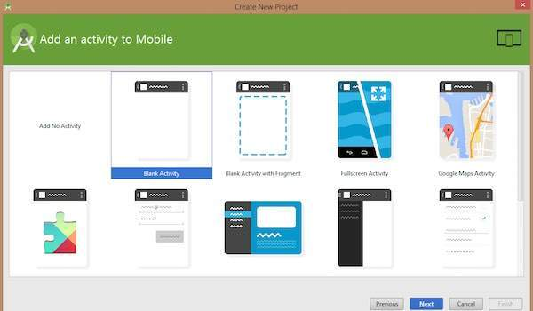

At the final stage it going to be open development tool to write the application code.

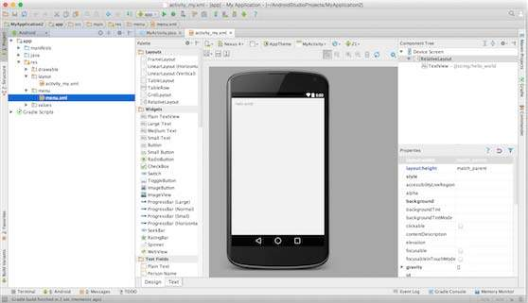

## Step 3 - Create Android Virtual Device

To test your Android applications, you will need a virtual Android device. So before we start writing our code, let us create an Android virtual device. Launch Android AVD Manager Clicking AVD_Manager icon as shown below

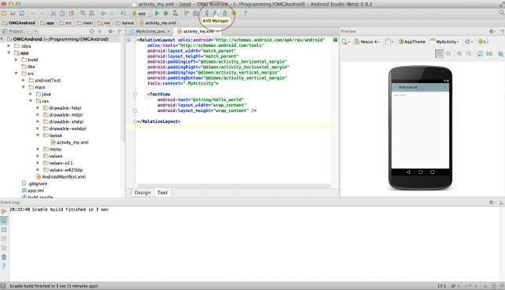

After Click on a virtual device icon, it going to be shown by default virtual devices which are present on your SDK, or else need to create a virtual device by clicking **Create new Virtual device** button

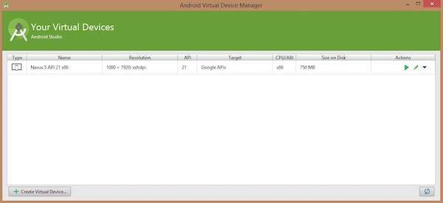

If your AVD is created successfully it means your environment is ready for Android application development. If you like, you can close this window using top-right cross button. Better you re-start your machine and once you are done with this last step, you are ready to proceed for your first Android example but before that we will see few more important concepts related to Android Application Development.

## Hello Word Example

Before Writing a Hello word code, you must know about XML tags.To write hello word code, you should redirect to **App>res>layout>Activity_main.xml**

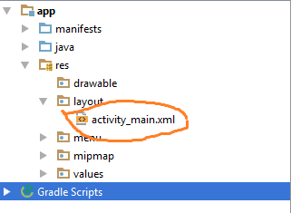

How to run application:

* Open Android studio go to Run menu and select option Run in Emulator
* First user needs to register by entering his/her Mail id as username and password length should be at least four characters.
* After user authentication we will be redirected to a page where our cloud space will be available.
* The data that we have stored in the cloud will be displayed there.
* If we want to upload any data then we can go to upload menu and select upload files then we will be redirecting to the files, then we can select any of the file that should be stored on the cloud.
* We can also download the required files which ever we want from the cloud.