Hypothesis testing

Linear modelling gives the relationship between the dependent and independent variables

In our data set we are finding the hypothesis between each attribute such as Age, sex, year and mean perspiration with the scores of scorer.

1.hypothesis : the score obtained does not depend on the demographics of the subject , session , age , year , sex and perspiration.

For this we did linear modelling of scores given by two scorers with all the other attributes

1.Linear modelling of Scorer1 with all other attributes

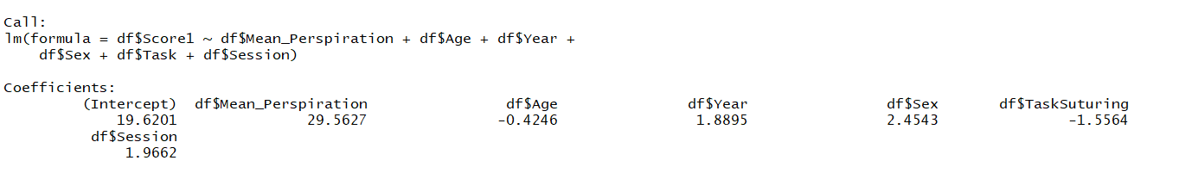

Intercept is 19.6201 and coefficient for mean perspiration is 29.56 , coefficient for age is -0.4246 . coefficient for year is 1.889 , coefficient for sex is 2.4543 , coefficient for session is 1.9662 . so the complete regression equation is

Score1= 19.62+ 29.56\*mean perspiration+ -0.4246\*Age+ 1.889\*year + 2.454\*Sex+-1.556\*Task+1.99\*Session

This equation informs us that scores will increase by 29.56 for every one percent increase in mean Perspiration value , and score is inversely proportional to age which states that the if younger age people are hired the score would have increased.

2.Linear modelling of Scorer2 with all other attributes

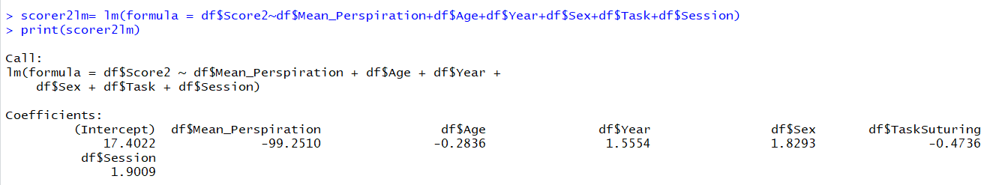

Intercept is 17.4022 and coefficient for mean perspiration is -99.2510 , coefficient for age is -0.2836 . coefficient for year is 1.5554 , coefficient for sex is 1.829, coefficient for session is 1.9009 . so the complete regression equation is

Score2= 17.4022+ -99.25\*mean perspiration+ -0.2836\*Age+ 1.5554\*year + 1.82\*Sex+-0.4736\*Task+1.9009\*Session

3.linear modelling of scores with age

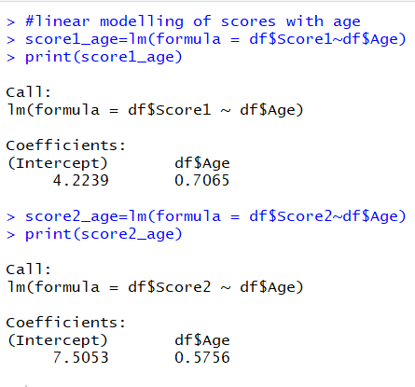

4.linear modelling of scores with year

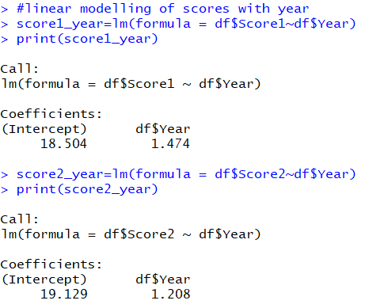

5.linear modelling of scores with perspiration

