1. Create a lib folder and added all the jar files.

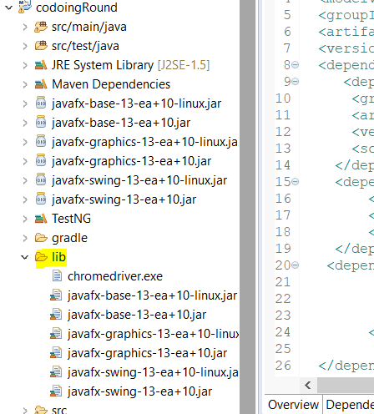

1. Made changes in pom.xml file (selenium dependencies)

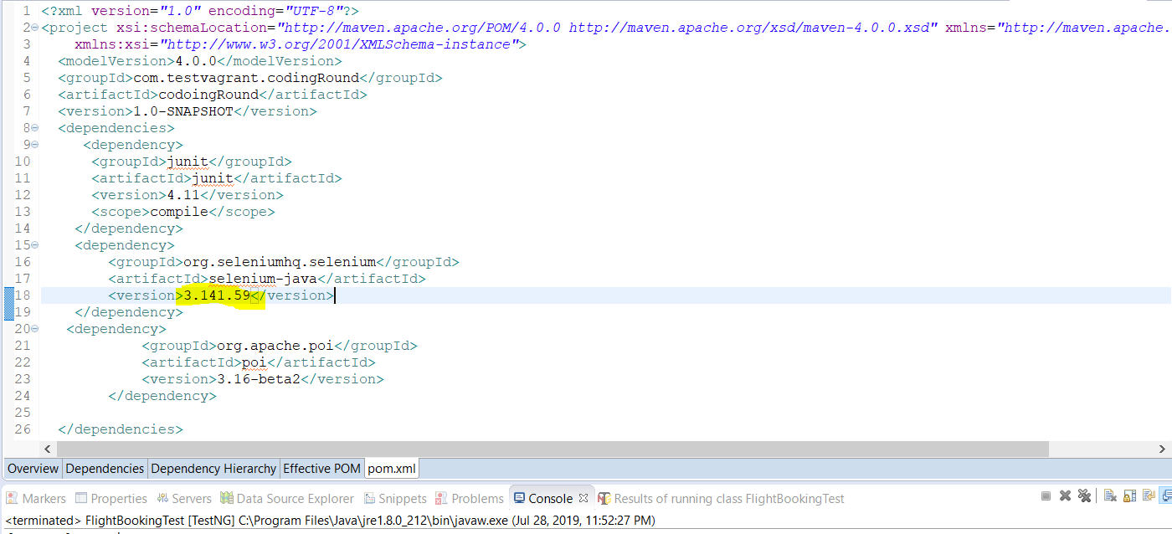

1. Remove unwanted chrome driver as it was throwing mismatching of jdk and selenium error.
2. Update the chromedriver version
3. I have used Hybrid framework with Page object model. It contains src/main/java and src/test/java.

**Src/main/java**

Com.cleartrip.base🡪TestBase is the parent class which has all the pre-requisite such as driver setting, TestBase class constructor etc.

Com.clearetrip.config🡪config.properties file has all the properties defined.

Com.cleartrip.packages🡪It includes three classes FlightBookingPage, HotelBookingPage, & SignInPage

I have created page factory, & methods that will be used for running test cases.

Com.cleartrip.util🡪It has Testutil class that includes common utilities.

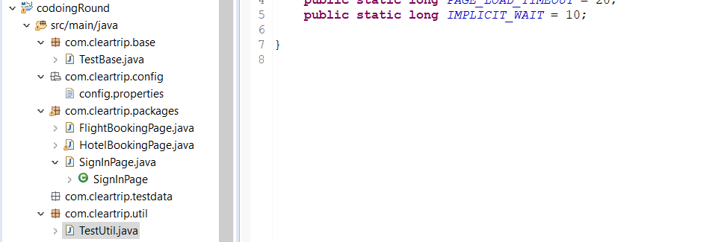

**Src/test/java**

It includes three test class FlightBooking, HotelBooking, & signin.