 | SR UNIVERSITY  Campus Warangal
 | Program: II - B.Tech (CS& AI)
 | Professor(a): Dr. Venkataramana Veeramsetty, Professor
 | Department: Computer Science and AI Semester: I
 | AI Assisted Coding - Lab Test 1 - Set B
Instructions:
- Use AI Tools like VScode+Github Copilot and Cursor AI for code generation
- This Assignment will be evaluated for 15 Marks (10 Marks for Tasks and 5 Marks for viva based on regular lab activities)
- Students need to submit assignment through canvas before due date
- Students who are absent for lab will receive 0 Marks
- Create a Python function that converts an amount from one currency to another using exchange rates stored in a dictionary. Use GitHub Copilot along with VS Code. Use Few shot prompting.
Create a Python function that converts an amount from one currency to another using exchange rates stored in a dictionary by taking input form the console
- ex: 1. converting rupees into dollars.
- 2.converting rupees into pounds.
- 3.converting dollars into euros.
- 4. coverting dollars into pounds.
- 5. converting euros into rupees.
- 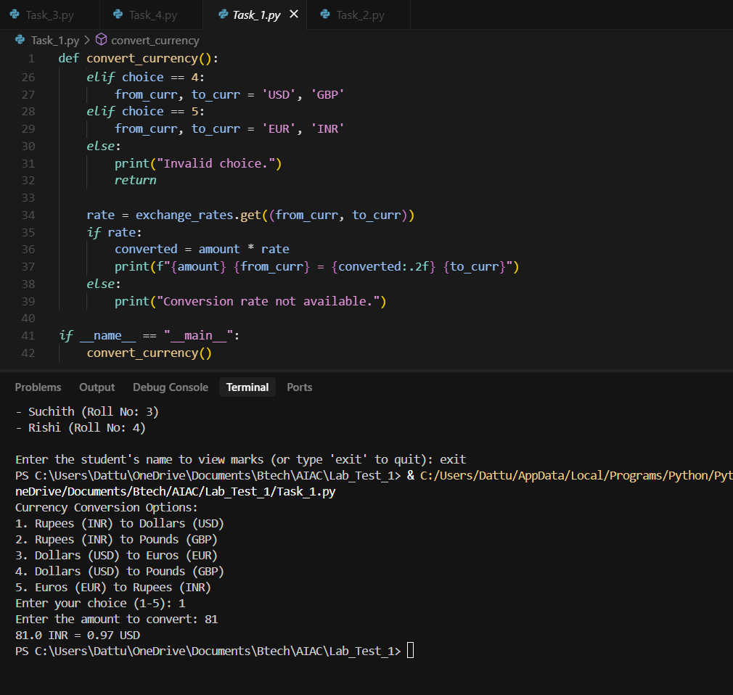

2.Write a Python program to extract all email addresses from a block of text using regular expressions. GitHub Copilot along with VS Code. Use zero shot prompting.
Prompt: create a Python program to extract all email addresses from a block of text using regular expressions by taking input randomly and generate the random email address
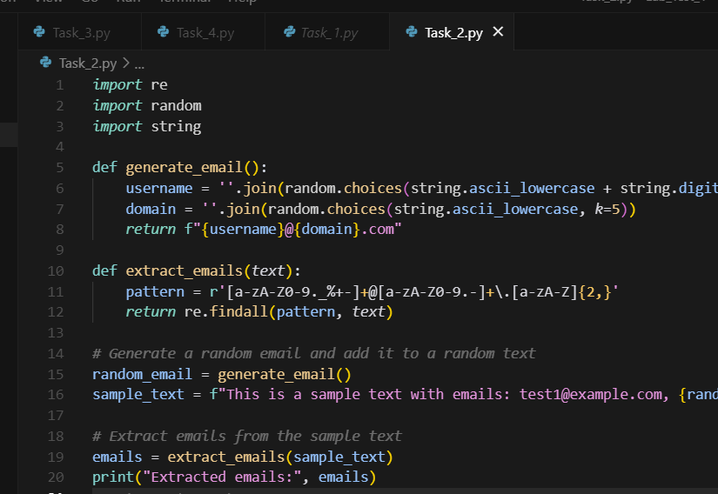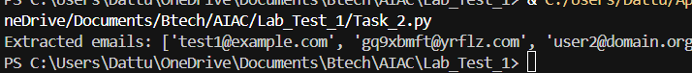
3.Given a list of movies with their genres, Write a Python function that recommends movies based on a user’s preferred genre. Use the Cursor AI tool. Use few shot prompting.
Pormpt:Create a Python function that recommends movies based on a user’s preferred genre by create a list of movies with their genres and by taking user's genres input through the console and recommend any three genres based on user's perferred .
Ex:
1. Enter your favourite genre : love
These are movies available:
Titanic
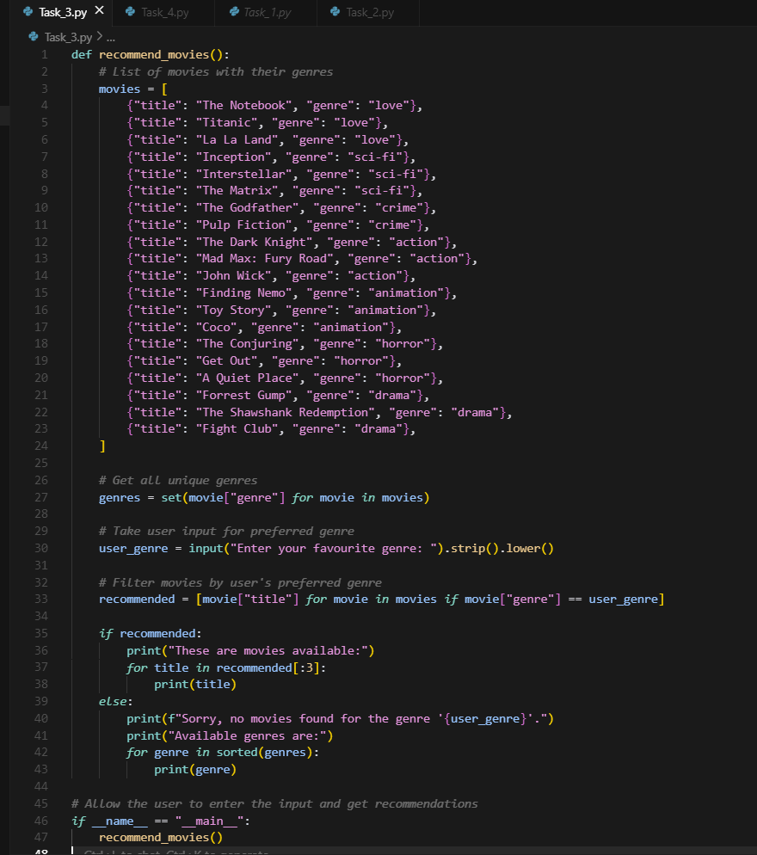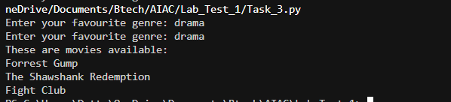
- Write Python code that reads a CSV file containing student names and marks in 3 subjects. Calculate the total and average marks for each student. Use the Cursor AI tool.
Prompt: Create a Python code that reads a CSV file containing student names and marks in 3 subjects. Calculate the total and average marks for each student
by taking the input form the console and ask the user which student's total mark or average of the marks want to see . the subjects are maths and physics and chemistry marks
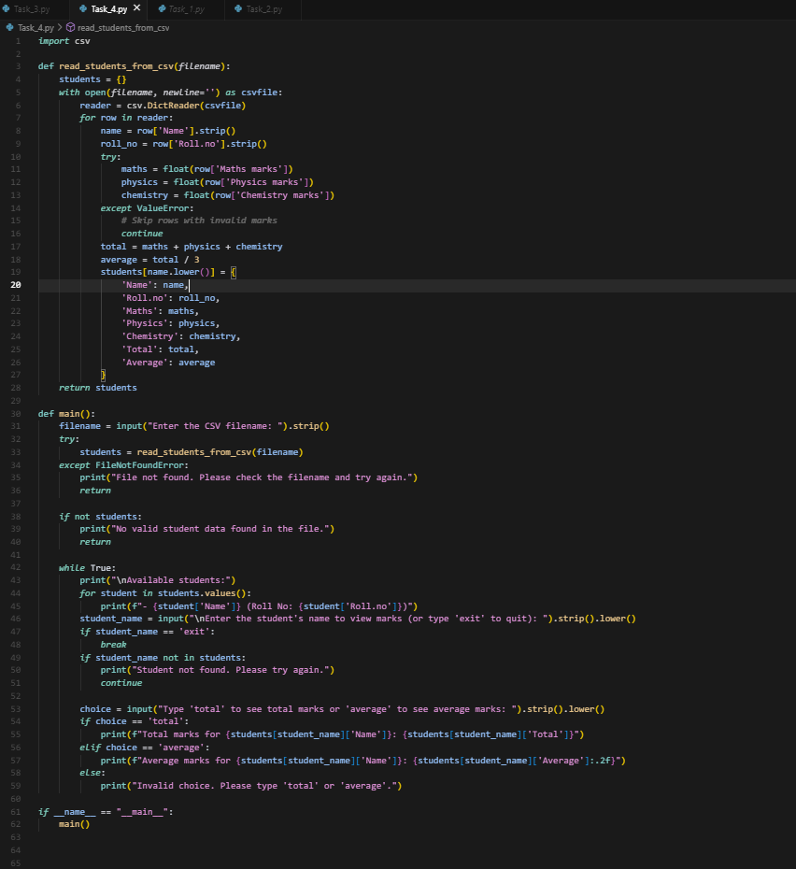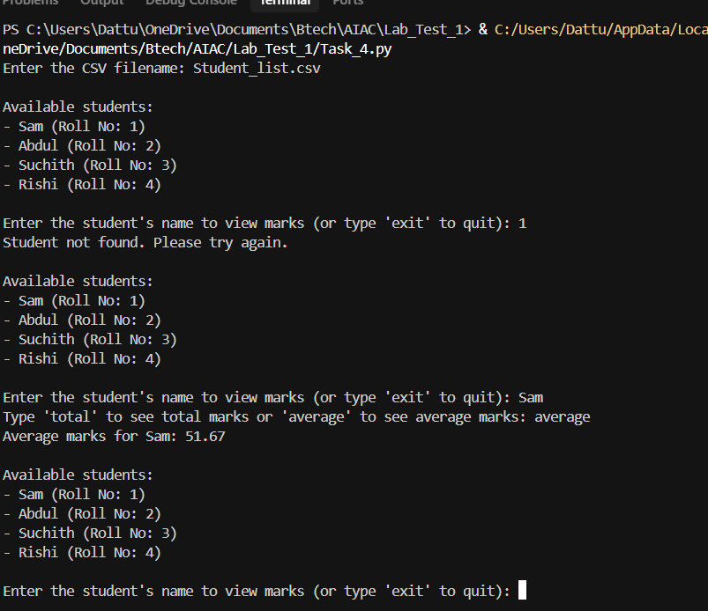
Date: 2025-08-14
©Dr. Venkataramana Veeramsetty, Professor Pag. 1 de 1

