Browse to the desired Directory through Commands in Git Bash - cd <path of the directory>

Open Git Bash directly in the folder - right click anywhere in the directory => Open Git Bash here.

How to Create a New Directory using Git Bash? - mkdir <folder name> - mkdir "first project"(one folder created) - mkdir first project(two folder created)

View all the Directories in Git Bash? - ls

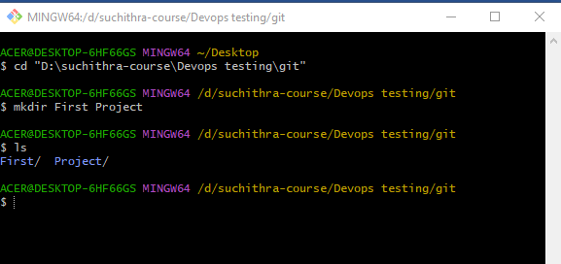

Remove directory

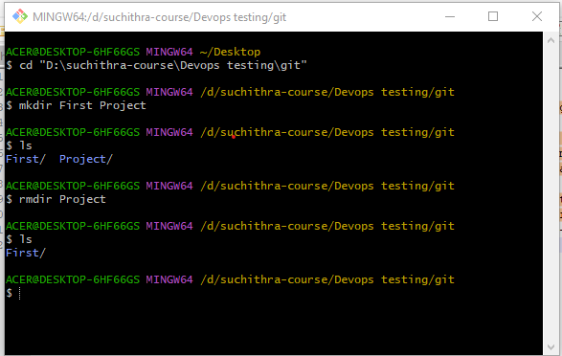

Git init

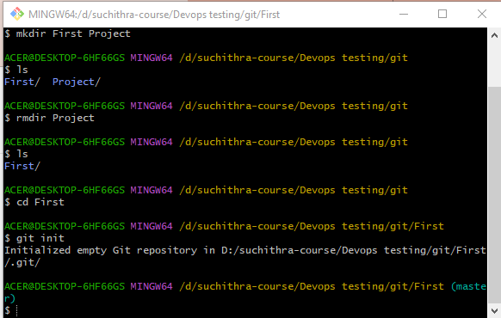

***Create a Bare Git Repository***

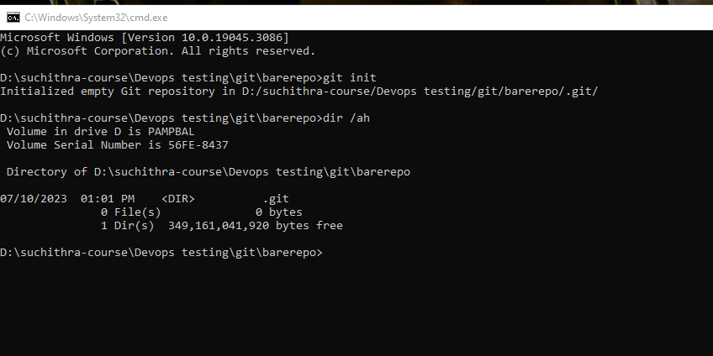

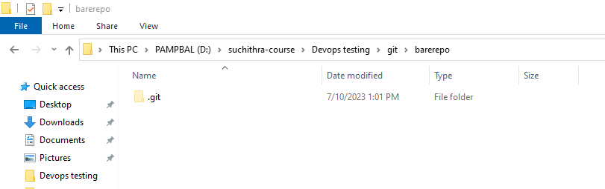

#### *****Create Git Repository for an Existing Project*****

