Langgraph
What is Langgraph”
Langgraph is an orchestration framework for building intelligent, statefuland mult step LLM workflows
It enables advanced features like parallelism,loops,branching,memory and resumability, making it ideal for agentic and production grade ai applications
It models your logic as a graph of nodes (tasks) and edges (routing) instead of a linear chain.

LLM Workflows
Workflow is a series of task in order to achieve a goal
- LLM workflows are a step by step process using which we build complex LLM applications.
- Each step in a workflow perform a distinct task—such as prompting, reasoning, tool calling,memory access or decision-making.
- Workflows can be linear, parallel, branched or looped,allowing for complex behaviours like retries, multi agent communication or tool-augmented reasoning
- Common workflows
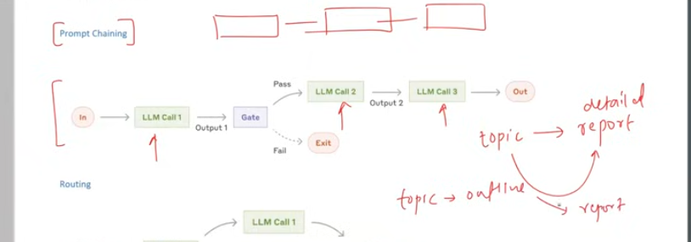
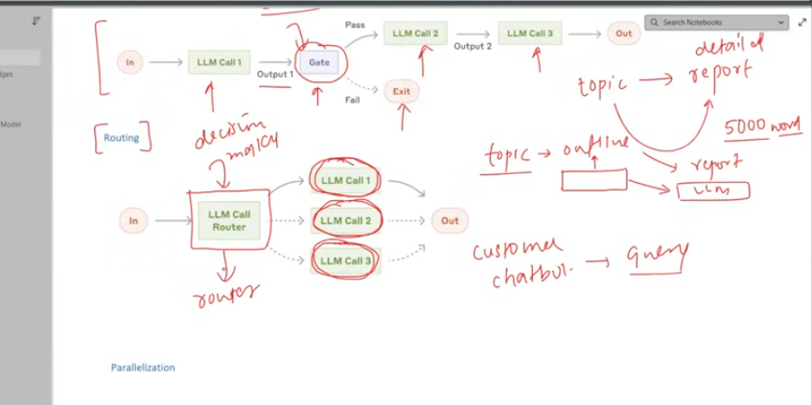
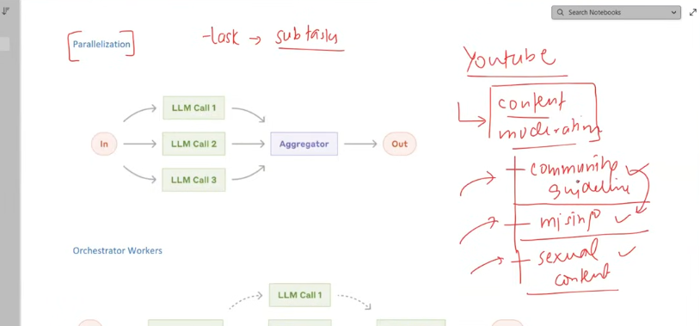
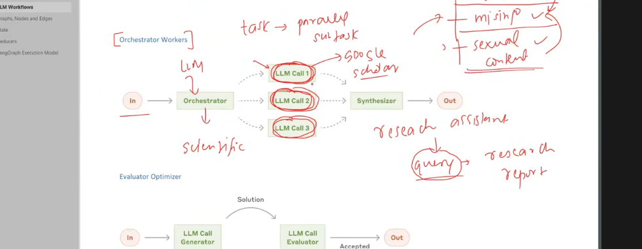
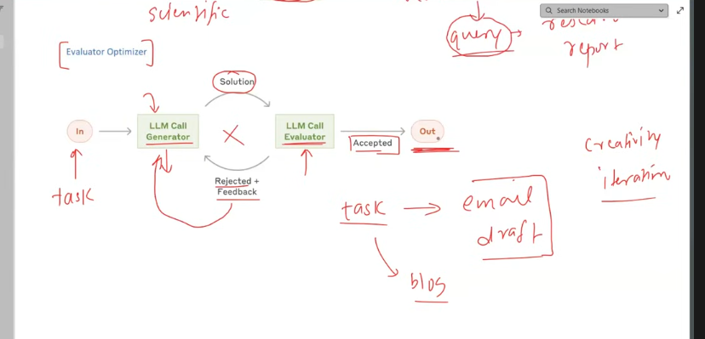

State
F
In Langgraph, state is the shared memory that flows through your workflow. It holds all the data being passed between nodes as your graph runs.
The information stored in state is in key value pair
For example
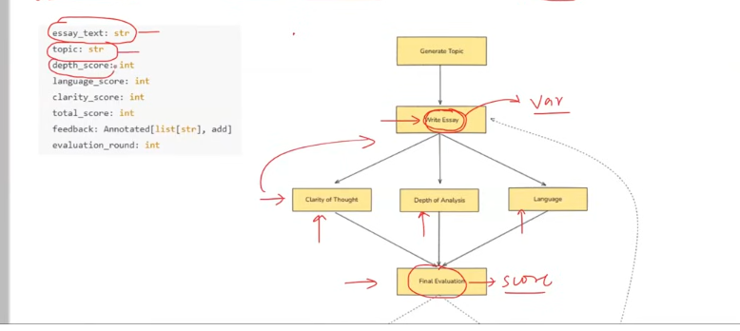
State is shared and mutable
State is a special dictionary which we called it as TypedDict. It is a class in python. We create a object of its class and add all those fields
State is accessible to all the nodes
States are mutable

Reducers
Reducers in langgraph define how updates from nodes are applied to the shared state
Each key in the state can have its own reducer, which determines whether new data replaces, merges, or adds to the existing value.
Reduceres decides how to update the value of the state, either by replacing, or adding or merging

Langgraph Execution model

1.Graph definition
You define :
- The state schema
- Nodes (function that performs the task)
- Edges (which node connects to which)
2. Compilation
You call .comile() on the Stategraph
This checks the graph structure and prepare it for execution
3. Invocation
You run the graph with .invoke(initial_state))
Langgraph sends the initial state as a message to the entry node(s)
4.Super-steps Begin
Execution proceeds in rounds
5.Halting Condition
Execution stops when
- No nodes are active
- No messages are in transit

