**ASSIGNMENT1**

**Q1)** . In the below elements which of them are values or an expression? eg:- values can be integer or string and expressions will be mathematical operators.

'hello' ------value

-87.8 ------value

- --------------expression

/ -------------------expression

+ ----------------------expression

6 ---------------------value

**Q2)** What is the difference between string and variable?

String: String can be written in quotes such: "apple", 'apple'

Variable: It is the thing in which we can store data just like a container.

**Q3)** Describe three different data types.

List: the list is used for storing multiple data items in a single variable.

Integer: integer can store only numerical values.

Float: float can store only floating values such as 233.33, 22.2, etc.

**Q4)** What is an expression made up of? What do all expressions do?

Expression is made up of values, containers, and mathematical operators

(operands) e.g

a = 2 + 3 and expressions are used to evaluate the values or represent the result on the screen.

**Q5)** This assignment statements, like spam = 10. What is the difference between an expression and a statement?

Expression is made up of values, containers, and mathematical operators (operands) and the statement is just like a command that a python interpreter executes like print.

**Q6)** After running the following code, what does the variable bacon contain? bacon = 22 bacon + 1

Sol: it gives 23 as execution code

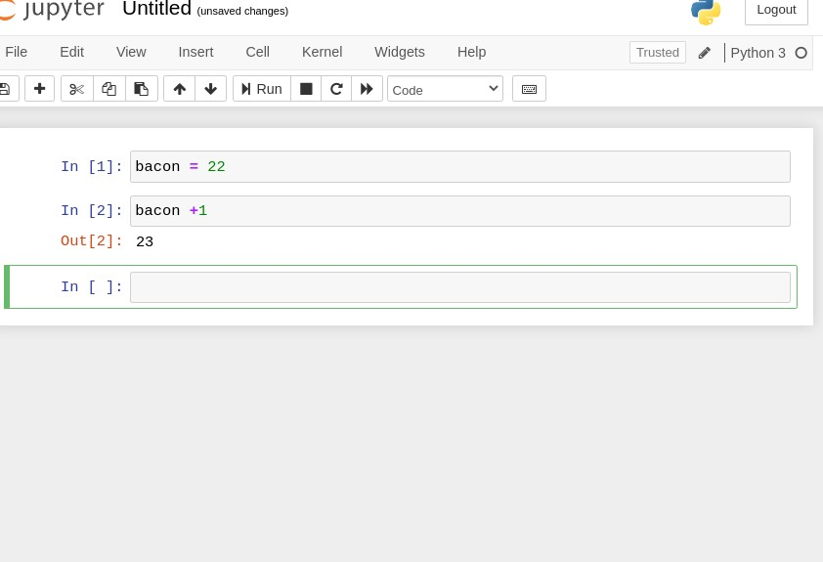

**Q7)** What should the values of the following two terms be?

'spam' + 'spamspam'

'spam' * 3 sol: it will be the same

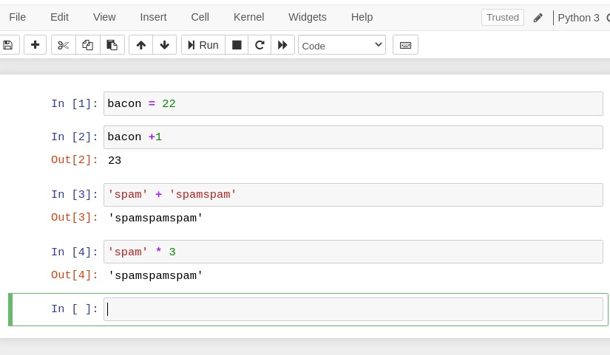

**Q8)** Why is eggs a valid variable name while 100 is invalid?

Ans: because we can't start giving variable an integer name. if we, we should begin with, a striWhat three functions can be used to get the integer, floatingpoint number, or string version of a value?

**Q9)** ans: str(), int(), float()

**Q10)** Why does this expression cause an error? How can you fix it?

'I have eaten' + 99 + 'burritos'

sol: because 99 is an integer it cannot be concatenated with strings, if we have to concatenate it we need to do typecasting.