**Android Application For Wireless Keyboard and mouse**

The android app used to control laptop/computer remotely.

**Steps**

1. Run the server on the laptop/computer to be controlled
2. Install the app on your android device
3. Connect the app and laptop using same wi-fi connection

## Usage

The app provides a trackpad to control the mouse and a keyboard to control the laptop keyboard. You can scroll on screen using 2 fingure gesture. For right click option long press on the trackpad.

**2) USER DOCUMENTATION**

**Software Installation Guide**

For your server you will need to have java run time environment to execute java code which is written for server.

To run java file you will need JDK.

1. Download JDK

To download click on below link-

<https://www.oracle.com/technetwork/java/javase/downloads/jdk8-downloads-2133151.html>

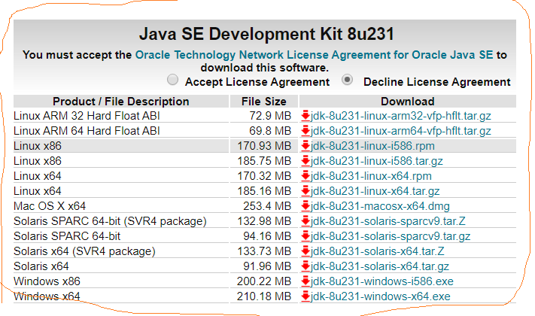

1. JDK Installation for Windows

Run the downloaded installer which will be .exe file and it will installs both the JDK and JRE.

By default, JDK is installed in directory "C:\Program Files\Java\jdk-11.8

1. Include JDK PATH

To edit the PATH environment variable in Windows 10:

1. Launch "Control Panel" ⇒ (Optional) "System and Security" ⇒ "System" ⇒ Click "Advanced system settings" on the left pane.
2. Switch to "Advanced" tab ⇒ Click "Environment Variables" button.
3. Under "System Variables" (the bottom pane), scroll down to select variable "Path" ⇒ Click "Edit...".

Variable name : **PATH**

Variable value : **c:\Program Files\Java\jdk-11.0.{x}\bin;**

**Pictures and explanation for Main Features in Android Application**

1. **Splash Screen**

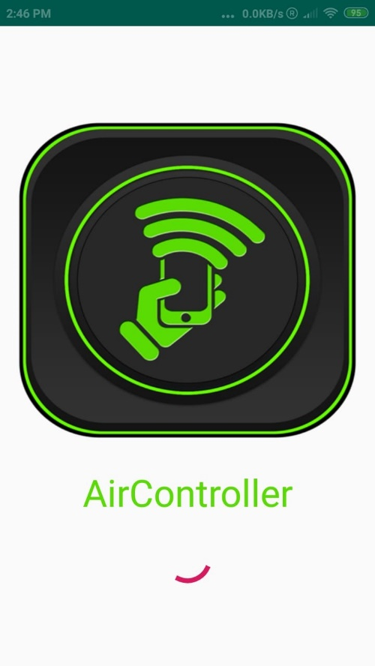

This is our first screen which is called as Splash Screen which will Showed up when you open app and it will remain for few seconds.

1. **Connection Screen**

This Windows will shows up after splash screen. This window is used to connect with the server. In this you need to add Host and Port number. In this Host can be either IPv4 or IPv6 and Port will be 9999.

1. **Main Screen**

This is our main screen in which white part will be default mouse and it will give you three features which is keyboard, Presentation and Setting.

1. **Keyboard Screen**

This screen showed up when you chose keyboard option. In this screen it shows keyboard and white Part so, we can use white part as a mouse pad and keyboard to write down something or to remove something.

1. **Presentation Screen**

This screen will shows up when you chose Presenation.

Black Screen- It will give you blank Black Screen during Your Presentation.

White Screen – It will give you white board if you want to explain something during your presentation.

Pen – Pen whill be use to write down something in Presentation.

Laser Pointer – To point in your Presentation slides.

Highlighter – To highlight something which is important in your project.

Full Screen – To Start your Slide Show.

ESC – to escape from full screen.

Clear Changes – To Clear all the changes you made on slide using pen and highlighter.

Hide- To Hide or Unhide your changes in Slide.

Left Click – To click Left which similar to left click in mouse.

Mouse Move – To use mouse and move something.

Two Arrows- One arrow to move next slide and one for previous slide.

1. **Setting Screen**

This screen showed up when you chose Setting. In setting tab you can connect or disconnect with server.

**FAQs**

**How to connect with server?**

To connect with your laptop you will need to start a server in your laptop and open your application. In your application you need to write down Host which can be IPv4 or IPv6 address and Port will be 9999.

**How to start server on laptop?**

You need to download two java file and run these java file in your laptop/PC.

**How to turn on Presentation mode using the app?**

In your application you need to open Presentation option in which we have one option which is Full Screen. Full Screen will turn on your slide show.

1. **Process Documentation**

**User Scenarios**

1. When user have to give a presentation in big hall then presentation remote won’t work well. But this application will work well and we tried for up to 200 meter distance and working perfect.
2. When User is far from his/her laptop and want to write something into his/her laptop. If user connected with this laptop he/she can write down without going back where laptop is.

**User stories**

User stories – Interaction with application, Connection with server, Keyboard use, Presentation mode, and Setting.

User tasks – Manage presentation using android phone, write down anything from distance in laptop, can use android phone as mouse, use android phone as presentation remote, Change slides.

**Test cases for Main Features**

1. Connectivity with server – we tried our application with IPv4 and IPv6 address.

We tried our application with public and private wi-fi connection.

1. Keyboard – We tried all keyboard keys in capital letters and in small letters with numbers. Tried keyboard for backspace, space and enter.
2. Presentation – We tried to use all of features like black and white screen, Pen, Highlighter, Lasor Pointer, full screen and ESC. We tried to use next and previous slide features from 200meter Distance.
3. Mouse – We tried mouse for scrolling, mouse movement, left click, right click.

**Explanation that software has a great quality**

We are using thread to perform a task and if any exception happen we are having each possible exception handling in our code.

**Failures that ever happened during project**

In the starting Backspace wasn’t working properly because of lack of communication with server. To solve this failure we tried to found proper key for android and proper key for windows server.

We faced Lambda Expression failure before due to lack of proper JDK version. Due to this we were having issue with working threads.

**Project progress in Gantt Chart**

**Human Hours**

|  |  |  |  |  |  |  |  |
| --- | --- | --- | --- | --- | --- | --- | --- |
| Type | Status | Title | Start date | End date | Duration (in days) | Hours | % Complete |
| Task |  | Requirements | 10/02/2019 | 10/16/2019 | 11 | 15 | 100 |
| Task |  | UI Design | 10/18/2019 | 10/30/2019 | 9 | 17.5 | 100 |
| Task |  | Implementation | 11/01/2019 | 11/22/2019 | 16 | 43 | 100 |
| Task |  | Integration | 11/23/2019 | 11/29/2019 | 5 | 10 | 100 |
| Task |  | Testing | 11/30/2019 | 12/02/2019 | 1 | 5 | 80 |

**Cost Estimation**

For this project we didn’t used any hardware and we don’t need any purchase of software or any subscription. Total cost for this project is 0$.