Notes: 08/12/25
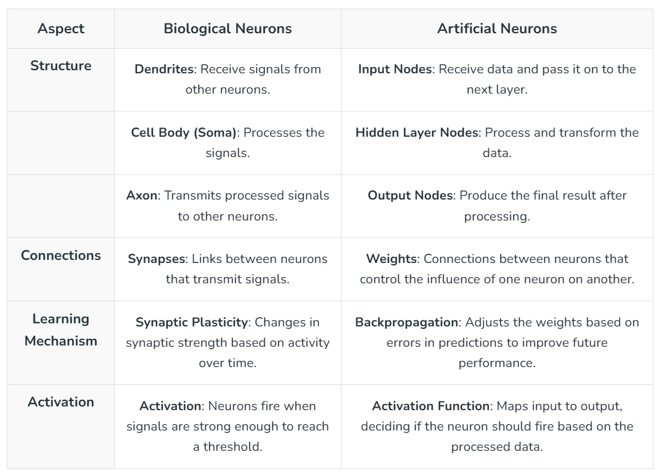
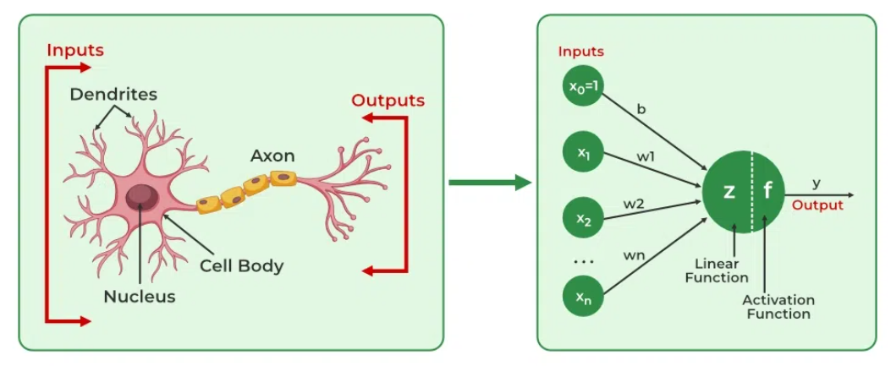

TensorFlow:
- A Comprehensive Framework:
TensorFlow is an open-source machine learning framework developed by Google. It provides a vast and powerful set of tools and libraries for numerical computation, especially suited for building and training deep learning models.
- Low-Level Control:
It offers both high-level and low-level APIs, giving developers fine-grained control over model architecture, optimization, and deployment. This control is beneficial for complex, large-scale projects and research where customization and performance optimization are critical.
- Scalability and Production:
TensorFlow is designed for scalability and robust production environments, supporting distributed training, various hardware accelerators (GPUs, TPUs), and deployment tools like TensorFlow Serving and TensorFlow Lite.
Keras:
- High-Level API:
Keras is a high-level API designed for rapid prototyping and ease of use in building deep learning models. It was originally a standalone library but is now integrated into TensorFlow as tf.keras, making it the recommended way to use Keras with TensorFlow.
- User-Friendly:
Keras emphasizes simplicity and modularity, allowing users to define and train neural networks with minimal lines of code. This makes it particularly appealing for beginners and for quickly experimenting with different model architectures.
- Runs on Backends:
Keras can run on top of various backend engines, including TensorFlow, Theano, and CNTK, though TensorFlow is the most common and integrated choice.

TensorFlow Lite
TFLite is an open-source framework for running machine learning models on mobile, embedded, and IoT devices, enabling on-device inference for apps on Android, iOS, and Linux-based systems like Raspberry Pi, with features for model optimization, small file sizes, and high performance. It works by converting standard TensorFlow/Keras models into a lightweight .tflite format (using FlatBuffers) and provides tools like Model Maker and Task Library to simplify training and deployment with minimal code.
Key Features & Components
- On-Device Inference:
Runs ML directly on the device, reducing latency and reliance on cloud connectivity.
- Cross-Platform:
Supports Android, iOS, Linux (including Raspberry Pi), and microcontrollers.
- Model Optimization:
Converts models to a compact .tflite format (FlatBuffers) and supports techniques like quantization to shrink size and improve speed.
- Model Maker:
A Python library to train TFLite models from your own data with few lines of code (transfer learning).
- Task Library:
Provides pre-built, task-specific APIs (e.g., image classification, Q&A) for easy integration in apps (Java, C++, Swift).
- Lightweight Runtime:
Optimized core engine for efficient execution on resource-constrained devices.

Inference
AI inference is the crucial phase where a pre-trained model uses its learned knowledge to analyze new, unseen data and make predictions, classifications, or decisions, essentially applying what it learned during training to solve real-world problems, like recognizing a stop sign or detecting spam. It's the "doing" part of AI, turning abstract patterns into

Quantization
Quantization in AI is a technique to reduce the precision of a model's numbers, converting them from high-precision formats like 32-bit floating point (FP32cap F cap P 32𝐹𝑃32) to lower-precision ones like 8-bit integer (INT8cap I cap N cap T 8𝐼𝑁𝑇8). This process shrinks the model's size and speeds up inference, making it possible to deploy on less powerful hardware, though it can introduce a minor loss in accuracy. It's a crucial method for making large language models (LLMs) more efficient for practical use.
How it works
- Conversion: Quantization maps a large, continuous range of values to a smaller, discrete set of values. In AI, this means converting model parameters (weights) and activations from high-precision floating-point numbers to lower-precision integers or floating-point numbers.
- Compression: By reducing the number of bits needed to represent each value, the overall size of the model is significantly decreased.
- Efficiency: Less precision means less data to process, which leads to faster inference speeds and reduced computational cost.
- Hardware friendly: The reduced memory footprint and computational demands allow for AI models to run on less powerful hardware, such as consumer-grade GPUs or edge devices.

Create Account on Google colab and open first notebook (in GitHub Embedded AI Folder)

Day 1: Morning Attendance 40, session 2 attendance 41, quiz 39

Notes: 15/12/2025
The seven steps of the deep learning workflow are:
- Decide on a Goal,
- Collect a Dataset,
- Design a Model Architecture,
- Train the Model,
- Convert the Model,
- Run Inference,
- Evaluate and Troubleshoot
LiteRT (short for Lite Runtime), formerly known as TensorFlow Lite, is Google's high-performance runtime for on-device AI. You can find ready-to-run LiteRT models for a wide range of ML/AI tasks, or convert and run TensorFlow, PyTorch, and JAX models to the TFLite format using the AI Edge conversion and optimization tools.
Key features
- Optimized for on-device machine learning: LiteRT addresses five key ODML constraints: latency (there's no round-trip to a server), privacy (no personal data leaves the device), connectivity (internet connectivity is not required), size (reduced model and binary size) and power consumption (efficient inference and a lack of network connections).
- Multi-platform support: Compatible with Android and iOS devices, embedded Linux, and microcontrollers.
- Multi-framework model options: AI Edge provides tools to convert models from PyTorch and TensorFlow models into the FlatBuffers format (.tflite), enabling you to use a wide range of state-of-the-art models on LiteRT. You also have access to model optimization tools that can handle quantization and metadata.
- Diverse language support: Includes SDKs for Java/Kotlin, Swift, Objective-C, C++, and Python.
- High performance: Hardware acceleration through specialized delegates like GPU and iOS Core ML.

Development workflow
The LiteRT development workflow involves identifying an ML/AI problem, choosing a model that solves that problem, and implementing the model on-device. The following steps walk you through the workflow and provides links to further instructions.
1. Identify the most suitable solution to the ML problem
LiteRT offers users a high level of flexibility and customizability when it comes to solving machine learning problems, making it a good fit for users who require a specific model or a specialized implementation. Users looking for plug-and-play solutions may prefer MediaPipe Tasks, which provides ready-made solutions for common machine learning tasks like object detection, text classification, and LLM inference.
Choose one of the following AI Edge frameworks:
- LiteRT: Flexible and customizable runtime that can run a wide range of models. Choose a model for your use case, convert it to the LiteRT format (if necessary), and run it on-device. If you intend to use LiteRT, keep reading.
- MediaPipe Tasks: Plug-and-play solutions with default models that allow for customization. Choose the task that solves your AI/ML problem, and implement it on multiple platforms. If you intend to use MediaPipe Tasks, refer to the MediaPipe Tasks documentation.
2. Choose a model
A LiteRT model is represented in an efficient portable format known as FlatBuffers, which uses the .tflite file extension.
You can use a LiteRT model in the following ways:
- Use an existing LiteRT model: The simplest approach is to use a LiteRT model already in the .tflite format. These models do not require any added conversion steps. You can find LiteRT models on Kaggle Models.
- Convert a model into a LiteRT model: You can use the PyTorch Converter or TensorFlow Converter to convert models to the FlatBuffers format (.tflite) and run them in LiteRT. To get started, you can find models on the following sites:
  - PyTorch models on Hugging Face and torchvision
  - TensorFlow models on Kaggle Models and Hugging Face
A LiteRT model can optionally include metadata that contains human-readable model descriptions and machine-readable data for automatic generation of pre- and post-processing pipelines during on-device inference. Refer to Add metadata for more details.
3. Integrate the model into your app
You can implement your LiteRT models to run inferences completely on-device on web, embedded, and mobile devices. LiteRT contains APIs for Python, Java and Kotlin for Android, Swift for iOS, and C++ for micro-devices.
Use the following guides to implement a LiteRT model on your preferred platform:
- Run on Android: Run models on Android devices using the Java/Kotlin APIs.
- Run on iOS: Run models on iOS devices using the Swift APIs.
- Run on Micro: Run models on embedded devices using the C++ APIs.
On Android and iOS devices, you can improve performance using hardware acceleration. On either platform you can use a GPU Delegate, and on iOS you can use the Core ML Delegate. To add support for new hardware accelerators, you can define your own delegate.
You can run inference in the following ways based on the model type:
- Models without metadata: Use the LiteRT Interpreter API. Supported on multiple platforms and languages such as Java, Swift, C++, Objective-C and Python.
- Models with metadata: You can build custom inference pipelines with the LiteRT Support Library.
Migrate from TF Lite
Applications that use TF Lite libraries will continue to function, but all new active development and updates will only be included in LiteRT packages. The LiteRT APIs contain the same method names as the TF Lite APIs, so migrating to LiteRT does not require detailed code changes.
For more information, refer to the migration guide.
Aravind,Samriddh,Pratik,Devesh, Jacob,Subodh, Nidhi W, Nidhi C,Navin, Niteesh, manasi, Sudipa,Albin,Shubankit,Akash,Ajay, Partmesh,Navin, Yash, Suguna,Ajinkya,Abhijeet, Sadu,Jaydeep,Sandesh,Tejas, Sanjeevani, Suraj

Notes: 04/01/2026 2.5Hrs
Introduction to Netron - https://netron.app/ , a tool used to Visualize model
Parent page of STM https://github.com/STMicroelectronics/STM32AI_Overall_Offer
STM Pretrained model zoo - https://github.com/STMicroelectronics/stm32ai-modelzoo
Quiz on three methods
Anomly detection Example https://github.com/ShawnHymel/tinyml-example-anomaly-detection

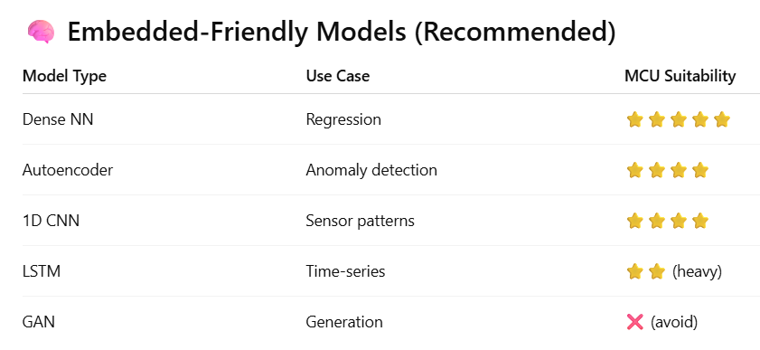
Machine Learning Method | Function (Goal) | Characteristics
Classification | The function of a classifier is to infer the class label of an unknown observation that is summarized by its features. | This involves partitioning the feature space into a limited number of known classes using a decision boundary. The classifier takes feature values as input and produces a class label as output. Classification problems typically deal with discrete outcomes (e.g., classifying CPU temperature as "hot" or "normal").
Regression | The function of a regressor is to find the relationship between two or more variables. This usually leads to predicting future values based on given data. | This method models the relationship between input variables (features) and continuous output variables, often framed as a function fit problem. Regression is used for tasks like filling missing data, filtering data, or predicting a numerical quantity (e.g., predicting the next hour's temperature).
Clustering | The function of a clustering algorithm is to group feature values based on their inherent characteristics. | Unlike classification and regression, clustering is performed without using labeled data. The algorithm takes feature values and the desired number of clusters (in some cases) as input, and it groups the data based on predefined rules, producing cluster centers (centroids) as output. Clustering is useful for identifying inherent groups within data (e.g., treating normal activity as one cluster and a fall action as another for a fall detection system).
Q1.
What is the primary goal of classification in machine learning?
A. To predict a continuous numerical value
B. To group data without labels
C. To assign an input to one of the predefined classes
D. To reduce the dimensionality of data
✅ Correct Answer: C

Q2.
Which type of output is most appropriate for a classification problem?
A. Temperature value of 32.5°C
B. Probability distribution
C. Class label such as “Hot” or “Normal”
D. Cluster centroid
✅ Correct Answer: C

Q3.
A system that determines whether CPU temperature is “Normal” or “Overheated” is an example of:
A. Regression
B. Clustering
C. Classification
D. Dimensionality reduction
✅ Correct Answer: C

Q4.
What does a regression model mainly try to learn?
A. Decision boundaries between classes
B. Relationships between input variables and continuous outputs
C. Cluster centers of unlabeled data
D. Rules for data compression
✅ Correct Answer: B

Q5.
Which of the following problems is best solved using regression?
A. Identifying spam emails
B. Predicting tomorrow’s temperature
C. Grouping similar sensor patterns
D. Detecting faces in images
✅ Correct Answer: B

Question Type | Ask Yourself
Classification | “Which category?”
Regression | “How much / how many?”
Clustering | “Which group looks similar?”

Notes 19/01/2026 , 2Hrs
STMcube AI

Model Related work :
STM32Cube Monitor : Data Collection,
Notepad++ or Using some Scripts in python for Data Refinement
Colab ->, Creating and Training Model
We get a model file .h5 or .tflite
Stm Cube AI will import the model to your project

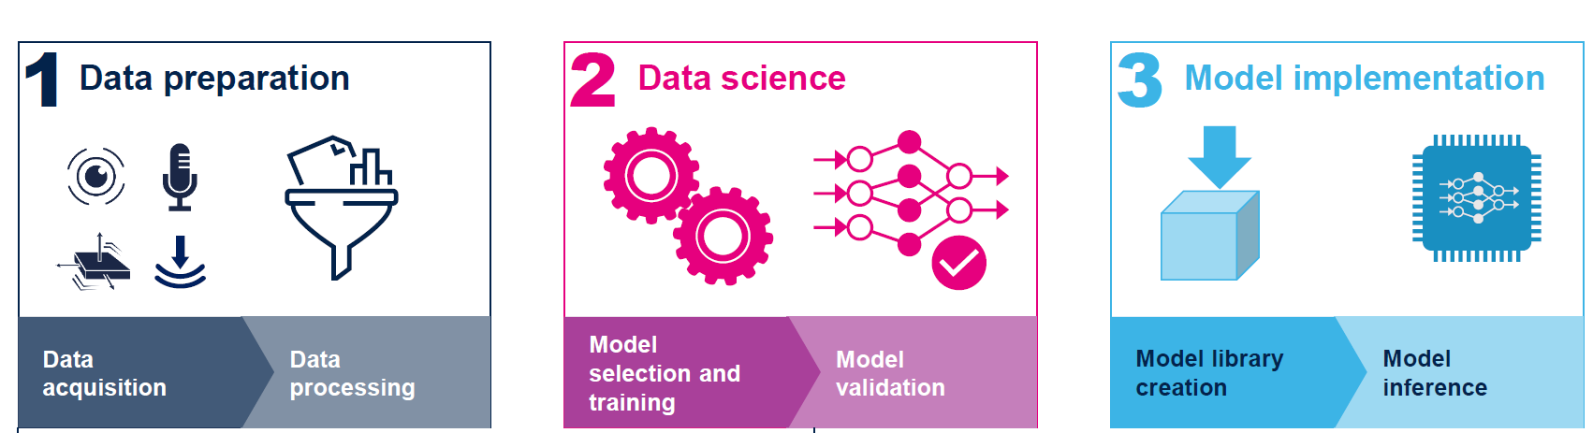
Notes : 21/01/2026
🎯 Goal: Generic Anomaly Detection Notebook (Sensor-Agnostic)
What we want
- Plug in any time-series sensor
- Train on NORMAL data only
- Detect anomalies using reconstruction error
- Same notebook → Python testing → TFLite → STM32

🧱 Final Architecture (Conceptual)
Raw Sensor Stream
↓
Sliding Window (N samples)
↓
Normalization
↓
Autoencoder
↓
Reconstruction Error (MSE)
↓
Threshold
↓
Normal / Anomaly
Wake word Detection:
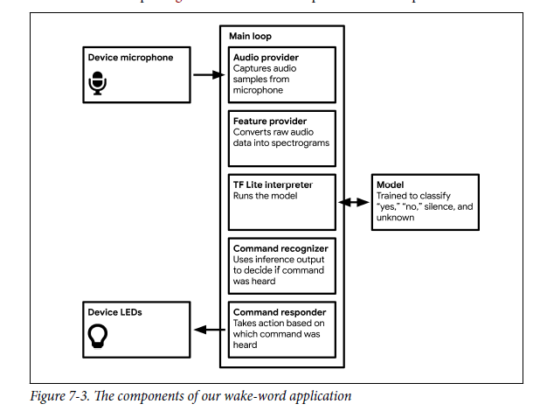

HAR Model Output Interpretation
Model Output: [[0.99527633 0.00348822 0.00123541]]
[Stationary, Walking, Running]

Embedded Mapping (for Students)
Python STM32
set_tensor() input_tensor->data.f[]
invoke() TfLiteInvoke()
get_tensor() output_tensor->data.f[]

