Libraries included:-
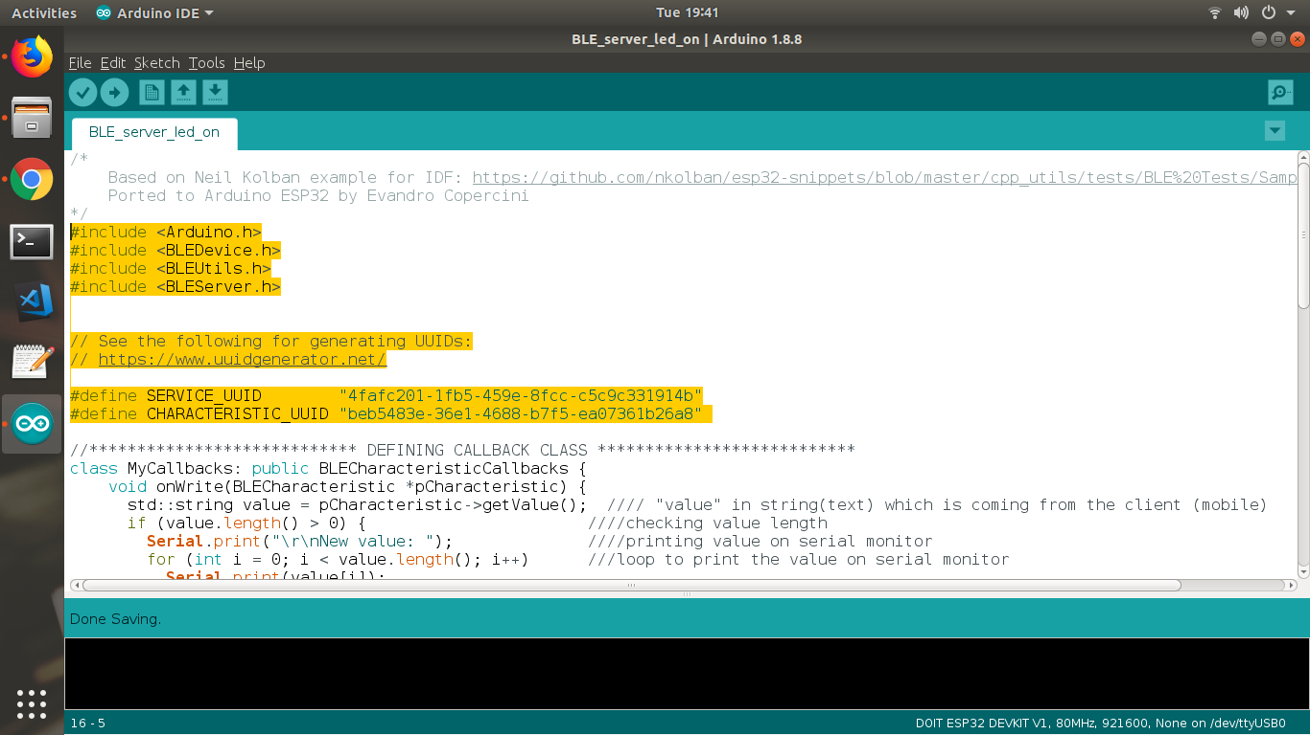

//**************************** DEFINING CALLBACK CLASS ***************************
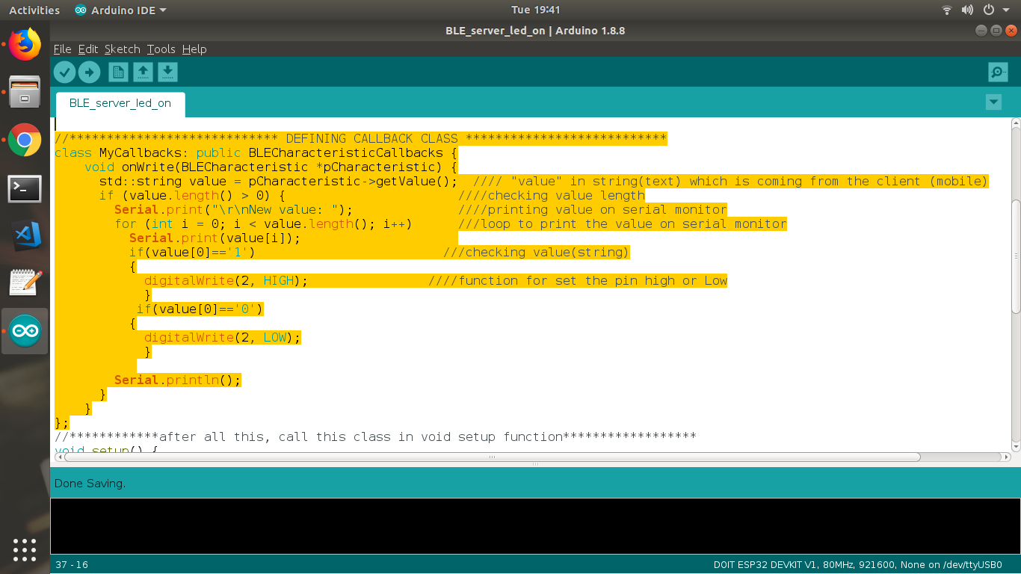

//************after all this, call this class in void setup function******************

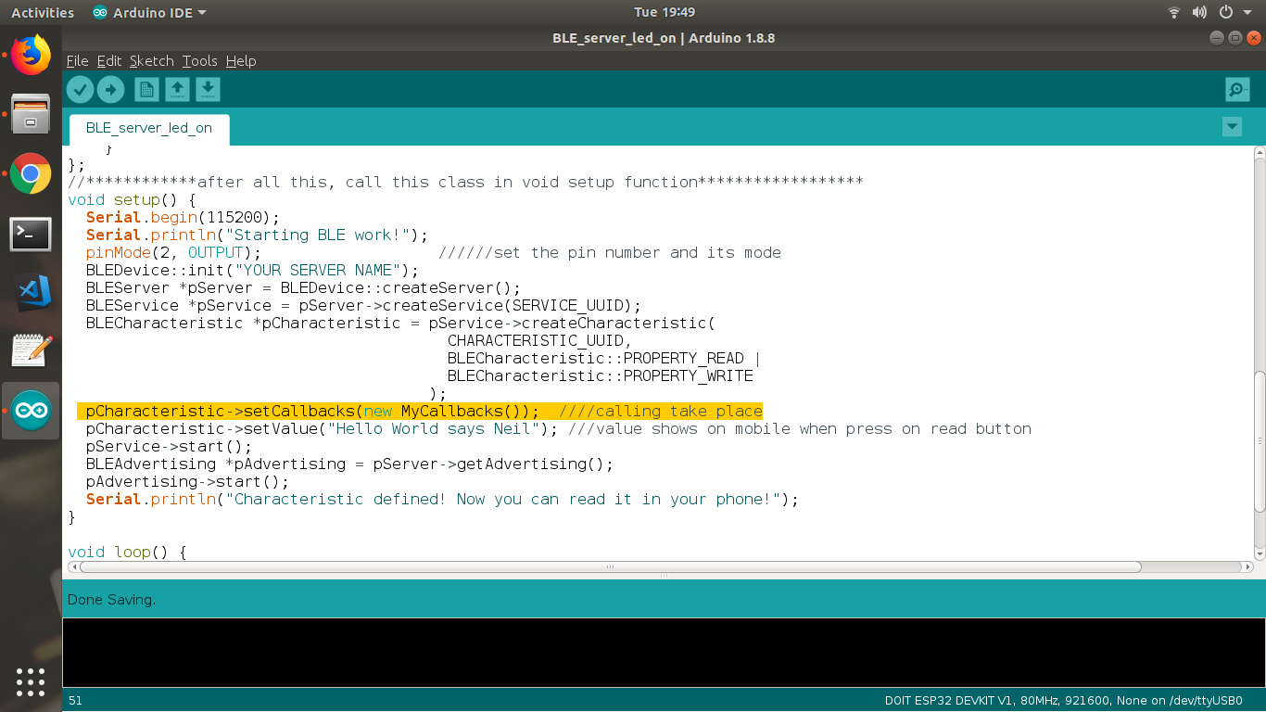
//****************************void loop******************
void loop() {

//put your main code here, to run repeatedly:

delay(2000);
}

**Verify and Compile this code to your ESP32.
**open serial monitor.
**press reset button.

** Open BleSERVER App in your mobile.
**Connect to the server name...which you have provided in Code
**press on CUSTOM SERVICE.
**press on (w).
**write 1 or 0 in text box.
**click on send button.
***you got your LED ON / OFF.

