Reading the value of DHT11 Sensor via ESP32 Board using BLE Scanner(app)

Requirements:

- ESP32 Board
- DHT11 Sensor
- Jumper Wires
- Install Arduino IDE

Step 1: Connections ===>

ESP 32 Pin number | DHT11 sensor
GND | -ve
3v | +ve
D13 | Data

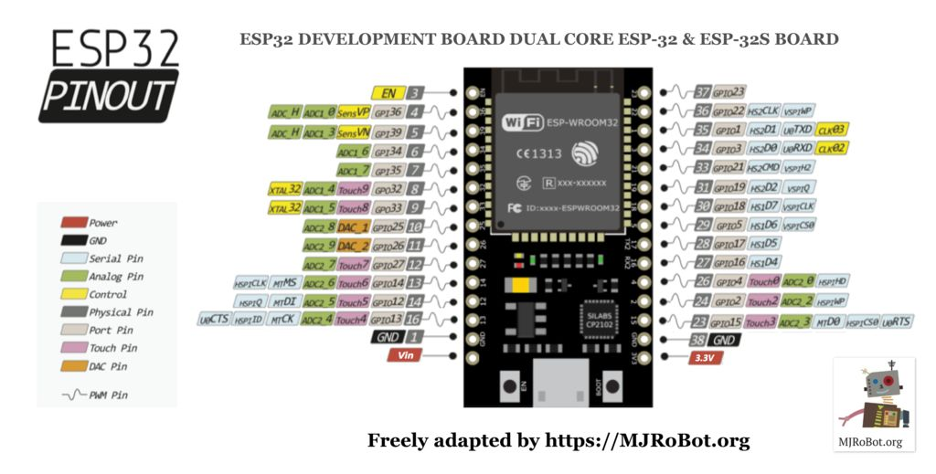
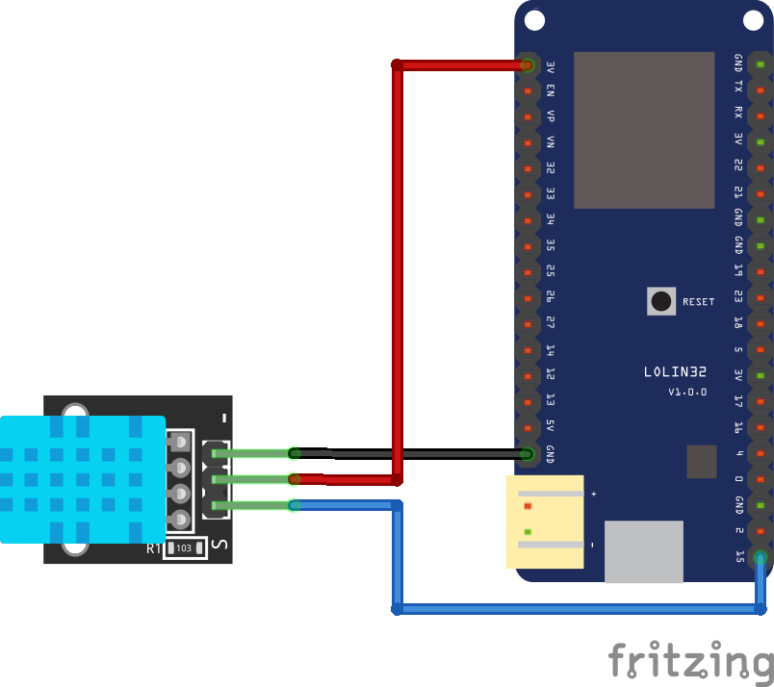

Step 2: In Arduino IDE :
Select Board – DOIT ESP32 DEVKIT

Step 3: Download the DHT11 library and include it
Link: https://codeload.github.com/adafruit/DHT-sensor-library/zip/master

Step 4: Write program as follows:

/*
Based on Neil Kolban example for IDF: https://github.com/nkolban/esp32-snippets/blob/master/cpp_utils/tests/BLE%20Tests/SampleServer.cpp
Ported to Arduino ESP32 by Evandro Copercini
*/

#include <BLEDevice.h>
#include <BLEUtils.h>
#include <BLEServer.h>
/*
Download "DHT.h" library from https://codeload.github.com/adafruit/DHT-sensor-library/zip/master
*/
#include "DHT.h"
#include <stdlib.h>
#include <string.h>

// Define the type of DHT you have i.e. DHT11, DHT22.
#define DHTTYPE DHT11

//Set pin for DATA in ESP32 (For more details check PinOut)
const int DHTPin = 13;

// Initialize DHT sensor.
DHT dht(DHTPin, DHTTYPE);

//Global Variables to get/read data from/to mobile.
char inputBuffer[10];
char tx[10];
int h, t;

Step 5: Generate UUIDs from https://www.uuidgenerator.net/ and define them as follows

#define SERVICE_UUID "df620f6f-8907-47b1-aa61-1e81d2db5f6f"
#define CHARACTERISTIC_UUID "beb5483e-36e1-4688-b7f5-ea07361b26a8"

Step 6: Define the class MyCallback to create the services and in class write a “onWrite” funtion which is going to call when write command comes from BLEScanner as shown below:

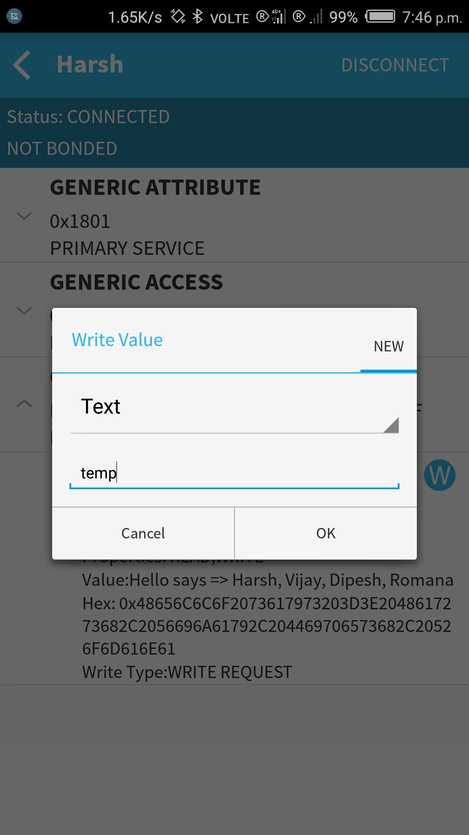
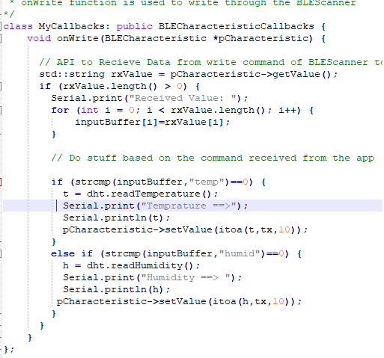

Step 7: SetCallbacks is an API used to create class object MyCallbacks()

void setup() {
Serial.begin(115200);
Serial.println("Starting BLE work!");
dht.begin();
BLEDevice::init("Harsh");
BLEServer *pServer = BLEDevice::createServer();
BLEService *pService = pServer->createService(SERVICE_UUID);
BLECharacteristic *pCharacteristic = pService->createCharacteristic(
CHARACTERISTIC_UUID,
BLECharacteristic::PROPERTY_READ |
BLECharacteristic::PROPERTY_WRITE
);

// setCallbacks is an API used to create class object MyCallbacks()
pCharacteristic->setCallbacks(new MyCallbacks());
pCharacteristic->setValue("Hello says => Harsh, Vijay, Dipesh, Romana");
pService->start();
BLEAdvertising *pAdvertising = pServer->getAdvertising();
pAdvertising->start();
Serial.println("Characteristic defined! Now you can read it in your phone!");
}

void loop() {
// put your main code here, to run repeatedly:
delay(2000);
}

Step 8: Now upload the code and open Serial Monitor.

Step 9:Now open BLE Scanner in phone and connect the bluetooth .

Step 10: In Custom Characteristics when you write “humid” following API is going to call.

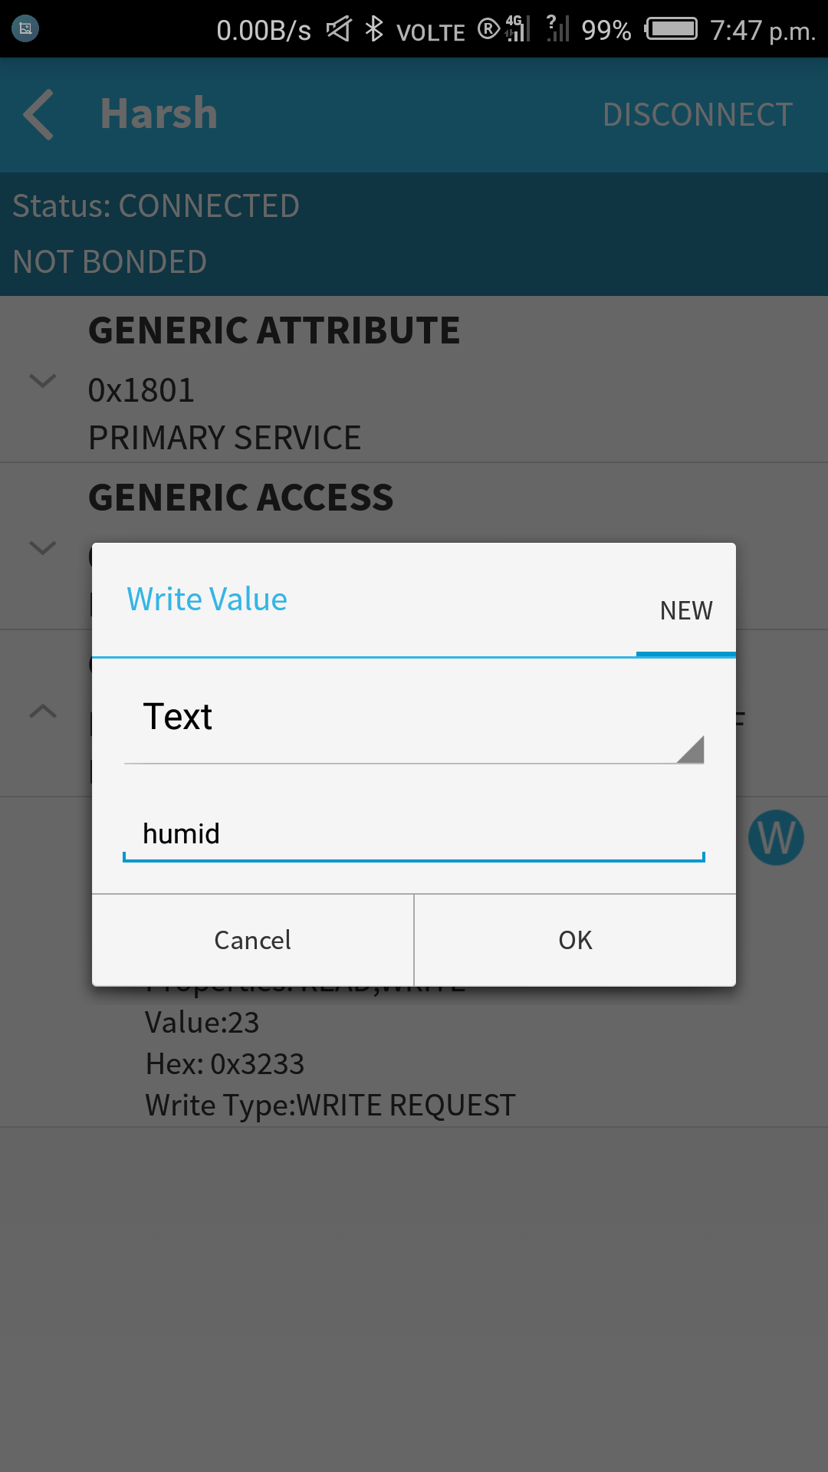
else if (strcmp(inputBuffer,"humid")==0) {
h = dht.readHumidity();
Serial.print("Humidity ==> ");
Serial.println(h);
pCharacteristic->setValue(itoa(h,tx,10));
}

Step 11: Same as for “temp” , following API is going to call when temp command is send via BLE

if (strcmp(inputBuffer,"temp")==0) {
t = dht.readTemperature();
Serial.print("Temprature ==>");
Serial.println(t);
pCharacteristic->setValue(itoa(t,tx,10));
}

Result: Hence communication via BLE is successfully setup and you can see the ouput in Serial monitor as well as on your Phone too.

THANK YOU

