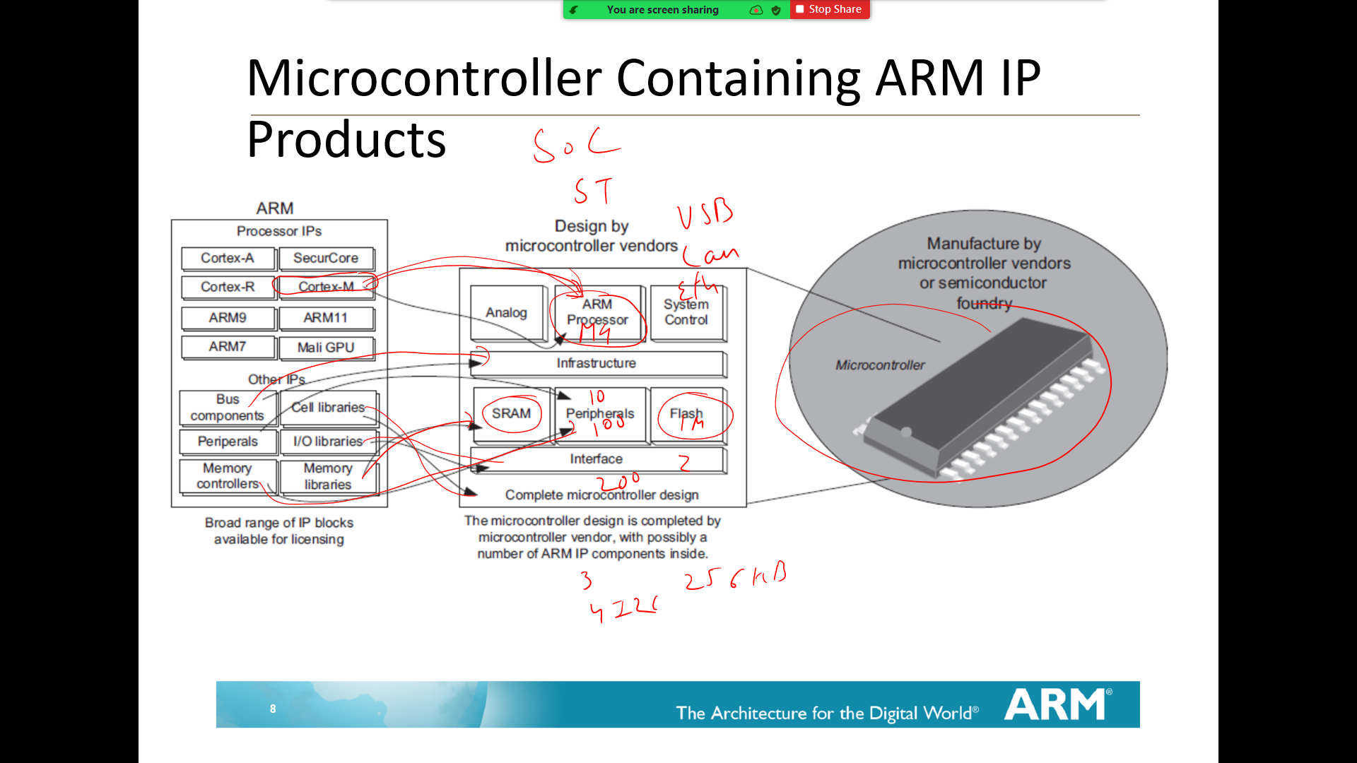

Assembly Language

MOV vs MOVS
Use of #
SYNTAX OF ASM Instruction

TEMP1 EQU 0x20
TEMP2 EQU 0x24
TEMP3 EQU 0x28
LDR R0, =TEMP1 ; Address 0x20 will be loaded in R0
LDR R1, =TEMP2 ; Address 0x24 will be loaded in R1
LDR R4, =TEMP3 ; Address 0x28 will be loaded in R4
LDR R2, [R0] ; R2= 01
LDR R3, [R1] ; R3= 02
ADD R3,R2 ; R3=R3+R2
STR R3, [R4] ; Store the Value in 0x28 address

MOV R0, #0x20
MOV R1, #0x24
MOV R2, #0x28

LDR R3, [R0]
LDR R4, [R1]
ADD R3, R4

; Stores a 8-bit Value at location 0x28
STR R3, [R2]

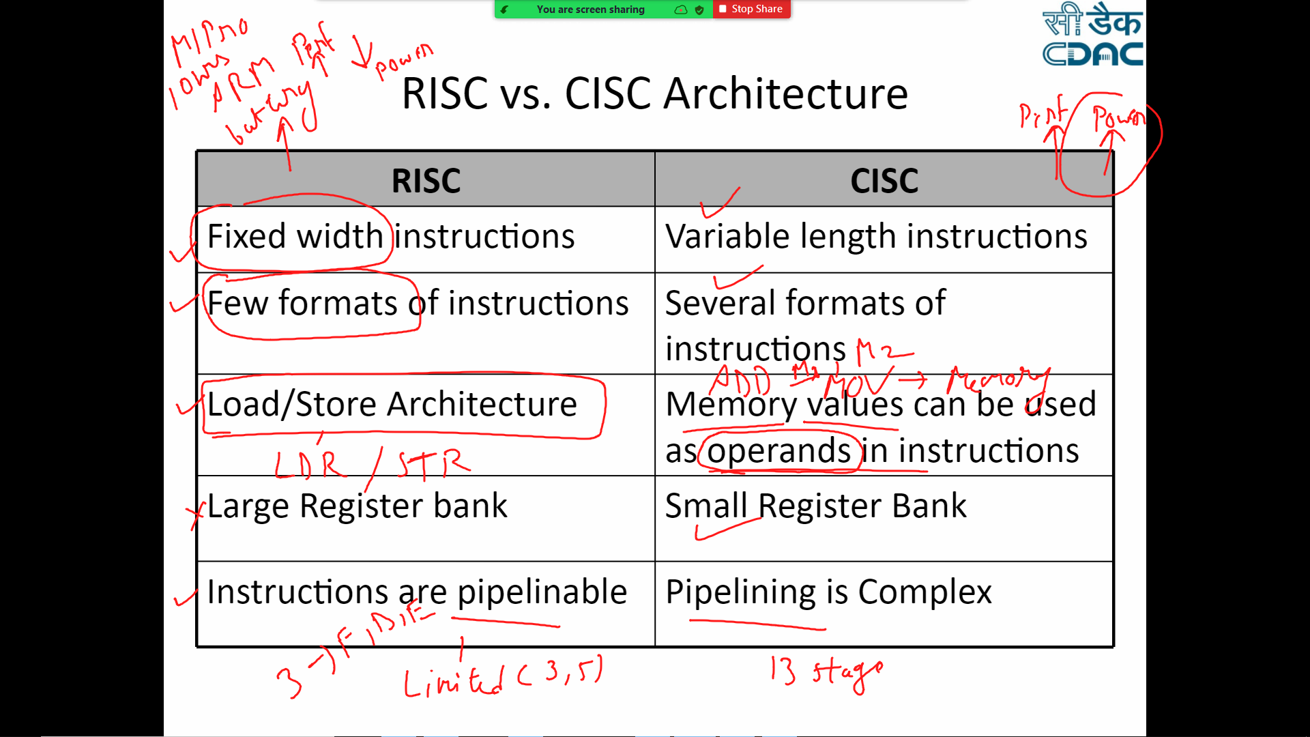

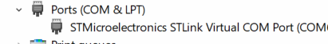
Hardware

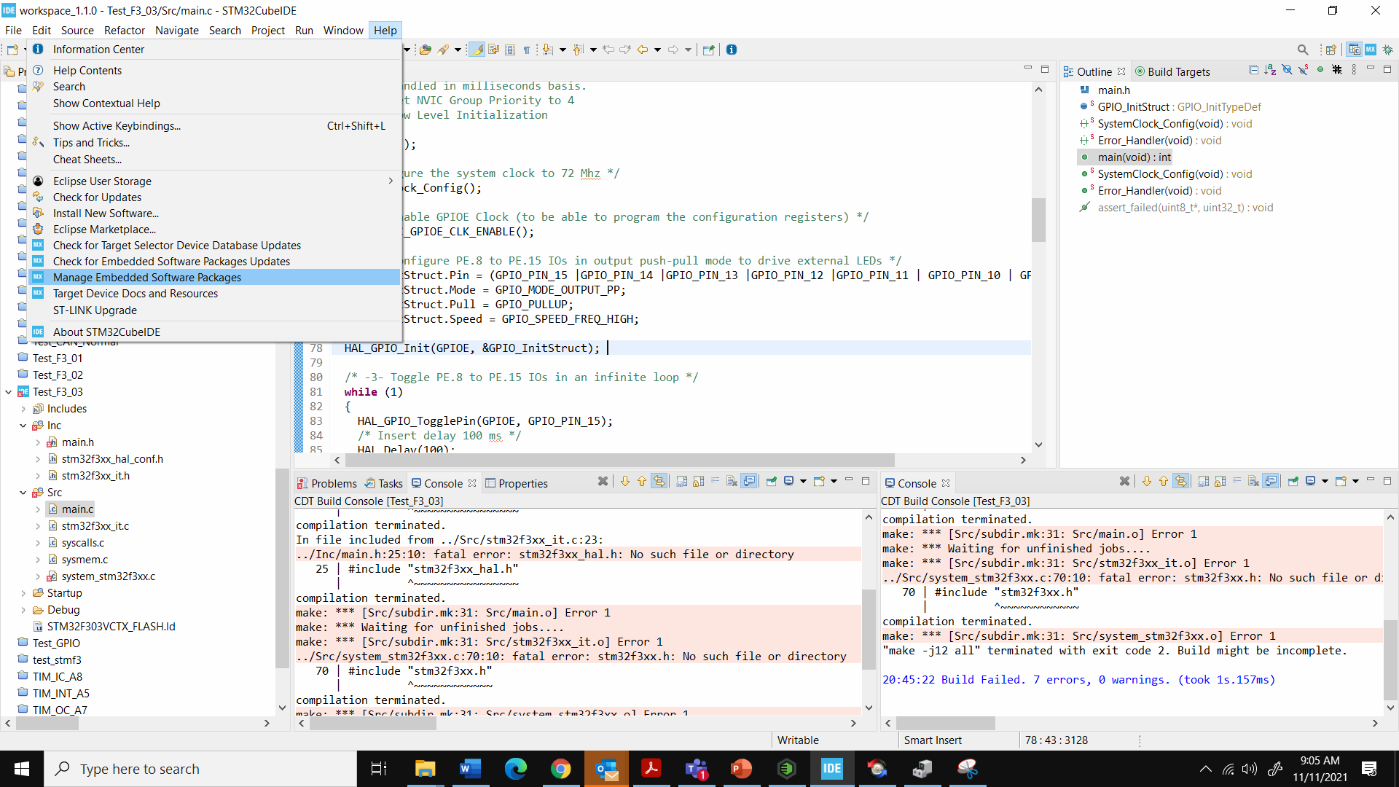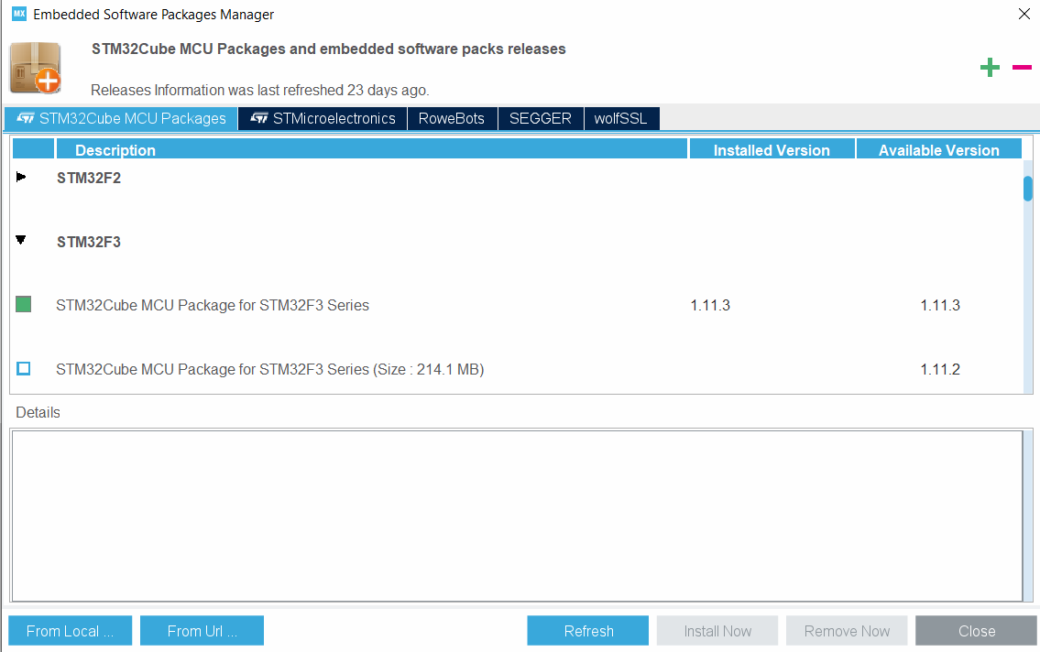

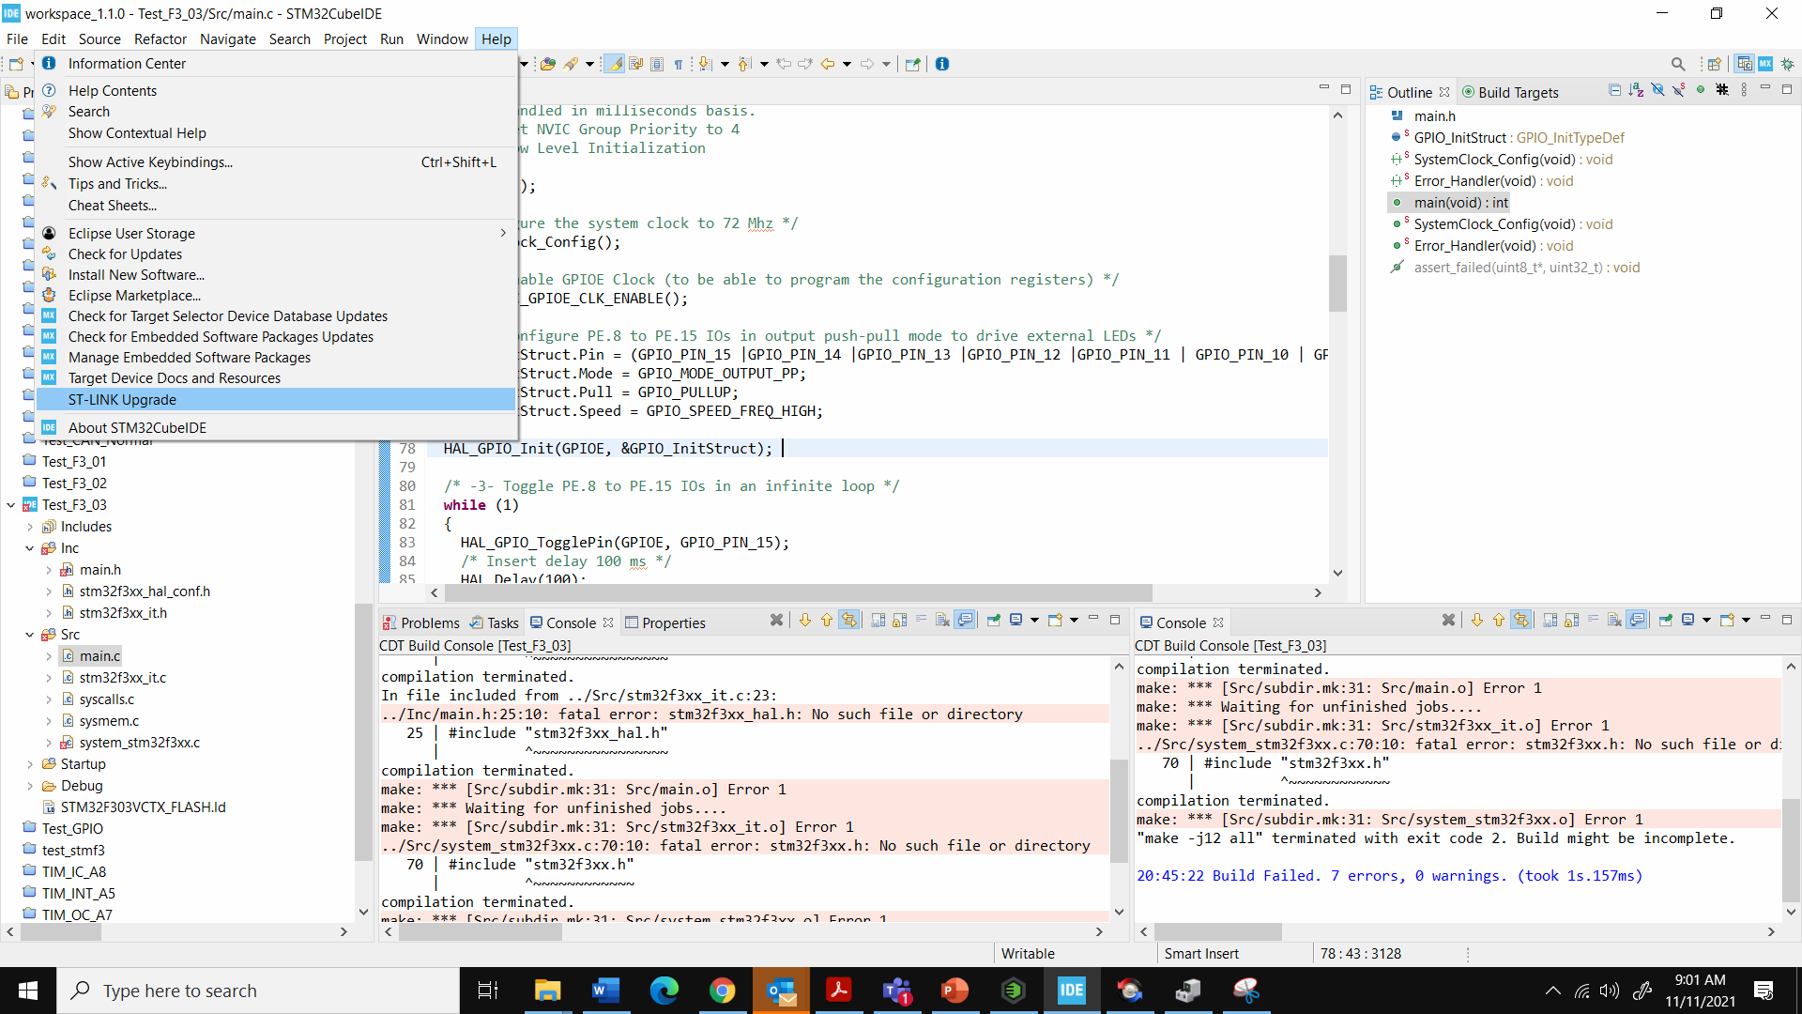
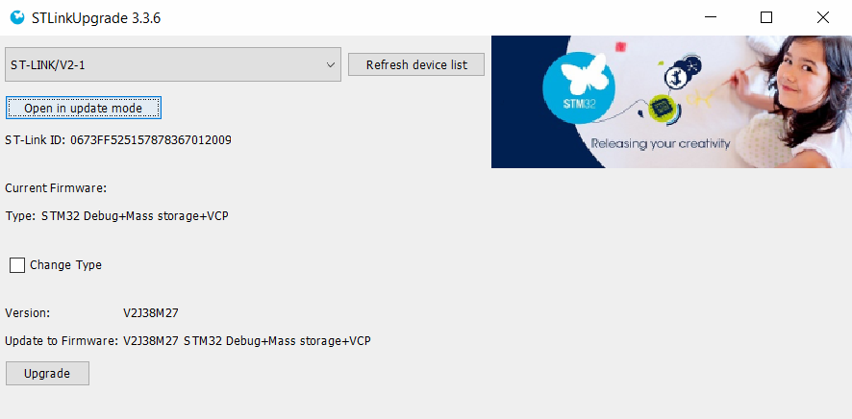

How to read Reference Manual (Data Sheet)

Laptop/ PC
USB
Debugger
STM32F303VC
Cortex M4
Core

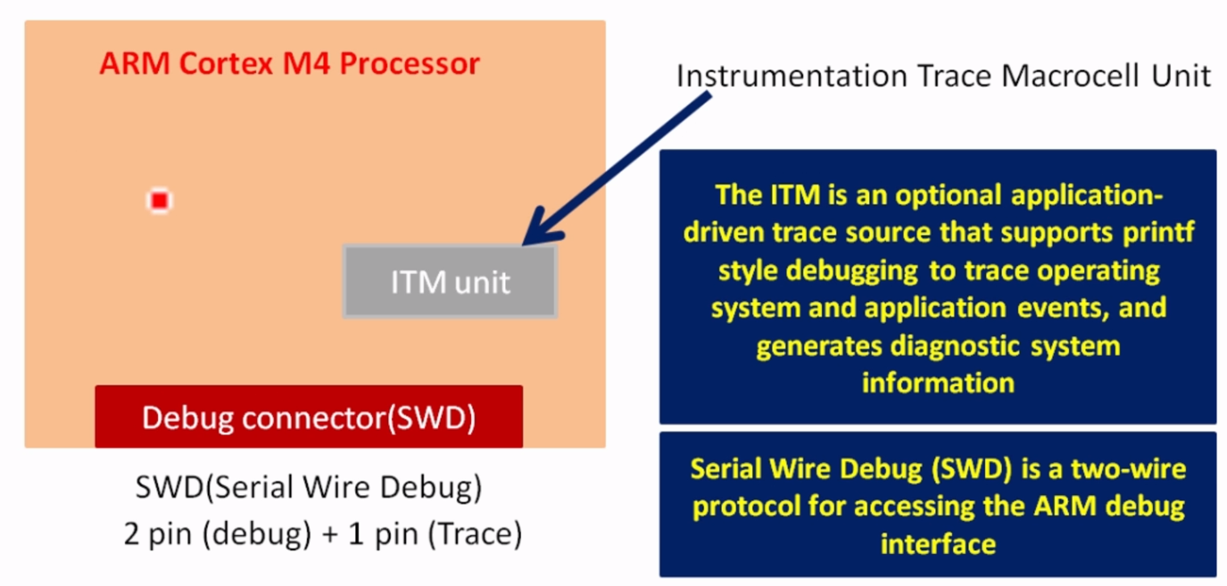

- Write any prog that has printf.
- In syscalls.c add Debugging code , modify _write API _IO_PUTCHAR >> ITM_SendChar
- Debug your code , Enable SWV in the debugging option tab (Check SWV & update clock to 8.0)
- Click on apply and Debug will take you to debugging session
- Open Window option->Show View->SWV->SWV ITM Data Console
- Update Settings of SWV ITM Data Console, Enable Port 0 (Check on port 0)
- Start your Trace Recording by clicking Red button on SWV ITM Data Console
- Resume/Run your Program in debugger.

Part 1 For a Delay of 200 MS , if Prescalar is 8000 and APB Bus Freq is 8Mhz, What is the count Required?

Part 2 For a Delay of 500 MS , if Prescalar is 8000 and APB Bus Freq is 8Mhz, What is the count Required?

Part 3 For a Delay of 50 MS , if Prescalar is 8000 and APB Bus Freq is 8Mhz, What is the count Required?

If Clock Freq for ABP1 Timer Bus is 32Mhz and we want a delay for 1MS (Tick) , what will be the Prescalar?

If Clock Freq for ABP1 Timer Bus is 32Mhz and Prescalar is 8000 , what will be the Delay or Tick?

ADC
TADC = TSMPL + TSAR = [ 1.5 |min + 12.5 |12bit ] x TADC_CLK

