**Name: Sudarshan Bibhas Dey**

**Rollo: A45 Division: MCA-4A**

1. **ipconfig**

**C:\Users\Hp>ipconfig**

**Windows IP Configuration**

**Ethernet adapter Ethernet:**

**Media State . . . . . . . . . . . : Media disconnected**

**Connection-specific DNS Suffix . :**

**Wireless LAN adapter Local Area Connection* 1:**

**Media State . . . . . . . . . . . : Media disconnected**

**Connection-specific DNS Suffix . :**

**Wireless LAN adapter Local Area Connection* 2:**

**Media State . . . . . . . . . . . : Media disconnected**

**Connection-specific DNS Suffix . :**

**Wireless LAN adapter Wi-Fi:**

**Connection-specific DNS Suffix . : domain.name**

**Link-local IPv6 Address . . . . . : fe80::3c38:862:dfe0:aa82%7**

**IPv4 Address. . . . . . . . . . . : 192.168.2.9**

**Subnet Mask . . . . . . . . . . . : 255.255.255.0**

**Default Gateway . . . . . . . . . : fe80::217:7cff:fe5a:907e%7**

**192.168.2.1**

b.) Arp –a

C:\Users\Hp>arp -a

Interface: 192.168.2.9 --- 0x7

Internet Address Physical Address Type

192.168.2.1 00-17-7c-5a-90-7e dynamic

192.168.2.5 a4-77-33-2e-75-40 dynamic

192.168.2.255 ff-ff-ff-ff-ff-ff static

224.0.0.2 01-00-5e-00-00-02 static

224.0.0.22 01-00-5e-00-00-16 static

224.0.0.251 01-00-5e-00-00-fb static

224.0.0.252 01-00-5e-00-00-fc static

239.255.255.250 01-00-5e-7f-ff-fa static

255.255.255.255 ff-ff-ff-ff-ff-ff static

**c.) netstat**

**C:\Users\Hp>netstat**

**Active Connections**

**Proto Local Address Foreign Address State**

**d.) tracert** [**www.wireshark.com**](http://www.wireshark.com)

**over a maximum of 30 hops:**

**1 1 ms 1 ms 1 ms 192.168.43.1**

**2 * * * Request timed out.**

**3 78 ms 33 ms 47 ms 10.71.57.179**

**4 67 ms 42 ms 26 ms 192.168.46.128**

**5 145 ms 25 ms 37 ms 192.168.46.133**

**6 96 ms 27 ms 47 ms 192.168.38.105**

**7 161 ms 27 ms 34 ms 172.17.112.46**

**8 * * * Request timed out.**

**9 * * * Request timed out.**

**10 * * * Request timed out.**

**11 * * * Request timed out.**

**12 * * * Request timed out.**

**13 72 ms 79 ms 76 ms 49.45.4.251**

**14 263 ms 280 ms 527 ms 49.45.4.85**

**15 286 ms 290 ms 287 ms 49.45.4.86**

**16 300 ms 290 ms 292 ms 49.45.4.80**

**17 273 ms 293 ms 277 ms be3243.ccr41.lax01.atlas.cogentco.com [154.54.27.117]**

**18 313 ms 311 ms 308 ms be2931.ccr31.phx01.atlas.cogentco.com [154.54.44.85]**

**19 310 ms 320 ms 348 ms be2929.ccr21.elp01.atlas.cogentco.com [154.54.42.66]**

**20 332 ms 335 ms 314 ms be2927.ccr41.iah01.atlas.cogentco.com [154.54.29.221]**

**21 319 ms 332 ms 402 ms be2441.ccr31.dfw01.atlas.cogentco.com [154.54.41.66]**

**22 317 ms 330 ms 312 ms be2560.rcr21.b010621-0.dfw01.atlas.cogentco.com [154.54.5.238]**

**23 321 ms 332 ms 326 ms 38.32.13.210**

**24 474 ms 329 ms 326 ms server.greenbaycrypto.com [23.91.67.6]**

**Trace complete.**

**e.) www.vodaphone.com**

**C:\Users\Hp>nslookup www.vodaphone.com**

**Server: UnKnown**

**Address: 192.168.43.1**

**Non-authoritative answer:**

**Name: cb25b8a2-b691-4fcb-ba15-078b134d7d6b.cloudapp.net**

**Address: 13.80.46.99**

**Aliases: www.vodaphone.com**

**www.vodafone.com**

**vodafone.adobecqms.net**

**f.)** [**www.vodafone.com**](http://www.vodafone.com)

**C:\Users\Hp>nslookup www.vodafone.com**

**Server: UnKnown**

**Address: 192.168.43.1**

**Non-authoritative answer:**

**Name: cb25b8a2-b691-4fcb-ba15-078b134d7d6b.cloudapp.net**

**Address: 13.80.46.99**

**Aliases: www.vodafone.com**

**vodafone.adobecqms.net**

**g.)** %packet loss and Max, Min and Average RTT of [www.netflix.com](http://www.netflix.com)

**C:\Users\Hp>ping www.netflix.com**

**Pinging www.eu-west-1.prodaa.netflix.com [2a01:578:3::22f6:5c7d] with 32 bytes of data:**

**Reply from 2a01:578:3::22f6:5c7d: time=186ms**

**Reply from 2a01:578:3::22f6:5c7d: time=493ms**

**Reply from 2a01:578:3::22f6:5c7d: time=437ms**

**Reply from 2a01:578:3::22f6:5c7d: time=384ms**

**Ping statistics for 2a01:578:3::22f6:5c7d:**

**Packets: Sent = 4, Received = 4, Lost = 0 (0% loss),**

**Approximate round trip times in milli-seconds:**

**Minimum = 186ms, Maximum = 493ms, Average = 375ms**

**h.)** %packet loss and Max, Min and Average RTT of www.netflix.com with packet size = 64 bytes and no. of trials = 6

**C:\Users\Hp>ping www.netflix.com -l size=64**

**Pinging www.eu-west-1.prodaa.netflix.com [2a01:578:3::34d3:5e91] with 0 bytes of data:**

**Reply from 2a01:578:3::34d3:5e91: time=167ms**

**Reply from 2a01:578:3::34d3:5e91: time=172ms**

**Reply from 2a01:578:3::34d3:5e91: time=165ms**

**Reply from 2a01:578:3::34d3:5e91: time=160ms**

**Ping statistics for 2a01:578:3::34d3:5e91:**

**Packets: Sent = 4, Received = 4, Lost = 0 (0% loss),**

**Approximate round trip times in milli-seconds:**

**Minimum = 160ms, Maximum = 172ms, Average = 166ms**

**WIRESHARK**

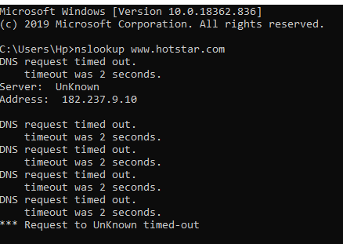

1. List the no of sites visited through Wireshark.

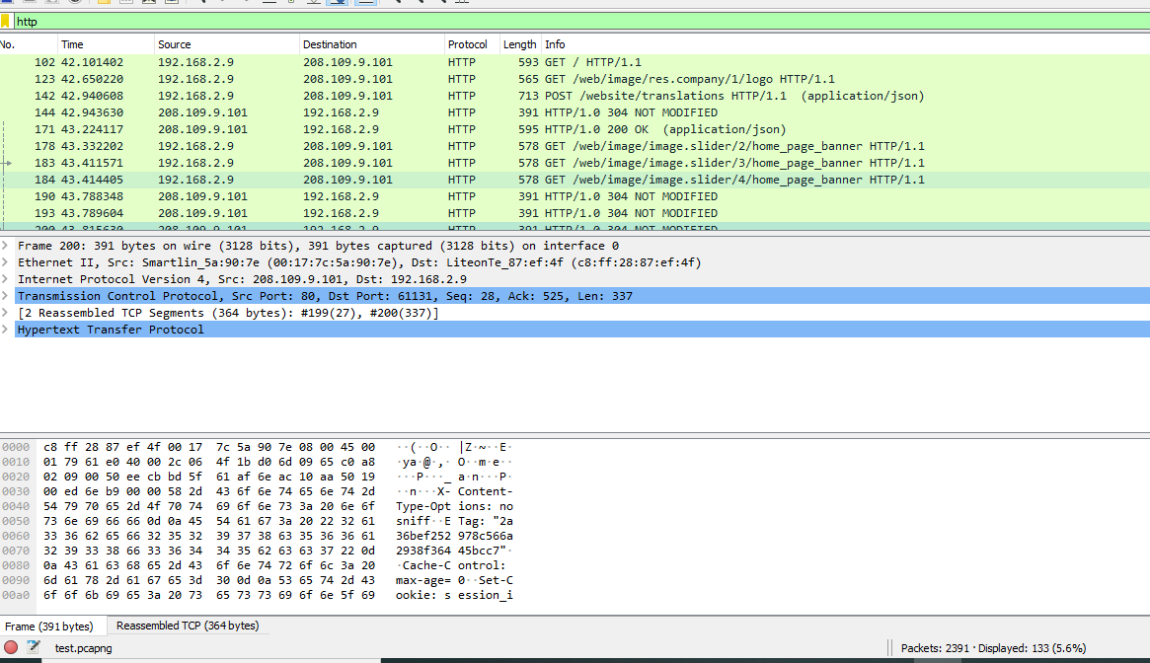

1. Display & find count the total number of HTTP GET requests.

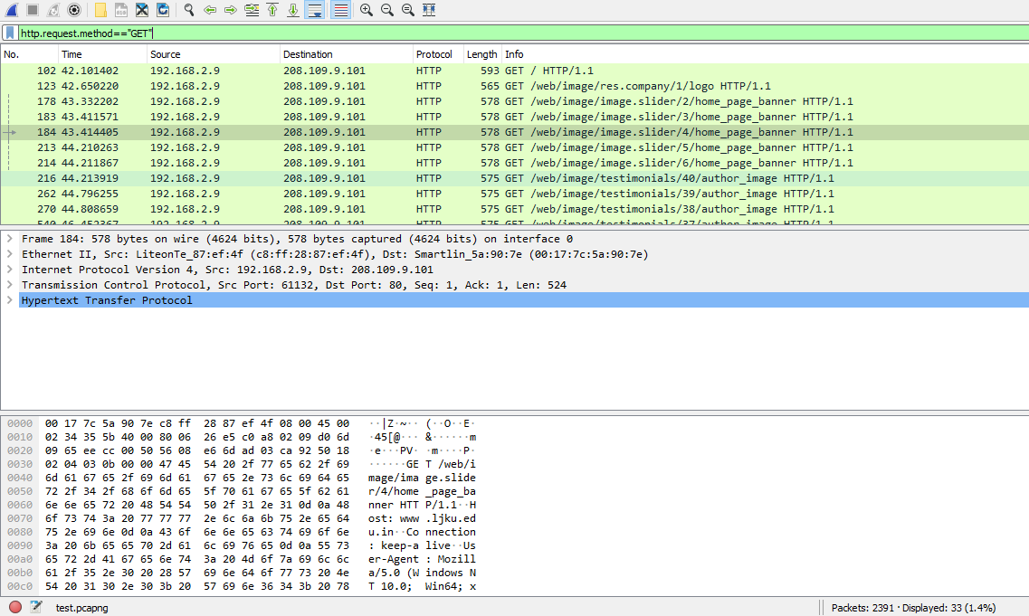

**C.)** What is the Load Distribution of the HTTP packets captured?

**Provide a screenshot of DNS statistics. What is the payload size count?**

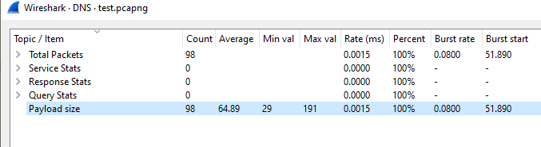

**What is the IPAddress of your pc and** [**www.ljku.edu.in**](http://www.ljku.edu.in)**.**

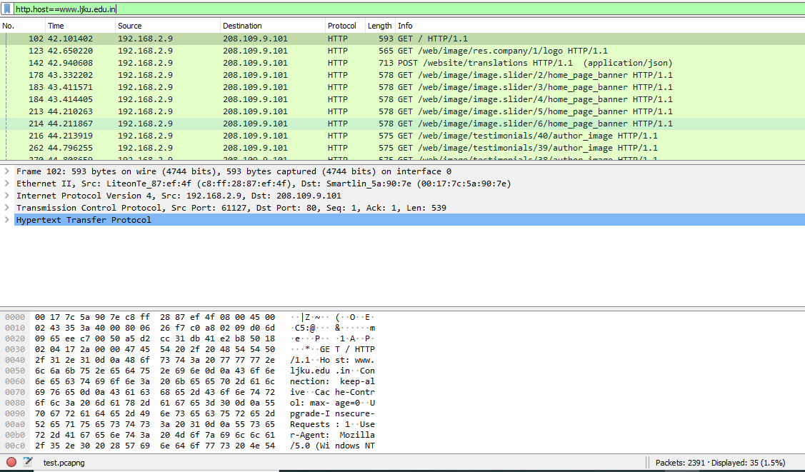

**System IP: 192.168.2.9 Website IP: 208.109.9.101**

**Source port: 61127 Destination port: 80**