**Blogs-App**

1. Install Dependencies



1. Run the app

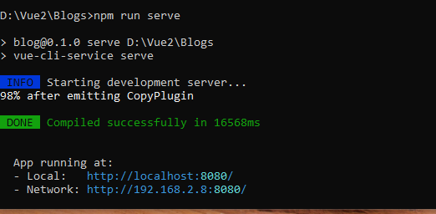

1. Created UI

Main.js: Here, we import bootstrap-vue and bootstrap-vue.css functionalities to use them in our application to create UI.

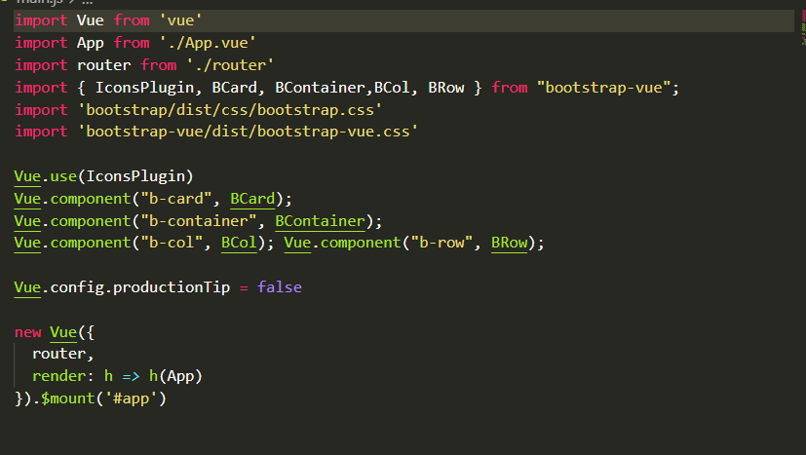

Router.js: Here, the ‘vue-router’ package is imported to set navigation routes for our components.

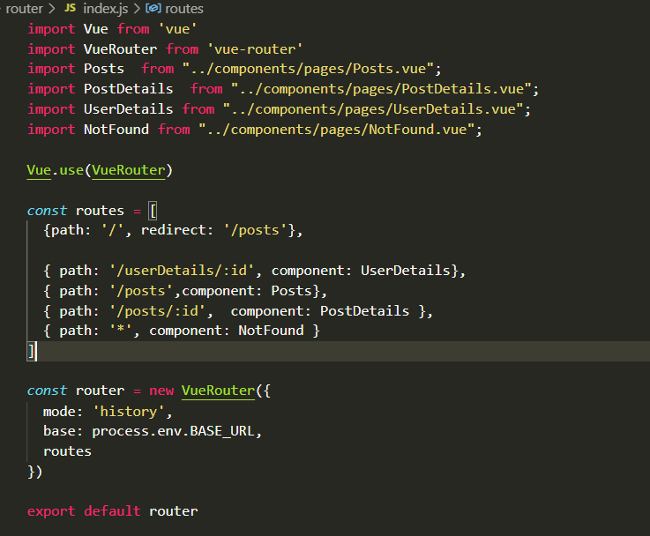

Service.js:

Data is stored in a remote location, which is accessed by URL. Here, we are importing ‘axios’ functionality to access the remote data.

We are creating an instance of axios using ‘create()’ method where the resource is configured(accessed) via baseURL prop.

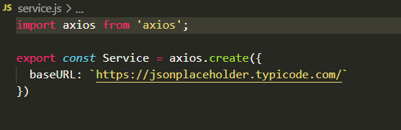

UI/BaseComment.vue:

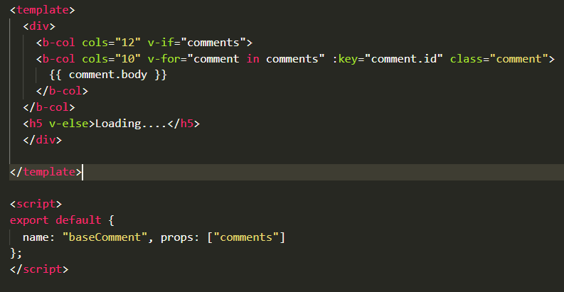

UI/BasePost.vue:

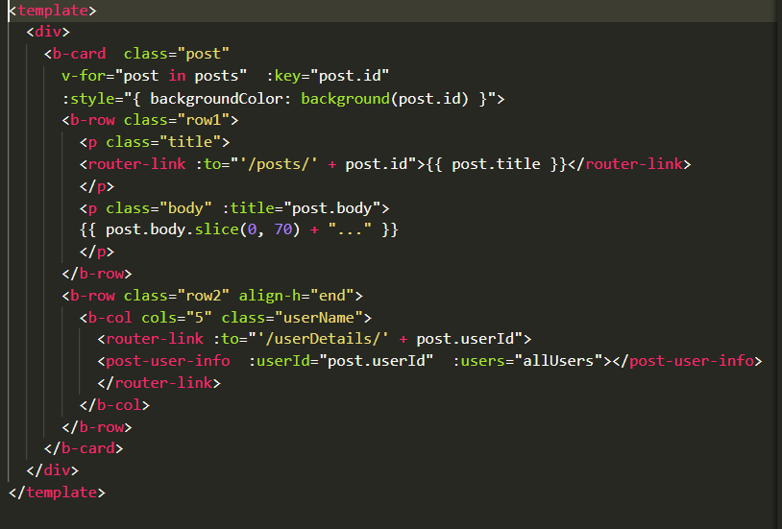

UI/PostUserInfo.vue:

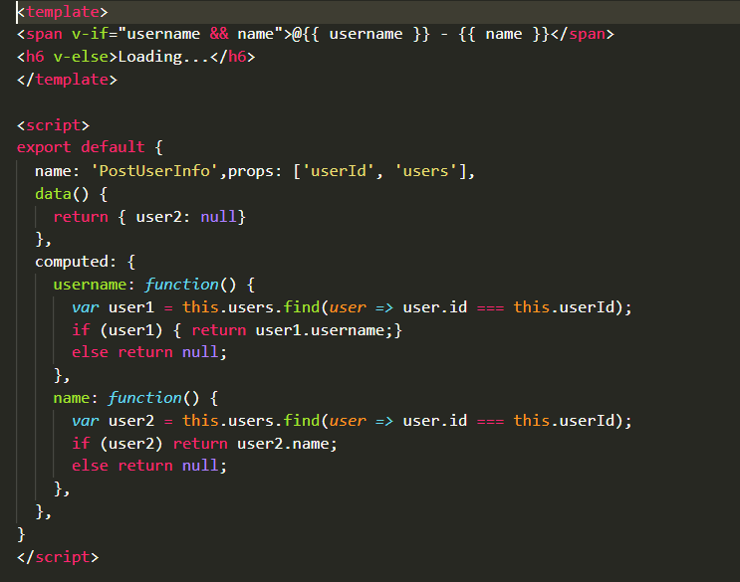

Pages/NotFound.vue:

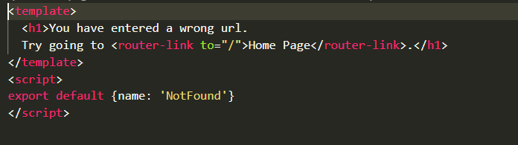

Pages/Posts.vue:

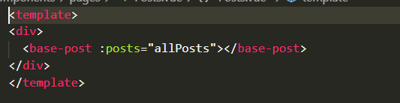

Pages/PostDetails.vue:

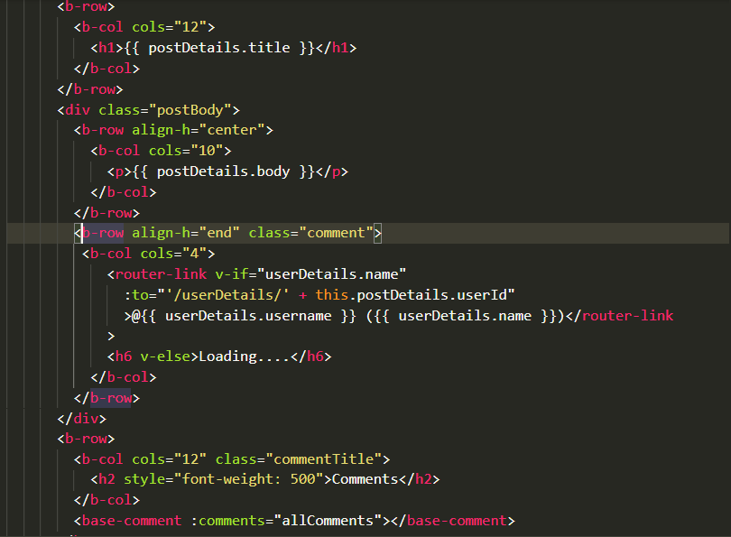

Pages/UserDetails.vue:

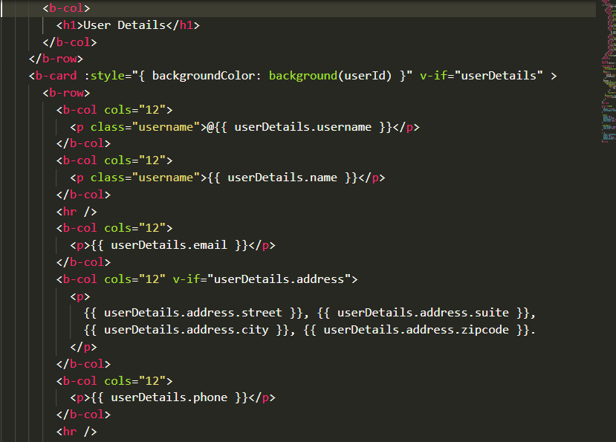

1. Blog-App Implementation

Posts.Vue:

In the getAllPosts method, the post data are fetched by ‘get’ method of axios instance from remote URL passed in ‘get’ method.

This data is stored in an array. ‘getAllPosts’ method is called during created hook of the app.

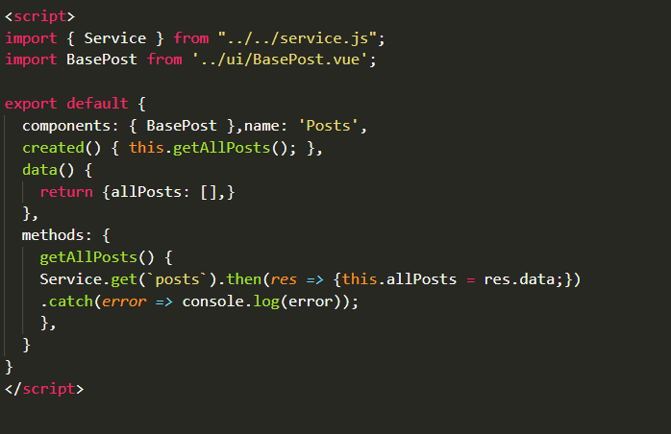

BasePost.vue:

This component contains the UI for displaying the posts. The ‘posts’ prop accepts the data from other components.

This app is loaded first in the browser, as mounted function is called. User data related to posts are loaded because we are fetching user data when app is mounted.

The User details are passed to ‘PostUserInfo’ component.

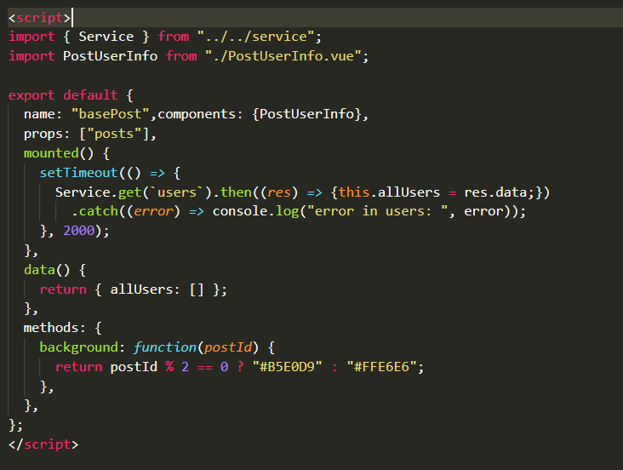

PostUserInfo.vue:

This component displays user data.

It accepts two props ‘userId’ and ‘users’.

It has two computed properties ‘username’ and ‘name’ which checks details of specific user via ‘userId’ prop.



PostDetails.vue:

getPostDetails method fetches post by its ‘id’, which is stored in postDetails object. This method calls two other methods ‘getComments(fetching comments related to post)’ and ‘getUserDetails(User related to post)’.

BaseComment.vue component displays all the comments. ‘allComments’ array is passed to ‘comments’ props.

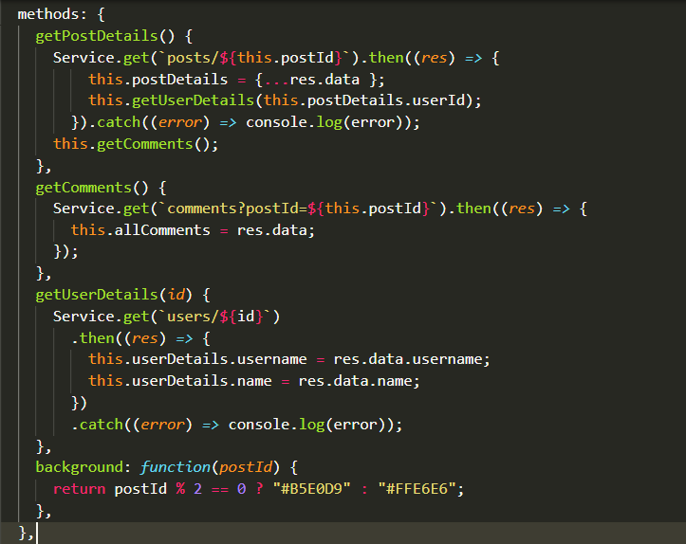

BaseComment.vue:



1. Output

Posts:

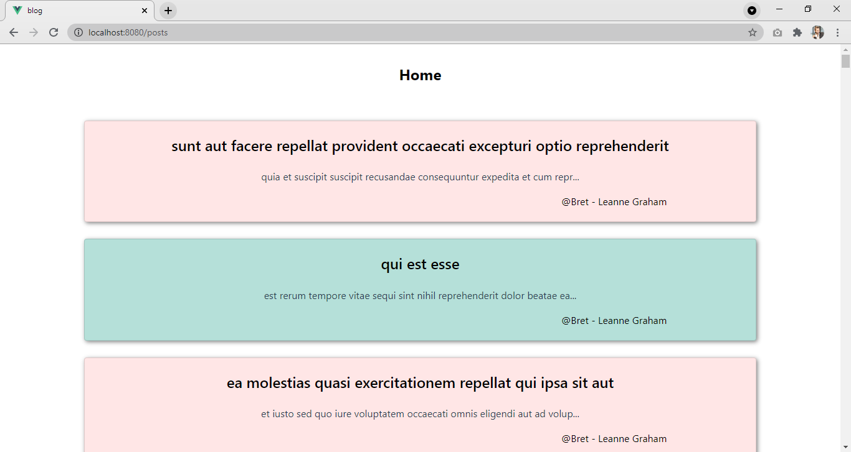

PostDetails:

