Report Assignment 3

**Teammates:-**

**Ashish Shinde – NUID 002199940.**

**Karan Patil – NUID 002130155.**

**Sudarshan Waydande – NUID 001563532.**

**Objective:-**

The objective of this assignment is to instill in you the techniques for turning an object model into a machine for information gathering and data aggregation. We want to use software engineering techniques to improve the quality of education anywhere and hold people accountable for improving the quality of life through education, learning to learn, and feedback. Your task is to study ways to create a performance measurement solution to enable universities to measure the quality of the education they deliver to their students. The approach will be to look into how an educational system in terms of faculty and courses contribute to the growth of their graduates over a 5-year period. You must figure out ways to track the jobs and promotions graduates get over time and assign rankings accordingly. In addition, track the connection of courses and their relevance to graduates' growth.

One of your deliverables will be to design a dashboard that enables college and university administrators to compare the performance of their academic units. One additional question is to consider ways to define your own ranking system for students to decide where they want to go for their studies. The current system is biased toward research.

**Deliverables:-**

1. **Report outlining your proposed solution.**
2. **Sequence diagrams showing how to navigate the university object model to deliver performance metrics needed for performance and feedback.**
3. **A class diagram showing the changes to the university model to support the new capabilities. This diagram must include the additional methods and attributes required to deliver the results.**

**Abstract:-**

A University Performance Evaluation Model indicates how various departments, courses are ranked based on the feedbacks provided by the current students as well as based on the alumni survey over a period of 5 years and presents our university ranking dashboard. This model also outlines the output of various courses taken by the student in their graduate studies. A UML diagram is created to showcase various classes its attributes and functions. Sequence diagram is also created to showcase the flow of the functions over the objects and actors in the University Performance Evaluation Model.

**Contents:-**

1. **Entity Identification.**
2. **Entity Description.**
3. **Proposed Solution.**
4. **Class Diagram.**
5. **Sequence Diagram.**
6. **Dashboard.**

Below are the details used to create performance measurement solution to enable university to measure, compare the quality of education they deliver to their studies.

1. **Entity Identification:-**

* University.
* College.
* Program.
* Courses.
* Professor.
* Student.
* Publications
* Feedback.
* Alumni.
* Employment Record.
* Alumni Survey.
* University Evaluation

1. **Entity Description:-**

* University: This entity/class holds the information regarding the university like:
* University Name.
* University Address.
* University Contact Information.
* University Email address.
* Admin: Every college has an admin who does all the operations and can also view every

information, here we are saving the information of admin:

* Admin User Id.
* Admin Password.
* College: A university has multiple colleges.
* College Name.
* College Address.
* College Contact Information.
* College Email address.
* Program: Programs are associated with the Colleges and Programs can have multiple courses
* Program Name.
* Total Credits.
* Course: A Program consists of multiple courses, hence we have taken a course catalog that

contains information related to the course as follow:

* Course Name.
* Course CRN.
* Course Credit.
* No. Of Seats.
* Professor: A College has multiple Professors and a single course can be taught by different

Professor, so here we have a Professor Directory which stores information of a professor as follow:

* Professor Name.
* Professor Address.
* Professor Email address.
* Professor Contact Number.
* Professor Salary.
* Student: Students attends university and register for different courses under a professor, so

we have a Student Directory that stores information of students as follow:

* Student ID.
* Student Name.
* Student Address.
* Gender.
* Student Email address.
* Student Contact Number.
* Financial Aid.
* Publications: A Student with a Professor under a course sometimes publishes different types

of publication like research papers, patents, etc. So here we are storing the publication record as follows:

* Publication Type.
* Student ID.
* Professor ID.
* Course CRN.
* Publication Description.
* Feedback: A student gives a feedback to evaluate the course, assignments, professor, delivery

method, etc. so will store the information accordingly:

* Feedback type.
* Rate Course Content.
* Rate Delivery Method.
* Rate Professor.
* Rate Assignment Quality.
* Alumni: After a student gets a degree and is graduated from the university we stores the

information of student in Alumni record:

* Alumni Name.
* Alumni Address.
* Alumni Email Address.
* Alumni Contact Number.
* Employment Record: Employment Record will store all the employment information of alumni:
* Employment Type.
* Service.
* Self Employed.
* Higher Education (If Taken).
* Alumni Survey: A survey given to alumni just to know the course studied was useful:
* Alumni Course Rating.
* Alumni Course Content.
* Alumni Course Impact.
* Previous Assignment Quality.
* University Evaluation Metric: This Class will take all the required data to evaluate University.
* Publication Record.
* Feedback Record.
* Employment Record.
* Alumni Survey Record.

1. **Proposed Solution:-**

A solution proposed by us to enable a university to measure quality of education they deliver to their students includes usage of metrics like feedbacks taken from students, considering if any publications published while studying a course, employment records and having surveys taken from alumni’s of the university.

In our solution, the first factor we are considering are the timely feedbacks (i.e. mid semester and end semester) taken from the students in the form of ratings to understand the quality of course content, delivery method of any professor, the assignments given by the professor and based on that having an overall rating of a professor which will help university to know a professor in a better manner. Based on these rating university can decide to make any changes if needed.

The second factor that we are considering are the publications published. Many times what happen is that the research area of a professor and students aligns, and both of them performs a research and publishes a research paper. In our solution, the publication is not limited to just the research paper, we are considering research papers as well as patents and copyrights published while in the university. This will allow the university to know its stand in the innovation and research department.

And the final factors that we are considering are the employment records and the surveys taken from the alumni’s of the university. After a student is graduated and becomes an alumni having the employment record of the student will help the university to understand the position and the sector of that student in the corporate world. There are many students who choose to be self-employed or goes for another higher education having that record is also we useful. Next, the surveys taken from these alumni’s like the impact of the previous courses taken in the form of rating, mentioning the some courses by a particular professor that were the most useful for their employment or rating the quality of assignments under a course. All these will help university understand that the current studying students are getting prepared for what the outside than university i.e. corporate world needs meets with studies.

Some of these factors like publications or employment records in addition with the financial aids data or course category data, if made available to students to preview will be useful for future incoming students to decide whether to go for these studies.

Lastly gathering the above data and then evaluating and presenting it will allow the admin to understand the data better.

1. **Class Diagram:-**

Below is the Class Diagram developed for the proposed solution with all the attributes and functions.

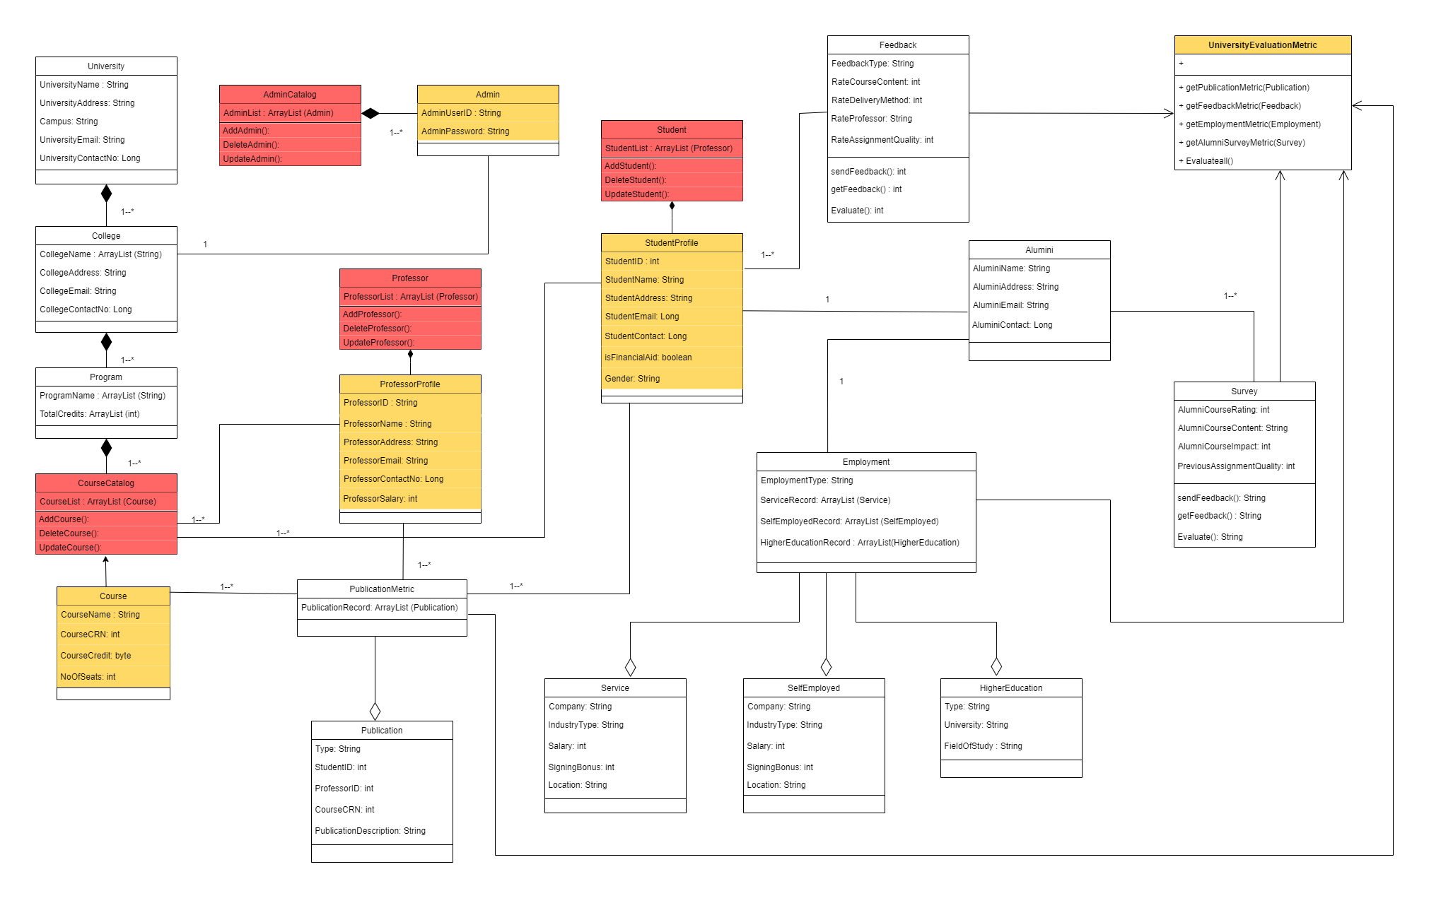

1. **Sequence Diagrams:-**

Below are the Sequence Diagrams developed for the proposed class diagram with the sequence of events.

1. Admin Sequence Diagram.

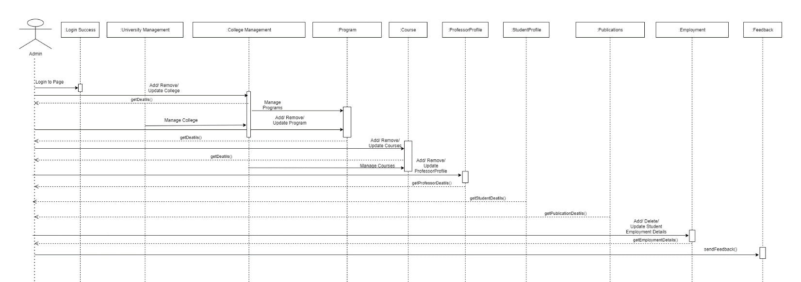

1. Professor Sequence Diagram.

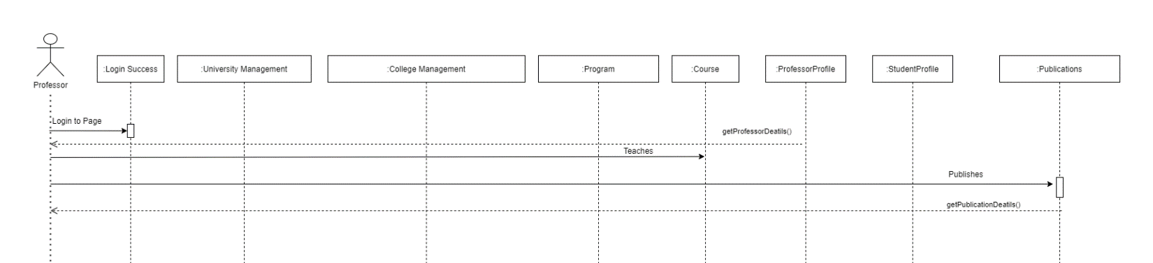

1. Student Sequence Diagram.

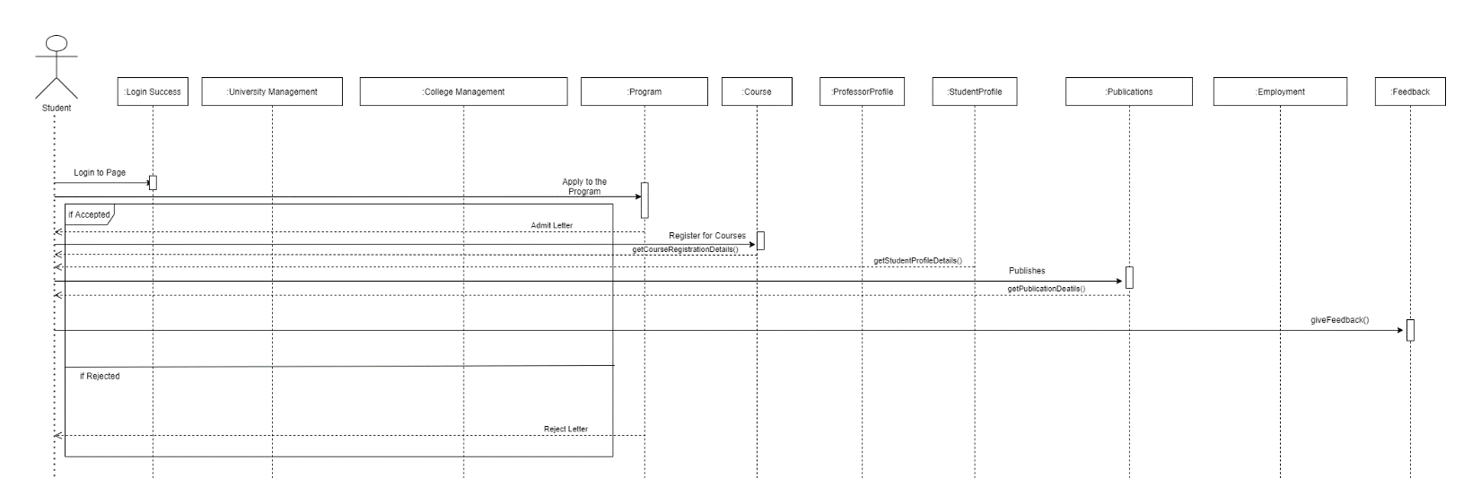

1. Alumni Sequence Diagram.

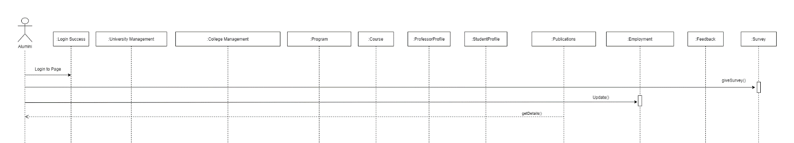

1. University Ranking Metric Diagram.

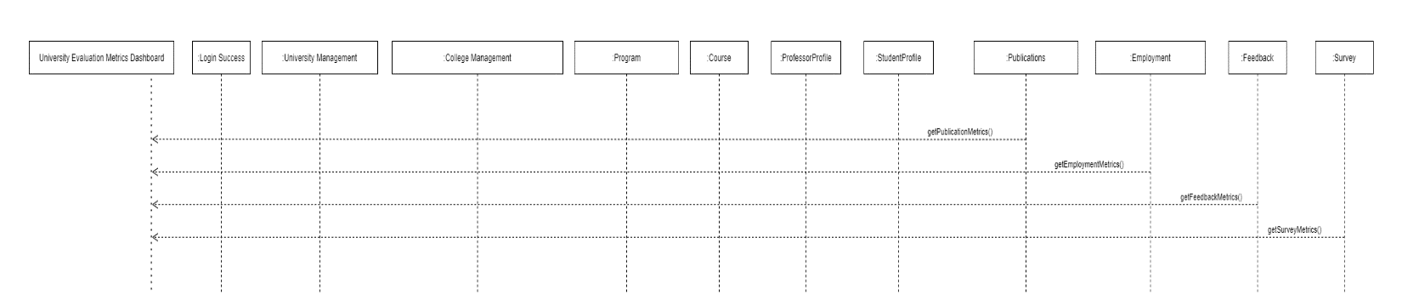

1. **Dashboard:-**

Below are the screenshots of the Dashboard for the proposed solution.

