##### ACKNOWLEDGEMENT

It is a great pleasure for us to acknowledge all those who have contributed towards the conception, origin and nurturing of this report that is on System analysis the **“ATM MACHINE”*.***

The way can’t walk itself. We have to walk on it. For that we must have a guide. Many guides have contributed to the successful completion of the project. We would like to place on record my grateful thanks to each one of them who help us in this project report.

Before we get into thick of the thing, we would like to add a few heartfelt words for the people who gave us unending time support whichever and whenever necessary.

Our grateful thanks go to our Dept., which provides us an opportunity as a project subject in **4th Semester** to develop a report work skill in this System analyzing.

Last but not the least; I heartily thank our class teacher **Dr. S.A Khan Sir**.

**ABSTRACT**

This report attempts to understand the design of an Automated Teller Machine (ATM) system, a device used by bank customers to process account transactions. Typically, a user inserts into the ATM a special plastic card that is encoded with information on a magnetic strip. The strip contains an identification code that is transmitted to the bank's central computer by modem. To prevent unauthorized transactions, a personal identification number (PIN) must also be entered by the user using a keypad. The computer then permits the ATM to complete the transaction; most machines can dispense cash, accept deposits, transfer funds, and provide information on account balances. Banks have formed cooperative, nationwide networks so that a customer of one bank can use an ATM of another for cash access. Some ATMs will also accept credit cards for cash advances. The first ATM was installed in 1969 by Chemical Bank at its branch in Rockville Centre, New York. A customer using a coded card was dispensed a package containing a set sum of money.

**INTRODUCTION**

**Project Summary**

An automated teller machine (ATM) or automatic banking machine (ABM) is a computerized telecommunications device that provides the clients of a financial institution with access to financial transactions in a public space without the need for a cashier, human clerk or bank teller. On most modern ATMs, the customer is identified by inserting a plastic ATM card with a magnetic stripe or a plastic smart card with a chip, that contains a unique card number and some security information such as an expiration date or CVVC (CVV). Authentication is provided by the customer entering a personal identification number (PIN).

**Purpose**

Using an ATM, customers can access their bank accounts in order to make cash withdrawals (or credit card cash advances) and check their account balances as well as purchase cellphone prepaid credit. If the currency being withdrawn from the ATM is different from that which the bank account is denominated in (e.g.: Withdrawing Japanese Yen from a bank account containing US Dollars), the money will be converted at a wholesale exchange rate. Thus, ATMs often provide the best possible exchange rate for foreign travelers and are heavily used for this purpose as well.

**Scope**

The main purpose of the ATM division and information service is to provide the customers financial flexibility, worldwide acceptance and round-the clock convenience. Bank issues only VISA Credit Cards, the renowned Credit Card brand. Cardholders can purchase goods/services up to the credit limit and can reuse the credit facility upon repayment. Credit Card is a safer substitute to cash and is the major mode of payment worldwide. Standard Chartered Bank is the first to introduce the TAKA CREDIT CARD. The card is issued basically to a person’s name and the specific person can use the card in anywhere in Bangladesh. The business activity of Premier Bank Credit Card section is to keep the records of all sales and customers’ requests, the information of cardholders and reports them to necessary documents.

**SYSTEM ANALYSIS**

**Study of Current System**

The OBS Administration falls short of controlling the employee’s activities in analyzing his/her strengths and weakness. The decision for appraisal of assigning next project to the employee or to train him/her to enhance the skills – where lies with proper projection. He is not provided with the detailed project information done or to be assigned based on Application / Verticals.

**Requirements of New System**

Decision in assigning proper skillful hands for the report is an important issue in OBS Module. The OBS Administrator should report with the personal holding the necessary skills required for the project assignment. The decision in making analysis about the employee’s skills is a prime important before booting in. The proposed system of OBS Module is the right software to be incorporated into the Automation of OBS Software for helping the organization needs with respect to skillful Human Resource.

The proposed system provides detail general information about the employee along with Educational, Certification, Skill and Project details. It enhances the OBS Management in adding, viewing and updating employees’ details and generates various reports regarding employee’s skill and experience. Suggestions and Grievances posted by the employees are upheld for taking care of the necessary steps in forwarding company’s obligation.

.

**ADVANTAGES OF PROPOSED SYSTEM:**

* Very fast and accurate.
* No need of any extra manual effort.
* No fever of data loss.
* Just need a little knowledge to operate the system.
* Doesn’t require any extra hardware device.
* At last very easy to find the employees.

**FEASIBILITY STUDY**

Once the problem is clearly understood, the next step is to conduct feasibility study, which is high-level capsule version of the entered systems and design process. The objective is to determine whether or not the proposed system is feasible. The obese tests of feasibility have been carried out.

* Technical Feasibility
* Economic Feasibility
* Operational Feasibility
* **TECHNICAL FEASIBILITY**

In Technical Feasibility study, one has to test whether the proposed system can be developed using existing technology or not. It is planned to implement the proposed system using java technology. It is evident that the necessary hardware and software are available for development and implementation of the proposed system. Hence, the solution is technically feasible.

* **ECONOMICAL FEASIBILITY**

As part of this, the costs and benefits associated with the proposed system compared and the project is economically feasible only if tangible or intangible benefits outweigh costs. The system development costs will be significant. So, the proposed system is economically feasible.

* **OPERATIONAL FEASIBILITY**

It is a standard that ensures interoperability without stifling competition and innovation among users, to the benefit of the public both in terms of cost and service quality. The proposed system is acceptable to users. So, the proposed system is operationally feasible.

**FUNCTIONS OF SYSTEM**

**Use Case:**

Use case is a description of a set of sequence of actions that a system performs that yields an observable result of value to a particular thing in a model. Graphically, Use Case is rendered as an ellipse with dashed lines, usually including only its name as shown below.

**Use Case Diagram**:

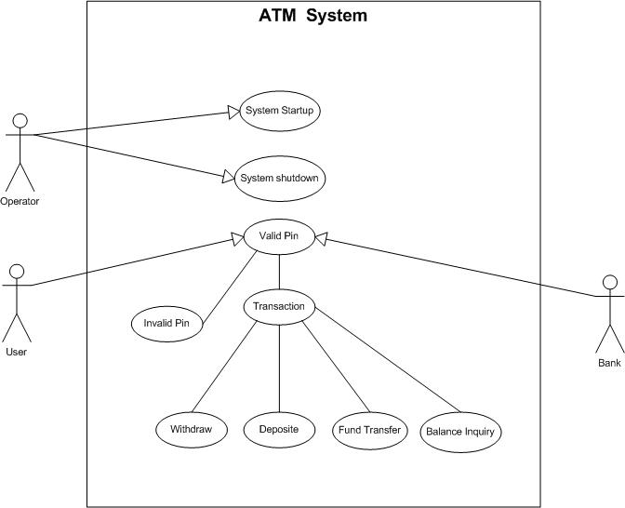

**DATA MODELING**

**Activity Diagram:**

An Activity Diagram is essentially a flow chart showing flow of control from activity to activity. They are used to model the dynamic aspects of as system. They can also be used to model the flow of an object as it moves from state to state at different points in the flow of control.

**Content:**

Activity diagrams commonly contain: Fork, Start & End Symbol

Activity Diagram

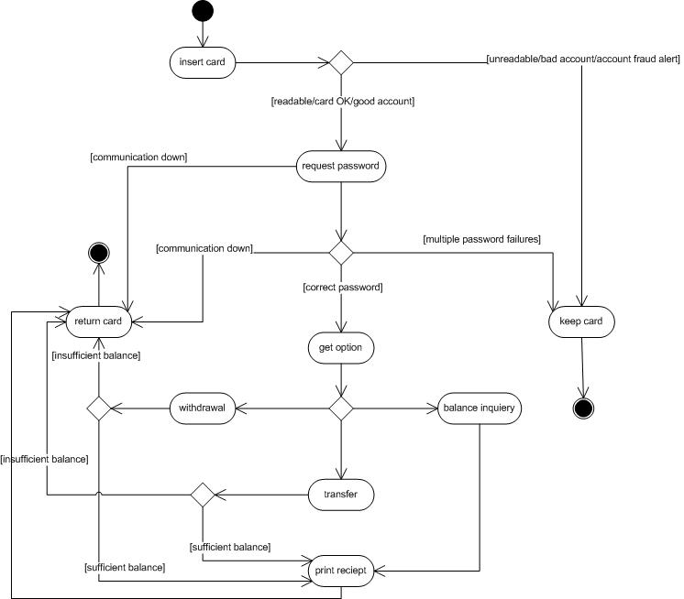

**Data Flow Diagram (0 and 1 level)**

A graphical tool used to describe and analyze the moment of data to Sough a system manual or automated including the process, stores of data, and delays in the system. Data Flow Diagrams are the central tool and the basis from which other components are developed. The transformation of data from input to output, to Sough processes, may be described logically and independently of the physical components associated with the system. The DFD is also known as a data flow graph or a bubble chart.

A graphical tool used to describe and analyze the moment of data through a system manual or automated including the process, stores of data, and delays in the system. Data Flow Diagrams are the central tool and the basis from which other components are developed. The transformation of data from input to output, through processes, may be described logically and independently of the physical components associated with the system. The DFD is also known as a data flow graph or a bubble chart.

**Data Flow Diagram(Level-0)**

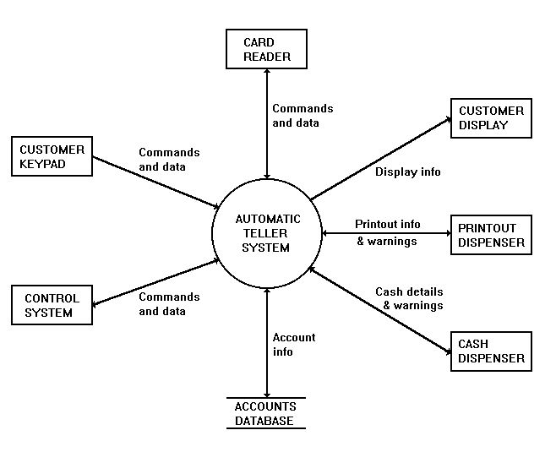

**External Entities**

**CONTROL SYSTEM**

This system enables and disables the customer interface and receives customer requests and system reports. A suitable Control System would be a personal computer linked to a central computer system with access to the Accounts Database. The customer interface (keypad, display, etc) is controlled by enabling and disabling the Card Reader, which is the customer's entry-point to the system. Requests for statements and chequebooks are posted to the Control System. It also receives status reports for low printer-paper and cash levels.

**ACCOUNTS DATABASE**

This is a database containing account numbers, balances and other account information. Data is retrieved from the database when a customer requests a balance report or a cash withdrawal. The database is updated after a withdrawal.

**CARD READER**

The Card Reader receives the customer's card and retrieves the PIN and account number stored on it. This information is transmitted to the software system which enables the Customer Keypad and initiates the PIN verification procedure. When business is completed the Card Reader is instructed to return the card. If the customer enters an incorrect PIN, a fixed number of retries is permitted, after which the Card Reader is instructed to confiscate the card.

**CUSTOMER KEYPAD**

The Customer Keypad allows a customer to enter a PIN number, select options and enter cash values. The keypad is only enabled when a card is detected in the Card Reader.

**CUSTOMER DISPLAY**

The Customer Display presents messages, options and reports to the customer. The display is active at all times.

**PRINTOUT DISPENSER**

This provides the customer with a printed balance or receipt. The Printout Dispenser reports to the system if the paper level is low.

**CASH DISPENSER**

This assembles and delivers cash to the customer. The dispenser receives information about the values and quantities of notes to dispense . The Cash Dispenser reports to the system if the cash levels are low.

**Data Flow Diagram(Level-1)**

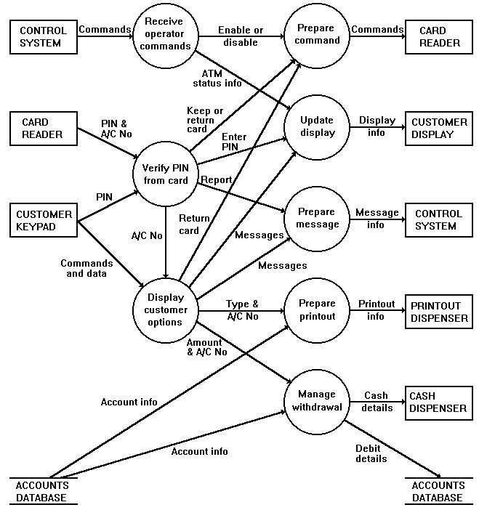

This diagram shows data entering and leaving the system. Input data is received from the hardware elements on the left. Various types of data are processed by different parts of the software system. Output data is sent to the elements of hardware on the right.

**CONCLUSION**

Back in 1969, Chemical Bank announced that a new form of banking was being launched. With that, customers were provided with plastic cards designed with a magnetic strip that could be used with a machine built into a wall. Gone were the days of having to stand in line for a teller or not having money on hand after normal banking hours. Almost everyone has heard of and used an ATM machine. Interestingly, some of people feel that ATM machines are the best thing to happen in the banking world while other people consider them a curse. The main complaint heard about ATM machines is that while they are convenient, they are expensive touse. However, if we look at it from a banking perspective, business is business. Regardless of what we think of ATM machines, there is no doubt that they have changed the world and the way in which we do things. For example, think how many times we have been out somewhere only to discover we have no cash and we are out of checks, ah, but in the corner, there is an ATM machine. In the blink of an eye, we swipe the card and now have cash on hand. In addition to pulling money out, the ATM machine also makes it convenient to deposit money, transfer money, and check balances. Best of all, to use an ATM machine, we do not have to go to the bank. We will find ATM machines at other banks, grocery stores, shopping malls, along the

roadside, Buckingham Palace, airports, in casinos, and even on the South Rim of the Grand Canyon. For this reason, ATM machines are extremely helpful!

**BIBLIOGRAPHY**

**Book Reference**

**🡺** Fundamentals of Software Engineering

**By Rajib Mall**

🡺Software Engineering

**By Ian Somerville**

**🡺** Analysis and Design of Information Systems

**By James Senn**

**Website Reference**

* www.google.com
* www.ask.com
* www.microsoft.com
* www.iit.edu.com