
UNIVERSITY OF ENGINEERING & TECHNOLOGY, MARDAN

DEPARTMENT OF COMPUTER SCIENCE

CS-305L: Parallel & Distributed Computing Lab

LAB 03:
Point-to-Point Communication In (MPI) in Python

NAME: Sudais Jamal
REGISTRATION NO: 23MDBCS470
SECTION: CS
SEMESTER: 6th
DATE: February 11, 2026

Blocking Communication

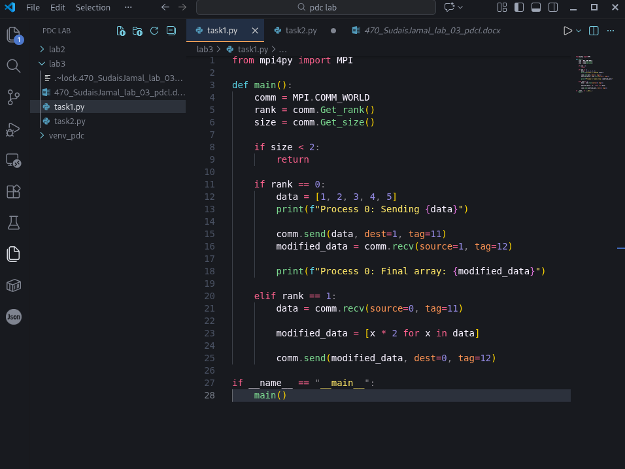
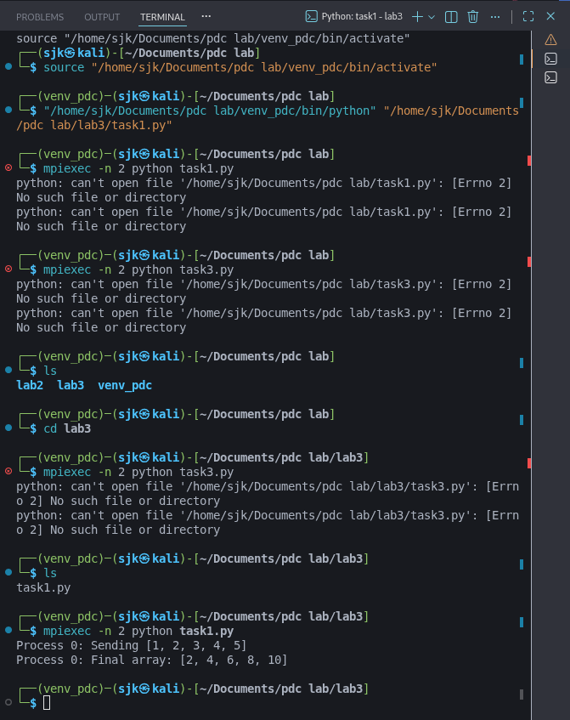

Non Blocking Communications

