

University of Engineering & Technology Mardan

Lab 02: Parallel & Distributed Computing

Name : Sudais Jamal

F/ Name : Mumtaz Jamal

REG NO : 23MDBCS470

Department : Comp-Sci .

SECTION : CS .

SUBMITTED TO : Sir Taseer .

Task_2.1 :

mpirun is the conductor that turns a single script into a parallel team. It launches multiple copies of your program at once, gives each copy a unique ID (rank), and builds the "phone lines" so they can talk to each other. Without it, you’re just running one lonely script; with it, you’re using your entire CPU's power to solve problems faster.

Task_2.2 :

CODE:

OUTPUT:
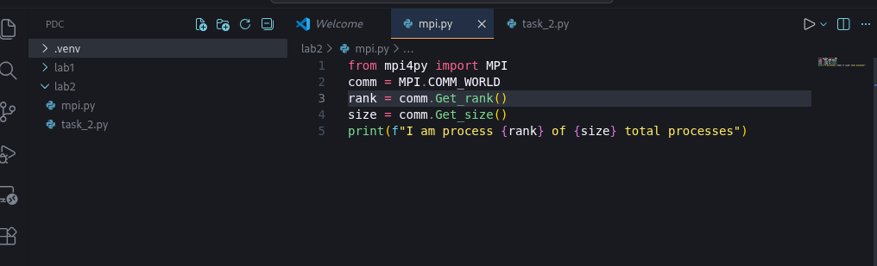

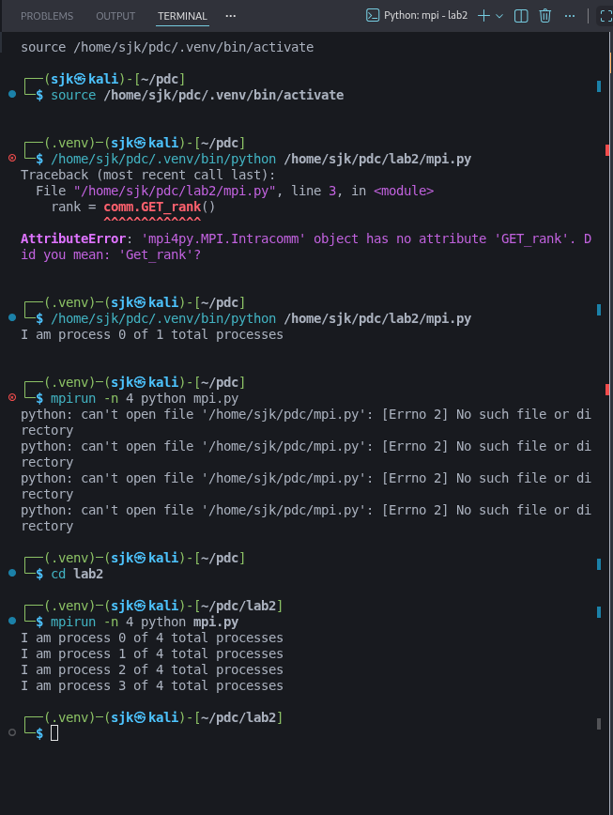
Task_2.3 :

MPI.COMM_WORLD is the "group chat" for your parallel program. It connects all the separate processes you launched into one team, giving each one a unique ID (rank) so they know who they are. Without it, your processes are strangers; with it, they can talk, share data, and work together in sync.

Task_2.4 :

CODE:

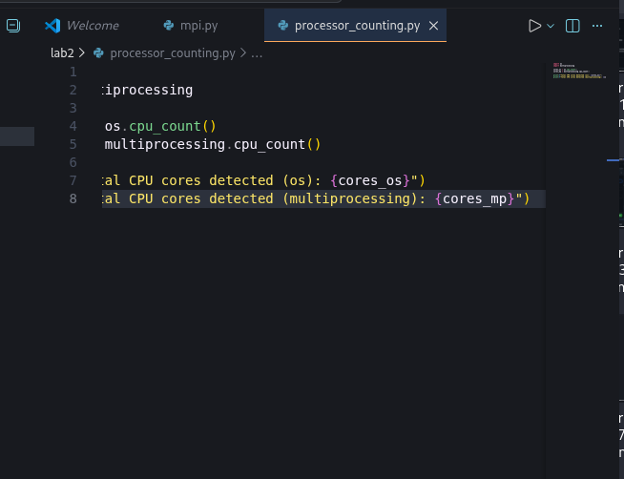

OUTPUT:
