12-week Plan

Title
An AI-Enhanced BGP Control Plane Architecture for Behavioral Route Leak and Hijack Mitigation

Team
M Sudalai Kumar / 2024503703
B Satlas Rohit / 2024503305
S Ajay Kumar / 2024503701
S Srinivasan / 2024503707

Problem Statement – Key Points
• The global Internet routing ecosystem relies on the Border Gateway Protocol (BGP), which fundamentally operates on decentralized trust between Autonomous Systems and provides limited built-in mechanisms for validating routing behaviour.
• Prefix hijacks allow malicious or compromised Autonomous Systems to falsely advertise IP prefixes, diverting traffic through unauthorized networks and enabling traffic interception, denial of service, or surveillance.
• Route leaks caused by configuration errors or policy violations propagate incorrect routing information across administrative boundaries, resulting in traffic loops, congestion, black holes, and large-scale Internet outages.
• Existing cryptographic routing security mechanisms such as Resource Public Key Infrastructure (RPKI) and Route Origin Validation (ROV) significantly improve origin authentication but require widespread operator adoption and cannot detect every operationally abnormal route that remains cryptographically valid.
• Emerging standards such as RFC 9234 (BGP Roles and Only-To-Customer) and ASPA strengthen routing security against route leaks but are still dependent on incremental ecosystem-wide deployment and cannot autonomously respond to unforeseen behavioural anomalies.
• Current commercial monitoring platforms (Kentik, Cloudflare Radar, Cisco Crosswork Cloud, CAIDA BGPStream, Qrator Radar) primarily perform out-of-band anomaly detection and operator alerting, leaving mitigation decisions to human administrators.
• Existing research prototypes such as ARTEMIS provide rapid automatic mitigation for prefix hijacks using predefined rule-based mechanisms but do not continuously adapt routing policy using behavioural learning.
• There remains a research gap for lightweight autonomous control-plane agents capable of continuously observing routing behaviour, classifying suspicious announcements, and dynamically adapting BGP policy while operating alongside existing routing protocols without modifying protocol specifications.

Proposed Solution
This project proposes an AI-enhanced behavioural control layer deployed alongside a standards-compliant Border Gateway Protocol implementation to provide autonomous behavioural route leak and hijack mitigation.
Instead of replacing BGP or introducing a new routing protocol, the proposed architecture augments the existing control plane by embedding a lightweight asynchronous AI agent adjacent to containerized FRRouting routers.
Each Autonomous System is implemented as an isolated Docker container interconnected through Containerlab, allowing realistic emulation of inter-domain routing behaviour using actual BGP UPDATE messages, route advertisements, path attributes, and policy evaluation.
The AI agent continuously monitors routing telemetry collected from FRRouting, including AS-path evolution, origin-AS stability, prefix advertisement frequency, route withdrawals, Local Preference history, and neighbour behaviour. These observations are processed using lightweight machine learning classifiers combined with behavioural heuristics to compute a dynamic trust score for each learned route.
Rather than modifying forwarding behaviour directly, the agent adjusts existing BGP policy through controlled Local Preference updates using route maps. Proposed policy changes are first validated through a shadow evaluation stage to minimise false positives before being applied. If network stability deteriorates following a policy adjustment, the system automatically restores the previous routing preference.
The architecture complements existing routing security mechanisms such as RPKI, Route Origin Validation, RFC 9234, and ARTEMIS by providing behavioural adaptation for routing anomalies that remain operationally suspicious despite satisfying existing cryptographic validation.
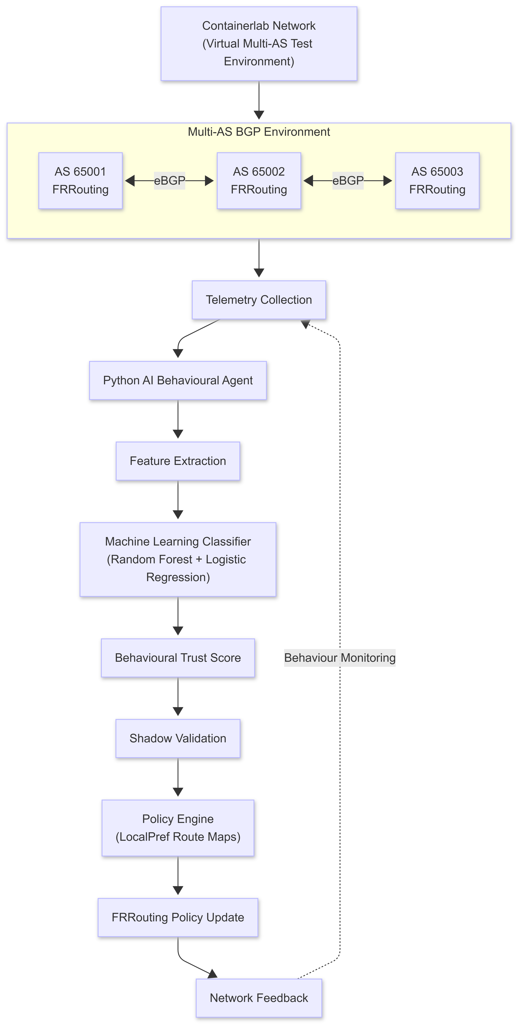

Month 1: Foundation and Setup

Week 1–2: Literature Review
• Study Border Gateway Protocol (BGP) architecture, inter-domain routing operations, best-path selection, and the role of key routing attributes including Local Preference, MED, AS Path, Next Hop, and Origin.
• Review the causes and characteristics of prefix hijacks, route leaks, route flapping, and policy violations using historical Internet incidents and operational studies.
• Analyse existing routing security mechanisms including RFC 4271, Resource Public Key Infrastructure (RPKI), Route Origin Validation (ROV), RFC 9234 (BGP Roles and Only-To-Customer), and ASPA to understand their strengths, deployment challenges, and remaining limitations.
• Review current research on machine learning for BGP anomaly detection, behavioural routing analysis, and lightweight routing classifiers.
• Study recent Agentic AI architectures, autonomous networking principles, digital twin frameworks, and AI-assisted network management to understand how intelligent agents can augment rather than replace existing network control planes.
• Identify the research gap between traditional cryptographic routing security, passive anomaly monitoring systems, and adaptive behavioural policy optimisation.

Week 3: Environment Setup and Infrastructure Configuration
• Deploy a virtualized inter-domain network using Containerlab, where each Docker container represents an independent Autonomous System running FRRouting (FRR) as a standards-compliant BGP router.
• Configure eBGP neighbour relationships, route advertisements, route maps, Local Preference policies, and route redistribution using native FRRouting configuration.
• Verify successful exchange of real BGP UPDATE messages and validate routing convergence across multiple Autonomous Systems.
• Develop a lightweight Python-based management framework capable of collecting routing telemetry from FRRouting through supported interfaces (vtysh, northbound APIs, or ExaBGP where appropriate).
• Build the initial project repository, container orchestration files, automation scripts, and reproducible deployment environment.

Week 4: Baseline Experiments
• Execute baseline routing experiments using unmodified FRRouting routers without AI-assisted behavioural policy adaptation.
• Measure baseline routing convergence time, route propagation latency, CPU utilisation, memory overhead, and network stability under normal operating conditions.
• Simulate benign topology changes such as link failures and router restarts to establish reference convergence behaviour.
• Establish quantitative baseline metrics including:
- Mean Time to Detect (MTTD)
- Mean Time to Mitigate (MTTM)
- Route convergence latency
- Route oscillation frequency
- Path stability
- Packet delivery ratio
- Control-plane resource utilisation
• These baseline measurements will serve as reference values for evaluating the effectiveness of the proposed AI-enhanced control plane during later experimentation.

Month 2: Implementation and Optimization

Week 5–6: AI Layer Development and Control Plane Integration
• Develop a lightweight asynchronous AI agent that operates alongside the FRRouting control plane without interfering with packet forwarding or the native BGP decision process.
• Design the AI subsystem as a continuously executing event loop responsible for observing routing behaviour, extracting features, computing trust scores, and recommending routing policy updates independently of the forwarding plane.
• Implement an in-memory sliding-window telemetry buffer using Python's collections.deque to efficiently maintain recent routing observations without excessive storage overhead.
• Collect real-time routing telemetry from FRRouting, including:
- AS Path changes
- Origin Autonomous System stability
- Prefix advertisement frequency
- Route announcement and withdrawal rates
- Prefix specificity (/24, /23, etc.)
- Local Preference history
- Neighbour reachability
- Route age
- AS Path edit distance from historical observations
- Consecutive route flapping events
• Construct behavioural feature vectors representing both short-term and long-term routing behaviour for each advertised prefix.
• Implement lightweight machine learning models using Random Forest and Logistic Regression to classify routing behaviour as:
- Normal
- Suspicious
- Route Leak Candidate
- Prefix Hijack Candidate
• Combine statistical predictions with rule-based confidence scoring to improve interpretability and reduce false-positive decisions.

Week 7: Behavioural Policy Engine and Autonomous Decision Framework
• Develop a behavioural trust scoring engine that continuously evaluates each received route using the extracted routing features and classifier outputs.
• Design a weighted trust model that considers multiple behavioural indicators rather than relying on a single anomaly score.
Example behavioural indicators include:
- Frequent origin-AS changes
- Sudden prefix deaggregation
- Abnormal advertisement bursts
- High route withdrawal frequency
- Significant AS Path deviation
- Repeated neighbour instability
- Historical trust consistency
• Map the calculated trust score to adaptive BGP policy decisions by dynamically adjusting the Local Preference (LocalPref) attribute using FRRouting route maps.
• Introduce configurable trust thresholds to determine whether routes should:
- remain unchanged,
- receive reduced preference,
- be temporarily deprioritized, or
- be restored after behavioural recovery.
• Implement a shadow validation mechanism before applying routing policy modifications.
Instead of immediately changing Local Preference, the proposed adjustment is first evaluated in a temporary validation stage to determine whether the predicted routing behaviour remains stable.
• Develop an automatic rollback mechanism capable of restoring previous routing policies whenever behavioural conditions improve or the AI agent detects potential false-positive decisions.
• Ensure that the AI subsystem operates entirely within the BGP control plane while preserving standards-compliant routing behaviour and interoperability with existing routers.

Week 8: Experimental Evaluation and Attack Simulation
• Construct multiple experimental scenarios representing both synthetic and real-world routing anomalies.

Synthetic Scenarios
• Simulate malicious Autonomous Systems capable of performing:
- Prefix hijacks
- Sub-prefix hijacks
- Route leaks
- Route flapping
- Advertisement flooding
- Sleeper-agent attacks
- Gradual trust manipulation attacks
using programmable FRRouting containers.

Historical Validation Scenarios
Replay routing characteristics derived from documented Internet incidents, including:
- Pakistan Telecom – YouTube Prefix Hijack (2008)
- Google – Rostelecom Route Leak (2017)
- Cloudflare / Verizon Route Leak (2019)
to evaluate the AI system against realistic routing behaviour rather than only synthetic attack patterns.
• Compare system performance under four configurations:
- Standard BGP (Baseline)
- BGP with RPKI/Route Origin Validation
- Behavioural Heuristic Detection
- Proposed AI-Enhanced Behavioural Control Plane
• Measure and record:
- Detection accuracy
- Precision
- Recall
- F1-score
- False Positive Rate
- False Negative Rate
- Mean Time to Detect (MTTD)
- Mean Time to Mitigate (MTTM)
- Route convergence latency
- Route oscillation count
- Number of Local Preference adjustments
- CPU utilisation
- Memory overhead
- Packet delivery ratio
- Network recovery time
• Analyse the effectiveness of behavioural trust scoring in mitigating routing anomalies while maintaining routing stability and minimizing unnecessary policy changes.
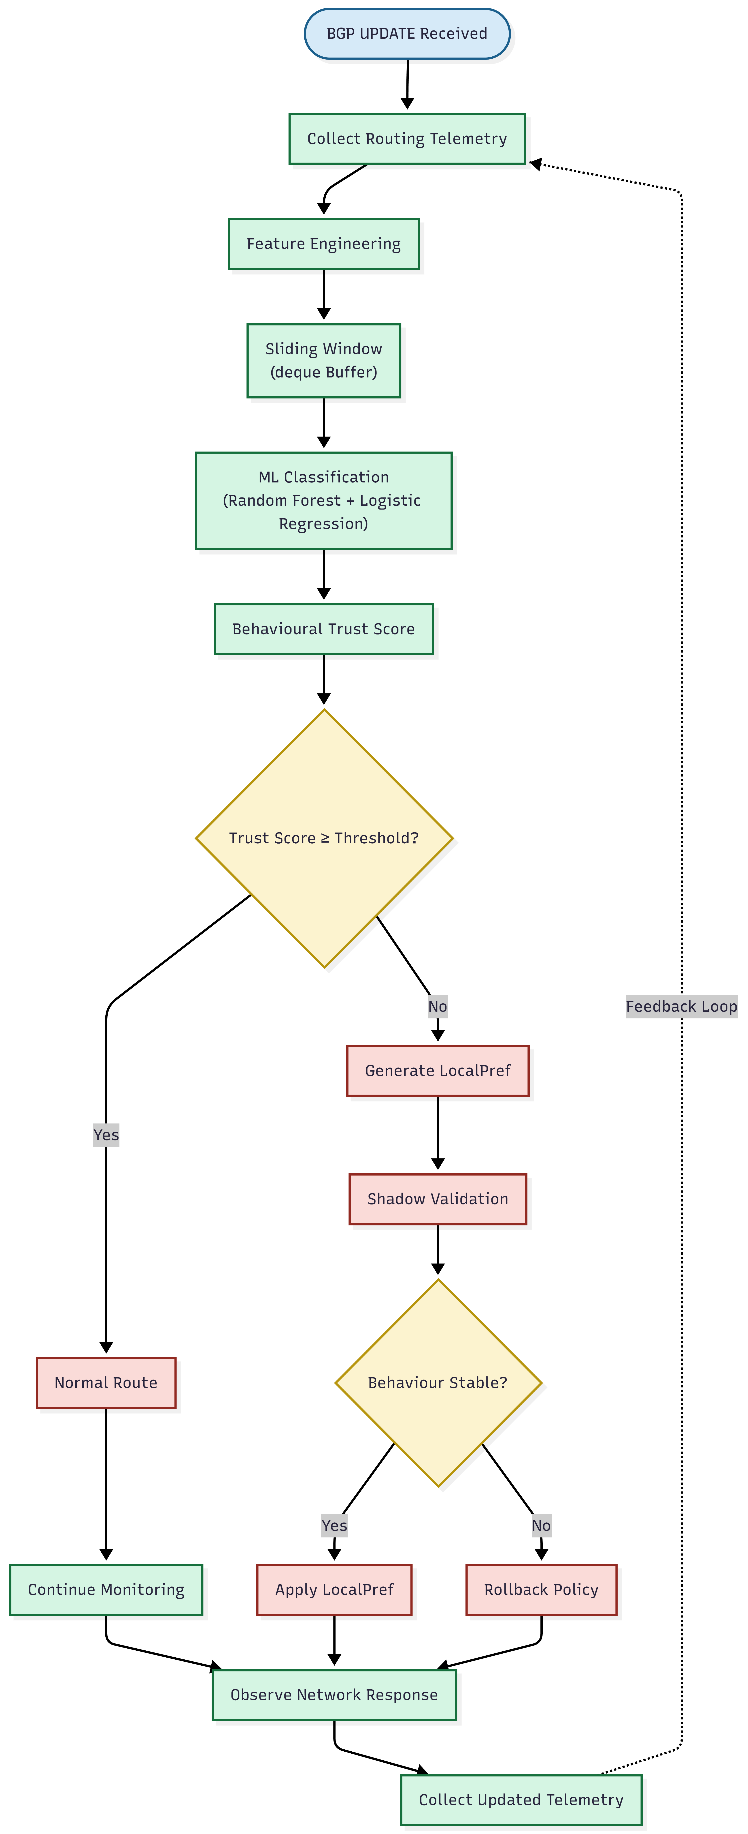

Month 3: Analysis, Documentation, and Presentation

Week 9–10: Experimental Analysis and Performance Evaluation
• Analyse the routing behaviour observed across all experimental scenarios using the collected telemetry and classifier outputs.
• Generate visualisations illustrating:
- Route convergence time before and after AI-assisted policy adaptation
- Trust score evolution for individual prefixes over time
- Local Preference adjustments during routing anomalies
- Route advertisement and withdrawal frequency
- CPU and memory utilisation of the AI-enhanced control plane
- Detection and mitigation timelines for each attack scenario
- Network topology behaviour during route leaks and prefix hijacks
• Compare the performance of the four experimental configurations:
- Standard BGP
- BGP with RPKI / Route Origin Validation
- Behavioural Heuristic Detection
- Proposed AI-Enhanced Behavioural Control Plane
• Evaluate system performance using quantitative metrics including:
- Precision
- Recall
- F1-Score
- False Positive Rate
- False Negative Rate
- Mean Time to Detect (MTTD)
- Mean Time to Mitigate (MTTM)
- Route convergence latency
- Route oscillation count
- Packet delivery ratio
- Network recovery time
- Number of Local Preference modifications
- Average trust score stability
- AI inference latency
- CPU utilisation
- Memory overhead
• Analyse the trade-off between faster anomaly mitigation and the risk of unnecessary routing policy modifications.
• Evaluate the effectiveness of the shadow validation mechanism and automatic rollback process in reducing false-positive routing decisions.
• Compare the experimental results against observations reported in recent literature and discuss how the proposed architecture complements existing routing security mechanisms such as RPKI, RFC 9234, ASPA, and ARTEMIS.

Week 11: Report Writing and Presentation Development
• Prepare the complete technical project report documenting the problem statement, literature review, system architecture, implementation methodology, experimental design, evaluation metrics, results, limitations, and future work.
• Clearly distinguish the research contribution of the proposed architecture from existing routing security approaches by demonstrating that the AI subsystem augments existing BGP implementations rather than replacing established cryptographic mechanisms.
• Develop high-quality architecture diagrams illustrating:
- Containerlab topology
- FRRouting-based Autonomous Systems
- AI behavioural control loop
- Telemetry collection pipeline
- Trust scoring engine
- Behavioural classifier
- Local Preference policy engine
- Shadow validation stage
- Automatic rollback mechanism
• Prepare flowcharts describing:
- AI decision-making workflow
- Behavioural feature extraction process
- Trust score computation
- Routing policy adaptation lifecycle
• Develop an interactive dashboard using React, Tailwind CSS, and D3.js (or Vis.js) to visualise:
- Network topology
- Active BGP sessions
- Route advertisements
- Trust score evolution
- AI-generated routing decisions
- Real-time convergence behaviour
• Finalise presentation slides demonstrating:
- Motivation
- Literature review
- Research gap
- System architecture
- Implementation
- Experimental methodology
- Comparative evaluation
- Results
- Limitations
- Future enhancements

Week 12: Final Validation, Review, and Submission
• Conduct multiple end-to-end validation runs to ensure reproducibility of all experimental results.
• Perform internal mock presentations focusing on technical discussions related to:
- BGP routing behaviour
- AI model selection
- Behavioural feature engineering
- Routing security mechanisms
- Experimental evaluation methodology
- System limitations
- Future research directions
• Verify that all reported experimental results are reproducible using the supplied deployment scripts and container configurations.
• Prepare a public GitHub repository containing:
- Source code
- Containerlab topology files
- FRRouting configuration
- AI agent implementation
- Deployment scripts
- Documentation
- Sample datasets
- Experiment automation scripts
• Package the final project deliverables, including:
- Technical report
- Presentation slides
- Source code
- Experimental datasets
- Configuration files
- Demonstration videos (optional)
• Submit the completed project to the university evaluation panel.

Tools & Technologies

Infrastructure Virtualization
• Docker and Containerlab for creating a realistic inter-domain routing environment where each Autonomous System is implemented as an independent FRRouting container.

Routing Platform
• FRRouting (FRR) as the standards-compliant Border Gateway Protocol implementation supporting real eBGP sessions, route advertisements, policy configuration, route maps, and Local Preference manipulation.

Programming Environment
• Python 3.11+ for implementing the AI behavioural control agent, telemetry processing, feature extraction, experimental automation, and evaluation framework.

Machine Learning
• Scikit-learn for lightweight machine learning models including:
- Random Forest
- Logistic Regression
used for behavioural route classification with low computational overhead suitable for control-plane deployment.

Control Plane Integration
• FRRouting management interfaces (vtysh, northbound APIs, or ExaBGP where appropriate) for collecting routing telemetry and dynamically applying Local Preference policy updates.

Data Structures
• Python collections.deque for implementing efficient sliding-window telemetry buffers and behavioural history management.

Data Processing & Visualisation
• Pandas and NumPy for telemetry analysis and statistical processing.
• Matplotlib and Plotly for generating experimental graphs and evaluation figures.

Interactive Dashboard
• React, Tailwind CSS, and D3.js (or Vis.js) for building a real-time dashboard displaying network topology, trust scores, routing behaviour, and AI-assisted policy decisions.

Version Control
• Git and GitHub for collaborative development, experiment tracking, and reproducible code management.

References
- Jadoon, M. A., et al. Agentic AI Architectural Principles for Autonomous Computer Networks. IRTF NMR G Internet-Draft (Work in Progress), 2026.
- Hong, J., et al. Motivations and Problem Statement of Agentic AI for Network Management. IRTF NMRG Internet-Draft, 2025.
- Auge, J., Betts, S., Carofiglio, G., Grassi, G., Gysi, M., & d'Souza, J. K. Aether: Network Validation Using Agentic AI and Digital Twin. arXiv, 2026.
- Chang, G., Lin, E., Yuan, C., Cai, R., Chen, B., Xie, X., & Zhang, Y. Agent Network Protocol (ANP) Technical White Paper. arXiv, 2025.
- Duan, Q., & Lu, Z. AI Agent Communications in the Future Internet: Paving a Path Toward the Agentic Web. Future Internet, 2026.
- Park, H., Kim, K., Shin, D., & Shin, D. "BGP Dataset-Based Malicious User Activity Detection Using Machine Learning." Information, 14(9), 501, 2023.
- Zhao, H., Wang, R., Zheng, T., Li, Q., Lv, B., Wang, Y., & Du, W. "From Topology to Behavioral Semantics: Enhancing BGP Security by Understanding BGP's Language with LLMs." arXiv:2511.14467, 2025.
- Li, H., Fedeli, M., Kolar, V., & Klabjan, D. "BEAR: BGP Event Analysis and Reporting." arXiv:2506.04514, 2025.
- Sermpezis, P., et al. ARTEMIS: Neutralizing BGP Hijacking Within a Minute. IEEE/ACM Transactions on Networking, 2018.
- Kotronis, V., et al. ARTEMIS: Real-Time Detection and Automatic Mitigation for BGP Prefix Hijacking. Proceedings of the Applied Networking Research Workshop (ANRW), 2018.
- Motaali, S., López de Vergara, J. E., et al. Generating Balanced and Realistic BGP Traffic for Machine Learning-Based Anomaly Detection. IEEE/IFIP Network Operations and Management Symposium (NOMS), 2026.
- Rekhter, Y., Li, T., & Hares, S. A Border Gateway Protocol 4 (BGP-4). RFC 4271.
- Mohapatra, P., et al. BGP Prefix Origin Validation. RFC 6811.
- Azimov, A., Bogomazov, E., Bush, R., Patel, K., & Sriram, K. "Route Leak Prevention and Detection Using Roles in UPDATE and OPEN Messages." RFC 9234, 2022.
- Azimov, A., Bogomazov, E., Bush, R., Patel, K., Snijders, J., & Sriram, K. "BGP AS_PATH Verification Based on Autonomous System Provider Authorization (ASPA) Objects." IETF Internet-Draft draft-ietf-sidrops-aspa-verification (Work in Progress), 2026.

