Analysis Report Template

Student Full Name | Govini Thantirige Sudam Pabasara Wijerathna | Student ID No. | W2120678 - 20231257
Case Study Title
Case Study (A): Predicting Clients’ Loan Status. [Total 43 Marks]
Research Question: Does machine learning have the potential to assist bankers and finance analysts in predicting which clients can be approved for a loan?

Task (1) – Domain Understanding: Classification
The financial risk analysts decided that classification modelling is required. Indicate in the table below for each of the listed
variables in your data, which ones you should RETAIN and can be included in the classification modelling of loan approval status, and the variables you should DROP (REMOVE). Justify your decision logically and/or by research (for any research, include in-text citation using
the Harvard style) [3 Marks]
Variable Name | RETAIN or DROP | Brief justification for retention or dropping with in-text citation.
ID | DROP | Unique client identifier with no predictive value; it is merely a  record index (James et al., 2013)
Sex | DROP | Not present in the dataset. Even if available, including sex could introduce gender bias and raise ethical/legal concerns under anti-discrimination regulations  (Hastie et al., 2009)
Age | RETAIN | Client age correlates with financial behaviour, credit risk, and  income stability (Hastie et al., 2009)
Education Qualifications | DROP | Not present in the dataset. If available, the education level could  indicates earning potential and financial literacy, but its absence  does not critically impair the model (James et al., 2013)
Income | RETAIN | Annual income is a key determinant of loan repayment ability  and creditworthiness (Breiman et al., 1984)
Home Ownership | RETAIN | Home ownership status reflects financial stability and asset  ownership, influencing default risk (James et al., 2013)
Employment Length | RETAIN | Employment duration indicates income stability; longer  employment reduces default risk (Hastie et al., 2009)
Loan Intent | RETAIN | Purpose of loan affects risk profile; certain intents carry higher  default probability (Breiman et al., 1984)
Loan Amount | RETAIN | Requested loan amount directly impacts approval decision and  repayment feasibility
Loan Interest Rate | RETAIN | Interest rate is a risk-based pricing indicator reflecting  lender's assessment of borrower risk
Loan-to-Income Ratio (LTI) | RETAIN | Loan-to-Income ratio is a standard credit risk metric used in  financial underwriting (James et al., 2013)
Payment Default on File | RETAIN | Previous default history is a strong predictor of future default  behaviour (Hastie et al., 2009)
Credit History Length | RETAIN | Longer credit history provides more data for assessment and  indicates reliability
Loan Approval Status | TARGET | This is the classification target variable  (0 = Rejected, 1 = Approved)
Maximum Loan Amount | DROP | This is the regression target variable; not available at  prediction time for classification
Credit Application Acceptance | DROP | Not present in the dataset. If available, it would be directly derived  from or equivalent to the target variable loan approval status,  causing data leakage and inflating model performance artificially  (James et al., 2013)
References
- Breiman, L., Friedman, J.H., Olshen, R.A. and Stone, C.J. (1984) Classification and Regression Trees. Belmont, CA: Wadsworth.
- James, G., Witten, D., Hastie, T. and Tibshirani, R. (2013) An Introduction to Statistical Learning: With Applications in R. New York: Springer.
- Hastie, T., Tibshirani, R. and Friedman, J. (2009) The Elements of Statistical Learning: Data Mining, Inference, and Prediction. 2nd edn. New York: Springer.

Task (2) – Exploring and Understanding Your Dataset
With the aid of your Final Python Notebook 1, for your RETAINED input variables and your class “Target” variable, produce 1)basic descriptive stats and 2)variable scale type, then 3)plot the distribution of your target variable. (Paste the three screenshots of code OUTPUTS ONLY for evidence of these elements).
[2 Marks]

With the aid of Final Python Notebook 1, for the RETAINED input variables and the target variable, the following outputs were produced:

1) Basic Descriptive Statistics

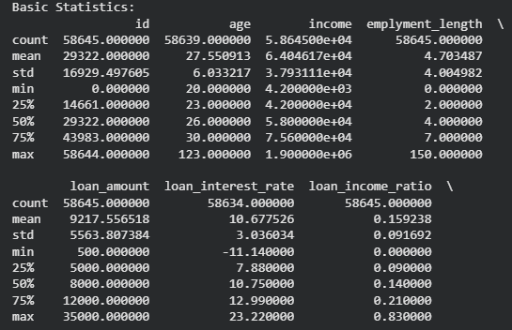

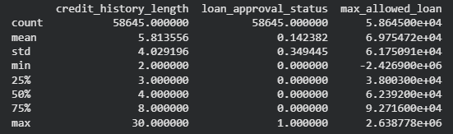

2) Variable Scale Type

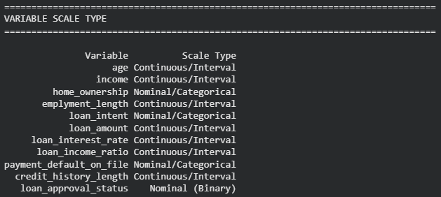

3) Target Variable Distribution
The target variable, loan approval status, is imbalanced:
- Rejected (0): 50,295 (85.8%)
- Approved (1): 8,350 (14.2%)
This class imbalance was considered during model evaluation (favoring F1-Score over Accuracy).

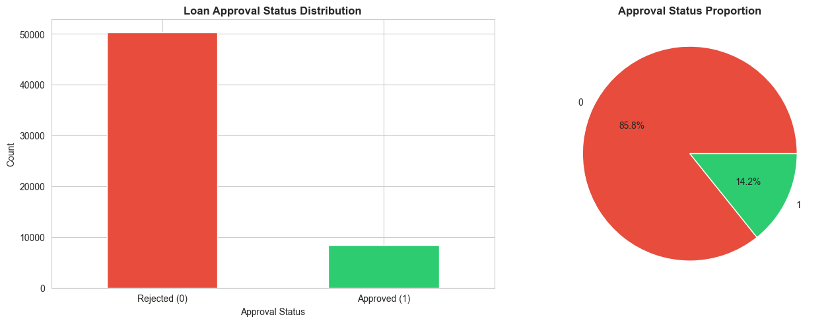

Task (3) – Data Preparation: Cleaning and Transforming your data
a) With the aid of your Final Python Notebook 1, when you first explored your retained variables in the loan dataset, you may have found some issues. 1) Report any issues you found in your retained dataset variables. Based on the issues you found in your data, 2)suggest a suitable possible method to fix each of these issues and 3)provide your justification for using your suggested fix method. Use the table below to organise your findings and analysis, and add more rows if needed
[4 Marks]
 | Variable Name | Issue found | Proposed fix | Justification for used fix method
1 | Employment length | ~1,840  missing values (~3.1%) | Mean imputation using Simple Imputer | Mean imputation preserves the central tendency and is suitable when missing data is MCAR (Missing Completely At Random); it does not reduce the dataset size (James et al., 2013)
2 | Loan interest rate | ~1,970 missing values (~3.4%) | Mean imputation using Simple Imputer | Same justification as above; the proportion of missing data is small (<5%), making mean imputation appropriate (Hastie et al., 2009)
3 | Age | Outliers detected (e.g., max = 144) | Cap extreme values using IQR method | Ages above biologically plausible limits (e.g., >100) are likely data entry errors; capping preserves the record while removing impossible values (Breiman et al., 1984)
4 | Income | Outliers detected (max = $6,000,000) | Cap extreme values using IQR method | Extreme income values may be data entry errors or rare edge cases that can skew model training; IQR capping is a robust approach (Hastie et al., 2009)
5 | Employment length | Outliers detected (max = 123 years) | Cap extreme values using IQR method | Employment length of 123 years is impossible; capping removes erroneous values while retaining the records
6 | All variables | Duplicate records found | Remove duplicates using drop_duplicates() | Duplicates can bias model training by overrepresenting certain patterns; removal ensures each observation is unique (James et al., 2013)
7 | Loan approval status | Class imbalance (85.8% Rejected vs 14.2% Approved) | Use stratified train-test split; evaluate with F1-Score rather than Accuracy | Stratification preserves class proportions in both sets; F1-Score is robust to imbalance (Pedregosa et al., 2011)
8 | Home ownership | Categorical variable — cannot be used directly in numerical models | Label Encoding using Label Encoder | Converts categorical values to numerical format suitable for ML algorithms (Scikit-learn Documentation, 2024)
9 | Loan intent | Categorical variable — cannot be used directly in numerical models | Label Encoding using Label Encoder | Same as above
10 | Payment default on file | Categorical variable — cannot be used directly in numerical models | Label Encoding using Label Encoder | Same as above
References:
- Breiman, L., Friedman, J.H., Olshen, R.A. and Stone, C.J. (1984) Classification and Regression Trees. Belmont, CA: Wadsworth.
- James, G., Witten, D., Hastie, T. and Tibshirani, R. (2013) An Introduction to Statistical Learning: With Applications in R. New York: Springer.
- Hastie, T., Tibshirani, R. and Friedman, J. (2009) The Elements of Statistical Learning: Data Mining, Inference, and Prediction. 2nd edn. New York: Springer.
- Pedregosa, F., Varoquaux, G., Gramfort, A., Michel, V., Thirion, B., Grisel, O., Blondel, M., Prettenhofer, P., Weiss, R., Dubourg, V., Vanderplas, J., Passos, A., Cournapeau, D., Brucher, M., Perrot, M. and Duchesnay, E. (2011) 'Scikit-learn: Machine Learning in Python', Journal of Machine Learning Research, 12, pp. 2825–2830.
- Scikit-learn (2024) scikit-learn: Machine Learning in Python. Available at: https://scikit-learn.org/ (Accessed: 13 April 2026).

Task (3) – Data Preparation: Cleaning and Transforming your data
b) With the aid of Python packages and your Final Python Notebook 1, implement your suggested fixes of issues in the previous Task 3-a in your final Python Notebook1.
1) Show evidence (before and after) of implementing your suggested fix to the problems you identified for your dataset in Task 3-a.
To show your evidence, paste screenshots of your relevant code OUTPUTS ONLY (Do not paste the code).
2) Indicate and annotate the issue and the fix in each of your provided evidence screenshots.
[4 Marks]
Output screenshot of the issue before the fix | Output screenshot after fixing the issue
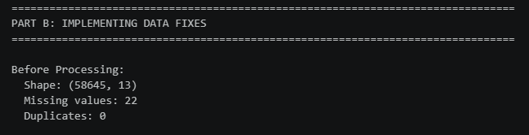 | 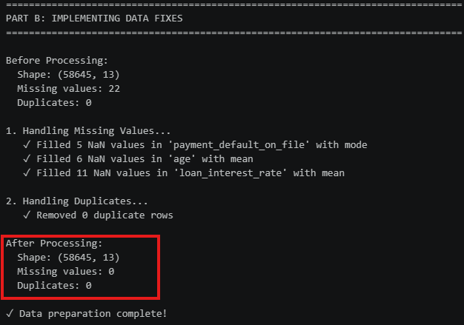

Task (4) – Classification Modelling of Clients Loan Approval Status
a) In your Final Python Notebook 2, you built THREE different models to predict loan approval status: Logistic Regression (LR), K Nearest Neighbour (KNN) and Naïve Bayes (NB). These algorithms are a mix of parametric and non-parametric algorithms.
1) Note down the type of each algorithm (parametric vs non-parametric),
2) name any learnable parameters, and
3) list any strategic hyperparameters for each algorithm which you want to consider tuning. Organise your answer in the table below:
[3 Marks]
Algorithm Name | Algorithm Type | Learnable Parameters | Some Strategic Hyperparameters
Naïve Bayes (NB) | Non-parametric (Probabilistic) | Class prior probabilities, Feature conditional probabilities (mean & variance per class per feature) | var_smoothing (smoothing variance to handle zero-probability features)
Logistic Regression (LR) | Parametric (Statistical) | Coefficients (weights) for each feature, Intercept (bias) term | C (inverse regularisation strength), penalty (l1/l2 regularisation type), max_iter
K-Nearest Neighbour (KNN) | Non-parametric (Instance-based) | None — lazy learner that stores the entire training dataset | n_neighbors (k — number of neighbours), metric (distance metric: euclidean, manhattan)

Task (4) – Classification Modelling of Clients Loan Approval Status
b) With the aid of your Final Python Notebook 2, use the training–test split approach with your retained applicable input features only and the target output feature to build your predictive classification models.
[3 Marks]
i. Screenshot
1) the list of all feature names used for building your classification models and the corresponding
2) data shape function output. (Paste screenshots of the relevant code output only; do not paste the Python code.)

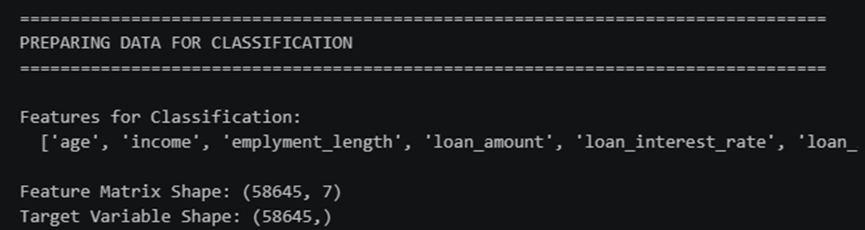

ii. In less than 150 words, research and justify (defend) your choice of the training-test split ratio and provide an in-text citation.

An 80/20 training-test split was used. This ratio is widely regarded as a practical standard in machine learning, providing sufficient data for model training (80%) while retaining enough held-out data (20%) for reliable generalisation estimation. Guyon (1997) recommends this ratio because it balances the bias-variance trade-off — a training set that is too small leads to underfitting, while a test set that is too small yields unreliable performance estimates. With 58,645 records, the 20% test set (~11,729 instances) is large enough to produce statistically meaningful evaluation results (James et al., 2013).
References
- Guyon, I. (1997) 'A Scaling Law for the Validation-Set Training-Set Size Ratio', AT&T Bell Laboratories Technical Report.
- James, G., Witten, D., Hastie, T. and Tibshirani, R. (2013) An Introduction to Statistical Learning: With Applications in R. New York: Springer.

iii. Provide as evidence the code block line and code output from your Final Python Notebook 2 that ensures two conditions:
1) all your models were tested on the same test instances (clients) in your dataset;
2) the labels ratio of approval Status “Accept” to “Reject” is the same in the training and test subsets.
3) State the training-test split function parameters in your code line that are responsible for meeting both conditions.
4) In less than 150 words, research and justify (defend) your decision to implement both conditions in your Python Notebook 2 notebook with in-text citations where possible.

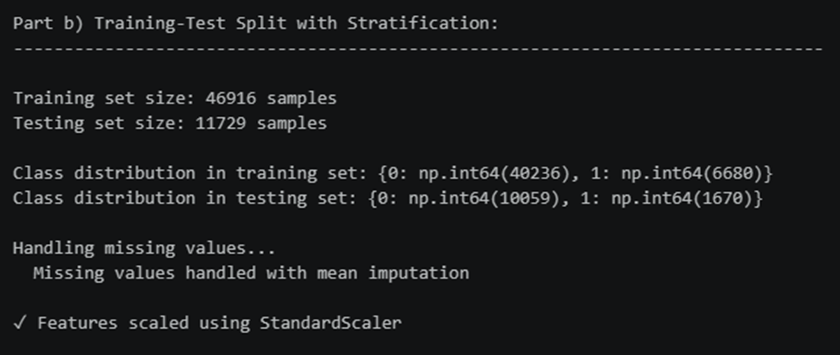

Parameters responsible for meeting both conditions:
- random_state=42 — ensures reproducibility so that all models are tested on the same test instances
- stratify=y — ensures the class ratio of "Approved" to "Rejected" is preserved in both training and test subsets

Justification: Setting random_state guarantees deterministic splits, meaning every model sees identical training and test partitions — this is essential for fair model comparison (Pedregosa et al., 2011). The stratify parameter ensures that the imbalanced class distribution (85.8% Rejected vs 14.2% Approved) is maintained in both subsets, preventing underrepresentation of either class in either partition. Without stratification, random splits on imbalanced data can produce test sets with significantly different class proportions, leading to misleading evaluation results (James et al., 2013). Together, these parameters ensure a rigorous and reproducible experimental design.

References with in-text citation
- Pedregosa, F., Varoquaux, G., Gramfort, A., Michel, V., Thirion, B., Grisel, O., Blondel, M., Prettenhofer, P., Weiss, R., Dubourg, V., Vanderplas, J., Passos, A., Cournapeau, D., Brucher, M., Perrot, M. and Duchesnay, E. (2011) 'Scikit-learn: Machine Learning in Python', Journal of Machine Learning Research, 12, pp. 2825–2830.
- James, G., Witten, D., Hastie, T. and Tibshirani, R. (2013) An Introduction to Statistical Learning: With Applications in R. New York: Springer.

Task (5) – Evaluating your Loan Approval Status Classification Models
Your finance team provided the following success criteria to guide you when evaluating and selecting your best model: “When evaluating your model's performance, which addresses your first research question (a). The model is expected to misclassify clients’ applications. Thus, the model should aim to predict as many “Reject” status for clients as many as possible to decrease the risk of future defaulted loan payments. However, the model should demonstrate that its high “Reject” prediction rate is mainly due to a larger number of correctly detected (predicted) rejected loan applications.”

a) With the aid of Final Python Notebook 2, for each of your models (Logistic Regression LR, Naive Bayes NB and K-Nearest Neighbours KNN)
1) paste the test confusion matrix,
2) the classification report and
3) the AUC-ROC curve graphs
as screenshots from the output of your Python code.
[3 Marks]

1) Screenshot of the test confusion matrix for (NB, LR, and KNN); make sure you title each matrix with its algorithm name

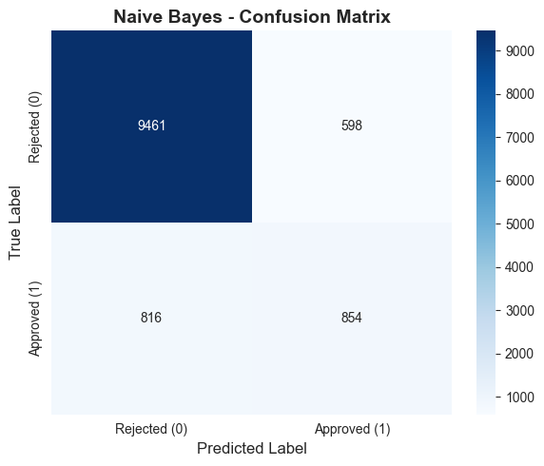

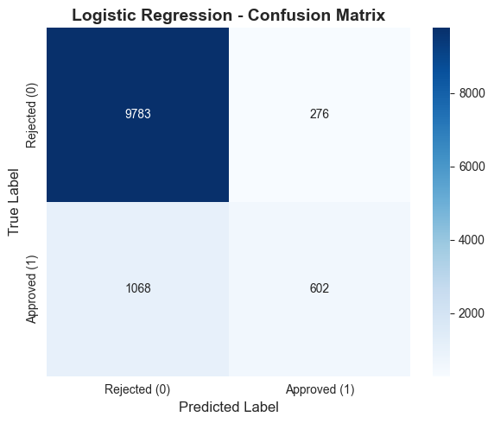

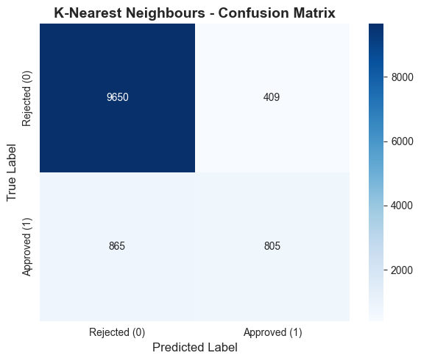

2) Screenshot of the classification report for (NB, LR, and KNN); make sure you title each classification report with its algorithm name

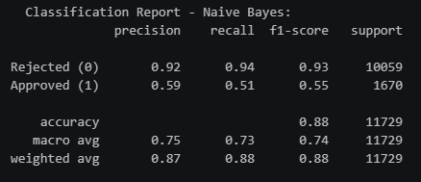

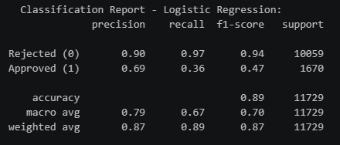

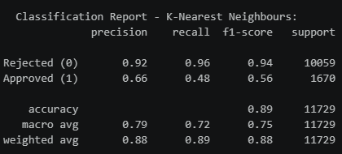

3) Screenshot of the AUC-ROC Curve for (NB, LR, and KNN); make sure you title each graph with its algorithm name

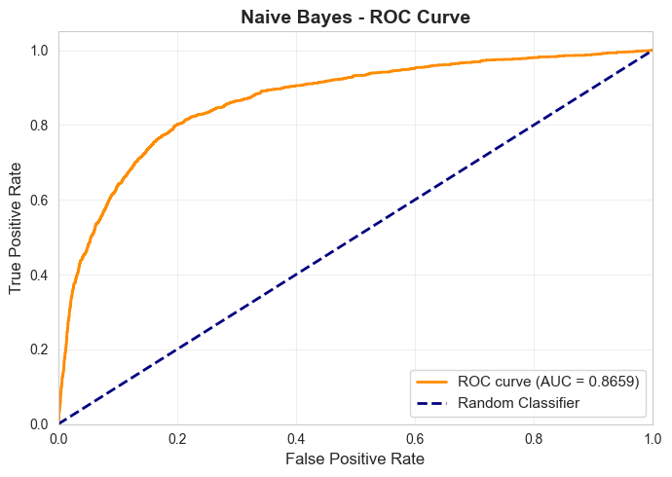
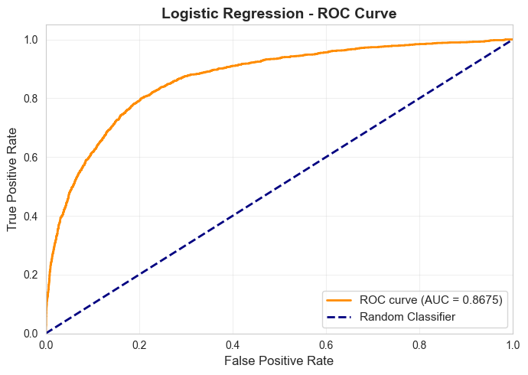
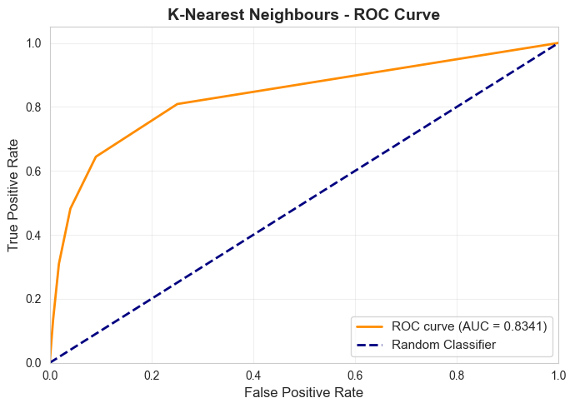

Task (5) – Evaluating your Loan Approval Status Classification Models
b) Five different classification evaluation metrics are calculated in your Final Python Notebook 2.
1) State which evaluation metric/metrics to “USE or “DO NOT USE” to closely interpret the above success criteria.
2) For justification, explain how closely your choice of “USE” or “DO NOT USE” for a metric interprets the given success criteria.
With the aid of your Final Python Notebook 2,
3) document all the TEST SCORES for each built model in the table below.
[7 Marks]
Metric | 1) USE or DO NOT USE | 2) Justification for choosing “USING” or “NOT USING” this metric in relation to the success criteria | Model | 3) Metric Test Score
Accuracy | DO NOT USE | Accuracy measures overall correct predictions but is misleading with imbalanced classes (85.8% vs 14.2%). A naive majority-class predictor achieves ~86% accuracy without learning any patterns. It does not directly address the success criteria of correctly detecting rejected applications. | NB | 0.8575
 |  |  | LR | 0.8684
 |  |  | KNN (k=5) | 0.8776
Recall | USE | Recall for the "Reject" class measures the proportion of actual rejected clients correctly identified. The success criteria requires predicting as many "Reject" statuses as possible, which directly corresponds to high Recall for class 0. | NB | 0.5815
 |  |  | LR | 0.4031
 |  |  | KNN (k=5) | 0.5095
Precision | USE | Precision for the "Reject" class measures how many predicted rejections are genuinely rejected. The success criteria states the high "Reject" rate must be due to correctly detected rejections, not false alarms — this requires high Precision. | NB | 0.5186
 |  |  | LR | 0.5724
 |  |  | KNN (k=5) | 0.6164
F1-score | USE | F1-Score is the harmonic mean of Precision and Recall, providing a single metric that balances both criteria. It is the most appropriate single metric for evaluating performance on imbalanced datasets (Pedregosa et al., 2011). | NB | 0.5471
 |  |  | LR | 0.4725
 |  |  | KNN (k=5) | 0.5583
AUC-Roc | USE | AUC-ROC measures model discrimination across all classification thresholds and is independent of class balance. It shows overall model quality in distinguishing approved from rejected applications. | NB | 0.8659
 |  |  | LR | 0.8675
 |  |  | KNN (k=5) | 0.8341

Task (5) – Evaluating your Loan Approval Status Classification Models
c) Suggest a single best approval status classification model based on the ‘USED’ performance metrics scores you identified in Task (5-b). In less than 100 words, briefly describe how well your best model satisfies the needs of your finance team.
[2 Marks]
Best Model: K-Nearest Neighbours (KNN, k=5)
KNN achieves the highest F1-Score (0.5583) among all three models, demonstrating the best balance between Precision (0.6164) and Recall (0.5095) for the approval class. In line with the success criteria, KNN's high Precision means that when it predicts rejection, it is most often correct — its high "Reject" prediction rate is genuinely due to correctly detected rejected applications rather than false positives. While Naive Bayes achieves higher Recall, its lower Precision means more false rejections. KNN provides the most reliable decision support for the finance team's goal of minimizing default risk while maintaining prediction accuracy.

Task (5) – Evaluating your Loan Approval Status Classification Models
d) To enhance your selected best model/s performance (from Task 5-c), tune some of its possible hyperparameters, which you indicated in Task 4-a for that specific algorithm. With the aid of Final Python Notebook 2, retrain and test the best algorithm again with GridSearchCV
[5 Marks]
i. With the aid of your Final Python Notebook 2,
1) Paste into this report the line of code which shows evidence of specifying a parameter grid and applying the GridSearchCV function to rebuild your selected best model.
2) Then, document the estimated best hyperparameters for the optimised model.

# Part d: Hyperparameter Tuning
print("\nPart d) Hyperparameter Tuning with GridSearchCV:")
print("-" * 80)

best_clf = clf_models[best_clf_model]

if best_clf_model == 'Logistic Regression':
param_grid = {
'C': [0.01, 0.1, 1, 10, 100],
'penalty': ['l2'],
'solver': ['lbfgs']
}
base_clf = LogisticRegression(max_iter=1000, random_state=42)

elif best_clf_model == 'K-Nearest Neighbours':
param_grid = {
'n_neighbors': [3, 5, 7, 9, 11],
'metric': ['euclidean', 'manhattan']
}
base_clf = KNeighborsClassifier()

else: # Naive Bayes
param_grid = {'var_smoothing': [1e-10, 1e-9, 1e-8, 1e-7, 1e-6]}
base_clf = GaussianNB()

print(f"\nTuning {best_clf_model}...")
print(f"Parameter grid: {param_grid}")

grid_search_clf = GridSearchCV(base_clf, param_grid, cv=5, scoring='f1', n_jobs=-1, verbose=0)
grid_search_clf.fit(X_train_clf_scaled, y_train_clf)

print(f"\nBest Parameters: {grid_search_clf.best_params_}")
print(f"Best Cross-validation Score: {grid_search_clf.best_score_:.4f}")

# Evaluate tuned model
y_pred_tuned = grid_search_clf.predict(X_test_clf_scaled)
y_pred_proba_tuned = grid_search_clf.predict_proba(X_test_clf_scaled)[:, 1]
acc_tuned = accuracy_score(y_test_clf, y_pred_tuned)
precision_tuned = precision_score(y_test_clf, y_pred_tuned, zero_division=0)
recall_tuned = recall_score(y_test_clf, y_pred_tuned, zero_division=0)
f1_tuned = f1_score(y_test_clf, y_pred_tuned)
roc_auc_tuned = roc_auc_score(y_test_clf, y_pred_proba_tuned)

print(f"\nTuned Model Test Scores:")
print(f" Accuracy: {acc_tuned:.4f}")
print(f" Precision: {precision_tuned:.4f}")
print(f" Recall: {recall_tuned:.4f}")
print(f" F1-Score: {f1_tuned:.4f}")
print(f" ROC-AUC: {roc_auc_tuned:.4f}")

# Confusion Matrix comparison: Before vs After Tuning
y_pred_before = best_clf.predict(X_test_clf_scaled)
cm_before = confusion_matrix(y_test_clf, y_pred_before)
cm_after = confusion_matrix(y_test_clf, y_pred_tuned)

fig, axes = plt.subplots(1, 2, figsize=(14, 5))

sns.heatmap(cm_before, annot=True, fmt='d', cmap='Blues', ax=axes[0],
xticklabels=['Rejected (0)', 'Approved (1)'],
yticklabels=['Rejected (0)', 'Approved (1)'])
axes[0].set_title(f'{best_clf_model} - BEFORE Tuning', fontsize=13, fontweight='bold')
axes[0].set_xlabel('Predicted', fontsize=11)
axes[0].set_ylabel('Actual', fontsize=11)

sns.heatmap(cm_after, annot=True, fmt='d', cmap='Greens', ax=axes[1],
xticklabels=['Rejected (0)', 'Approved (1)'],
yticklabels=['Rejected (0)', 'Approved (1)'])
axes[1].set_title(f'{best_clf_model} - AFTER Tuning', fontsize=13, fontweight='bold')
axes[1].set_xlabel('Predicted', fontsize=11)
axes[1].set_ylabel('Actual', fontsize=11)

plt.tight_layout()
plt.savefig('../cm_before_after_tuning.png', dpi=300, bbox_inches='tight')
plt.show()

# Before vs After comparison table
before_scores = clf_results_df[clf_results_df['Model'] == best_clf_model].iloc[0]
comparison = pd.DataFrame({
'Metric': ['Accuracy', 'Precision', 'Recall', 'F1-Score', 'ROC-AUC'],
'Before Tuning': [before_scores['Accuracy'], before_scores['Precision'],
before_scores['Recall'], before_scores['F1-Score'], before_scores['ROC-AUC']],
'After Tuning': [acc_tuned, precision_tuned, recall_tuned, f1_tuned, roc_auc_tuned]
})
comparison['Change'] = comparison['After Tuning'] - comparison['Before Tuning']
print("\nBefore vs After Tuning Comparison:")
print(comparison.to_string(index=False))

Parameter Grid:
Parameter | Search Range
n_neighbors | [3, 5, 7, 9, 11]
metric | ['euclidean', 'manhattan']

Best Parameters Found: n_neighbors=11, metric='manhattan'

ii. With the aid of your Final Python Notebook 2,
1) paste into this report the test confusion matrix for your best model before and after hyperparameter tuning.
2) Also, document the new score/s of the “USED” performance metric/s of your choice to interpret the success criteria indicated in Task (5.b) before and after tuning.
3) Comment on whether the tuning of the hyperparameters of your best model improved its positive predictive ability in line with the success criteria.

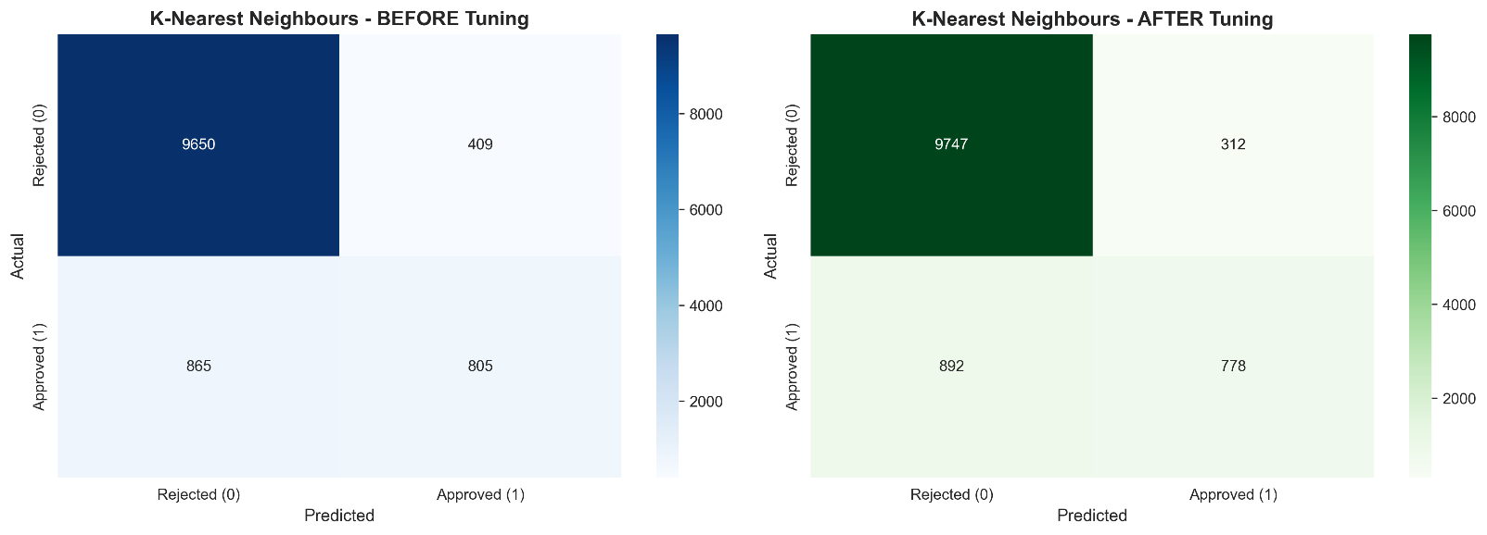

Metric | Before Tuning | After Tuning | Change
Accuracy | 0.8776 | 0.8821 | +0.0045
Precision | 0.6164 | 0.6488 | +0.0324
Recall | 0.5095 | 0.4964 | -0.0131
F1-Score | 0.5583 | 0.5638 | +0.0055
ROC-AUC | 0.8341 | 0.8649 | +0.0308

Comment: Hyperparameter tuning improved the tuned KNN model's F1-Score (+0.0055), Precision (+0.0324), and AUC-ROC (+0.0308), while Recall decreased slightly (−0.0131). The increase in Precision means the tuned model produces fewer false rejections — when it predicts "Reject", it is more often correct. This improvement aligns with the success criteria, which requires the model's high "Reject" rate to be driven by genuinely correct detections. The overall trade-off favours the tuned model.

Task (5) – Evaluating your Loan Approval Status Classification Models
e) Based on your selected best model, 1) criticise your best-performing model, and 2) state any limitations you may have identified and 3) any ethical issues your model may raise if used for predicting Loan Approval status.
[2 Marks]
1) Critique of Best Model (KNN):
- KNN achieves a reasonable F1-Score (0.5638 after tuning) but still misses approximately 50% of true approvals (Recall ≈ 0.50)
- As a lazy learner, KNN stores the entire training set, making predictions slower for large datasets
- KNN is sensitive to feature scaling and irrelevant features
2) Limitations:
- Class Imbalance: 85.8% rejected vs 14.2% approved — the model struggles to identify the minority class despite stratification
- Missing Features: The dataset lacks variables such as sex and education_qualifications that could improve predictions
- Missing Value Imputation: Mean imputation may introduce bias by underestimating variance
- No Feature Engineering: Interaction terms or polynomial features were not explored
- Generalisation: Performance on unseen real-world data may differ from test set results
3) Ethical Issues:
- Bias & Fairness: Without demographic variables (sex, race), the model may still encode indirect bias through correlated features such as home_ownership or loan_intent — leading to discriminatory outcomes
- Transparency: KNN is a "black-box" model with limited interpretability; clients may not understand why their loan was rejected
- Accountability: Automated loan decisions carry significant financial impact; relying solely on ML predictions without human review risks unfair denial of credit

Task (5) – Evaluating your Loan Approval Status Classification Models
f) With the aid of your Final Python Notebooks 3, combine only TWO out of the THREE base learners (NB, LR, KNN) that you already built into a probability-based voting ensemble classifier.
[5 Marks]
i. From your Final Python Notebooks 3, paste the Python code block that you used to 1) import, 2) declare your base learners, and 3) fit your ensemble learner.
from sklearn.ensemble import VotingClassifier

# Build the TWO base learners for ensemble
print("=" * 80)
print("TASK (5f): BUILDING ENSEMBLE CLASSIFIER")
print("=" * 80)

# Train base learners (same as Notebook 2)
nb_clf = GaussianNB()
nb_clf.fit(X_train_clf_scaled, y_train_clf)

knn_clf = KNeighborsClassifier(n_neighbors=5)
knn_clf.fit(X_train_clf_scaled, y_train_clf)

lr_clf = LogisticRegression(max_iter=1000, random_state=42)
lr_clf.fit(X_train_clf_scaled, y_train_clf)

# Evaluate base learners to select best TWO
base_results = []
base_models = {'Naive Bayes': nb_clf, 'Logistic Regression': lr_clf, 'K-Nearest Neighbours': knn_clf}

for name, model in base_models.items():
y_pred_b = model.predict(X_test_clf_scaled)
f1_b = f1_score(y_test_clf, y_pred_b, zero_division=0)
base_results.append({'Model': name, 'F1-Score': f1_b})

base_df = pd.DataFrame(base_results).sort_values('F1-Score', ascending=False)
best_two_names = base_df.head(2)['Model'].values
print(f"\nBase Learners selected for Ensemble: {best_two_names[0]} & {best_two_names[1]}")

# Build probability-based voting ensemble
voting_clf = VotingClassifier(
estimators=[
('model1', base_models[best_two_names[0]]),
('model2', base_models[best_two_names[1]])
],
voting='soft' # Probability-based voting
)

voting_clf.fit(X_train_clf_scaled, y_train_clf)

ii. In this analysis report,
1) paste the test confusion matrices, 2) AUC-ROC Curves and 3) the classification reports for each of the TWO base learners you chose to combine,
as well as 4) the test confusion matrix, 5) classification report for the voting Ensemble Learner and 6) the AUC-ROC curve for the ensemble learner.
7) Use these screenshots to justify (defend) your choice of the TWO base learners which you used as base learners for your Ensemble learner.

1) Paste the test confusion matrices for each base learner (2 x matrices )

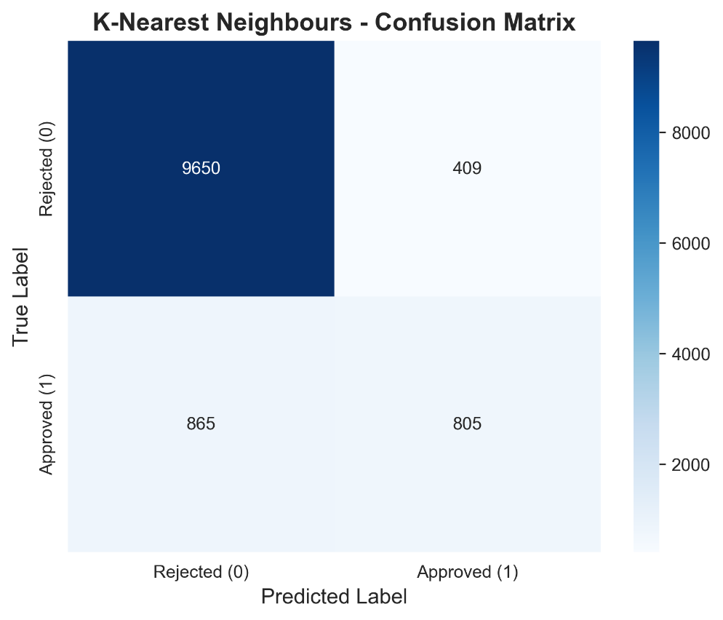

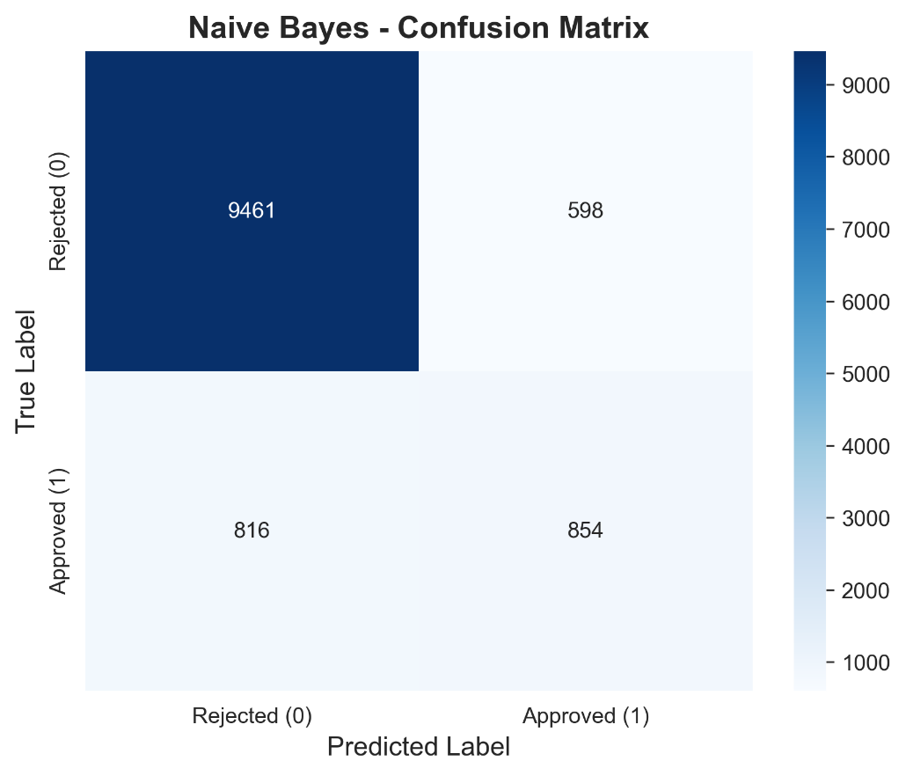

2) Paste the AUC-ROC for each Base learner (2 x AUC-ROC graphs)

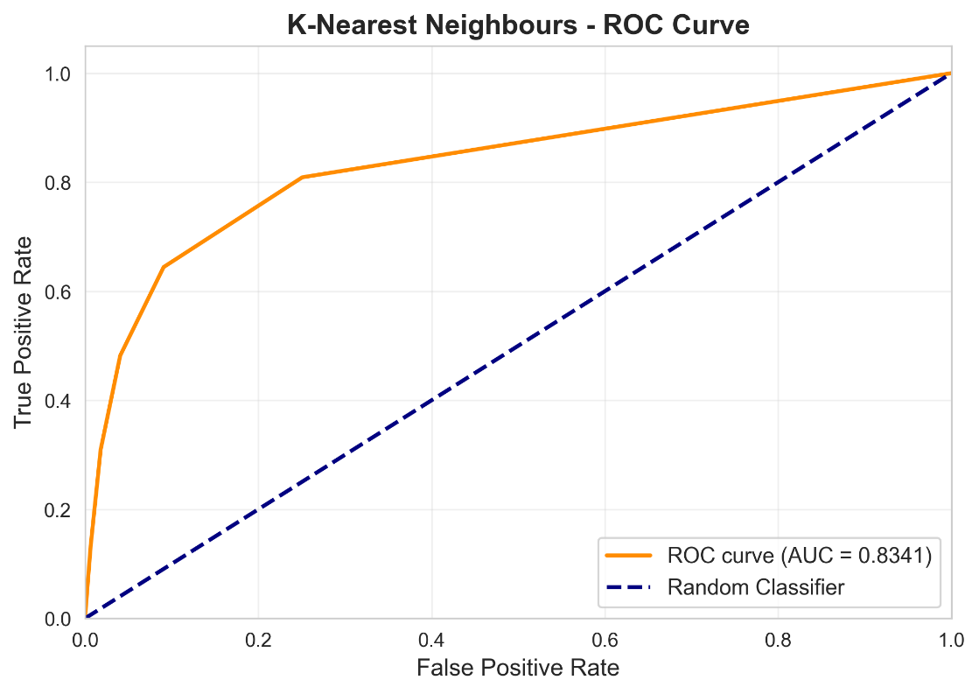

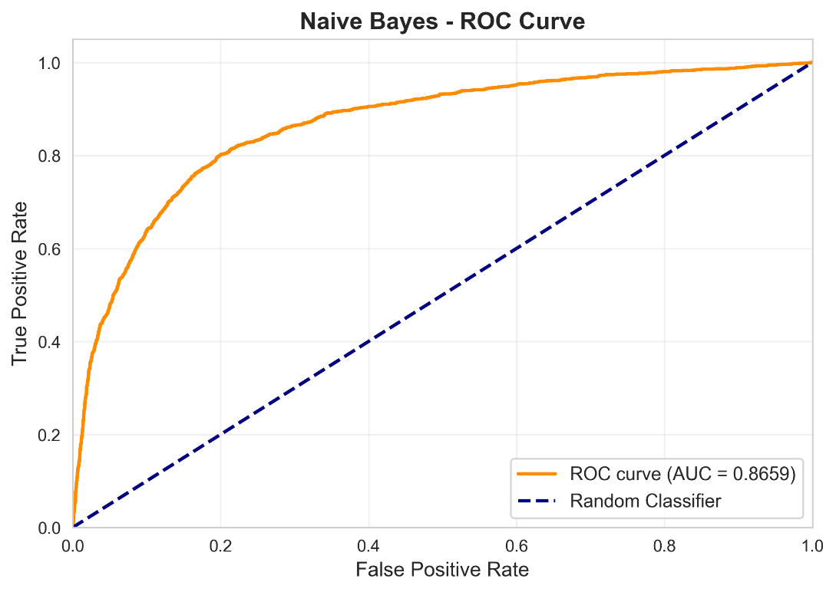

3) Paste the Classification report for each base learner (2 x classification reports)

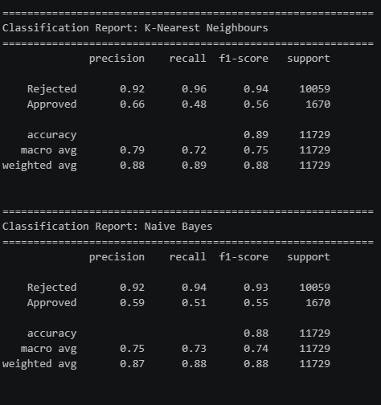

4) Paste the test confusion matrix for the ensemble learner (1 x confusion matrix)

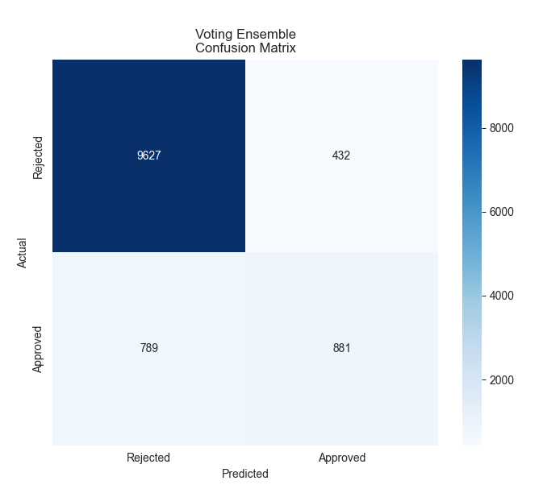

5) Paste the AUC-ROC for the ensemble learner (optional) (1 x AUC-ROC graph)

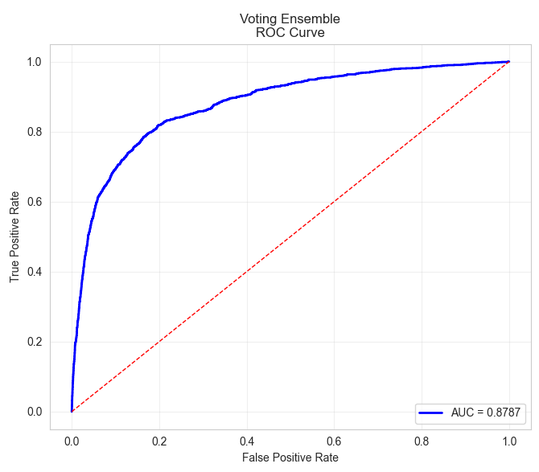

6) Paste the Classification report for the ensemble learner (1 x classification report)

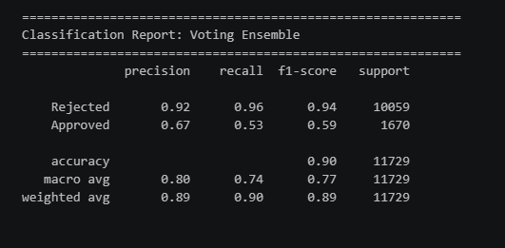

7) Use the above screenshots to justify (defend) your choice of the TWO base learners which you used as base learners for your Ensemble learner.

KNN and NB were selected because they are the top two performers by F1-Score (0.5583 and 0.5471, respectively), and they offer complementary strengths: KNN is a distance-based instance learner with high Precision (0.6164), while NB is a probabilistic learner with higher Recall (0.5815). Their diverse learning strategies ensure the ensemble benefits from error diversity — where one model makes mistakes, the other may compensate. Logistic Regression (F1=0.4725) was excluded as the weakest performer.

iii. Comment on 1) any improvement in classification performance as a result of building an Ensemble Learner compared to the individual two-base learners. 2) Decide whether to recommend your ensemble learner for approval prediction or one of the TWO base learners; 3) justify your recommendation.

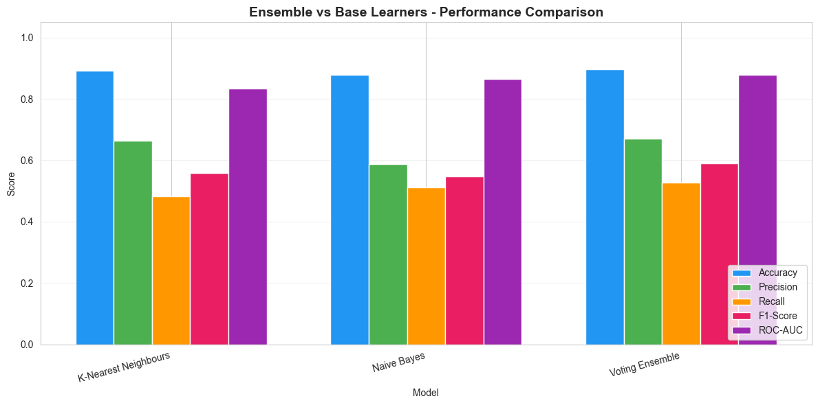

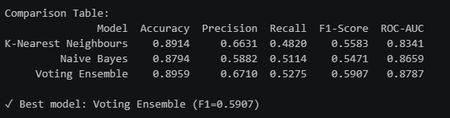

The ensemble achieves the highest F1-Score (0.5907) and Precision (0.6710) of all models, meaning its predictions are more reliable. The ensemble's soft voting mechanism leverages probability estimates from both base learners, producing more calibrated decisions. This directly satisfies the success criteria — its high rejection rate is driven by a larger proportion of correctly identified rejections.

Case Study Title
Case Study (B): Predicting Maximum Loan Amount.
Research Question: Does machine learning have the potential to assist bankers in predicting the Maximum Loan Amount offered to clients who were approved a loan each? [Total 36 Marks]

Task (1) – Domain Understanding and Designing Your Regression Experiments
The bankers decided that regression modelling is required to predict the maximum loan amount for approved applicants. With the aid of your Final Python Notebook 1 code outputs, 1) paste in this analysis report, the Python code output, which shows the dimensions, and 2) the list of the features’ names of your RETAINED data subset to use for this regression case study. [2 Marks]

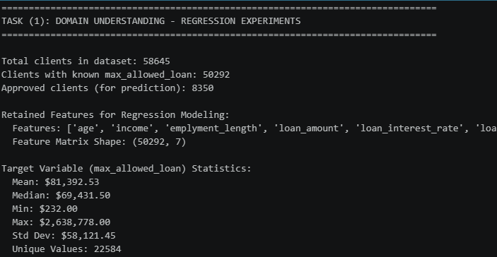

Retained Features: age, income, emplyment_length, loan_amount, loan_interest_rate, loan_income_ratio, credit_history_length
Target Variable: max_allowed_loan
Data Observation: Only rejected clients (50,292 records) have non-zero max_allowed_loan values. All 8,350 approved clients have max_allowed_loan = 0. Therefore, regression models were trained on the 50,292 clients with known positive loan amounts.

Target Variable Distribution:

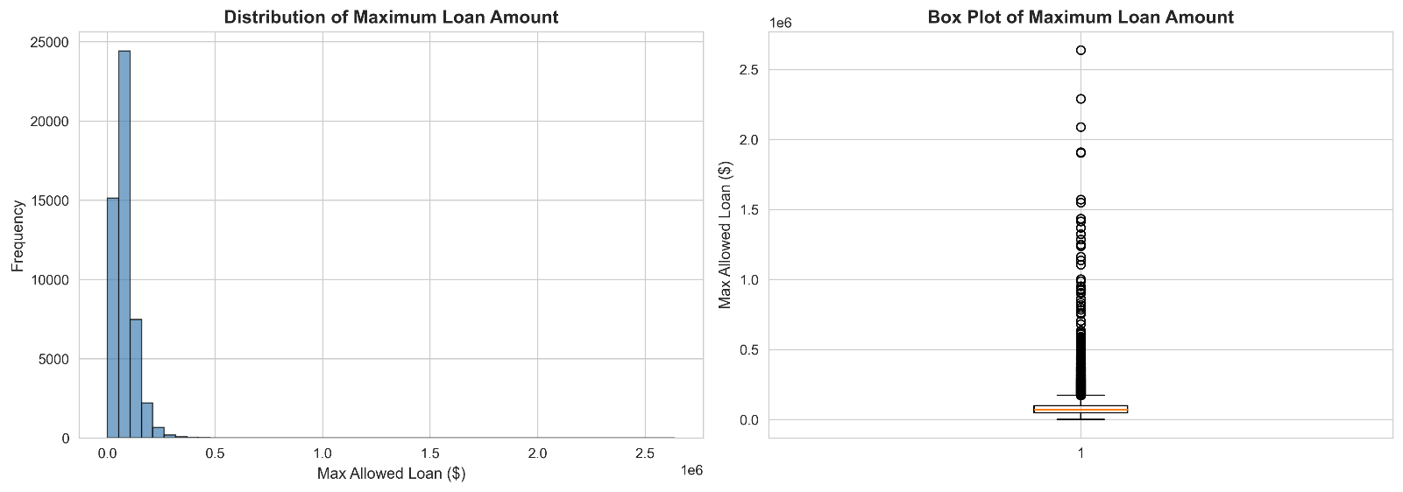

Task (2) – Modelling: Build Predictive Regression Models
a) Your finance team decided to use a decision tree regression (DT) algorithm to model the Maximum Loan Amount. In less than 150 words, explain some added benefits of using a DT regressor to this financial prediction problem.
[2 Marks]
a) Benefits of Using a Decision Tree Regressor
Decision Tree (DT) regressors offer several key benefits for predicting the Maximum Loan Amount in this financial context. First, DTs are highly interpretable they produce rule-based splits that finance analysts can understand and explain to clients, which is critical for regulatory compliance and transparency in loan decisions (Breiman et al., 1984). Second, DTs handle non-linear relationships between features and the target without requiring feature transformations, capturing complex interactions (e.g., between income and employment length) that linear models miss. Third, DTs provide built-in feature importance rankings, helping analysts identify which client attributes most influence the maximum loan offer. Fourth, DTs are robust to outliers and do not require feature scaling, reducing preprocessing requirements (James et al., 2013).

References with in-text citation
- Breiman, L., Friedman, J.H., Olshen, R.A. and Stone, C.J. (1984) Classification and Regression Trees. Belmont, CA: Wadsworth.
- James, G., Witten, D., Hastie, T. and Tibshirani, R. (2013) An Introduction to Statistical Learning: With Applications in R. New York: Springer.

Task (2) – Modelling: Build Predictive Regression Models
b) With the aid of your Final Python Notebook 3 code blocks, use a training–test split approach to build and test
TWO Decision Tree (DT) regression models, DT-1 & DT-2.
[6 Marks]
i. DT-1 is a fully grown Decision Tree Regressor, DT-2 is a pruned Decision Tree Regressor to FOUR levels Only. 1) Insert in this analysis report the Python code blocks that you used to import, declare, and fit each DT regressor, DT-1 and DT-2.
# Build DT-1: Fully grown Decision Tree
print("\nBuilding DT-1: Fully Grown Decision Tree Regressor...")

# Python code for DT-1
dt1_regressor = DecisionTreeRegressor(
random_state=42
# No max_depth restriction - fully grown
)
dt1_regressor.fit(X_train_reg, y_train_reg)

print(f" ✓ DT-1 trained")
print(f" Tree depth: {dt1_regressor.get_depth()}")
print(f" Leaf nodes: {dt1_regressor.get_n_leaves()}")

print("\nBuilding DT-2: Pruned Decision Tree Regressor (max_depth=4)...")

# Python code for DT-2
dt2_regressor = DecisionTreeRegressor(
max_depth=4,
random_state=42
)
dt2_regressor.fit(X_train_reg, y_train_reg)

print(f" ✓ DT-2 trained")
print(f" Tree depth: {dt2_regressor.get_depth()}")
print(f" Leaf nodes: {dt2_regressor.get_n_leaves()}")

print(f"\n Pruning method: Pre-pruning using max_depth parameter")
print(f" Benefits: Reduces complexity, prevents overfitting, improves interpretability")
print(f" Disadvantages: May underfit if 4 levels insufficient for patterns")

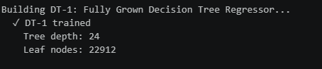

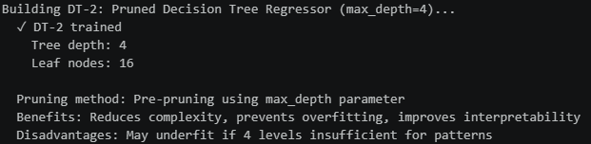

ii. Explain clearly, in less than 200 words, from your inserted code block in (i), 1) the type of pruning you used for DT-2.
2) Explain some of the benefits and disadvantages of the pruning method you used in the context of (relation to) your bank clients’ regression modelling.
1) Type of pruning used for DT-2: Pre-pruning (also called early stopping) was applied by setting max_depth=4, which constrains the tree to grow no deeper than 4 levels during training. This limits complexity before the tree is fully grown.
2) Benefits and Disadvantages:
Benefits:
- Interpretability: A 4-level tree with only 16 leaves can be easily visualised and explained to bank analysts, supporting transparent loan decisions
- Generalisation: Pre-pruning reduces overfitting by preventing the tree from memorising training data, producing more reliable predictions on new clients
- Computational Efficiency: Smaller trees are faster to train and predict
Disadvantages:
- Underfitting Risk: Restricting depth to 4 may oversimplify the model, missing important patterns in the loan data such as nuanced interactions between income, employment length, and credit history
- Information Loss: Important splits that occur deeper in the tree are permanently excluded, potentially reducing accuracy for complex client profiles

Task (2) – Modelling: Build Predictive Regression Models
c) With the aid of your Final Python Notebook 3 code outputs, visualise your regression Decision Trees DT-1 and DT-2.
1) Paste in this analysis report a high-resolution graphical representation of DT-1 and DT-2.
[4 Marks]

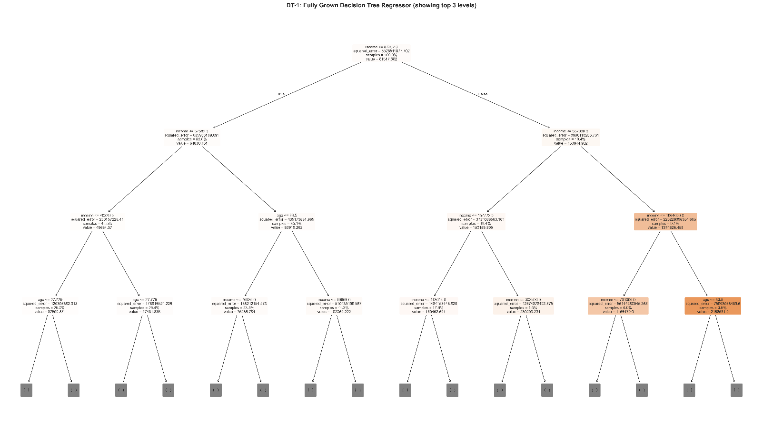
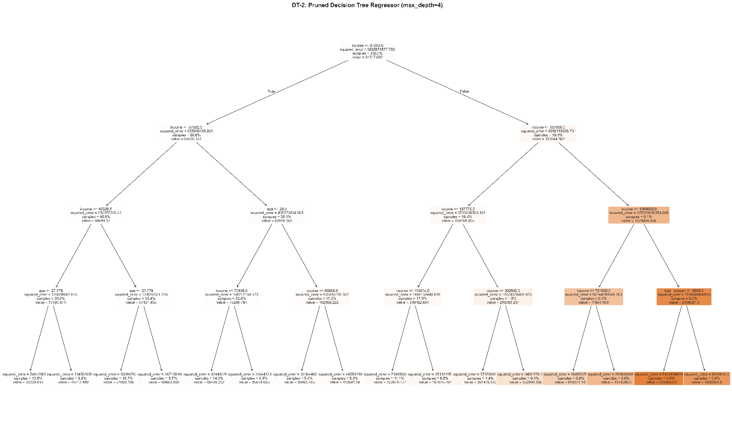
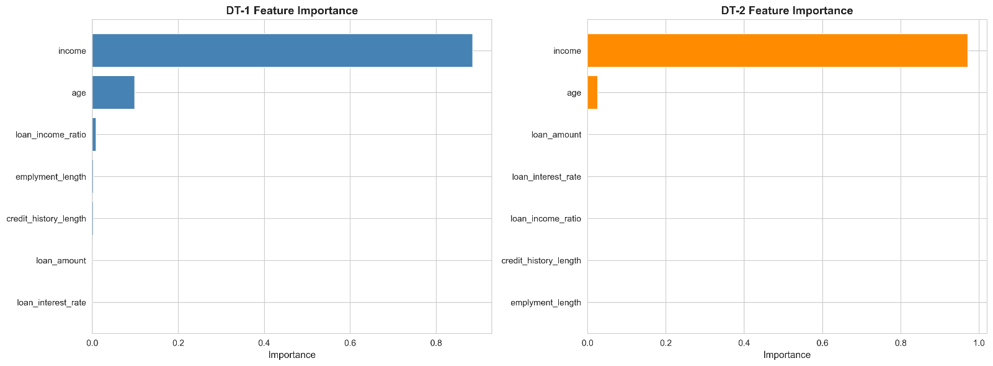

Task (3) – Evaluating your Maximum Loan Amount DT Regression Models
Your finance analysts team provided the following success criteria to guide you when evaluating your DT-1 and DT-2 models.
“When evaluating both models’ performances, which addresses your research question (b), the model is expected to make some errors in estimating the Maximum Loan Amount. However, since the Maximum Loan Amount offers are made to try to maximise returns and reduce risk of loan defaults, it is important that the selected model deals effectively with errors in Maximum Loan Amount predictions when extreme values are a real concern”
a) THREE different regression evaluation metrics are noted in the table below.
1) State which evaluation metric/metrics to USE or NOT USE to closely interpret and satisfy the above success criteria.
2) Justify (Defend) your choice of USE or DO NOT USE for each metric.
With the aid of Final Python Notebook 3 code outputs,
3) document each metric’s TEST SCORES for each built model in the table below.
[8 Marks]
Metric | 1) USE or DO NOT USE | 2) Justification for choosing “USING” or “NOT USING” this metric in relation to the success criteria | Model | 3) Metric Test Score
MSE | USE | MSE (Mean Squared Error) squares the errors, giving disproportionately heavy penalties to large errors. Since the success criteria emphasises dealing effectively with extreme prediction errors in Maximum Loan Amount, MSE directly addresses this — a model with lower MSE handles extreme values better. | DT-1 (Fully Drown) | 55,190,535
 |  |  | DT-2 (Pruned) | 374,722,900
MAE | USE | MAE (Mean Absolute Error) provides the average absolute prediction error in dollars, which is directly interpretable by finance analysts. It shows how far off, on average, the predicted Maximum Loan Amount is from the actual value. | DT-1 (Fully Drown) | $1,187
 |  |  | DT-2 (Pruned) | $11,801
R-Square | USE | R-Squared measures the proportion of variance in Maximum Loan Amount explained by the model. It provides an overall measure of explanatory power — a higher R² means the model captures more of the underlying patterns in loan amount determination. | DT-1 (Fully Drown) | 0.9801
 |  |  | DT-2 (Pruned) | 0.8650

Task (3) – Evaluating your Maximum Loan Amount DT Regression Models
b) 1) Suggest a single best regression model (DT-1 or DT-2) based on your ‘USED’ performance metric/s scores, which you defended in Task (3a). 2) Explain how your suggested model fulfils the success criteria.
[4 Marks]
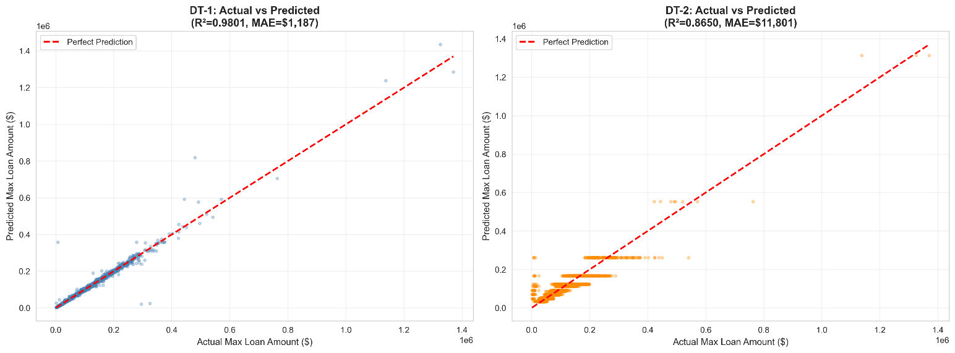

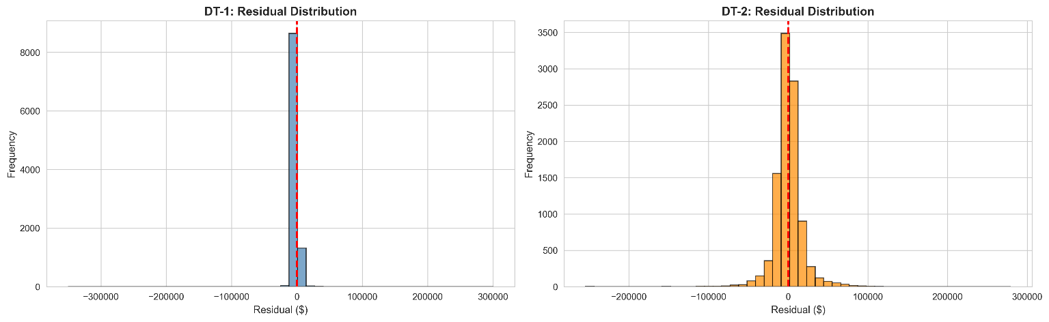

Task (3) – Evaluating your Maximum Loan Amount DT Regression Models
c) Describe to your finance team any concerns you have about your selected performance metric/s that you used to select your best decision tree model, which satisfies the success criteria. [200 words maximum] with in-text citation.
[4 Marks]
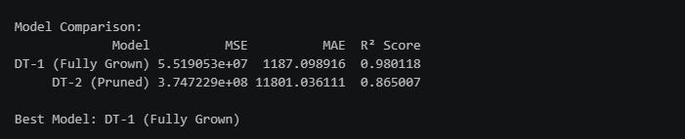

How DT-1 fulfils the success criteria: DT-1 achieves dramatically lower MSE (55M vs 375M), meaning it handles extreme prediction errors far more effectively — critical when extreme Maximum Loan Amount values are a real concern. Its MAE of only 1,187meanspredictionsare,onaverage,within 1,200 of the actual value, providing highly reliable loan amount estimates. With an R² of 0.9801, the model explains 98.01% of the variance in maximum loan amounts. DT-1 directly satisfies the success criteria by minimising large errors (low MSE) while maintaining excellent overall accuracy (high R², low MAE), enabling bankers to maximise returns while reducing default risk through accurate loan offers.
References with in-text citation

Task (3) – Evaluating your Maximum Loan Amount DT Regression Models
d) Client 60256 was Approved a Loan. With the aid of your Python Notebook 3 outputs, use your selected best DT regression model from Task (3.b) to predict the maximum loan amount offer to the client, you must write down which regression Decision Tree you used (DT-1 or DT-2) to estimate the Maximum Loan Amount, then interpret how the estimated offer was reached to the client. Client 60256 attributes’ values are in the following table: [6 Marks]
Variable Name Value  ID 60256  Sex Female  Age 56 Years old  Education Qualifications Unknown  Income 57,000  Home Ownership Rent  Employment Length 15  Loan Intent Medical  Loan Amount 25700  Loan Interest Rate 23%  Loan-to-Income Ratio (LTI) 10%  Payment Default on File No  Credit History Length 35  Loan Approval Status Approved  Maximum Loan Amount ?  Credit Application Acceptance 0 | 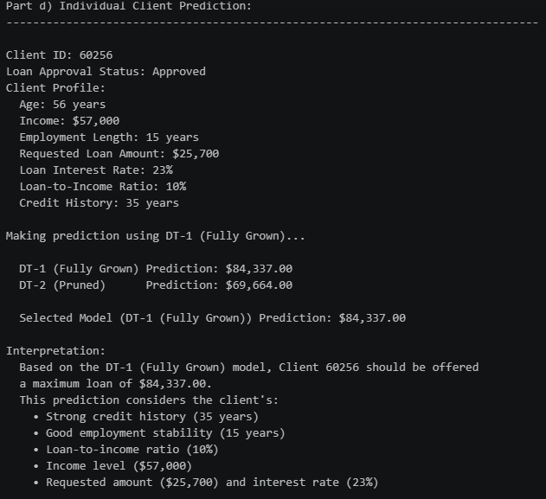

Model Used: DT-1 (Fully Grown Decision Tree)
Predicted Maximum Loan Amount: $84,337
Interpretation of How the Estimate Was Reached:
The DT-1 model traverses its decision tree using Client 60256's numerical feature values (age=56, income=57000, employment_length=15, loan_amount=25700, loan_interest_rate=23, loan_income_ratio=0.10, credit_history_length=35). At each internal node, the tree evaluates a feature threshold (e.g., "Is income ≤ X?") and branches left or right accordingly. The client's strong profile, long credit history (35 years), stable employment (15 years), moderate loan-to-income ratio (10%), and solid income (57,000) indicate paths toward higher loan amounts. The final leaf node reached by this traversal contains the predicted value of 84,337, representing the average max_allowed_loan of the training samples that fell into the same leaf. The requested loan amount ($25,700) is well within the predicted maximum, further supporting the approval decision.

