**CP Project Proposal**

**On Ilam Tea Garden**

**Softwarica College of IT and E-Commerce**

**Kathmandu, Nepal**

**9th April 2019**



**Submitted by Submitted to**

**Sudarsan Udash Sudeep Bajimaya**

**NCCID:170354 Module Leader**

**Batch 22C L5DC**

Contents

**Introduction** 2

Introduction to your project 2

Background of the project 2

Problem statement 2

Description of the project 3

Features of the project 3

Overview of the project 3

**Scope of the project** 3

Scope 3

Limitations 4

Aims 4

Objectives 4

Overview of the scope 4

**Development of methodology** 4

Description of the methodology chosen 4

Design Pattern 6

Architecture 7

**Project Planning** 8

WBS (Work Breakdown Structure) 8

Milestones 9

Gantt Charts 10

**Risk Management** 12

**Configuration Management** 13

**Conclusion** 13

**References and Bibliography** 14

# 

Content for figures.

Figure 1Waterfall model 7

Figure 2 Model View Controller Design Pattern 9

Figure 3 Work Breakdown Structure 10

Figure 4 Milestones of project IlamTeaGarden 12

Figure 5 Gantt chart schedules 13

Figure 6 Gantt chart 14

Figure 7 Consequences and their values 14

Figure 8 Likelihood and their values 15

Figure 9 Risk Table 15

Figure 10 Configuration Management 16

# **Introduction**

## Introduction to your project

Ilam district, located on the eastern corner of the country is where most of the tea for Nepali Tea Traders is grown and harvested. The green tea along with churpi, lollipop etc. are those few products that people from all over the country as well as several foreign countries crave for but do not get to enjoy enough because of various factors.

My project IlamTeaGarden will be a commercial website that can connect the tea market of Ilam all over Nepal. People from all places will be aware of the tea market that the place flourishes on. The projects will be focusing on commercializing those products that are uncommon to other places but easily manufactured in Ilam.

## Background of the project

As an underdeveloped place of a developing country, Ilam tea market until now does not have a proper information system to commercialize their products and are being marketed manually through communications only. Because the place is located at the eastern border of the country, most of the market has been taken by India rather than our own. Even in the capital city, most people are unaware of the products. Farmers too are unaware of the massive market that their products can create in the national as well as international level. Several companies are focused on increasing the tea market, but are limited by the lack of a proper information system to properly market the products.

## Problem statement

The project will allow the tea farmers and manufacturers of Ilam to make a direct contact with buyers that will allow them to make the best benefits from the products that they produce which as of now is being handled by different mediators and will create a national market for those products as well.

Mediators who are involved in the projects are highly benefitted while trading these products and those mediators does not include people who trades through online information system. Not all of those mediators are from the place of product manufacture which I turn does not support the economic status of the place. People from around the country have only heard of Ilam as a place where Tea grows but they have not actually used the product.

The project will focus to solve these problems and bring the best benefits to both the production area as a whole and consumer.

## Description of the project

The project will be based around marketing products like tea, dairy products like churpi, lollipop, local cheese, ghee etc. Since farmers and manufacturer can directly market their products without any mediators and sell them directly to the buyers, they will be highly impacted by the project. The project will require high level of user details to make trades more trustworthy. Online bookings and online payments will also be included to increase the efficiency of the project.

Since tea growing areas in Ilam are tourists attracting areas, the project will in some level attract people from other places when they get to view the manufacture areas of the Ilameli products.

### Features of the project

* Features to signup, login as well as apply for memberships to all users.
* Sellers will be able to market their products along with their qualities, quantities, locations of manufacture, seller details etc.
* Buyers will be able to view, order, make, get manufacture details as well as review the products.
* There will be a feature of membership will provide some advantages to the members.
* Features of online booking.
* Buyers as well as sellers can directly communicate to make the marketing more trustworthy.

## Overview of the project

The project will be directly involved in marketing products manufactured in Ilam which will help in increasing the economic standard of the people along with the GDP of the place. People from all over Nepal will get to enjoy the local products of Ilam easily. The project will be highly focused on giving a household name to those products

# **Scope of the project**

## Scope

To provide a product market directly to the farmers and manufacturers of the area.

To allow manufacturers and buyers perform trade directly without any mediators.

To make the trades more secure and documented under a controlled environment.

As a place where internet is not yet understood and used by many people (especially farmers), the project will also have a secondary but a passive scope to promote the use of information technology to make their life better.

## Limitations

The limitations of my project is given below:

* The project will only be specific for marketing limited products of a limited area.
* The project will only be applicable for our country for now.

## Aims

The main aims of the projects are as follows:

* To create an e-commerce market for the unique products of the place which will help increase the low economic standard of the people of the place.
* To make the products accessible to people in every places of the country.

## Objectives

* Throughout the project I will be using as well as learning more of programming languages like Php, JavaScript, Bootstrap.
* A functional signup and login system for users will be track their progress.
* Additional membership features to allow users to be a part of the community and benefit from it.
* To make users feel easy while operating with our projects I will be focusing more on eye-catching icons rather than pictures and texts.
* An online booking system will be created to make sure people get the value of the project whenever they want.
* A community forum will be created to allow users to make a discussion.

## 

## Overview of the scope

As a residence of Ilam myself, I have seen how behind are we from the actual world that operates in this century. It has only been a year since people from my village got an internet access. Not everyone has any idea of the information system that the world runs under. As specific as the project is to Ilam, it will have a high impact and also require a heavy change to a better lifestyles of the place.

# **Development of methodology**

## Description of the methodology chosen

Since, people from my place are not habitual to information technology, the project has to be an easy process for them. Keeping this in mind, I will be developing my project based on the waterfall methodology. This method is a traditional approach of development methodology that has different phases which are carried out in a linear sequence. Development cannot proceed further without completing the current phase of development. The process has to go one after the other just like the name waterfall suggests.

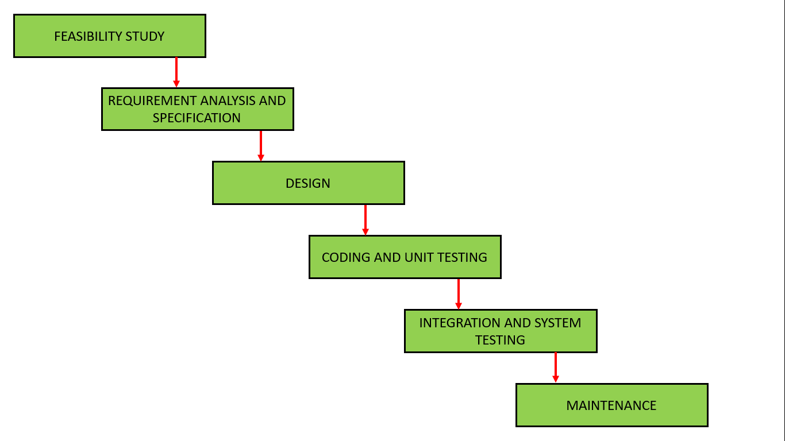

Figure 1Waterfall model

This method of project development will provide the following advantages to my project

* First of all, it can be easy understood and used by the local people.
* Developers and customers, through interactions knows what is being deployed early and agree on that which makes planning and design straightforward.
* Interaction between the local people and developer is done during requirement analysis and some parts of reviews and approvals. Except these the process does not hinder the daily life of the local people.
* Progress of each phases can be easily measured, since each phases of waterfall model has a unique and fixed scope.

The different phases of a waterfall model are given below.

* Feasibility study

The process of identifying whether or not a project is practically possible based on the cost, benefits and time given to its development is known as feasibility study. IlamTeaGarden will be a small project meant.

* Requirement analysis and specification.

The identification of different aspects required for the project and following up on those requirements throughout the project is known as requirement analysis.

* Design

The phase of project development which focuses on how the system looks like and also determines the functionality of the project to its users.

* Implementation (Coding and unit testing)

The implementation of the project will be based on the analysis and design developed for the project. The whole system is broken into different units and each units is developed and at last combined for implementation.

* Integration and system testing.

Testing is the process of determining whether a project does what is it meant to do or not before deployment. In this phase, different units are integrated as one system and tested.

* Deployment and Maintenance

Deployment is the process of making a system available to the market after testing becomes successful. Maintenance is the process of bringing changes to the deployed project whenever situations like bugs, errors and missing features is seen to make a system better and efficient.

Object Oriented Approach

The approach to modelling that focuses on the objects and data rather than actions and logic is known as object oriented approach. It makes use of data and objects which can be maintained and reused. Since it facilitates modular design, updating a part of the system is easier without having to make big changes. Software development is faster, economic and also facilitates high quality software.

## Design Pattern

Design patterns are unique methods or templates of solving problem of different kinds but same situations and act as a guiding map for project development.

The design pattern that I am using for my project is Model View Controller (MVC) Pattern. This design pattern separates the project into three interconnected parts namely Model, View and Controller.

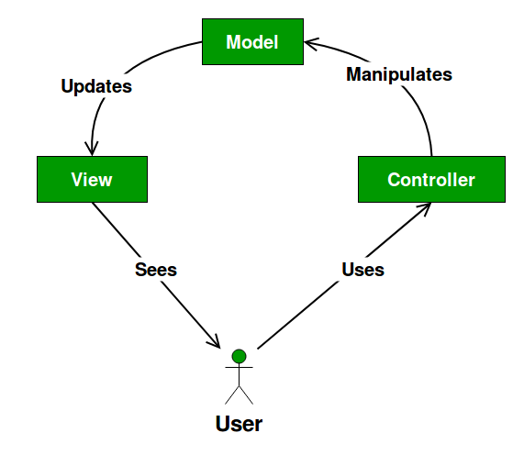

Figure 2 Model View Controller Design Pattern

The advantages of this pattern to my project are.

* This is a faster means for project development process since when developers can split to work on model, view and controller separately.
* Modifications done on one part doesn’t affect the entire model in this pattern.
* It returns the data without formatting and those components can be used for any interface.

## Architecture

The network architecture that I am using for my project is Peer-to-Peer Architecture (P2P Architecture) which is a commonly used architecture. It is like a classic client/server architecture in which some computing devices used to serve other computing devices. This can act both as a client and server with same responsibilities.

# **Project Planning**

## WBS (Work Breakdown Structure)

The development of a project will be successful if it is performed under scheduled time and expected costs. For this to happen a number of people are involved in a project who are further divided among several project teams based on their field of expertise. In the same way, different works of a project are split into different project teams. A Work Breakdown Structure is an outline obtained after the decomposition of the whole projects into several phases or parts which can again be split further based on requirements, no of projects teams, time for project completion etc. The WBS of my project is given below.

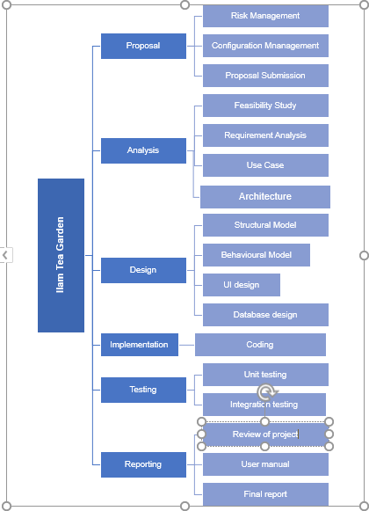  
Figure 3 Work Breakdown Structure

## Milestones

Since a project is broken down into several phases by a work breakdown structure, each phases need to be given required amount of time for its completion. Milestones is a tool for determining specific objectives at a specific time along a bounded project timeline. They are also called zero duration tasks because tasks completed under milestones are said to be achievements and balances the time spent for the tasks.

The milestones of my project is given below.

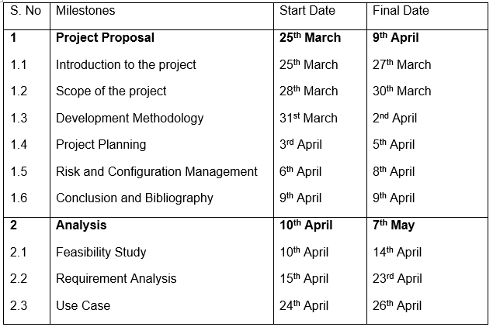

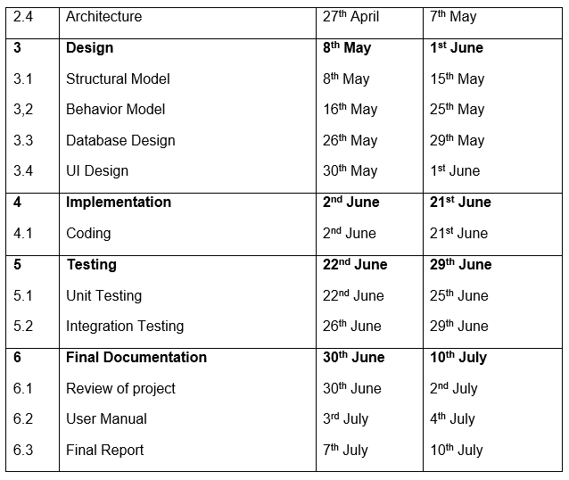

Figure 4 Milestones of project IlamTeaGarden

The milestones given above present the following information.

* The whole project has been divided into six phases that has strict deadlines with proposal, analysis, design, implementation, testing and documentation having 16, 28, 25, 20, 8 and 11 days respectively.
* Each phases have been divided into subtasks that has different deadlines which can vary based on the developers and project teams. These days are not strict deadlines but rather depends on the knowledge and conditions of the one performing the

## Gantt Charts

A Gantt chart is a type of bar chart that illustrates different events and tasks to be done against its estimated amount of time keeping in mind the starting and ending specific time schedules. The events and tasks are kept at the left part and the estimated time is kept at the right in a required tie cycle/period.

The Gantt chart of my project is given below.

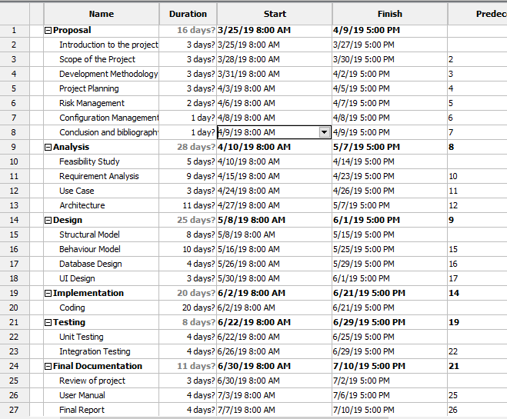

Figure 5 Gantt chart schedules

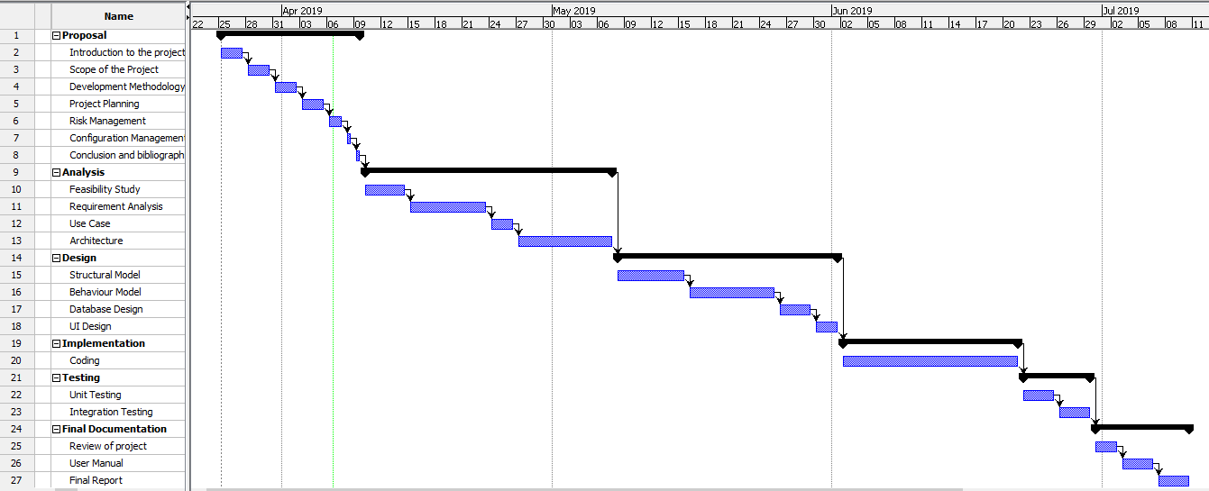

Figure 6 Gantt chart

# **Risk Management**

Risk Management is the process of identifying different risks related to a project and undertaking viable solutions based the threat level of the risks. Every project will have risks and the impact of those risks to the business. Impact of risks can be measured by multiplying the level of likelihood and consequences.

**Risk Impact** = **Likelihood value** * **Consequences**

The different levels of likelihood and consequences are shown in the table below.

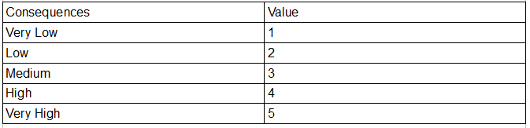

Figure 7 Consequences and their values

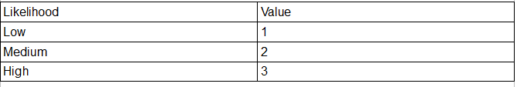

Figure 8 Likelihood and their values

Some of the risks to my project along with their likelihood of occurrence, consequences and their value of impacts are shown below.

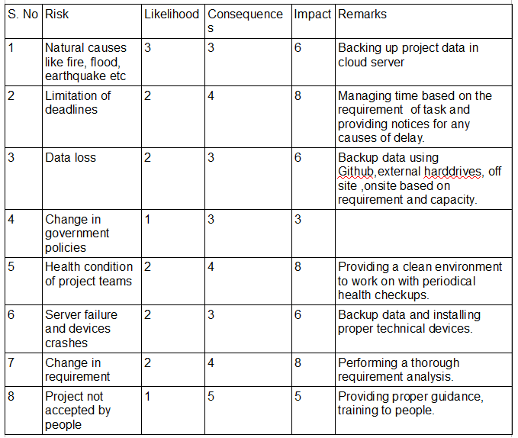

Figure 9 Risk Table

# **Configuration Management**

The process of handling the system changes in a systematic way in order update the system while maintaining the integrity of the system is known as configuration management. It helps to maintain the consistency of the system no matter the change in functionality, and other physical attributes of the system.

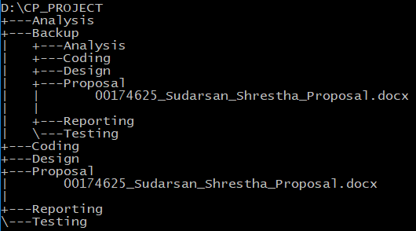

Figure 10 Configuration Management

Also the project has been uploaded to GitHub with account

<https://github.com/SudarsanUdash>

<https://github.com/SudarsanUdash/SudarsanUdashCPProposal/blob/master/Mycpproject.docx>

# **Conclusion**

With a scope to help the people of my place easily commercialize their local products, the project will be based on people oriented methodology. The estimated time for the completion of this project shall be around 108 days.

If this project becomes successful, not only it will help the people of my place but also educate them of the importance of information technology in our daily livelihood. Thus, I am making a proposal of this project with a clear intent to commercialize IlamTeaProducts.

# Bibliography

Anon., n.d. *Clarizen.com.* [Online]   
Available at: https://www.clarizen.com/what-are-project-milestones/

Anon., n.d. *gantt.com.* [Online]   
Available at: http://www.gantt.com

Anon., n.d. *workbreakdownstructure.com.* [Online]   
Available at: http://www.workbreakdownstructure.com