**Testing**

In software development, the process of verifying whether a software or a particular feature is performing what it is meant to perform with an additional intent to find the software related bugs and errors is known as testing. Several testing such as black box testing, white box testing unit testing are performed are performed on a developed software. Among those methods I have used Black box testing and unit testing methods.

I preferred Black box testing for my project since it is used to check whether a certain feature is actually working or not by using certain test data. In the same way I performed unit testing in order to detect error in my codes if any which would help identify and mitigate errors at the developmental phase.

The process of Black Box Testing is performed below.

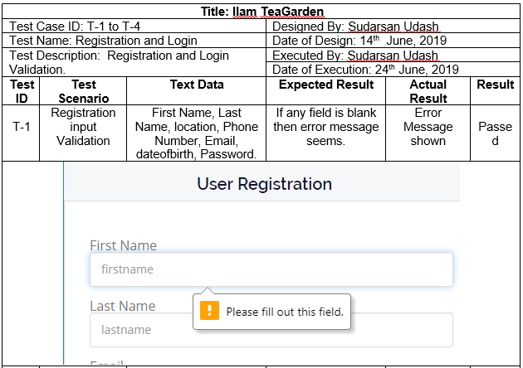

Figure 1 Test for incomplete user registration

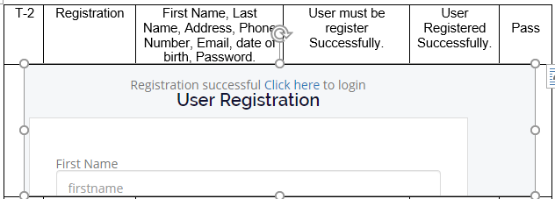

Figure 2 Test for successful user registration

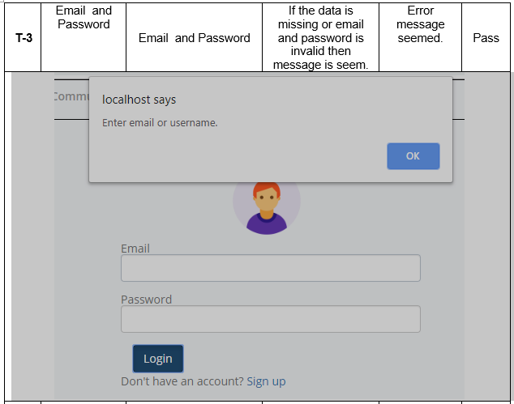

Figure 3 Test for incomplete details login

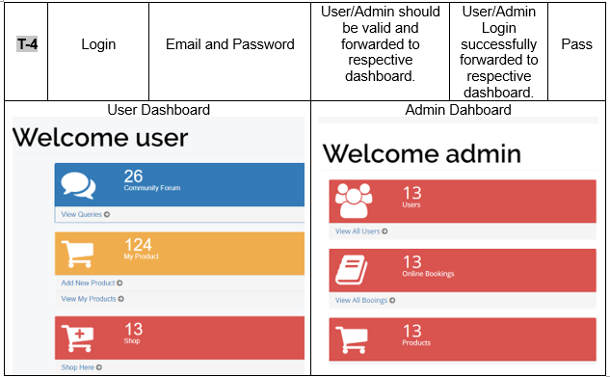

Figure 4 Test for successfullogins

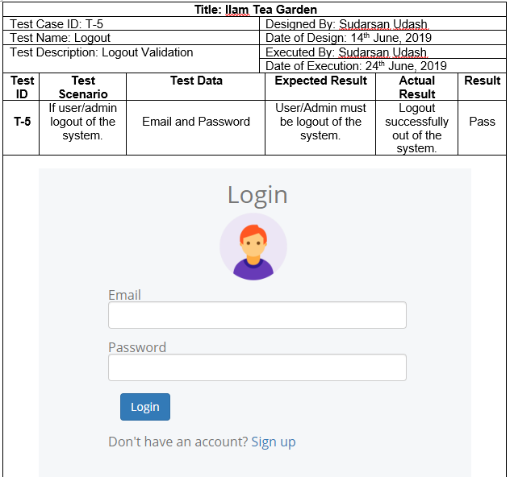

Figure 5 Check for Logout

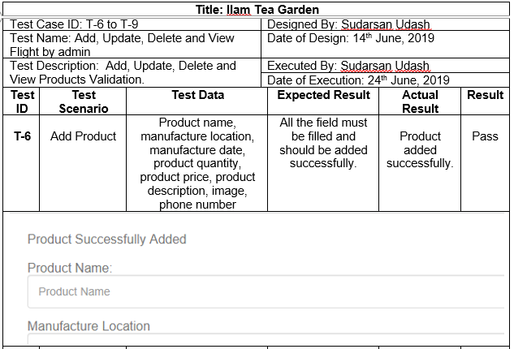

Figure 6 Test for product adding

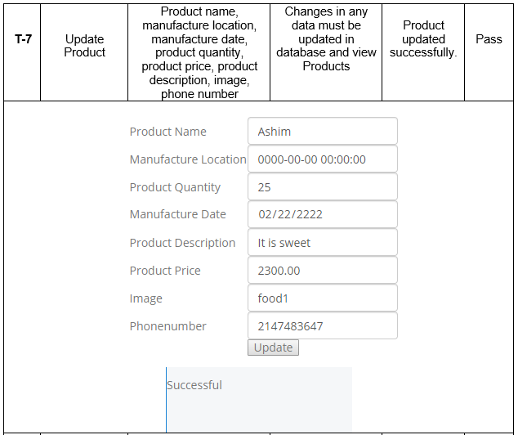

Figure 7 Test for product update

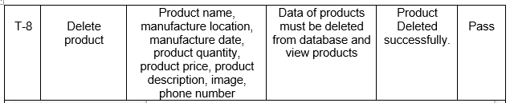

|  |
| --- |
| Figure 8 Test for deleting products    Figure 9 Test for successful deletion |

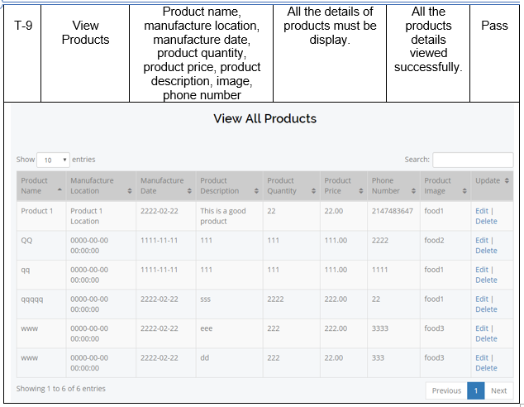

Figure 10 Test for viewing all products

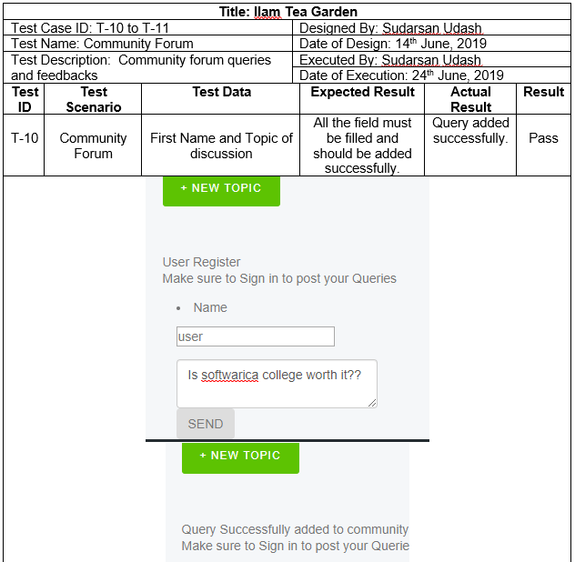

Figure 11 Test for adding community queries

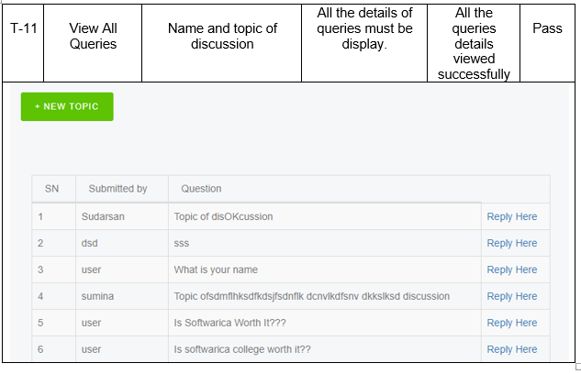

Figure 12 Test for viewing all queries

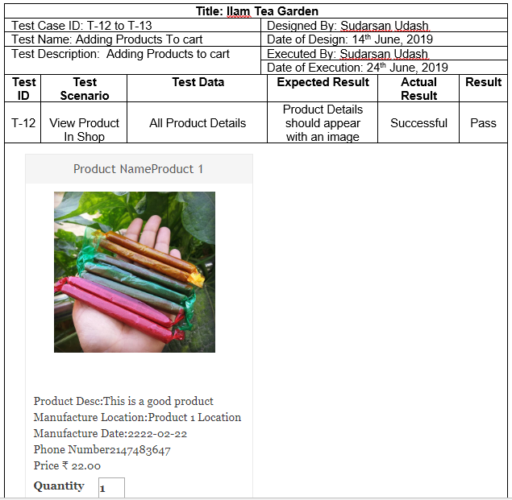

Figure 13 Test for viewing products in shop

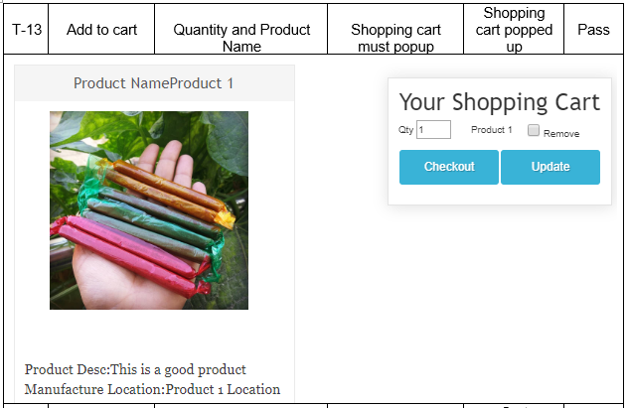

Figure 14 Test for adding to cart

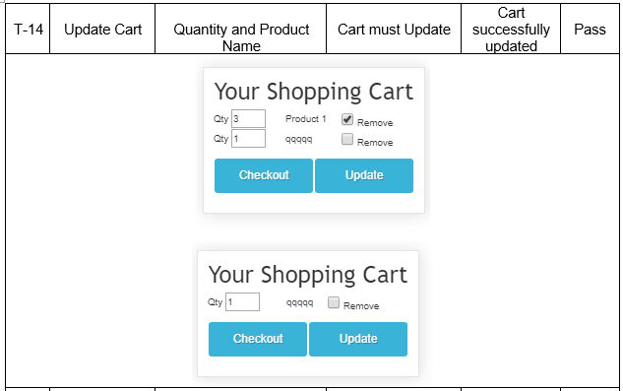

Figure 15 Test for updating cart

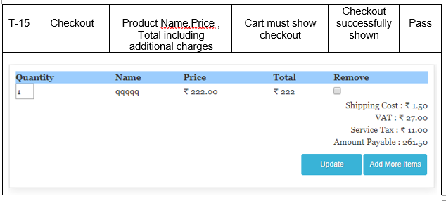

Figure 16 Test for cart checkout

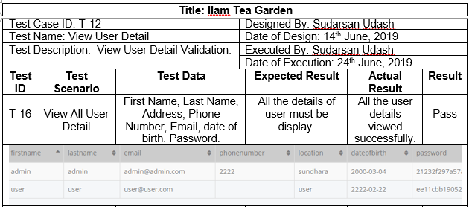

Figure 17Test for viewing all users

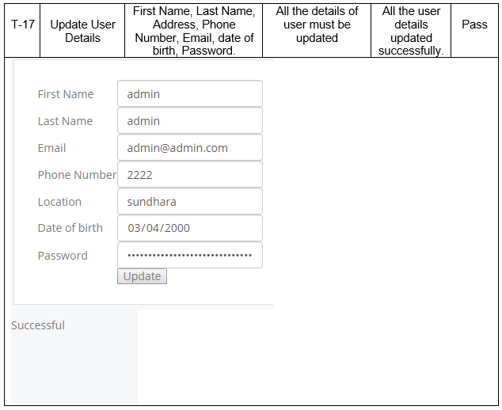

Figure 18 test for updating users

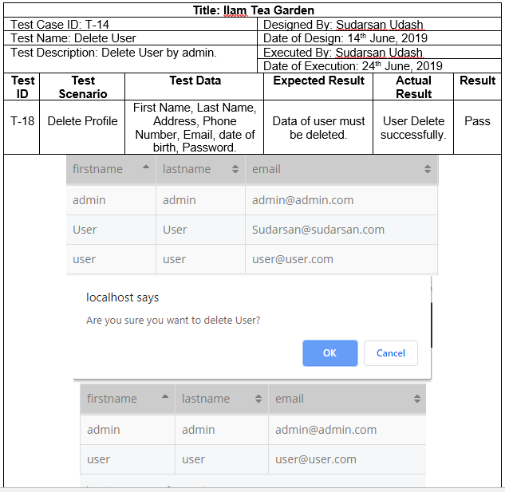

Figure 19 Test for deletig user