GridSense – Phase 1 Product Development & Enhancement Plan
Scope: Map, Bus Dashboard, Summary & Assumptions, Import Data, Subscription & Platform Enhancements

Important note on visuals: The screenshots included in this document are preliminary UI concepts prepared for discussion purposes only. The final implementation in the production GridSense tool should use a more polished visual design, responsive layout and interaction patterns consistent with Continuum Associates’ design system.

1. Preliminary UI Concepts (for Discussion Only)
This section documents the initial UI mock-ups used during requirement discovery. They are intended to illustrate the intent behind Phase 1 enhancements for the Map view, Bus Dashboard, and Summary & Assumptions tabs.

Feature 1 – Map Layer – Multi-Selection Reset Bug
Type: Bug Priority: High Tab / Module: Map

Detailed Requirement
When multiple substations are selected in the list, the constraints are loaded correctly. If some substations are unselected or Clear All is used, the constraint table incorrectly falls back to the state when no substations were selected, or keeps the values of the first selection set.

User Story
As a user, I want the constraints table to always match my current substation selection so that I can trust the filters and any exported data.

Acceptance Criteria
- Given multiple substations are selected, when individual substations are unchecked, the constraints table refreshes to reflect only the currently selected substations. When Clear All is clicked, both the selection and constraints table are completely reset. No stale constraints remain from previously selected substations.

UI Requirements
No change to visual layout. Filter controls should behave predictably, with clear loading and empty states when constraints refresh.

Backend Requirements
Fix selection-state handling for substations and constraints queries. Ensure Clear All resets both selection state and constraints query. Add regression tests for select / unselect / Clear All workflow.

Admin Requirements
None.

Data Requirements
Constraints queries must always use the currently selected bus IDs from the front‑end state only.

Subscription Logic
Available for all subscription levels that can view constraints.

Additional Notes
Source requirement from manual Excel ‘Map Layers’ row.
Jira Link: https://continuum-associates-team.atlassian.net/browse/GRID-95

Feature 2 – Data Source Switch – Stale Info Panel Bug
Type: Bug Priority: High Tab / Module: Map

Detailed Requirement
When a few substations are selected on the map and the info panel shows details for the active data source, switching the data source leaves the previous info still visible in the panel.

User Story
As a user, I want the info panel to always reflect the currently selected data source so that I do not confuse nodes from different datasets.

Acceptance Criteria
- When a user switches the data source, any selected substations/lines are cleared and the info panel either closes or reloads with empty/default content. No information from the previous data source remains visible. Clicking again on the map loads details only from the newly active data source.

UI Requirements
Show a brief loading indicator when the data source is switched. The info panel closes or shows an empty state until a new feature is selected.

Backend Requirements
On data‑source change, clear all cached selections and panel data. Reload layer configuration for the new data source. Ensure map, info panel and constraints all honour the active data‑source key.

Admin Requirements
None.

Data Requirements
All queries must be parameterised by data‑source ID to avoid mixing data.

Subscription Logic
Same behaviour for all subscription levels.

Additional Notes
Aligns with manual Excel ‘Change of data source bug’.
Jira Link: https://continuum-associates-team.atlassian.net/browse/GRID-97

Feature 3 – Update Customer Notification Email Address
Type: Bug Priority: High Tab / Module: User Email / Notifications

Detailed Requirement
System‑generated emails still reference an outdated email address. All user‑facing emails must use gridsense@continuum-associates.com.

User Story
As an admin, I want all outgoing emails to use the official GridSense address so that clients respond to the correct support channel.

Acceptance Criteria
- All user‑facing emails (invites, password reset, notifications, data‑update notices) show gridsense@continuum-associates.com as the From/Reply‑To email. No reference to the old email remains in templates or configuration.

UI Requirements
No UI change.

Backend Requirements
Update mailer configuration and environment variables. Verify all email templates. Add unit/integration tests if feasible.

Admin Requirements
None.

Data Requirements
None.

Subscription Logic
Applies to all users and tiers.

Additional Notes
Configuration‑only change but important for branding and support.
Jira Link: https://continuum-associates-team.atlassian.net/browse/GRID-103

Feature 4 – Info Panel Disappears When Substation Layer Turned Off
Type: Bug Priority: High Tab / Module: Map

Detailed Requirement
When Substation, T&D Lines, Generators and Loads are enabled and the user clicks on the map, the info panel opens with all available elements. Turning off only the Substations layer currently causes the full info panel to disappear even though other layers still have data at that location.

User Story
As a user, I want the info panel to stay open as long as at least one visible layer has data so that I can continue exploring generators, loads or lines.

Acceptance Criteria
- Turning off the Substations layer hides only substation rows in the info panel. The info panel remains visible and still lists generators, loads and lines. The panel auto‑closes only when all layers are turned off or when the user manually closes it.

UI Requirements
Minor behaviour change; keep the info panel docked. Provide per‑layer chips or labels so users can see which layers contributed rows.

Backend Requirements
Layer‑visibility logic should filter content per layer instead of closing the panel. Implement per‑layer visibility filtering in the info‑panel data source.

Admin Requirements
None.

Data Requirements
Panel data queries should join by feature type and respect current layer‑visibility flags.

Subscription Logic
No subscription logic.

Additional Notes
Matches manual Excel ‘Info Panel disappears with turn off substation layer’.
Jira Link: https://continuum-associates-team.atlassian.net/browse/GRID-108

Feature 5 – Clear‑All in Substation Filter Closes Info Panel
Type: Bug Priority: High Tab / Module: Map

Detailed Requirement
Using Clear All in the substation filter currently closes the info panel, interrupting the analysis flow.

User Story
As a user, I want to clear my filters without losing the context in the info panel so that I can quickly adjust my selections.

Acceptance Criteria
- When Clear All is clicked, filters reset and selected buses are cleared, but the info panel remains open. The panel updates to show an informative empty state such as “No buses selected”. The panel closes only when the user explicitly clicks the close icon.

UI Requirements
Info panel remains docked. Show an empty‑state message when no features are selected. Maintain consistent layout.

Backend Requirements
Update filter handler to avoid closing the panel. Reset selection state and trigger a safe refresh of info‑panel content without destroying the component.

Admin Requirements
None.

Data Requirements
No specific data changes.

Subscription Logic
All tiers.

Additional Notes
Based on manual Excel ‘Clear all in substation filter closes the info panel’.
Jira Link: https://continuum-associates-team.atlassian.net/browse/GRID-107

Feature 6 – Expandable Map Side Panel with Constraints & Bus Dashboard Tabs
Type: New Feature Priority: High Tab / Module: Map
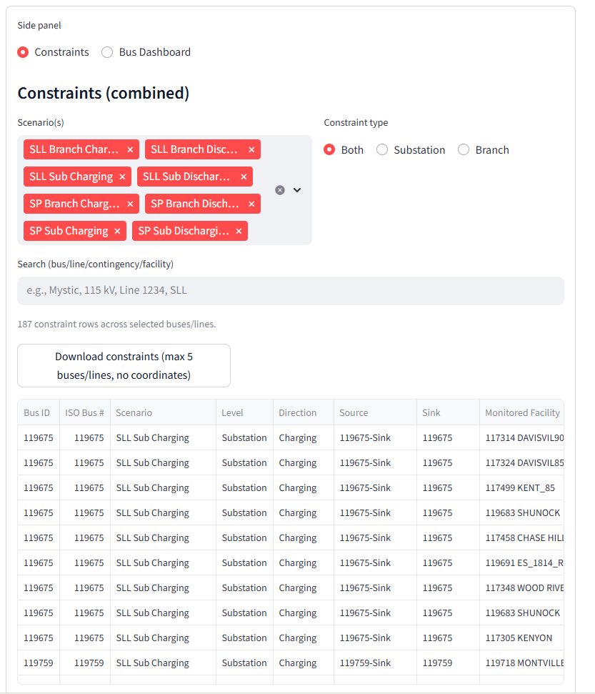
Figure 3 – Sample side-panel layout for Constraints tab, with scenario filter, constraint type toggle and download action.

Detailed Requirement
Introduce a resizable side panel within the Map tab that can be expanded/collapsed and contains two tabs: Constraints and Bus Comparison Dashboard. This side panel will be the container for constraints tables and all bus‑level graphs.

User Story
As a user, I want a dedicated side panel where I can toggle between constraints and bus analytics so that I can analyse data without losing map context.

Acceptance Criteria
- The side panel is hidden or collapsed by default on smaller screens and can be expanded using a clear arrow handle. When expanded, the panel covers approximately 25% of horizontal space. The panel contains two clearly labelled tabs: “Constraints” and “Bus Dashboard”. Panel state (expanded/collapsed and active tab) persists while navigating within the Map tab. The panel is responsive on 1080p and ultrawide monitors.

UI Requirements
Modern, responsive drawer/side panel with a clear toggle arrow and tab headers. Works with existing Layers and Filters sidebars without overlap. Uses GridSense styling tokens for colours, spacing and typography.

Backend Requirements
Add layout container and state management for the side panel. Wire up tab switching and resizing logic. Ensure the panel integrates with routing and does not reload unnecessarily when switching tabs.

Admin Requirements
Admin can define default state (open/closed and default tab) per data source in configuration if required.

Data Requirements
No new data; the panel consumes existing constraints and bus‑analytics data.

Subscription Logic
Visibility of content (especially Bus Dashboard graphs) will depend on subscription tier, but the panel shell is visible for all logged‑in users.

Additional Notes
Implements the ‘Expand/Collapse window which should cover 25% of the screen and include two switchable tabs’ requirement from manual Excel items 10 and 11.

Feature 7 – Combined Constraints Table View (Substations + Branches)
Type: New Feature Priority: High Tab / Module: Map / Constraints Tab

Detailed Requirement
Modify/merge the current two constraints tables (Substations and Branches) into a single combined table that shows relevant constraints based on the user’s selection and chosen scenarios.

User Story
As a user, I want to see all relevant constraints for my selected substations and T&D lines in one table so that I do not have to switch back and forth between separate views.

Acceptance Criteria
- Constraints tab shows a single table with both substation and branch constraints. The table supports filters for constraint type (Substation / Branch / Both) and a multi‑select scenario filter. All constraints tables (for substations and branches) can be uploaded as a single CSV or DB and are shown in this unified view. The table supports pagination, sorting and search. Integration works for existing PV cases as well.

UI Requirements
Within the Constraints tab, display a full‑width table with sticky header, scenario filter dropdown/multi‑select and constraint‑type toggle. Provide horizontal scroll for many columns. Use clear column labels to distinguish substation vs branch columns.

Backend Requirements
Implement a unified API/query to source constraints from both substation and branch datasets. Add parameters for bus IDs, line IDs, scenario IDs and constraint type. Support input coming from a single combined CSV/DB or from multiple tables.

Admin Requirements
Admin can upload all constraint data as a single CSV or DB file. Admin can configure which columns are visible by default and adjust labels. Admin can create preset scenario filters commonly used by users.

Data Requirements
Data model must support a combined constraints entity with fields referencing bus or line IDs, scenario, headroom values etc. Multi‑scenario filters rely on scenario IDs being part of the dataset.

Subscription Logic
Only Level 1+ subscriptions with Grid Capacity data can see constraints. Download functionality (Feature 11) is limited to higher‑tier subscriptions.

Additional Notes
Implements manual Excel item ‘Modify Constraints table view’ and aligns with the new side‑panel structure.

Feature 8 – Bus Comparison Dashboard & Graph Configurator
Type: New Feature Priority: High Tab / Module: Map / Bus Dashboard Tab
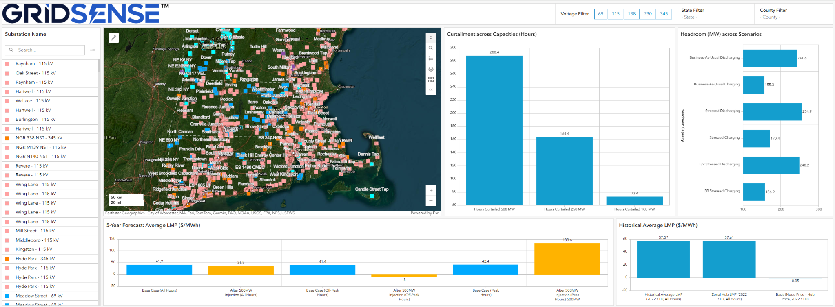
Figure 1 – Example of LMP and capacity graphs displayed alongside the map in the legacy ISO-NE prototype.

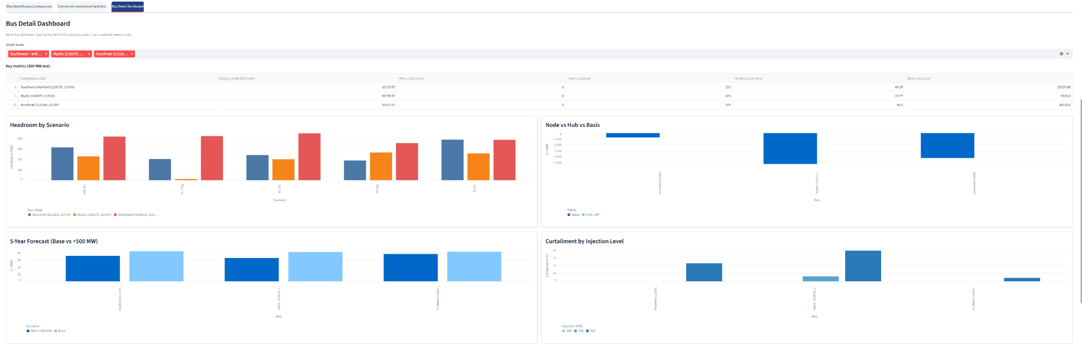
Figure 2 – Concept bus-level dashboard layout showing multi-bus comparison, headroom by scenario, basis and curtailment by injection level.

Detailed Requirement
Create a configurable Bus Comparison Dashboard inside the side panel to display headroom, curtailment and LMP analytics for up to five selected buses. Admins must be able to add/remove/replace graphs, map axes to any available columns, choose chart types (bar, line, stacked, multi‑axis, pie, etc.) and assign subscription levels per graph.

User Story
As a developer or investor, I want to compare multiple substations across scenarios and KPIs so that I can quickly prioritise attractive POIs and understand economic/capacity trade‑offs.

Acceptance Criteria
- Bus Dashboard tab provides a graph area with default graphs as per manual spec: Graph #1 Headroom (MW) across scenarios (Level 1), Graph #2 Curtailment across capacities (hours) (Level 2), Graph #3 5‑year forecast average LMP ($/MWh) (Level 2), Graph #4 Historical average LMP & basis (Level 2). The user can select up to five buses for comparison using a clear bus selector. By default, the dashboard shows graphs for the bus selected in the map window. Charts refresh when bus selection changes. If the admin adds/removes graphs using the configurator, the dashboard updates without code changes.

UI Requirements
Use a responsive card/grid layout with one chart per card. Each card shows chart title, scenario/bus legend and an optional fullscreen icon. Charts support multiple series and multiple Y‑axes (primary and secondary) where configured. Chart types available to admin include bar, stacked bar, line, multi‑axis line and pie where appropriate. Use consistent colours and legends for scenarios and tiers.

Backend Requirements
Expose analytics endpoints that aggregate substation‑layer data by bus and scenario. Endpoints must be flexible enough to provide arbitrary columns so that newly configured graphs can be served without further backend changes. Support multi‑bus (up to five) and multi‑scenario queries with efficient performance and caching.

Admin Requirements
Provide an Admin Graph Configurator (in Import Data or Admin tab) where admin can: (1) create, edit, delete dashboard graphs; (2) select data source and dataset (substation layer / economic attributes); (3) map X‑axis and one or more Y‑axis columns; (4) choose chart type; (5) configure primary/secondary Y‑axes and axis labels; (6) choose default filters such as scenario; (7) assign a subscription level required to view each graph.

Data Requirements
Requires substation‑layer and economic datasets to expose all necessary columns: headroom by scenario, curtailment hours at different capacities, 5‑year LMP forecasts (base and after injection, peak/off‑peak/all‑hours), historical averaged LMPs and basis as specified in the manual Excel. Data must be keyed by bus ID and scenario.

Subscription Logic
Graph #1 is accessible at Level 1 (Grid Capacity). Graphs #2–4 and additional economic graphs are available at Level 2. Full dashboard, including advanced comparisons and downloads, is available at Level 3 (both economic + grid). Admin can override per graph in the configurator.

Additional Notes
Directly implements manual Excel item ‘Map window – Economic and Capacity Graphs’ including the exact four default graphs and the requirement that admin can modify/add/remove/create graphs using available data and multiple axis/chart types.
Jira Link: https://continuum-associates-team.atlassian.net/browse/GRID-109

Feature 9 – Map Legend Enhancements & Heatmap Creator
Type: Enhancement Priority: Medium Tab / Module: Map / Import Data

Detailed Requirement
Provide a way for admins to generate heatmaps (e.g., LMP or headroom heatmaps) within GridSense from uploaded CSV data, avoiding external GIS tools. Legends must reflect admin‑defined value ranges, radius and transparency.

User Story
As an analyst, I want to visualise LMP and other numeric heatmaps directly in GridSense so that I can understand congestion and pricing patterns without using external tools.

Acceptance Criteria
- An admin can upload a CSV and choose which columns represent latitude, longitude and the numeric metric. The admin can define legend breakpoints (e.g., 0–10, 10–20, …), radius and transparency, then save the configuration. The system creates a heatmap layer clipped to ISO/state boundaries and automatically adds a corresponding legend entry. Regular users can toggle heatmap layers on/off in the Layers panel but cannot create or edit them.

UI Requirements
Add a “Create Heatmap” modal, accessible only to admins from Map or Import Data. Extend the legend UI to show custom ranges and colours. Heatmap legend entries appear grouped under a 'Heatmaps' category and follow GridSense look and feel.

Backend Requirements
Implement efficient heatmap generation using the uploaded points (server‑side or optimised client‑side). Store configuration (breakpoints, radius, transparency, colour scale, ISO/state) for each heatmap. Clip rendering to ISO/state polygons.

Admin Requirements
Admin can manage saved heatmap configurations: create, edit and delete heatmaps; choose default visible heatmaps for each data source/ISO.

Data Requirements
CSV must include lat/long columns and at least one numeric column. Heatmap configuration is stored per ISO/data source. Initial focus is on headroom and LMP metrics, but the tool should support any numeric metric.

Subscription Logic
Heatmaps based on economic metrics may be visible only to Level 2 or Level 3 subscribers. Basic headroom heatmaps may be enabled at Level 1.

Additional Notes
Implements manual Excel item ‘Map Legend Enhancements’, including generating heatmaps from CSV with custom legends, radius and transparency, within ISO boundaries.

Feature 10 – Categorised Layers Panel
Type: Enhancement Priority: High Tab / Module: Map / Layers

Detailed Requirement
Group map layers by category (e.g., Transmission System, Heatmaps, Economic Data, Parcel Areas) and map each existing layer to a category as listed in the manual specification.

User Story
As a user, I want logically grouped layers so that I can quickly find and toggle the datasets I need as more content is added.

Acceptance Criteria
- Layers sidebar shows expandable category groups: (1) Transmission System, (2) Generators & Queue, (3) Loads, (4) Retirements, (5) Substation Upgrades, (6) Transmission Upgrades, (7) Heatmaps (higher kV, lower kV, per scenario), (8) Economic Data and any future categories like Parcel Areas. Category state (expanded/collapsed) is remembered per session. Existing layer toggles continue to work as before.

UI Requirements
Redesign the left Layers panel with nested accordions for each category. Maintain existing icons where possible. Provide clear labels and tooltips for categories.

Backend Requirements
Minor changes to layer‑configuration model to include category keys. No heavy backend logic required beyond serving metadata.

Admin Requirements
Admin can assign each layer to a category from a dropdown and control category ordering. Admin can add new categories (e.g., Parcel Areas) without code changes.

Data Requirements
Layer metadata must now include a category. No impact on underlying spatial data storage.

Subscription Logic
No direct subscription restrictions here, though certain categories (Economic Data, some Heatmaps) will only contain data for higher‑tier users.

Additional Notes
Implements manual Excel item ‘Categories the Layers’ including the explicit list of layers and Heatmaps split by kV.

Feature 11 – Download Constraints Table (5 Nodes/Lines, No Coordinates)
Type: New Feature Priority: High Tab / Module: Map / Constraints Tab

Detailed Requirement
Allow users to download the constraints table based on the currently selected substations and T&D lines, limited to a maximum of five nodes/lines, and explicitly excluding geographical coordinates from the export.

User Story
As a user, I want to download a clean constraints table for a small set of substations/lines so that I can share or further analyse it in Excel.

Acceptance Criteria
- A Download button is available in the Constraints tab when 1–5 buses/lines are selected. If more than five are selected, a clear validation message indicates the limit and the button is disabled. Downloaded CSV excludes geographic coordinates (latitude/longitude) and any other columns flagged as sensitive. The user sees a toast/snackbar confirming the download. Only users with the correct subscription can see the Download button.

UI Requirements
Add a primary action button in the Constraints‑tab header with tooltip: “Download constraints (max 5 buses/lines, no coordinates)”. Show a warning banner when more than five items are selected and disable the button.

Backend Requirements
Implement an export endpoint that accepts selected IDs and returns filtered CSV. Enforce the max‑5 limit and coordinate exclusion server‑side. Use the combined constraints view as the data source.

Admin Requirements
Admin can configure which columns are allowed in exports and can adjust the 5‑node limit if policy changes later.

Data Requirements
Use the same constraints dataset as the combined table. Maintain an explicit list of excluded columns (coordinates, internal IDs).

Subscription Logic
Download is only available for users who subscribe to both Economic Data and Grid Capacity Data (Level 2 and Level 3).

Additional Notes
Directly implements manual Excel ‘Download’ requirement including the SUPER IMPORTANT coordinate exclusion and 5‑node limit.
Jira Link: https://continuum-associates-team.atlassian.net/browse/GRID-102

Feature 12 – Dynamic Column Support for Layers & Constraints
Type: Enhancement Priority: High Tab / Module: Import Data / Map

Detailed Requirement
Even if we add more columns or data to any layers, the system should accept the file during upload and show the data in the info panel and constraints tables, without breaking other tables that are not map‑related.

User Story
As an admin, I want flexibility to add new attributes to my datasets without code changes so that GridSense can evolve with new KPIs and studies.

Acceptance Criteria
- System accepts files with extra columns beyond the predefined headers without failing validation. The info panel and constraints tables automatically expose the new columns with matching headers. Only info panel and constraints tables adapt to extra columns—no other tables are affected. Existing users see a notification or banner when new data is uploaded and authorised by admin, indicating that new columns are available.

UI Requirements
Info panel and constraints table must support horizontal scroll and dynamic column rendering. Column headers by default mirror the raw column names; friendly labels may be shown if configured by admin.

Backend Requirements
Ingest all columns from uploaded CSV/GeoJSON into storage. Remove strict header validation for map‑related tables. Update APIs to return dynamic column lists rather than hard‑coded sets.

Admin Requirements
Admin UI to (1) hide/show specific columns, (2) override display labels, and (3) trigger a “data updated” notification. Admin can specify which columns are user‑visible or internal‑only.

Data Requirements
Data store and schema layer must handle variable columns per data source, possibly via JSON/dynamic fields. Need mapping between raw column names and display labels.

Subscription Logic
Subscription tiers may control visibility of certain columns (for example, hide economic attributes for capacity‑only users).

Additional Notes
Implements manual Excel item ‘Add more column in future and it should upload’, including column‑name consistency, map‑only adaptability, admin controls and user notifications.

Feature 13 – Upload Raw Files in Database File Format
Type: New Feature Priority: High Tab / Module: Import Data

Detailed Requirement
Support uploading a single database file that contains all layers and constraints instead of separate CSVs, and handle the case where constraints are provided as Part 1 and Part 2 by uploading them as a single DB.

User Story
As an admin, I want to upload one DB file containing all relevant tables so that I can refresh data sources quickly and handle split constraints tables without manual merging.

Acceptance Criteria
- Import Data screen supports selecting a DB file as an alternative to multiple CSVs. The system validates schema and lists included tables. Admin can map tables (e.g., substations, lines, queue, constraints) to GridSense layer types. If constraints are split into Part 1 and Part 2 tables, importing them via one DB correctly merges or exposes them as a unified constraints dataset. Clear success/error messages are shown.

UI Requirements
Extend Import Data screen with an “Upload DB” tile. Provide status messages (validating, importing, success/failure). Keep UI simple and consistent with existing upload cards.

Backend Requirements
Implement a DB‑ingestion pipeline that maps DB tables to internal layer/constraint entities. Provide a mapping configuration per ISO/data source. Support transactional replace/update to avoid partial imports. Support combining Part 1 and Part 2 constraints into a single logical dataset.

Admin Requirements
Admin can create and save mapping profiles (DB‑table → GridSense layer) per ISO. Admin can re‑run imports using saved mappings for future DB versions.

Data Requirements
DB schema must include consistent primary keys and columns. Document minimal required fields per table. Confirm that Part 1/Part 2 constraints can be joined reliably.

Subscription Logic
No direct subscription changes, but imported tables feed features that may have tiered access.

Additional Notes
Implements manual Excel item ‘Upload the raw files in Database file format’.

Feature 14 – New Main Tab – Summary & Assumptions
Type: New Feature Priority: High Tab / Module: Summary & Assumptions

Detailed Requirement
Add a high‑level overview/write‑up of study assumptions and country‑wide metrics under a new top‑level tab called “Summary & Assumptions”.

User Story
As a user, I want a dedicated tab where I can see a summary of coverage, market overview and assumptions so that I understand the context behind GridSense analytics.

Acceptance Criteria
- The navigation bar shows a “Summary & Assumptions” tab in addition to Map, Import Data and Admin. Clicking it opens a page with two sub‑tabs: “Summary” and “Assumptions”. Behaviour is consistent with existing navigation.

UI Requirements
Add a new top‑level route and tab button. Use the same header style as Map / Import Data / Admin. Inside, render a secondary tab switcher between Summary and Assumptions.

Backend Requirements
Configure routing, authentication and authorisation for the new tab. Ensure shared components (header, breadcrumbs) work here as well.

Admin Requirements
Admin will manage content of both subtabs (see Features 15–17).

Data Requirements
No numeric data specific to this container—subtabs will fetch underlying datasets.

Subscription Logic
All users can at least view high‑level content, with some detailed charts gated by subscription.

Additional Notes
Implements the container described in manual Excel “Assumption Overview”.

Feature 15 – Summary Subtab – US & ISO Market Overview
Type: New Feature Priority: High Tab / Module: Summary & Assumptions / Summary
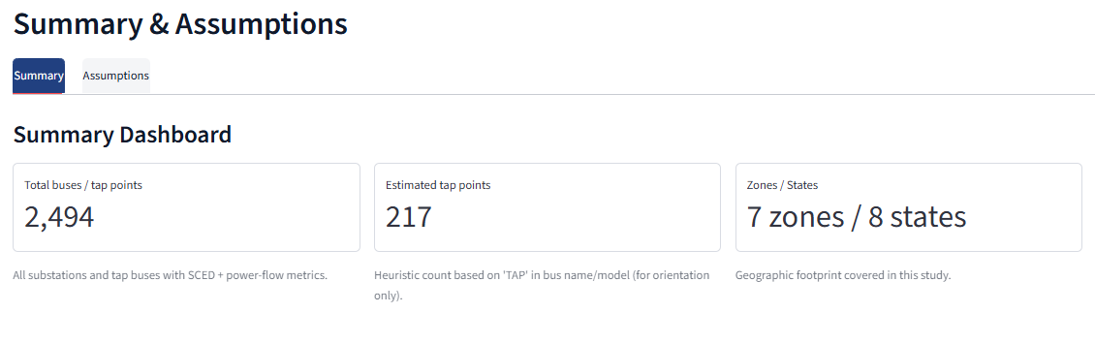
Figure 4 – Summary & Assumptions top-level tab structure with sub-tabs for Summary and Assumptions.

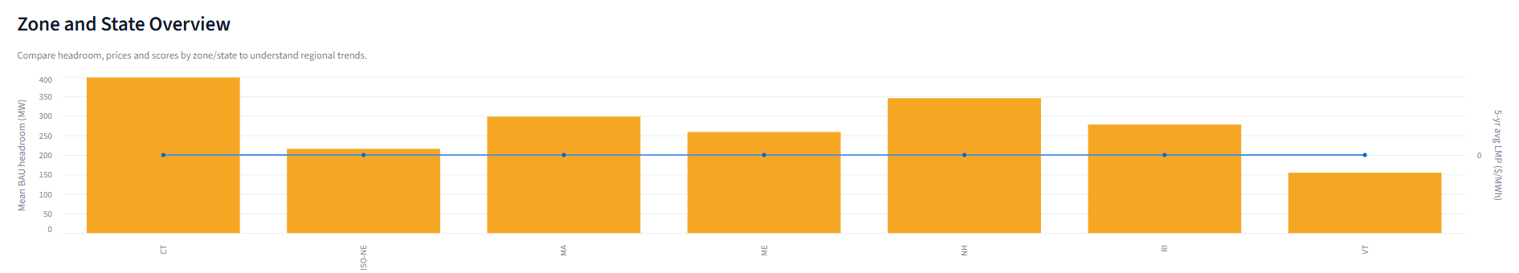
Figure 5 – Zone and State overview chart combining headroom and LMP metrics for orientation.

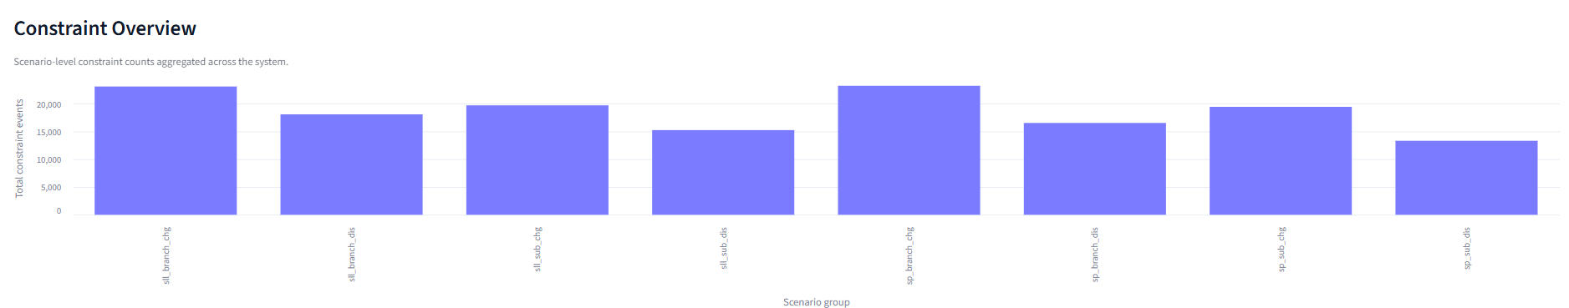
Figure 6 – Constraint overview bar chart aggregating system-wide constraint counts by scenario group.

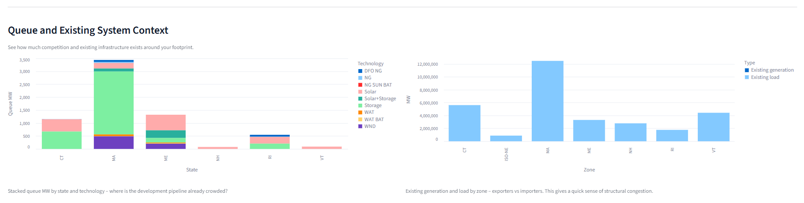
Figure 7 – Example of queue and existing system context charts (queue by state/technology and generation vs load by zone).

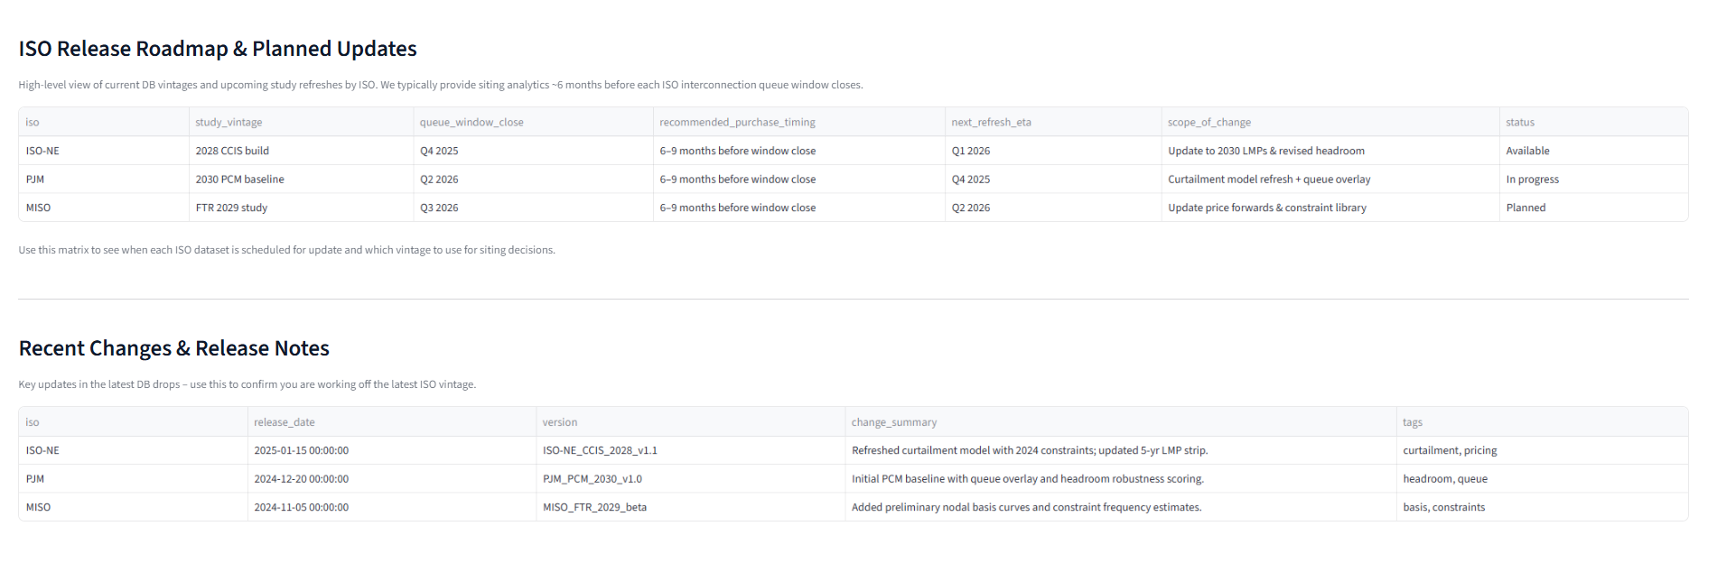
Figure 8 – ISO Release Roadmap, Planned Updates and Recent Changes & Release Notes editable tables within Summary tab.

Detailed Requirement
Within the Summary & Assumptions tab, create a “Summary” subtab that provides a whole‑of‑US overview: total buses, states/ISO/RTO count, headroom capacity in the entire US, and high‑level charts for substation characteristics and release roadmap.

User Story
As a developer or investor, I want a one‑page summary of current market outlook across the US so that I can quickly compare regions.

Acceptance Criteria
- Summary subtab shows: (1) counts of buses, states and ISOs/RTOs covered; (2) total and average headroom capacity; (3) one or more charts summarising generic substation details across the country; (4) a table editable by admin for “ISO Release Roadmap & Planned Updates”; and (5) a table for “Recent Changes & Release Notes”. All content loads within an acceptable time and looks good on standard monitors.

UI Requirements
Responsive dashboard layout with cards for KPIs and charts, plus two editable tables with clear headers. Use GridSense styling and ample whitespace. Optionally allow filtering charts by ISO or technology.

Backend Requirements
Create endpoints to aggregate coverage and headroom statistics by ISO/state. Provide CRUD endpoints (or reuse CMS‑like backend) for roadmap and release‑note tables.

Admin Requirements
Admin can edit roadmap and release‑notes tables directly from the UI (inline edit or admin‑only form). Admin can update the narrative summary text.

Data Requirements
Requires aggregated datasets that summarise substation/headroom counts by ISO/state. Roadmap and release‑notes tables are stored in the database as simple entities.

Subscription Logic
High‑level summary (counts, non‑sensitive values) is visible to all tiers. Detailed metrics or additional charts may require Level 2 or Level 3.

Additional Notes
Implements part 1 of manual Excel “Assumption Overview” – the Summary section.

Feature 16 – Assumptions Subtab – Powerflow
Type: New Feature Priority: High Tab / Module: Summary & Assumptions / Assumptions
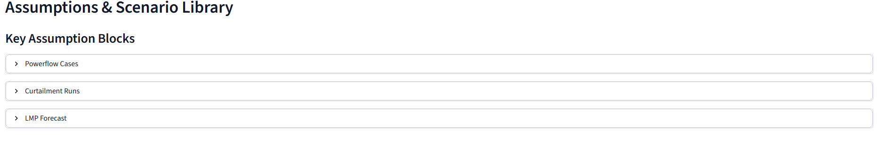
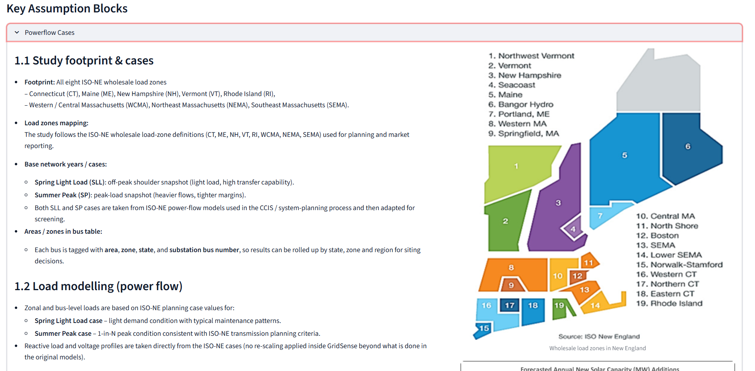
Figure 9 – Sample of Powerflow assumptions documentation block used as a reference for the Assumptions sub-tab design.

Detailed Requirement
Within Summary & Assumptions, create an “Assumptions” subtab with a “Powerflow” inner section containing the usual study‑assumption document for each ISO, including a short description of powerflow models used, build‑outs included and scenario definitions.

User Story
As a user, I want to read the core powerflow assumptions behind the capacity results, including which models and build‑outs were used, so that I can understand methodology and caveats.

Acceptance Criteria
- Assumptions subtab includes a Powerflow toggle/inner tab. Users can choose ISO from a dropdown. The content area displays the latest powerflow‑assumption document (HTML, markdown or embedded PDF) with sections describing: base network model, incremental build‑outs, and scenario definitions. A “Download PDF” link is available. Last‑updated date is shown.

UI Requirements
Two‑level tab/segment control: Powerflow vs Curtailment/SCED. Clean, scrollable text/PDF viewer. ISO dropdown at the top.

Backend Requirements
Backend stores powerflow‑assumption content per ISO and serves it through an API. Optionally store file attachments and derived HTML for rendering.

Admin Requirements
Admin editor for uploading or editing powerflow assumptions, including file upload and rich‑text or markdown editor. Admin can set last‑updated metadata.

Data Requirements
Metadata‑level content only; may reference external SCED datasets but does not require them here.

Subscription Logic
Basic assumptions visible to all tiers. Any detailed technical appendices may be restricted to higher tiers later.

Additional Notes
Implements the “Powerflow” part of manual Excel “Assumption Overview”.

Feature 17 – Assumptions Subtab – Headroom & Curtailment / SCED
Type: New Feature Priority: High Tab / Module: Summary & Assumptions / Assumptions

Detailed Requirement
Within Summary & Assumptions → Assumptions, add content for (a) how headroom/capacity results are derived from powerflow, and (b) a 'Curtailment / SCED' section that documents production‑cost modelling assumptions.

User Story
As a user, I want to see how headroom, curtailment and SCED modelling were treated so that I can understand the economic outputs, limitations and how they relate to powerflow results.

Acceptance Criteria
- Assumptions subtab includes a Curtailment/SCED toggle/inner tab, complementary to the Powerflow tab. Users select ISO and scenario (e.g., 2030 Base, 2033 High Build). The content area lists assumptions such as load‑forecast sources, fuel prices, installed‑capacity mix, curtailment‑treatment rules, key modelling constraints and how these link back to headroom/powerflow assumptions. A downloadable assumptions document (PDF) is available. Last‑updated date is shown.

UI Requirements
Use the same layout and styling as Powerflow assumptions with an additional scenario dropdown. Use headings and bullet lists for readability and include a short paragraph explaining linkage to headroom results.

Backend Requirements
Backend stores SCED/curtailment‑assumption documents per ISO and scenario. Provide API to fetch structured content and links to files.

Admin Requirements
Admin can upload/edit SCED‑assumption documents and map them to ISO + scenario. Admin can manage version history or at least last‑updated date.

Data Requirements
Assumption text may reference demand, fuel‑price and generation‑mix tables that live in separate datasets.

Subscription Logic
Detailed SCED assumptions are typically visible only to Level 2 and Level 3 subscriptions; only a high‑level overview may be shown for Level 1.

Additional Notes
Implements the Curtailment / SCED portion of manual Excel “Assumption Overview”, and clarifies the relationship between headroom and SCED results.

Feature 18 – Economic Data Attributes on Substation Layer
Type: New Feature Priority: High Tab / Module: Map / Data Model

Detailed Requirement
Ingest an additional Excel (or DB table) with substation‑wise economic data that provides LMP and other economic metrics required for the info panel, Bus Dashboard graphs and Summary analytics.

User Story
As an analyst, I want economic metrics directly on each bus so that I can correlate capacity and price outcomes quickly.

Acceptance Criteria
- Info panel and Bus Dashboard graphs can reference new economic columns including historical average LMP (2022–YTD), hub LMP, basis (node–hub), and 5‑year forecast LMP metrics (base vs after injection, peak/off‑peak/all‑hours) as specified in the manual Excel. When data is missing, “N/A” is shown instead of blank fields.

UI Requirements
Info panel groups new attributes under an “Economic Metrics” section with tooltips explaining each metric. Bus Dashboard charts use these fields as per default graph definitions.

Backend Requirements
Modify data model, ETL and APIs to ingest the additional substation‑wise Excel/DB data and expose the new economic columns on the substation layer. Ensure mapping between bus IDs and economic results is robust.

Admin Requirements
Admin can upload/refresh the economic‑attributes file, toggle visibility for each economic attribute, and rename labels where needed. Admin ensures that datasets are loaded and aligned before exposing graphs to users.

Data Requirements
Economic data is sourced from historical LMP datasets and SCED simulations. Data must be keyed by bus, scenario, year and, where relevant, injection level.

Subscription Logic
Economic attributes are visible to Level 2 and Level 3 subscribers. Level 1 users may not see economic fields in the info panel or Bus Dashboard.

Additional Notes
Implements manual Excel item ‘Economic Data Attributes’.

Feature 19 – Subscription Tier System (Level 1–3)
Type: New Feature Priority: High Tab / Module: Platform‑wide

Detailed Requirement
Introduce three subscription levels as defined in the manual spec: Level 1 – Grid Capacity data only; Level 2 – both Economic and Grid Capacity data (full current dataset access); Level 3 – Level 2 access plus advanced analytical features that will be implemented in a later phase (for example, a dedicated Analytics tab with multi‑quadrant views, bus scores by fuel type, etc.). Use these tiers to control access to graphs, downloads and data attributes.

User Story
As a product owner, I want to manage feature access via subscription tiers so that we can offer differentiated plans to clients.

Acceptance Criteria
- Three standard tiers are available: Level 1 (Grid Capacity only), Level 2 (Grid Capacity + Economic data), Level 3 (Level 2 data plus advanced analytics). UI elements (graphs, downloads, economic attributes, constraints) show or hide based on tier. When a user tries to access a restricted feature, an informative upgrade message appears. Admin can assign tiers per organisation and per user.

UI Requirements
Use subtle lock icons or greyed‑out states on restricted features. Show non‑intrusive inline messages or modals explaining the required tier. Keep experience consistent across Map, Summary and Bus Dashboard.

Backend Requirements
Implement central authorisation utilities that check subscription tier for each feature. Integrate with existing user/organisation models. Provide helpers for the front‑end to query capabilities.

Admin Requirements
Admin UI in the Admin tab to assign tiers to organisations and users. Admin can see current tier per client and quickly adjust as deals change.

Data Requirements
Store subscription tier and individual feature entitlements in the database. Design the model so it is easily extendable for future add‑ons or higher tiers (e.g., Advanced Analytics).

Subscription Logic
For Phase 1: Map window Graph #1 (Headroom) is available at Level 1. Graphs #2–4 (curtailment, LMP, historical/basis) require at least Level 2. Constraints download and advanced multi‑scenario comparison are reserved for Level 3. Summary and basic assumptions are visible at all tiers. Future analytics features (separate Analytics main tab) will be attached to Level 3.

Additional Notes
Implements the Level 1 / Level 2 / Level 3 definitions described in manual Excel ‘Map window – Economic and Capacity Graphs’, and anticipates the next‑phase Analytics tab.

Feature 20 – Performance & Scalability Enhancements
Type: Enhancement Priority: High Tab / Module: Platform‑wide

Detailed Requirement
Ensure that map interactions, constraints tables, Bus Dashboard graphs and Summary analytics remain performant for large multi‑ISO datasets.

User Story
As a user, I want the UI to remain responsive even when working with large datasets so that I can explore data without delays.

Acceptance Criteria
- Constraints table loads using server‑side pagination and sorting. Bus Dashboard charts render within acceptable time for up to five buses and multiple scenarios. Summary‑tab charts load within a few seconds. No noticeable lag when toggling layers or zooming the map on typical hardware.

UI Requirements
Use skeleton loaders or spinners for heavy tables/charts. Avoid blocking the entire UI while data loads. Provide pagination controls for large tables.

Backend Requirements
Optimise queries, add database indexes and caching for frequent requests (constraints, bus analytics, summary aggregates). Consider pre‑computing scenario aggregates.

Admin Requirements
Optionally provide an internal admin‑only performance dashboard, but this is not required for Phase 1 release.

Data Requirements
May require additional aggregated tables or materialised views for Summary analytics and cross‑scenario bus metrics.

Subscription Logic
Performance improvements benefit all subscription tiers equally.

Additional Notes
Supports the ‘future‑proof’ and US‑wide scale requirement mentioned in your instruction.

Feature 21 – Cross‑Scenario Comparison Mode (Bus Dashboard)
Type: New Feature Priority: High Tab / Module: Map / Bus Dashboard Tab

Detailed Requirement
Allow users to compare key metrics (headroom, curtailment, LMP) across multiple scenarios for the same set of buses within the Bus Dashboard.

User Story
As a user, I want to compare the same buses across different future scenarios so that I can understand how outcomes change under alternative builds and assumptions.

Acceptance Criteria
- Bus Dashboard adds a scenario multi‑select control (e.g., up to 3–5 scenarios). Headroom, curtailment and LMP charts can plot multiple series per scenario, clearly differentiated by colour and legend. If scenario data is missing for a bus, that series is omitted with a note. Charts remain readable and performant.

UI Requirements
Add a scenario‑selector control above charts. Use multi‑series chart designs with clear colour coding and legends. Consider small multiples for clarity if needed.

Backend Requirements
Extend analytics endpoints to accept multiple scenario IDs and return data grouped by scenario. Ensure caching/performance to handle multi‑scenario queries.

Admin Requirements
Admin can configure which scenarios are exposed for comparison (Base, High Build, etc.) on a per‑data‑source basis.

Data Requirements
Requires consistent scenario identifiers and aligned datasets across scenarios for each bus. Data preparation may be done offline in ETL.

Subscription Logic
Cross‑scenario comparison depends on economic/SCED data and is therefore available for Level 2 and Level 3 users only.

Additional Notes
Supports the ‘future‑proof’ requirement by enabling scenario analysis without additional coding later.

