Dockerize

Wednesday, August 3, 2022

11:11 AM

* Spring boot rest controller created

Write the docker file

* New file ==> Dockerfile.
* Create a docker image from it
* Go to docker terminal and
  + Move to project directory to create a docker image
  + ==> docker build -t spring-*jar .
  + Fixed the issue==>
  + [WSL 2 is not installed / docker engine failed to start](https://www.youtube.com/watch?v=SjdFip4t3kI&ab_channel=apoorvpandey)

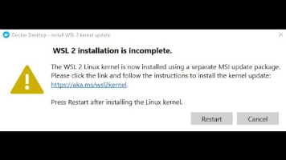

From powershell nevigate to project

**--===> docker build -t spring-boot-docker:latest-test-sp .**

===> run a docker images on docker container

======> **docker run -p 8081:8081 fb53a1e6f99c**

Docker images remove

==>

history

1 docker images

2 docker container ls

6 docker logs -f b9c3e002c989

7 docker container ls

8 docker conatiner stop b9c3e002c989

10 docker stop musing_einstein

11 docker ps

12 docker images

13 docker start musing_einstein

14 docker ps

15 history

==============

* docker ps -a: To see all the running containers in your machine.
* docker stop <container_id>: To stop a running container.
* docker rm <container_id>: To remove/delete a docker container(only if it stopped).
* docker image ls: To see the list of all the available images with their tag, image id, creation time and size.
* docker rmi <image_id>: To delete a specific image.
* docker rmi -f <image_id>: To delete a docker image forcefully
* docker rm -f (docker ps -a | awk '{print$1}'): To delete all the docker container available in your machine
* docker image rm <image_name>: To delete a specific image

To remove the image, you have to remove/stop all the containers which are using it.

* docker system prune -a: To clean the docker environment, removing all the containers and images.

