**Assignment-1**

1. WACP to find the sum of Fibonacci series.

**Code-**

#include<stdio.h>

int main()

{

int a=0, b=1, range, c, sum=0;

clrscr();

printf("Enter the range of Fibonacci series: ");

scanf("%d",&range);

printf("The fibonacci series is: \t");

while( a <= range )

{

printf("%d\t",a);

sum += a;

c = a + b;

a = b;

b = c;

}

printf("\nTheir sum is = %d", sum);

return 0;

}

**Output-**

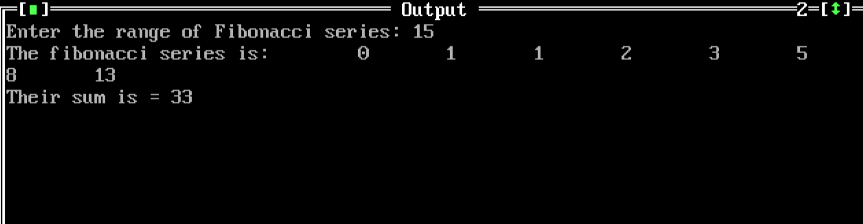

1. WACP to find the sum of even numbers of n numbers.

**Code-**

#include<stdio.h>

int main()

{

int i, number, sum = 0;

clrsccr();

printf("\nEnter the Maximum Limit Value : ");

scanf("%d", &number);

printf("\n Even Numbers between 0 and %d are : ", number);

for(i = 1; i <= number; i++)

{

if ( i%2 == 0 )

{

printf("%d ", i);

sum = sum + i;

}

}

printf("\n The Sum of All Even Numbers upto %d = %d", number, sum);

return 0;

}

**Output-**

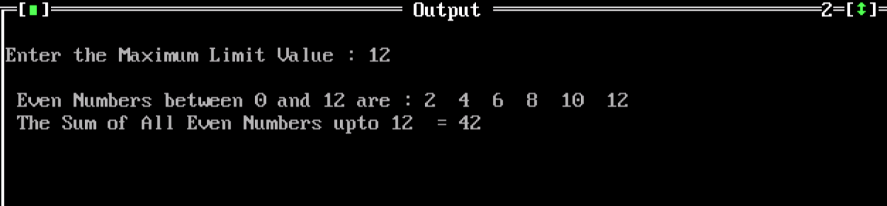

1. WACP to find sum of odd numbers of n numbers.

**Code-**

#include<stdio.h>

int main()

{

int i, number, sum = 0;

clrscr();

printf("\n Enter the Maximum Limit Value : ");

scanf("%d", &number);

printf("\n Odd Numbers between 0 and %d are : ", number);

for(i = 1; i <= number; i++)

{

if ( i%2 != 0 )

{

printf("%d ", i);

sum = sum + i;

}

}

printf("\n \n The Sum of Odd Numbers from 1 to %d = %d", number, sum);

return 0;

}

**Output-**

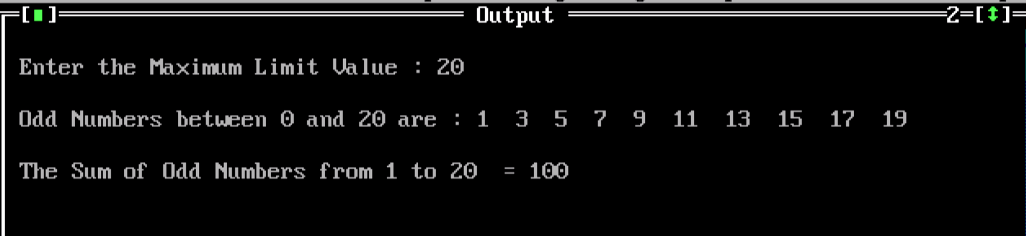

4.WACP to print

a. Hello World

b. Hello world

c. hello world

d. HELLO WORLD

**Code-**

#include <stdio.h>

#define MAX 100

int main()

{

char str[MAX]={0};

int i;

clrsrc();

printf("Enter a string: ");

scanf("%[^\n]s",str);

strupr(str);

printf("%s\n",str);

for(i=0; str[i]!='\0'; i++)

{

if(i==0)

{

if((str[i]>='a' && str[i]<='z'))

str[i]=str[i]-32;

continue;

}

if(str[i]==' ')//check space

{

++i;

if(str[i]>='a' && str[i]<='z')

{

str[i]=str[i]-32;

continue;

}

}

else

{

if(str[i]>='A' && str[i]<='Z')

str[i]=str[i]+32;

}

}

printf(" %s\n",str);

strlwr(str);

for(i=0; str[i]!='\0'; i++)

{

if(i==0)

{

if((str[i]>='a' && str[i]<='z'))

str[i]=str[i]-32;

}

}

printf(" %s\n",str);

}

**Output-**

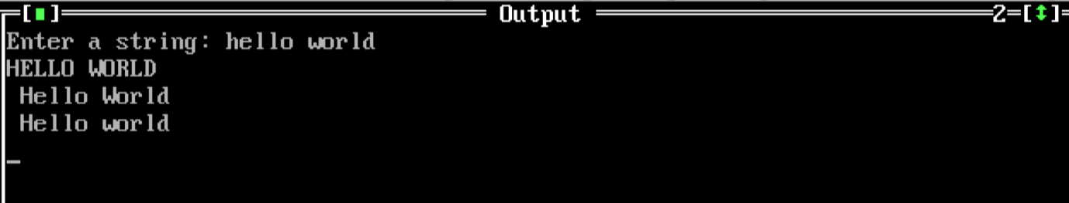

1. WACP to implement string methods.

**Code-**

#include <stdio.h>

#include <string.h>

int main()

{

char s1[10] = "Hello";

char s2[10] = "World";

strcat(s1,s2);

printf("Output string after concatenation: %s", s1);

return 0;

}

**Output-**

