**Scenario-1**

**Code -**

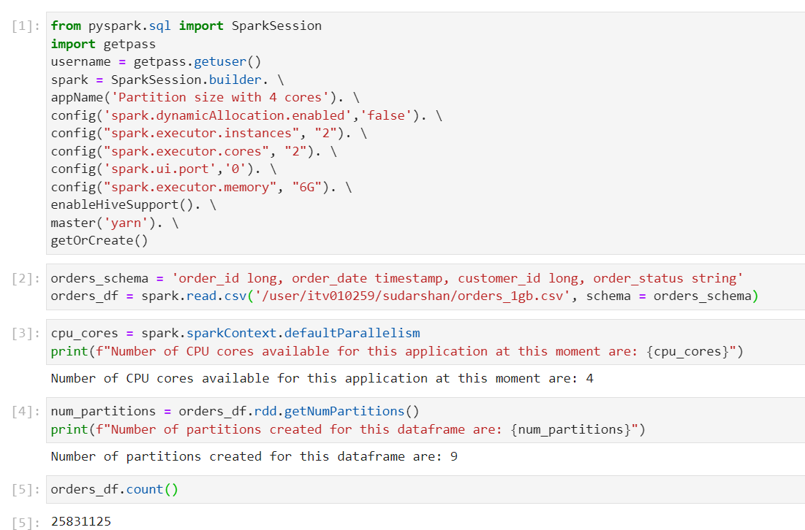

Number of CPU cores = num of executors * cores per executor = 2*2 = 4

**Spark UI-**

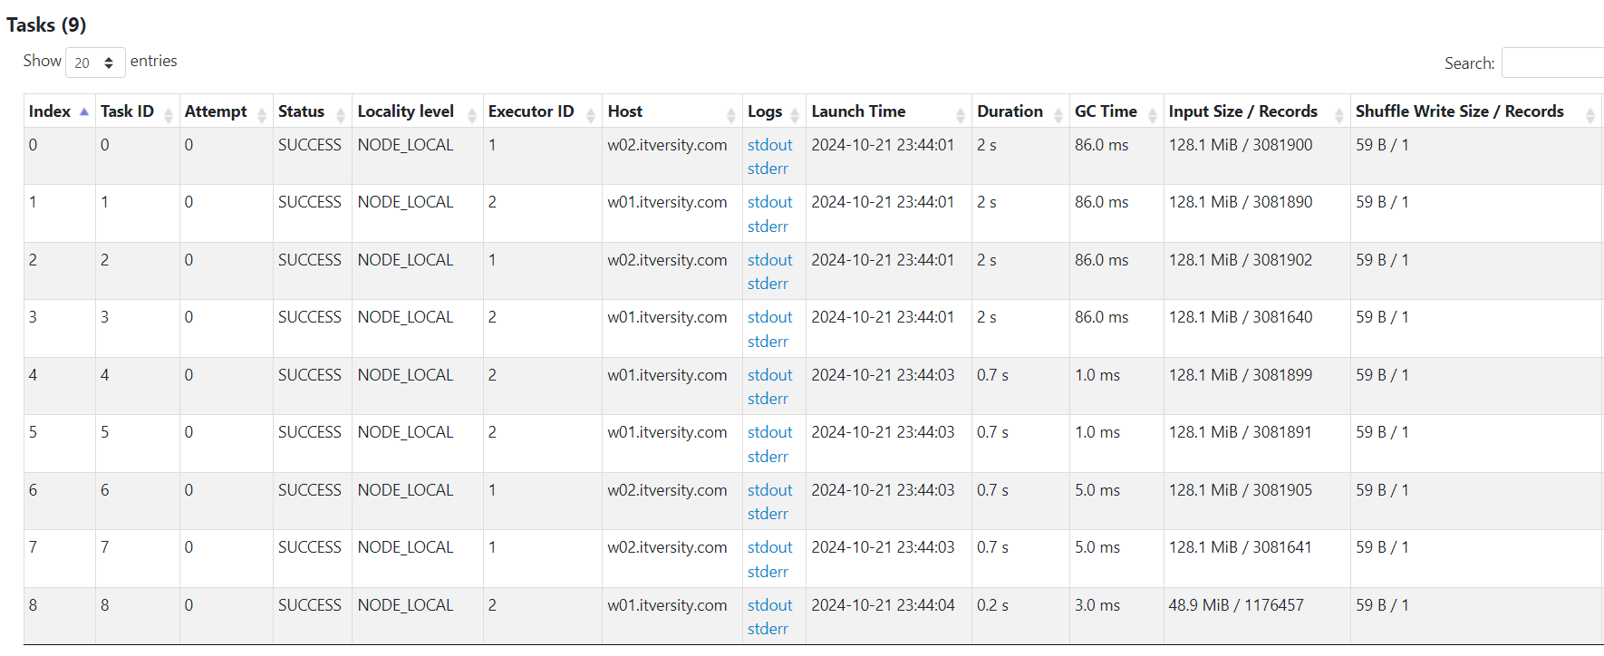

Partition size

**Scenario-2**

**Code-**

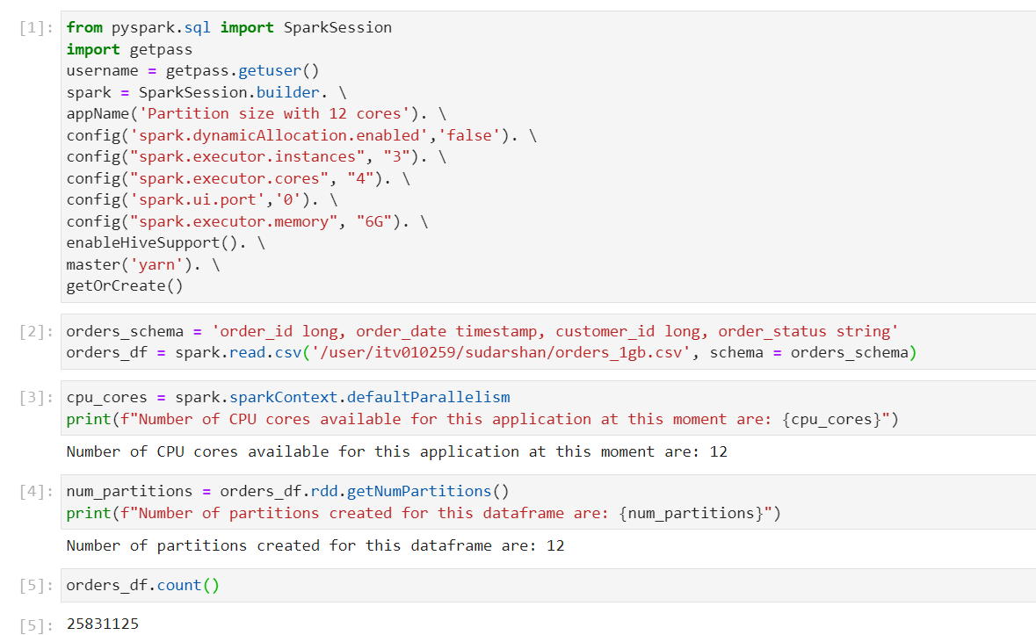

Number of CPU cores = num of executors * cores per executor = 3*4 = 12

**Spark UI-**

Partition size

