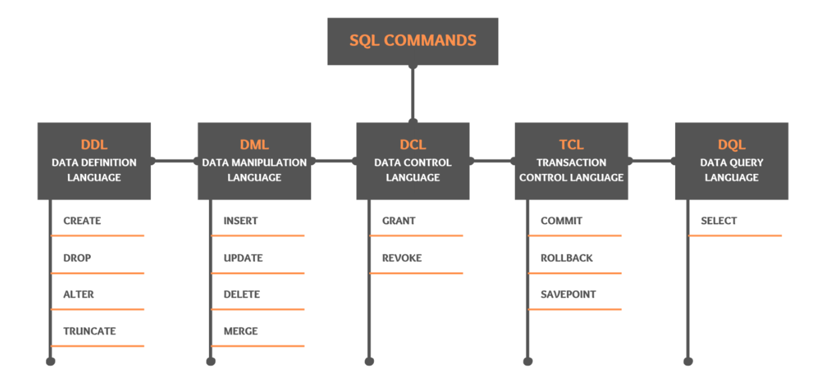

Link for SQL basics: <https://techtfq.com/blog/sql-basics-tutorial-for-beginners>

Commonly used data-types in SQL:

VARCHAR, INT, FLOAT, DATE, BOOLEAN





While doing union, make sure that column in first query & column in second query are same. Otherwise there will be an error.