# Project Plan Document

TEAM DETAILS:

|  |  |
| --- | --- |
| NAME | SRN |
| P SUDARSHAN | PES2UG20CS238 |
| PATEEL SAI KRISHNA REDDY | PES2UG20CS241 |

**Things to be included as part of the project plan.**

1: Identify the lifecycle to be followed for the execution of your project and justify why you have chosen the model.

Answer:

We are going to use Waterfall Model Because:

* Requirements are well defined and fixed.
* There are no Ambiguous Requirements.
* Our Project Requirements are Clear and not complicated.
* It is a Small scale Project.
* Technology and tools used are stable.

2: Identify the tools which u want to use it throughout the lifecycle like planning tool, design tool, version control, development tool, bug tracking, testing tool.

Answer: Tools used in our project are:

1. Visual Studio Code
2. Database support - MySQL 5.7O
3. Django(3.0.5)
4. Python(3.10.4)

3: Determine all the deliverables and categorise them as reuse/build components and justify the same.

Answer:

1. Doctors Panel

* Apply for job in hospital. Then Login (Approval required by hospital admin, Then only doctor can login).
* Can only view their patient details (symptoms, name, mobile ) assigned to that doctor by admin.
* Can view their discharged(by admin) patient list.
* Can view their Appointments, booked by admin.
* Can delete their Appointment, when doctor attended their appointment.

2. PATIENTS PANEL

* Create account for admit in hospital. Then Login (Approval required by hospital admin, Then only patient can login).
* Can view assigned doctor's details like ( specialization, mobile, address).
* Can view their booked appointment status (pending/confirmed by admin).
* Can book appointments.(approval required by admin)
* Can view/download Invoice pdf (Only when that patient is discharged by admin).

3. ADMIN MODULE

* Signup their account. Then Login (No approval Required).
* Can register/view/approve/reject/delete doctor (approve those doctor who applied for job in their hospital).
* Can admit/view/approve/reject/discharge patient (discharge patient when treatment is done).
* Can Generate/Download Invoice pdf (Generate Invoice according to medicine cost, room charge, doctor charge and other charge).
* Can view/book/approve Appointment (approve those appointments which is requested by patient).

4: Create a WBS for the entire functionalities in detail

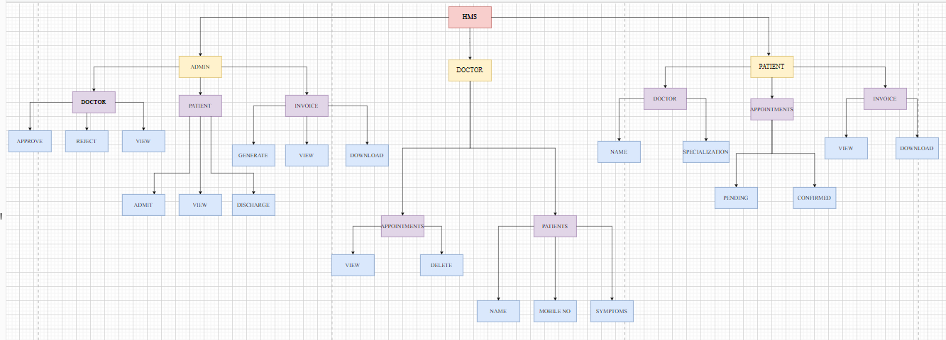

5: Do a rough estimate of effort required to accomplish each task in terms of person months.

Answer:

Basic COCOMO Model Values:

|  |  |  |  |  |
| --- | --- | --- | --- | --- |
| Software Projects | a | b | c | d |
| Organic | 2.4 | 1.05 | 2.5 | 0.38 |
| Semi Detached | 3.0 | 1.12 | 2.5 | 0.35 |
| Embedded | 3.6 | 1.20 | 2.5 | 0.32 |

Since we are beginners, we are going to use the **Organic Basic COCOMO model** to estimate the effort required to accomplish each task in terms of person-months: -

Effort= a(KLOC)^b person-months

time= c(Effort)^d months

Person required = Effort/ time

Therefore, Assuming we are going to write 1,000 lines of code, i.e., 1.0 KLOC, then:

**Effort(E) = 2.4 * (1.0) ^1.05 = 2.40 person-months**

**Time(T) = 2.5 * (2.40) ^0.38 = 3.486 Months**

**Person required ≈ 1 Person**

6: Create the Gantt Chart for scheduling using any tool.

