# **Software Requirements Specification**

# **For**

# **HOSPITAL MANAGEMENT SYSTEM**

**Prepared by:**

P SUDARSHAN : PES2UG20CS238

PATEEL SAI KRISHNA REDDY : PES2UG20CS241

**Organization:**

PES UNIVERSITY, BANGALORE

13/09/2022

Table of Contents

Table of Contents ii

Revision History ii

1. Introduction 1

1.1 Purpose 1

1.2 Intended Audience and Reading Suggestions 1

1.3 Product Scope 1

1.4 References 1

2. Overall Description 2

2.1 Product Perspective 2

2.2 Product Functions 2

2.3 User Classes and Characteristics 2

2.4 Operating Environment 2

2.5 Design and Implementation Constraints 2

2.6 Assumptions and Dependencies 3

3. External Interface Requirements 3

3.1 User Interfaces 3

3.2 Communications Interfaces 3

**4. Analysis Models**

5. System Features 4

5.1 System Feature 1 4

5.2 System Feature 2 (and so on) 4

6. Other Nonfunctional Requirements 4

6.1 Performance Requirements 4

6.2 Safety Requirements 5

6.3 Security Requirements 5

6.4 Software Quality Attributes 5

6.5 Business Rules 5

7. Other Requirements 5

Appendix A: Glossary 5

Appendix B: Field Layouts 5

Appendix C: Requirement Traceability matrix 6

# Introduction

HOSPITAL MANAGEMENT SYSTEM PROJECT: A web application with features from other sample software projects. A user-friendly web application for patients and doctors including some other helpful features.

## Purpose

HOSPITAL MANAGEMENT SYSTEM is a user-friendly web application which caters the major need of patients and doctors. This web application contains major fields like DOCTORS PANEL, PATIENTS PANEL, SUPPORT SYSTEM, ADMIN which serves the purpose of users.

## Intended Audience

Developers, Project managers, Marketing staff, Users(Doctors, Patients, Admin), testers, and documentation writers

## Product Scope

1. Doctors Panel

* Apply for job in hospital. Then Login (Approval required by hospital admin, Then only doctor can login).
* Can only view their patient details (symptoms, name, mobile ) assigned to that doctor by admin.
* Can view their discharged(by admin) patient list.
* Can view their Appointments, booked by admin.
* Can delete their Appointment, when doctor attended their appointment.

2. PATIENTS PANEL

* Create account for admit in hospital. Then Login (Approval required by hospital admin, Then only patient can login).
* Can view assigned doctor's details like ( specialization, mobile, address).
* Can view their booked appointment status (pending/confirmed by admin).
* Can book appointments.(approval required by admin)
* Can view/download Invoice pdf (Only when that patient is discharged by admin).

3. ADMIN MODULE

* Signup their account. Then Login (No approval Required).
* Can register/view/approve/reject/delete doctor (approve those doctor who applied for job in their hospital).
* Can admit/view/approve/reject/discharge patient (discharge patient when treatment is done).
* Can Generate/Download Invoice pdf (Generate Invoice according to medicine cost, room charge, doctor charge and other charge).
* Can view/book/approve Appointment (approve those appointments which is requested by patient).

# Overall Description

## Product Perspective

Medical care is one of the most essential and in-demand services for all. It requires a lot of attention and high-quality service that also causes health care workers to do a lot of effort. These issues also add to the situations where there’s a need for a physical attendant for every patient wherein it could be automated and handled with technology.

The hospital management system could handle specific tasks such as securing various information of the patients. This will help them secure the data to keep patient-doctor confidentiality as well as assure them of their healing factors. It can also improve the productivity of the health care workers and could let them accommodate more patients.

## Product Functions

## The Hospital management system database design is a database design used for managing **hospital** functions and events. It enables the admin to register a patient for the hospital, store their disease details into the database. Any of the staff members, doctor & admin is able to add, view, edit, update or delete data.

1. Doctors Panel

* Apply for job in hospital. Then Login (Approval required by hospital admin, Then only doctor can login).
* Can only view their patient details (symptoms, name, mobile ) assigned to that doctor by admin.
* Can view their discharged(by admin) patient list.
* Can view their Appointments, booked by admin.
* Can delete their Appointment, when doctor attended their appointment.

2. PATIENTS PANEL

* Create account for admit in hospital. Then Login (Approval required by hospital admin, Then only patient can login).
* Can view assigned doctor's details like ( specialization, mobile, address).
* Can view their booked appointment status (pending/confirmed by admin).
* Can book appointments.(approval required by admin)
* Can view/download Invoice pdf (Only when that patient is discharged by admin).

3. ADMIN MODULE

* Signup their account. Then Login (No approval Required).
* Can register/view/approve/reject/delete doctor (approve those doctor who applied for job in their hospital).
* Can admit/view/approve/reject/discharge patient (discharge patient when treatment is done).
* Can Generate/Download Invoice pdf (Generate Invoice according to medicine cost, room charge, doctor charge and other charge).
* Can view/book/approve Appointment (approve those appointments which is requested by patient).

## 

## 2.3 User Classes and Functions

## 2.4 Operating environment

### **Software:**

1. Visual Studio Code
2. Database support - MySQL 5.7O
3. Django(3.0.5)
4. Python(3.10.4)

## 2.5 Design and implementation constraint

We have developed different pages for different types of users such as doctors, patients and admins. The implementation part is yet to be done. The communication protocol will be HTTP. There are number of tools which can be used for its implementation. The maximum number of users at a time is yet to be decided.

2.6 Assumption and dependencies

The user is familiar with internet and Web based software like social networking sites. The browser with the user is using Windows 8 and above.

1. External Interface Requirements
   1. User Interfaces

The user interface design is simple and clear. Users can easily view the events which he/she is a part of. In this software, an individual can create a new account to get access to the website and accordingly the website filters the users into the respective category. The view is different for all the actors.

* 1. Communications Interfaces

We require a JDBC connection between the front end and backend com ponents to write to the database and fetch required data.

## 4. Analysis Model

### 

### 4.1. Use Case View:

* Three actors have been identified for the product, HMS , and each of them are shown with their own set of use cases.
* The actors are depicted as stick figures in the use case diagram.
* An overall system view of the software, HMS is depicted with all the actors and their corresponding use cases put together.
* All the events would have to proceed with a Login. The other events are self-explanatory as shown in the use case diagram.

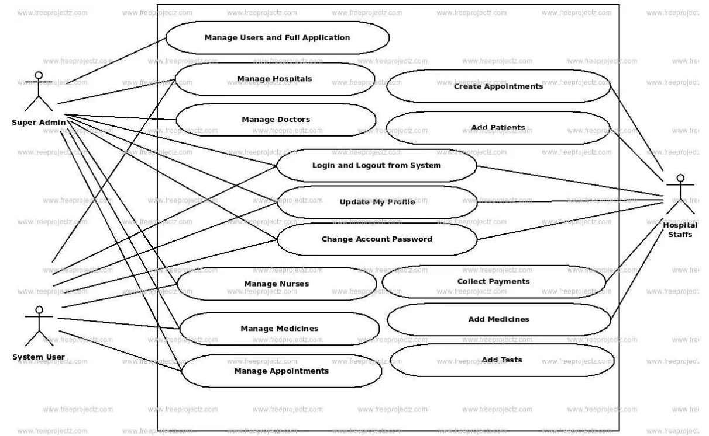

**4.2. Data flow diagram:**

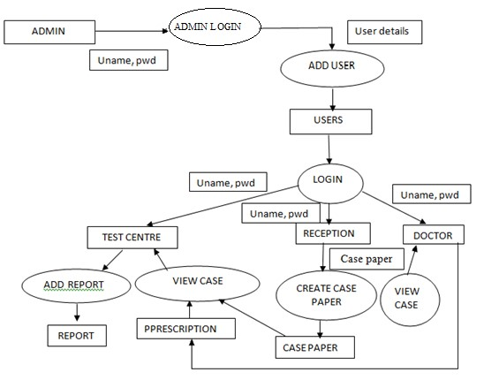

**b. Entity Relationship Diagram:**

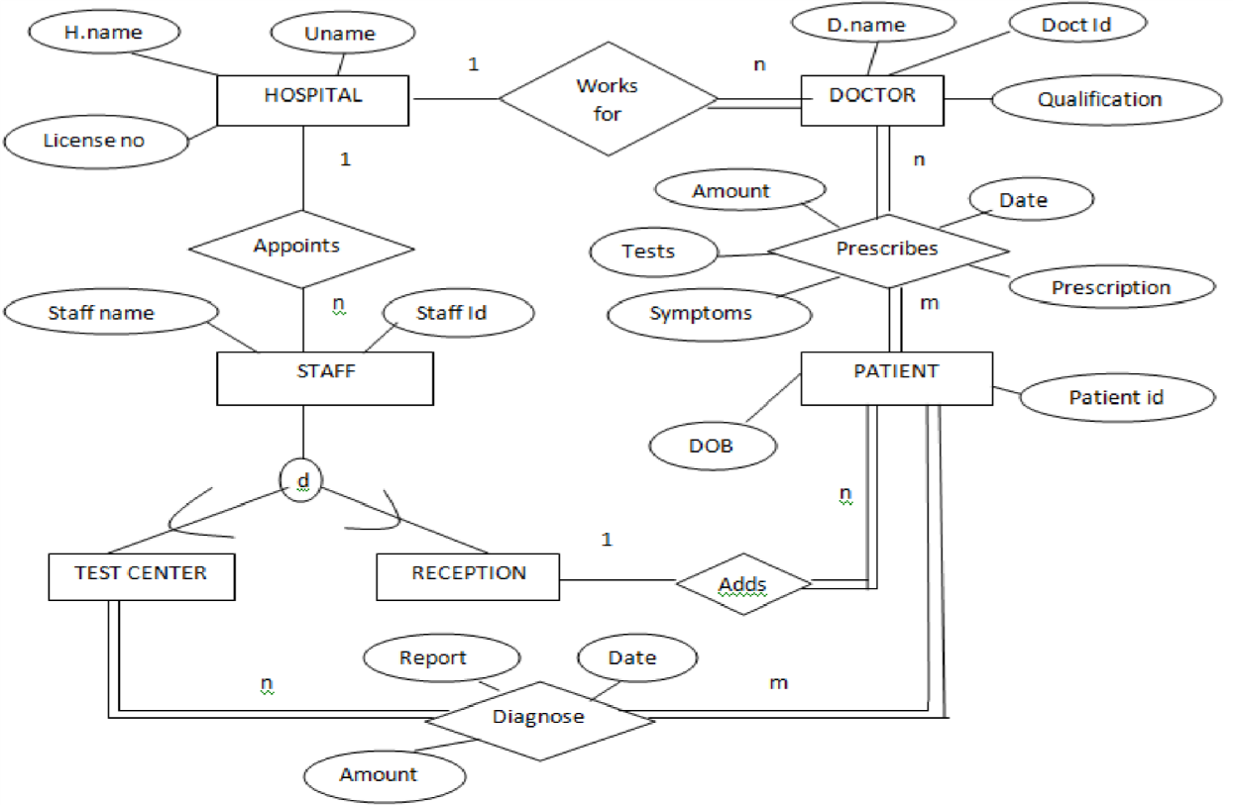

**5. System features**

## Admin:

5.1.1 Description and Priority: This module in HMS has the highest priority. Admin has the power to approve or reject doctors who applied for job. Can approve or cancel patient appointments, Generate invoice.

5.1.2 Stimulus/Response Sequences:

* When a doctor is approved he/or she can login can view his account in HMS.
* Once the appointment is approved the doctor can view the patient details.
* Can generate an invoice when a patient is discharged.

5.1.3 Functional Requirements:

* Can register/view/approve/reject/delete doctor.
* Can admit/view/approve/reject/discharge patient.
* Can Generate/Download Invoice pdf.
* Can view/book/approve Appointment.

## Doctor:

5.2.1 Description and Priority: A Doctor can apply for job in the hospital. He can only login when he is approved by admin. He can view details of patients assigned to him and also their appointments booked by admin. This module has second most priority.

5.2.2 Stimulus/Response Sequences:

* Once doctor clicks on the patient list, he can view all the list of patients assigned to him.
* List of all appointments for the day.

5.2.3 Functional Requirements:

* Can only view their patient details (symptoms, name, mobile ) assigned to that doctor by admin.
* Can view their Appointments, booked by admin.
* Can delete their Appointment, when doctor attended their appointment.

## Patient:

5.3.1 Description and Priority: A patient can signup their account then login. He/She can view doctor details, book appointment, view appointment status, download invoice. It assumes least priority.

5.3.2 Stimulus/Response Sequences:

* Once the admin approval is given he/she can login and view their account.
* Shows the details of the doctor assigned to him.
* Booked appointment status pending/confirmed.

5.3.3 Functional Requirements:

* Create account for admit in hospital. Then Login (Approval re-quired by hospital admin, Then only patient can login).
* Can view assigned doctor's details like ( specialization, mobile, Name).
* Can view their booked appointment status (pending/confirmed by admin).
* Can view/download Invoice pdf (Only when that patient is dis-charged by admin).

**6. Other Non-Functional Requirements**

**6.1. Performance Requirements**

5.3 Maintainability

SRS021 Back Up

The system shall provide the capability to back-up the Data

SRS022 Errors

The system shall keep a log of all the errors.

5.4 Reliability

SRS023 Availability

The system shall be available all the time

1. **Response Time:** The system shall give response in 1 hour after checking patient’s information
2. **Capacity:** The system will support 1200 people at a time.
3. **User interface:** The UI screen will respond within 10 seconds**.**
4. **Conformity:** The booking will be confirmed after 1 hour. Sends message to the registered phone number.

**Availability:** The system will be available all time.

**6.2. Safety Requirements**

**1. Patient Identification:** The system needs the patient to recognize herself or himself using the phone.

**2. Login ID:** Any users who make use of the system need to hold a Login ID and password.

**3. Modifications:** Any modifications like insert, delete, update, etc. for the database can be synchronized quickly and executed only by the ward administrator.

**4. Administrator rights:** The administrator can view as well as alter any information in the Hospital Management System.

**6.3. Security Requirements**

**1. Maintainability:** The system will provide the ability to back-up of data

**6.4. Software quality requirements**

**1. Availability:** The system will be available all time.

**6.5. Business roles**

**1. Improved process:** It helps to optimize user experience. Medical specialist, patients, hospital authorities can interact online.

**2. Financial and tax planning:** The management can monitor different financial operations including expenses, profits and losses, paying bills and taxes. The financial awareness helps us to analyze business prospects quite clear and it helps to take correct decision.

It helps to optimize the user experience. Medical specialists, patients, and hospital

authorities can interact online.

**3. Market strategy:** Due to high market competitive nature, the medical industry is also open to all different innovations that enable communication between patients, doctors, supplier and marketing service provider.

Appendix A: Glossary

HMS – Hospital Management System

Appendix B: Field Layouts

An Excel sheet containing field layouts and properties/attributes and report requirements.

**Sample sheet with information required to register the customer**

|  |  |  |  |  |
| --- | --- | --- | --- | --- |
| **Field** | **Length** | **Data Type** | **Description** | **Is Mandatory** |
| Account Number | 16 | Numeric |  | Y |
| ISFC code | 11 | Alphanumeric | | Y |
| Card Amount | 20 | Numeric |  | Y |
| Mandate Start Date | 8 | Date | Date of Mandate Registration | N |
| Mandate End Date | 8 | Date | Date of Mandate Expiry | N |
| Status | 25 | Alphanumeric | Status of Registration | Y |
| Customer Name | 60 | String |  | Y |
| Reject Reason Code | 4 | String | Reject Reason code in case mandate is rejected | N |

**Sample Report Requirements: Include the fields to be included in the report**

|  |  |
| --- | --- |
| **Registration Report** | **Transaction Report** |
|  |  |
| Bank Account Number | Transaction Reference Number |
| ISFC Code | Bank Account Number |
| Bank Name | IFSC Code |
| Account Status | Bank Name |
| Account Type | Customer Name |
| Customer Name | Card Number |
| Card Number | Debit Transaction Amount |
| SI Start Date | Transaction Date |
| Status | Status |
| Remarks | Debit Attempt Number |
|  | Remarks |

Appendix C: Requirement Traceability Matrix

|  |  |  |  |  |  |  |  |
| --- | --- | --- | --- | --- | --- | --- | --- |
| **Sl. No** | **Requirement ID** | **Brief Description of Requirement** | **Architecture Reference** | **Design Reference** | **Code File Reference** | **Test Case ID** | **System Test Case ID** |
| 1 | R01 | Admin approval of doctor | A01 | D01 | mngdoc | T01 | S01 |
| 2 | R02 | Admin approval of patient | A02 | D02 | mngptnts | T02 | S02 |
| 3 | R03 | Booking appointment | A03 | D03 | bookapn | T03 | S03 |
|  |  |  |  |  |  |  |  |
|  |  |  |  |  |  |  |  |