Software Architecture and Design Specification
Project: Web based code merge simulator
Version: 1.0
Authors: Example Team
Date: 02-10-2026
Status: Draft

Revision History
Version | Date | Author | Change summary

Approvals
Roll | Name | Signature/Date

1. Introduction
1.1 Purpose
This document specifies the architecture and design of the Web-Based Code Merge Simulator, a browser-based educational tool that lets learners practice branching, merging, and conflict resolution the way Git does it internally, without touching a real repository.
1.2 Scope
The system covers three core simulated operations, mirroring how a real VCS handles divergent work:
- Branch & commit simulation: creating branches from a common ancestor and simulating edits/commits on each.
- Automatic merge execution: running a three-way merge when changes don't overlap.
- Conflict detection & manual resolution: flagging overlapping changes and letting the learner resolve them interactively

1.3 Audience
Developers building the simulator, QA engineers validating merge correctness, instructors who design and assign scenarios, and maintenance teams supporting the platform after release.
1.4 Definitions
- VCS — Version Control System
- DAG — Directed Acyclic Graph (used to represent commit history)
- Three-way merge — a merge strategy comparing two branches against their common ancestor
- Diff algorithm — the method used to detect line-level changes (this project uses a Myers-diff-based approach)
- ADR — Architecture Decision Record
- TLS — Transport Layer Security
- XSS — Cross-Site Scripting (relevant since user code is rendered in-browser)

2. Document Overview
2.1 How to use this document
This document provides the architectural deliverables for the project: a component diagram, two sequence diagrams, a threat model, and API design specifications, to guide implementation and review.
2.2 Related Documents
Software Requirements Specification (SRS), Software Test Plan (STP), and Requirements Traceability Matrix (RTM) for this project.

3. Architecture
3.1 Goals & Constraints
Goals: the merge and diff logic must behave correctly and consistently with real Git semantics (since the entire teaching value depends on it), the UI must feel responsive when rendering diffs, and the system should remain available for uninterrupted classroom or lab sessions.
Constraints: must run fully in-browser without requiring a native Git installation for the core learning flows, must handle reasonably sized files without noticeable lag, and must work consistently across major browsers.

3.2 Stakeholders & Concerns
- Students/learners: usability, accuracy of feedback, clarity of conflict explanations
- Instructors: ability to customize scenarios, visibility into learner progress
- Developers: modularity of the merge engine, ease of extending diff logic
- QA: correctness across edge cases (overlapping edits, adjacent changes, deletions)

3.3 Component (UML) Diagram
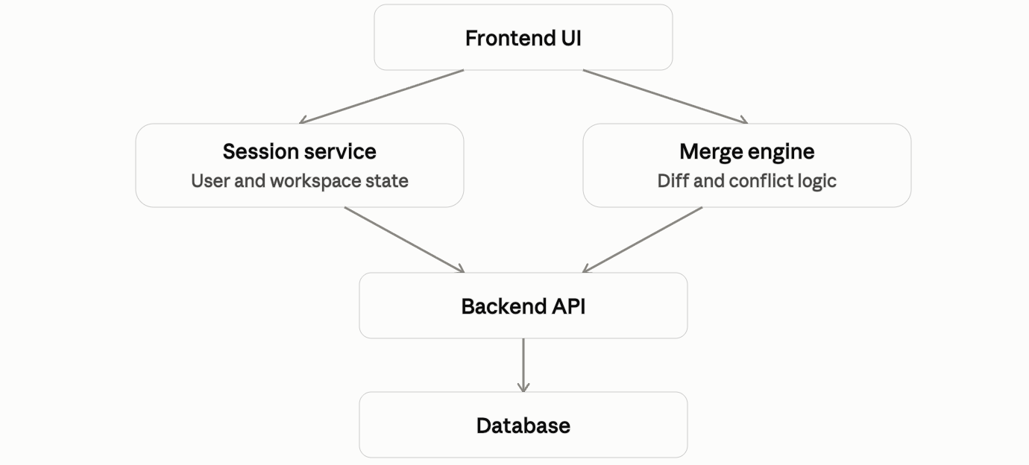

3.4 Component Descriptions
- -Frontend UI: renders the branch/commit graph, the diff view, and the conflict-resolution editor; handles all learner input and output.
- Session Service: tracks which scenario a user is working on, the current branch state, and progress within that scenario — playing the role Auth Service plays in a transactional system, but for workspace identity rather than payment credentials.
- Merge Engine: the core processor. Runs three-way diffing, detects overlapping changes, and produces either a merged file or a conflict result.
- Backend API: exposes REST endpoints, coordinates requests between the Session Service, Merge Engine, and Database.
- Database: stores scenario definitions, saved repository states, and learner progress/history.

3.5 Chosen Architecture Pattern and Rationale
A layered architecture (presentation → application/session → domain/merge logic → data) was chosen because it cleanly isolates the merge algorithm which is the most correctness-critical part of the system from UI and persistence concerns, making it independently testable. A microservices approach was considered and rejected: asthe system has a single well-defined purpose, modest traffic expectations, and no component that genuinely needs independent scaling, so the added operational complexity wouldn't be more optimal.

3.6 Technology Stack & Data Stores
- Frontend: React (or Vue) with TypeScript, using Monaco Editor or CodeMirror for syntax-highlighted diff and conflict views.
- Backend: a REST API (Node.js/Express or Java/Spring Boot), hosting the Merge Engine as a pure, testable module.
- Diff engine: a Myers-diff-based implementation extended with three-way merge logic, built in-house so it's fully understood and controllable rather than a black box.
- Database: PostgreSQL or MySQL for scenarios, session state, and progress records.
- Transport: TLS enforced on all API traffic.

3.7 Risks & Mitigations

- Risk: the merge engine produces output that doesn't match real Git behavior, undermining the learning objective
- Mitigation: validate the engine's output against actual git merge-file results in an automated test suite.

- Risk: large files or deep commit histories slow down in-browser rendering
- Mitigation: cap file size for simulation scenarios and virtualize long diff views.

- Risk: a learner loses progress on refresh or disconnect
- Mitigation: periodic autosave of session state to the backend.

3.8 Traceability to Requirements
- R1 (Simulate branches and commits): Frontend UI + Session Service
- R2 (Perform automatic merge): Merge Engine
- R3 (Detect and resolve conflicts): Merge Engine + conflict-resolution UI
- R4 (Persist scenarios and progress): Backend API + Database

3.9 Security Architecture
Even as an educational tool, the system follows standard threat-modeling discipline (STRIDE):
- Spoofing → workspace/session identifiers are unguessable, signed tokens rather than sequential IDs.
- Tampering → the server always re-validates a submitted "resolved" merge against the actual diff, rather than trusting whatever the client claims the final content is.
- Information disclosure → all API traffic is served over TLS; user-submitted code is escaped, not injected as raw HTML, to prevent it leaking through rendering bugs.
- Denial of Service → merge/diff requests are rate-limited per session to prevent abuse of the diff engine with oversized or repeated payloads.
- Elevation of Privilege → role-based access separates instructors (who can create/edit scenarios) from students (who can only attempt them).

4. Design

4.1 Design Overview
The system is organized into layered modules: a presentation layer (UI components), an application layer (session and scenario orchestration), a domain layer (the merge/diff core, written as pure functions with no UI or storage dependencies), and a data layer. Keeping the domain layer pure is deliberate as it's what makes the merge logic straightforward to unit-test against known Git behavior.

4.2 UML Sequence Diagrams
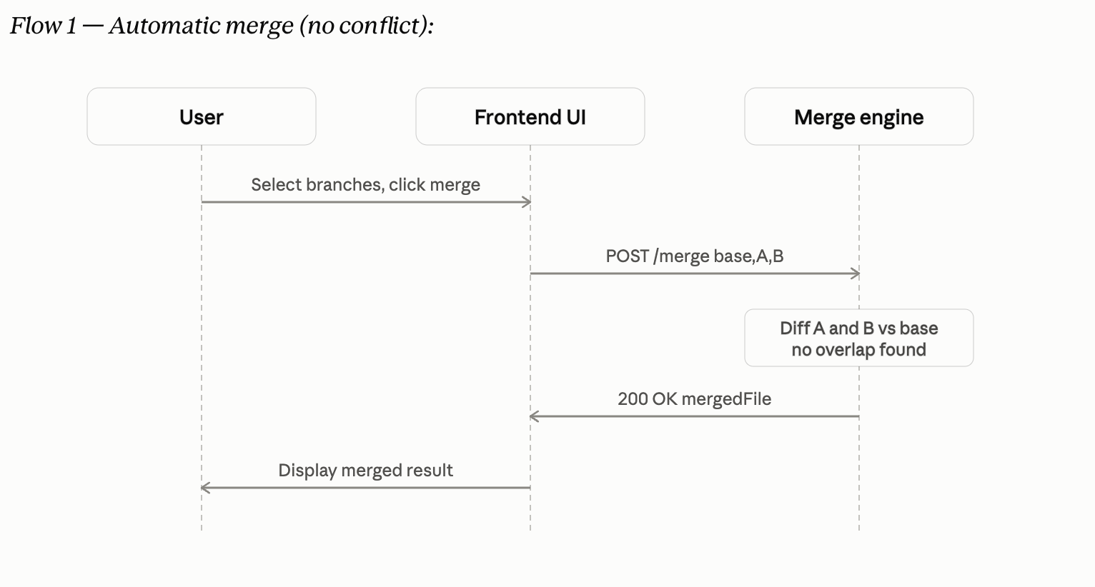
At least 2 sequence diagrams covering 2 flows specific to your project

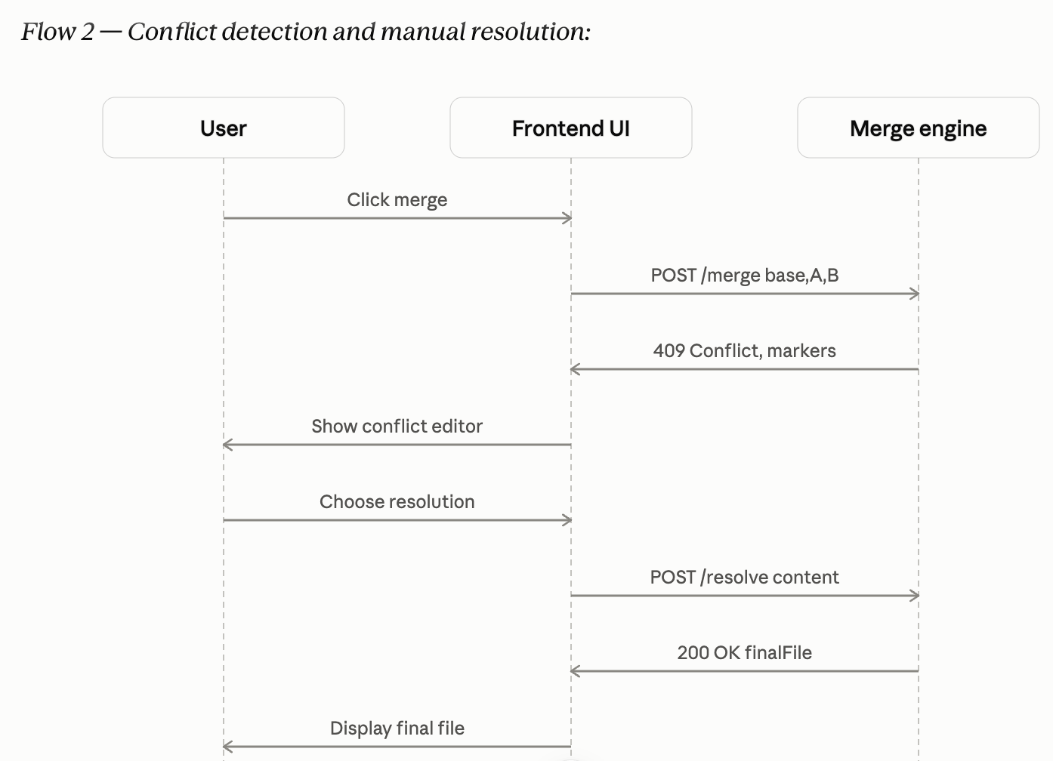

4.3 API Design
Endpoint 1:
- Endpoint: /merge
- Method: POST
- Request: {sessionId, baseId, branchAId, branchBId}
- Response: {status: "merged" | "conflict", mergedContent?, conflicts?}
- Errors: 400 Invalid branch reference, 409 Conflict detected (returns conflict markers), 422 Malformed file content
Endpoint 2:
- Endpoint: /resolve
- Method: POST
- Request: {sessionId, conflictId, resolutions: [{hunkId, chosen: "mine"|"theirs"|"custom", customText?}]}
- Response: {status, finalContent}
- Errors: 400 Missing resolution for a hunk, 404 Conflict or session not found

4.4 Error Handling, Logging & Monitoring
Errors follow a standardized envelope ({code, message}) across all endpoints. Logs avoid storing full user-submitted source content in plaintext where it isn't strictly needed for debugging. Monitoring tracks merge request latency, conflict rate, API error rate, and merge engine uptime.

4.5 UX Design
The interface uses accessible font sizing and a high-contrast, keyboard-navigable conflict-resolution flow. Syntax highlighting is language-agnostic so it works across whatever language a scenario uses. A guided/step-by-step mode helps first-time users, and an optional "explain this conflict" panel gives plain-language context on why a particular conflict occurred.

4.6 Open Issues & Next Steps

Planned future enhancements include importing a real Git repository to simulate merges on actual project history, supporting multi-file merge scenarios, enabling live collaborative simulations where two users edit branches simultaneously, and exploring AI-assisted suggestions for conflict resolution.

5. Appendices
5.1 Glossary
- VCS (Version Control System) — software that tracks changes to files over time (e.g., Git), the system this project simulates.
- DAG (Directed Acyclic Graph) — the structure used to represent commit history, where each commit points back to its parent(s).
- Three-way merge — a merge strategy that compares two divergent branches against their common ancestor to determine what changed on each side.
- Diff algorithm — the method used to detect line-level differences between two versions of a file; this project implements a Myers-diff-based approach.
- Merge conflict — the state where the same region of a file was changed differently on two branches, requiring manual resolution.
- ADR (Architecture Decision Record) — a short document capturing a significant architectural decision and its rationale.
- TLS (Transport Layer Security) — the protocol used to encrypt API traffic between the frontend and backend.
- XSS (Cross-Site Scripting) — a web vulnerability class relevant here because user-submitted code is rendered in the browser and must be escaped, not injected as raw HTML.
5.2 References
- IEEE 42010 — Systems and software engineering — Architecture description (the standard this document's structure loosely follows).
- OWASP Top 10 — guidance on common web application vulnerabilities (XSS, injection, broken access control), relevant to securing the merge/conflict API.
- NIST SP 800-160 — Systems Security Engineering, referenced for the threat-modeling and secure-design approach in Section 3.9.
- Myers, E.W., "An O(ND) Difference Algorithm and Its Variations" (1986) — the foundational algorithm behind the diff engine's core logic.
- "Pro Git" by Scott Chacon & Ben Straub — used as the behavioral reference for how real Git merge semantics should work, so the simulator's output stays faithful to it.
5.3 Tools
- PlantUML / draw.io — for authoring the component and sequence diagrams during design.
- Mermaid.js — for lightweight in-browser diagram rendering where applicable (e.g., illustrating commit graphs within the app itself).
- Swagger / OpenAPI — for documenting and testing the /merge and /resolve REST endpoints.
- Postman — for manual and automated API testing against the Merge Engine endpoints.
- Jest / JUnit (depending on backend language choice) — for unit-testing the diff and merge logic against known Git behavior, which is the most correctness-critical part of the system.

