Lab Exercise – 3
Sudarshan Rao
BL.AI.U4AID25064

Question – 1
1. Identify the DNS query message generated when accessing the website. What is the
destination IP address of this query?
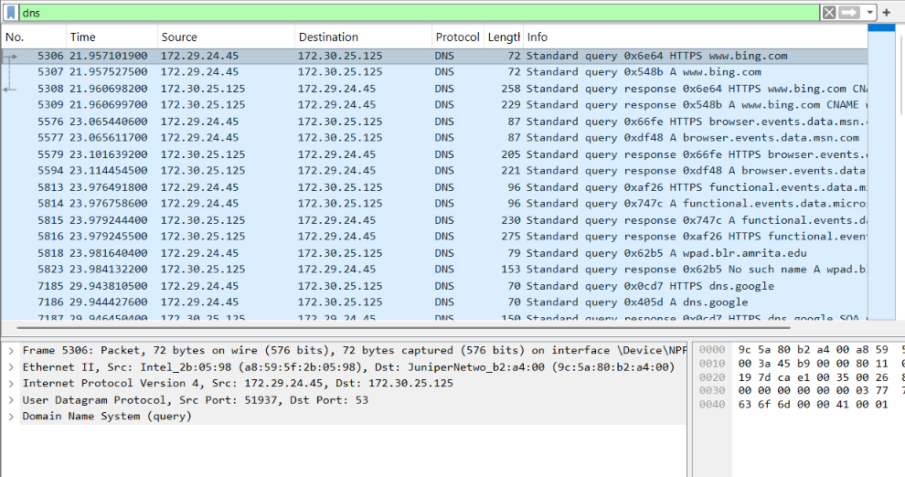
IP address - 5306 21.957101900 172.29.24.45 172.30.25.125 DNS 72 Standard query 0x6e64 HTTPS www.bing.com
Question – 2
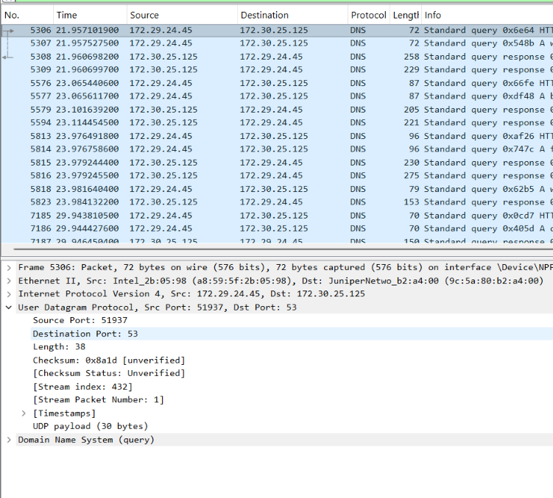
Port number – 53
Question – 3
3. Examine the DNS response. How many IP addresses (answers) are returned?
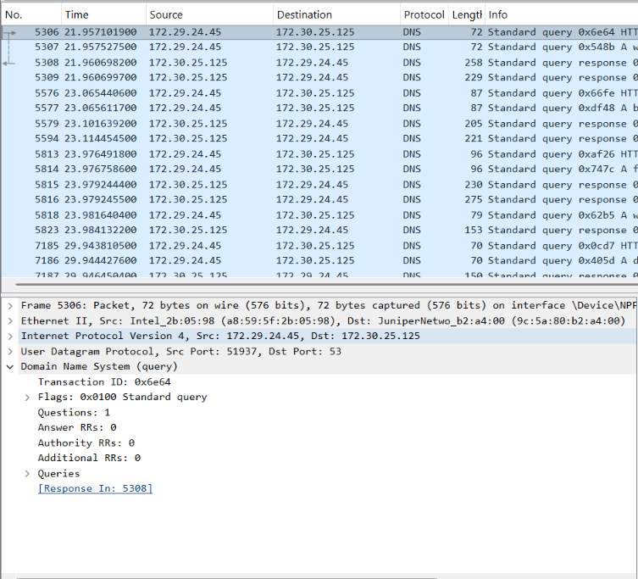
For this it has returned 0 IP address
Question – 4
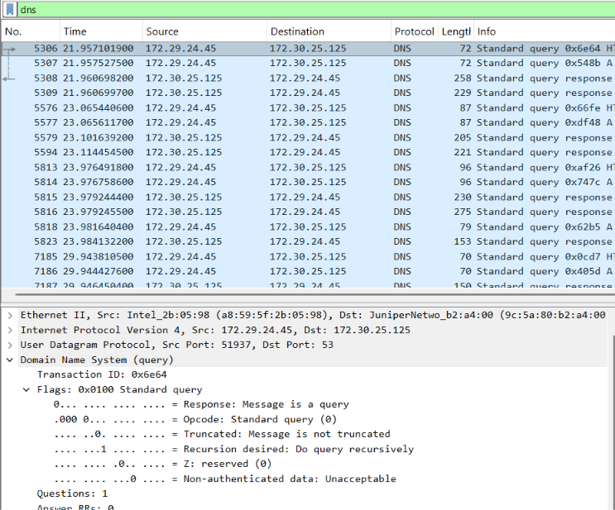
This is non – authoritative
Question – 5
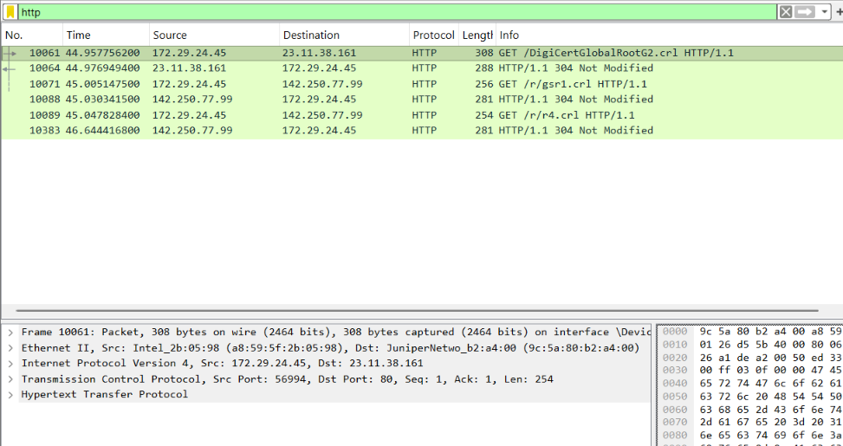
The method is persistent
Question – 6
10061 44.957756200 172.29.24.45 23.11.38.161 HTTP 308 GET /DigiCertGlobalRootG2.crl HTTP/1.1
Question – 7
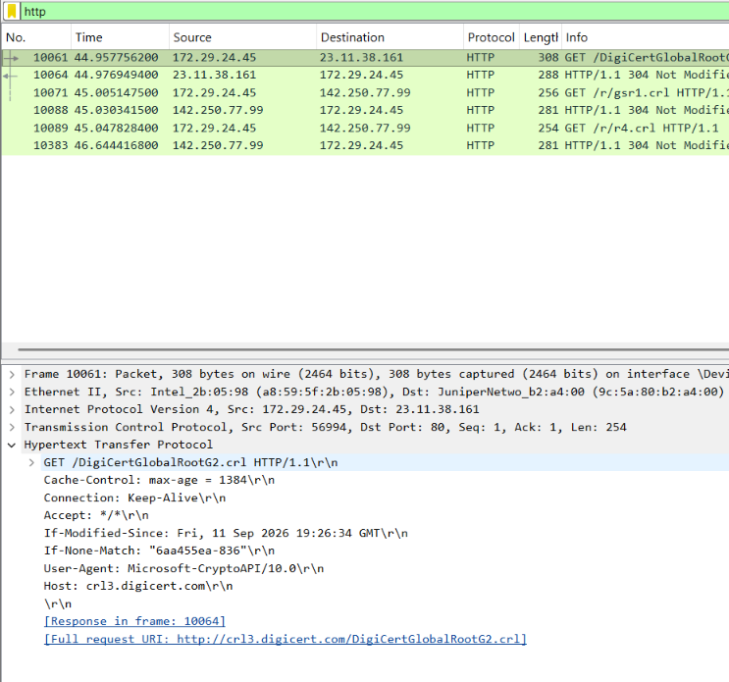
Host
The Host header identifies the hostname of the server being requested. It allows a web server to determine which website/resource the client wants when multiple websites are hosted on the same server/IP address.
User – agent
The User-Agent header identifies information about the client/browser making the request, such as the browser and operating system.
Question – 8
The status code is 304 which is not modified
Question – 9
No. In the captured trace, only one HTTP request is visible, so there is no evidence of additional HTTP objects being requested.
Question – 10
The entire sequence is
I opened an browser -> entered http://www.example.com -> the browser system will be needing an IP address -> it will go for the DNS server [Quary] -> DNS main server -> DNS IP address was returned ->web page is connected -> http – GET -> web page processing the request -> web page is loaded

